Team Members:
- Mayur Pokharkar (24M0840)
- MVS Sri Harsha (24M2151)

Introduction:
In recent years, retrieval augmented generation (RAG) has emerged as a powerful paradigm for developing robust question answering systems. Traditional QA pipelines commonly operate on the pattern of a "retrieve-and-read" solution wherein the system first retrieves relevant passages based on the query and then uses a language model for generating the answer. But, most retrieval methods currently work under the presumption that individual passages or chunks of passages are stand-alone; i.e., they overlook the rich interlinkages and semantic relations that can exist between various passages.

In this assignment, through the use of a Graph Neural Network (GNN)-based retrieval scheme which relies on the Graph of Passages (GoP). By forming a graph with passage nodes and relationships as edges that capture dependencies such as semantic similarity, keyword overlaps, sequential order, the GNN infuses knowledge from adjoining passages. This enables the retriever to accumulate contextual signals from nearby nodes, enhancing passage ranking that, although semantically far from the query, is contextually consistent with supporting evidence. The method is evaluated on the 2WikiMultihopQA dataset that includes multi-hop questions involving reasoning across multiple passages. The use of GNNs facilitates the system to pull out an extensive set of supporting facts, even when they have high semantic divergence from the question.
For many real-world questions, a single query might require evidence or supporting facts that are distributed across multiple passages. However, when these passages are evaluated in isolation using conventional similarity measures whether sparse (e.g., BM25) or dense (e.g., DPR) they might miss out on capturing crucial semantic and contextual similarities. As a result, supporting passages that could collectively contribute to answering the query might not be retrieved if they appear semantically distant from the query on their own.

Model Architecture:
In our implementation for this assignment we have used Graph Neural Networks (GNNs) to propagate contextual information across passages in a Graph of Passages (GoP). GNN is designed to refine passage embeddings by aggregating features from neighboring nodes. Refined embeddings are aligned with question embeddings for retrieval both designed to refine passage embeddings by aggregating features from neighboring nodes. Refined embeddings are aligned with question embeddings for retrieval.

GRAPHSAGE:
- Structure:
  - Input:
    - Node features: Precomputed passage embeddings (768D) from a Sentence Transformer.
    - Graph edges: Defined by heuristics (semantic similarity, shared keywords, sequential edges).
  - GraphSAGE Layers:
    - Layer 1: Maps 768D input → 256D hidden states.
    - Layer 2: Maintains 256D hidden states.
    - Aggregation: Mean-pooling neighbors’ features.
  - Projection Layer:
    - Linear layer maps 256D → 768D to match question embedding dimensions.
    - Ensures compatibility with question embeddings for similarity computation.
- Node Embedding → GraphSAGE (2 layers) → Projection → Refined Embedding (768D)

GCN:
- Structure:
  - Input:
    - Node features: Precomputed passage embeddings (768D) from a Sentence Transformer.
    - Graph edges: Defined by heuristics (semantic similarity, shared keywords, sequential edges).
  - GCN Layers:
    - First Convolution : GCNConv(768, 256) : Reduces dimensionality while preserving neighborhood structure and an activation function ReLU introduces non-linearity.
    - Second Convolution : GCNConv(256, 256): Further refines features.
  - Projection Layer:
    - Linear layer maps 256D → 768D to match question embedding dimensions.
    - Ensures compatibility with question embeddings for similarity computation.
- Node Embedding → GCNConv → ReLU → GCNConv → Projection → Refined Embedding (768D)
BASELINE MODELS:
- BM25Retriever:
  - It ranks passages based on lexical overlap with the question using the BM25 scoring function, without relying on learned embeddings or graph structures.
  - Input:
    - A question.
    - A context list of tuples (title, sentences), where passages are formed by concatenating sentences under each title into a single string.
  - Structure:
    - Tokenization: A simple function that splits text into lowercase tokens based on whitespace.
    - BM25 Scoring: Uses the BM25Okapi algorithm to compute relevance scores between the tokenized question and tokenized passages.

- DPRRetriever:
  - It uses pre-trained transformer embeddings to compute semantic similarity between the question and passages.
  - Input:
    - A question.
    - A context list of tuples (title, sentences), where passages are formed by concatenating sentences.
  - Structure:
    - Embedding Model: Utilizes a pre-trained SentenceTransformer to encode text into 768D embeddings.
    - Similarity Computation: Computes the inner product (cosine similarity) between the question embedding and each passage embedding.

Implementation:
Train the GNN models to refine passage embeddings such that relevant passages (identified by supporting_facts or similar labels) have higher similarity to the question embedding than irrelevant ones, improving retrieval accuracy for question-answering tasks.

Data Handling:

The Dataset: 2WikiMultihopQA
For this assignment, we have used the 2WikiMultihopQA dataset, a challenging benchmark for multi-hop question answering. Each data sample in this dataset comprises:
- Question: A complex query that may require evidence from multiple passages.
- Context: A collection of passages where each is presented as a title and a list of sentences.
- Supporting Facts: The gold-standard list of passages that collectively contain the evidence required to answer the question.
- Data Sampling and Graph Construction:
  - For each training sample, the dataset provides a set of passages and a query.
  - A function that constructs a Graph of Passages (GoP) where each node represents a passage. Edges between nodes are created based on heuristics (sequential order, semantic similarity) so that related passages are connected.
  - Along with the graph, a corresponding list of passage titles is maintained. These titles are later used to determine which passages are the gold (supporting) passages.
- Loss function:
  - Contrastive Margin Loss
    - Objective of the contrastive loss is to encourage the (question) embedding to be closer to the supporting passages (positives) while being further away from non-supporting passages (negatives).
    - L=mean(max(0, margin − pos_sim + neg_sim)) pos_sim: Cosine similarity between question and positive passages.
neg_sim: Cosine similarity between question and hard negatives.
margin: Forces a minimum gap between positive and negative similarities.
- Training:
  - The training loop optimizes a GNN-based retriever (e.g., GAT, GraphSAGE, or GCN) to refine passage embeddings by leveraging the Graph of Passages (GoP).
  - The training loop iterates over the dataset sample-by-sample. Individual samples (graphs) are used to simplify handling variable graph sizes and structures.
  - Hyperparmeters:
    - Epochs : we have performed the training for epochs in the range [2 - 10].
    - Optimizer: The training uses the Adam optimizer which is well-suited for handling sparse gradients and noisy data.
    - Learning Rate: Set to 1e-4, a typical choice for fine-tuning neural network layers, especially when dealing with pre-trained components.
  - To avoid exploding gradients and stabilize training, gradient clipping is performed by restricting the gradient norm to a maximum of 1.0.
  - The query is encoded using a SentenceTransformer (e.g., all-mpnet-base-v2, all-MiniLM-L6-v2, multi-qa-MiniLM-L6-cos-v1), which produces a 768-dimensional vector. Passage embeddings are initially computed and later refined by the chosen GNN model (for example, using a GAT, GraphSAGE, or GCN variant). After propagation through the GNN, a projection layer maps the updated passage embeddings back to the 768-dimensional space. This ensures they are directly comparable to the query embedding.

Results:

- For Retrieval
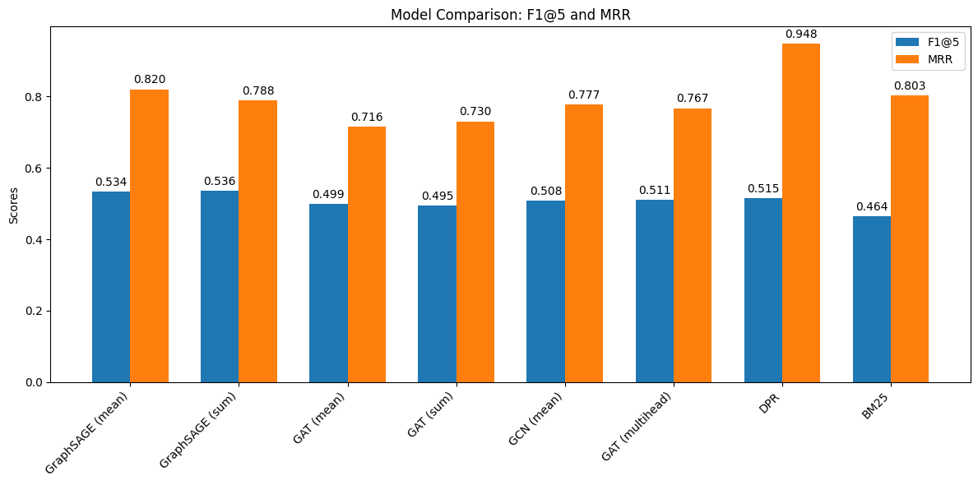
Fig 1. Different GNN implementations

- Observations
- GraphSage Variants:
  - Both GraphSAGE configurations (mean and sum) yield similar F1 scores (∼0.534–0.536). The mean aggregation variant shows a marginally higher MRR (0.82) compared to the sum approach (0.788), suggesting that mean aggregation may be a more robust choice when dealing with varying neighborhood sizes.
- GAT Variants:
  - The GAT-based models exhibit slightly lower F1@5 scores (∼0.495–0.499) and lower MRR scores (∼0.716–0.730) when compared to GraphSAGE. The multihead GAT variant shows a modest improvement in F1@5 (0.511) but still trails in MRR (0.767) relative to GraphSAGE.
- GCN:
  - The GCN model provides competitive performance with an F1@5 score of 0.508 and an MRR of 0.777. This underscores that even simple graph convolutional operations can capture useful inter-passage relationships.
- Baselines:
  - Interestingly, while the DPR (Dense Passage Retrieval) method achieves a competitive F1@5 (0.515), its MRR score is significantly higher (0.948). This indicates that DPR excels in ranking at least one supporting passage very high. However, the BM25 baseline lags with the lowest F1@5 (0.464), although its MRR (0.803) is still reasonable. This reinforces the notion that lexical methods may struggle with the full spectrum of evidence needed in complex queries.
- Challenges Faced
- Graph Construction Complexity:
  - Edge Design: Determining the optimal heuristics for constructing the Graph of Passages was non-trivial. While sequentially linking passages is straightforward, setting appropriate thresholds for semantic similarity to add additional edges required extensive experiments.
  - Scalability: For larger documents or corpora, constructing and processing dense graphs can be computationally intensive.
- Heavy Computation Time and Resource Intensive Operations:
  - Computational Overhead: The process of constructing graphs for each sample, encoding multiple passages using SentenceTransformers, and performing GNN propagation is computationally expensive. This overhead increases with dataset size and model complexity.
  - Memory Consumption: Working with high-dimensional embeddings (768D) and large graph structures can lead to significant memory usage. GPU memory limitations often restrict batch sizes and can slow down training or even necessitate running on CPU, which further increases computation time.
  - Long Training Times: The heavy computation required for both the GNN propagation and the iterative process of hard negative mining means that training may take a considerable amount of time, requiring careful scheduling and possibly distributed computing resources to accelerate experimentation.

Conclusion:
This assignment offers a deep insight into how well different retrieval models perform on the task. While our GNN-based methods (GraphSAGE, GAT, GCN, etc.) show competitive performance, especially in F1@5, the dense retrieval approach (DPR) stands out in ranking precision as indicated by its high MRR. However, challenges in graph construction, hyperparameter tuning, and loss stabilization point to avenues for future improvements and further experimentation.

