**Visual Structure**

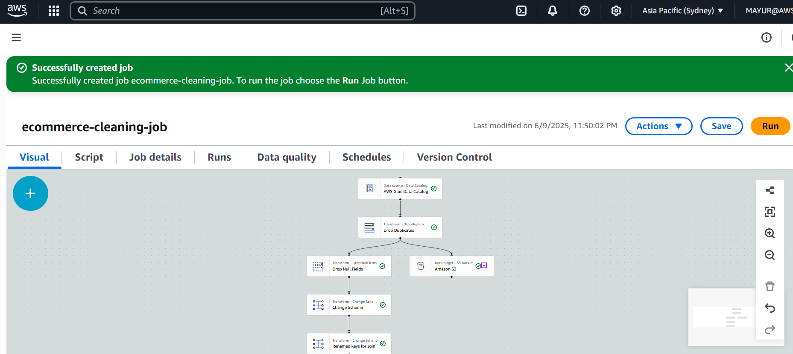

**Script**

import sys

from awsglue.transforms import *

from awsglue.utils import getResolvedOptions

from pyspark.context import SparkContext

from pyspark.sql import SparkSession

from awsglue.context import GlueContext

from awsglue.job import Job

from pyspark.sql.functions import to_date

# Initialize Glue context

args = getResolvedOptions(sys.argv, ['JOB_NAME'])

sc = SparkContext()

glueContext = GlueContext(sc)

spark = glueContext.spark_session

job = Job(glueContext)

job.init(args['JOB_NAME'], args)

# Load sales_data table from Glue Catalog

sales_data = glueContext.create_dynamic_frame.from_catalog(

database="ecommerce_db", table_name="sales_data"

)

# Load product_data table from Glue Catalog

product_data = glueContext.create_dynamic_frame.from_catalog(

database="ecommerce_db", table_name="product_data"

)

# Convert to DataFrame for transformations

sales_df = sales_data.toDF()

product_df = product_data.toDF()

# ---------------------- ETL CLEANING ---------------------- #

# 1. Remove Duplicates

sales_df = sales_df.dropDuplicates()

# 2. Fill Missing/Null Values

# Replace nulls in quantity and price with 0

sales_df = sales_df.fillna({'quantity': 0, 'price': 0.0})

# 3. Fix Date Format (Assuming 'order_date' is in MM/dd/yyyy)

sales_df = sales_df.withColumn("order_date", to_date("order_date", "MM/dd/yyyy"))

# 4. Join with product data on 'product_id'

final_df = sales_df.join(product_df, on="product_id", how="left")

# ---------------------- SAVE TO S3 ---------------------- #

# Write the cleaned data to S3 in Parquet format

final_df.write.mode("overwrite").parquet("s3://ecommerce-raw-data/output/")

# Finish the job

job.commit()