Memorization

Memoization is an optimization technique for accelerating computer programs by caching the results of heavy function calls and returning them when similar inputs are encountered repeatedly. Simply, React memoization is similar to caching.

optimazation in react ==  
  
usememo --  
agar koi state change hogi tohi render karega  
diff bet useeffect and usememo -  
usememo return value (memoize value) of function   
use only when function return value.  
  
pure component - component which is render when its props values are change   
impure compo - component which are changed even if its props values are not changed

pure component code –

pass props through 3 component and add console.log to check rendering in all component.

With useeffect change props of first component , other component will also render

To stop rendring add react.memo(purecompoent)

Pure components are the components which render the same output for the same state and props.   
  
react.memo -  
it accept component.  
in functional component we import memo function from react library to convert impure component into pure component.  
in class component there is function called 'Pure component"  
  
import {memo} from 'react'  
export default memo(todo)  
  
usecallback --  
refreential equality - whenever component is rerender , functions inside it are recreated ie. it is changed.  
it returns memoized value.  
  
usememo = function returns value  
react.memo =component making pure by passing export in memo  
usecallback = return function  
  
Hooks -=   
Hooks are reusable fucntions provided by react.  
custom hooks –

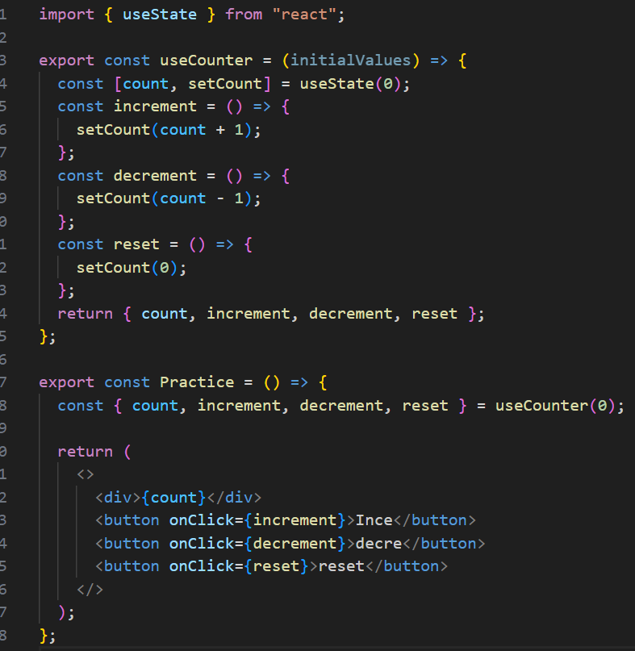

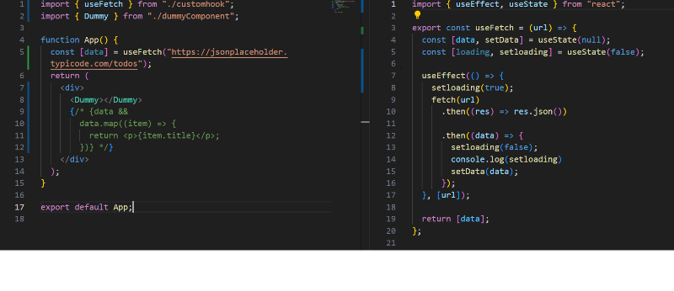  
useRef -  
1)useref is hook which allows us to persist value between the render.  
useref hook value store change zaleli value store karto but re-render karat naslyamule UI la show karat nahi  
2)didn't re-render byself - jar UI madhe dusra component render zala tar ha pan re- render hoil ,swata re-render nahi hot  
3)can access DOM element and can change it.  
can access method of DOm like html tag ,style ,focus  
4)we can track changes.  
  
useref return only one object which is current and to access this -- Object.current  
syntax -- useref{return (current:" ")}  
  
  
usereducer --