useReducer Hook –

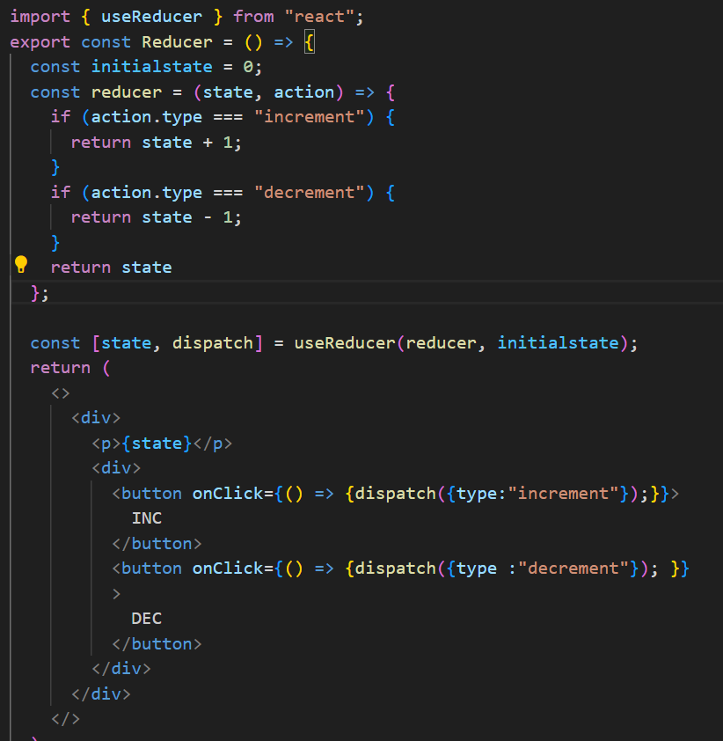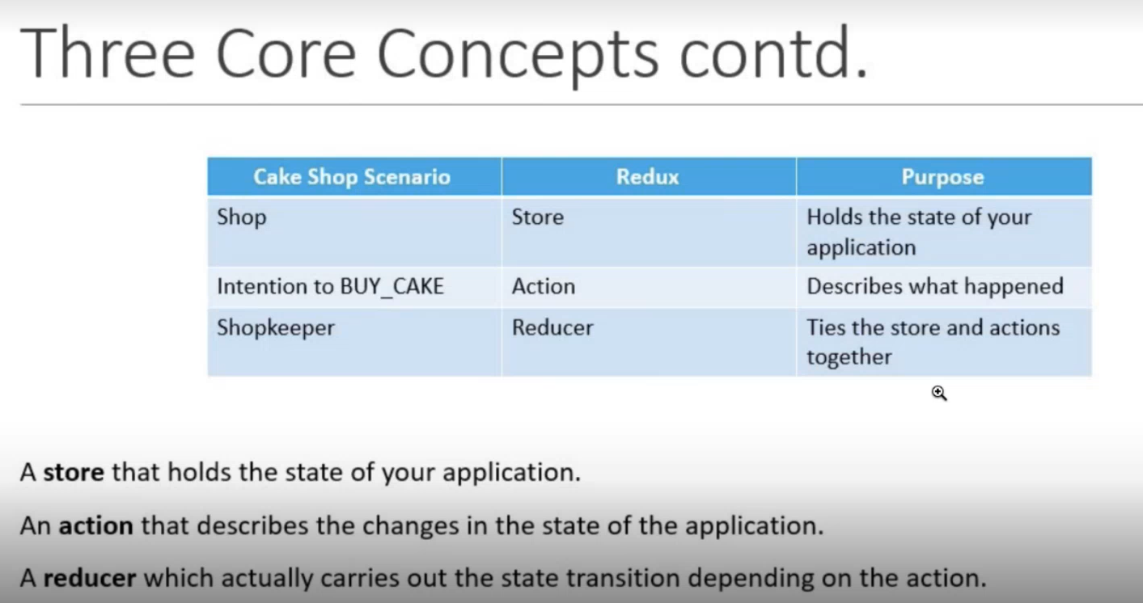

Redux

https://www.freecodecamp.org/news/what-is-redux-store-actions-reducers-explained/

State ,actions and reducer.

Definition –

Redux is a state management library that you can use with any js library or framework like react ,angular or Vue.

Alternate for usecontext api and use state.

Why use redux?

Consider e-comm web , has many compo like cart, login, so on

Being state management library,redux will basically store and mange all the application’s states.

It also provide us with some important API using which we can make changes to the existing state as well as fetch the current state of the application.

What makes redux predictable?

State is Read-only in Redux. To make change in state of the application, we need to dispatch an action which describes what changes we want to make in the state. This action is consumed by Reducer(has two parameter – current state, action) whose solely job is to accept the things and return a new updated instance of state.

Core principle of Redux -

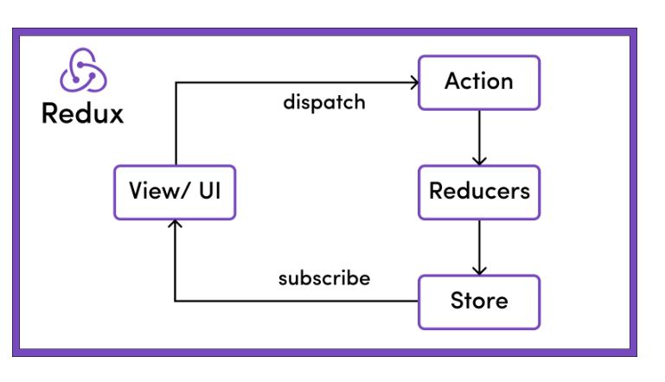

What is Redux store?

The global state of an application is stored in an object tree within a single store.

The Redux store is the main, central bucket which stores state of application. It is Single source of truth.

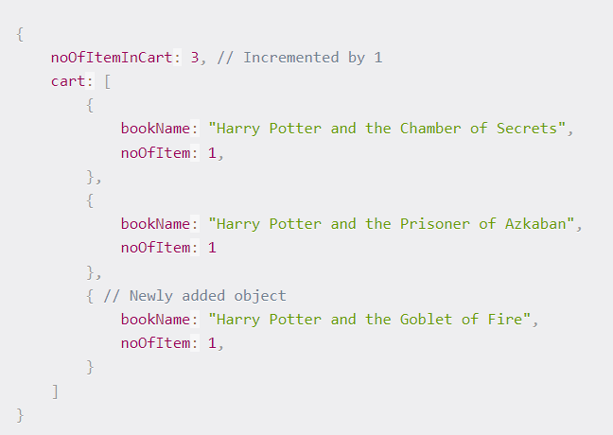

What are actions in Redux?

The only way to change state Is to emit an action which is an object describing what happened.

Type - to describe purpose of the action.

What are Reducers in Redux?

To specify how the stat e tree is transformed by actions, we write pure reducers.

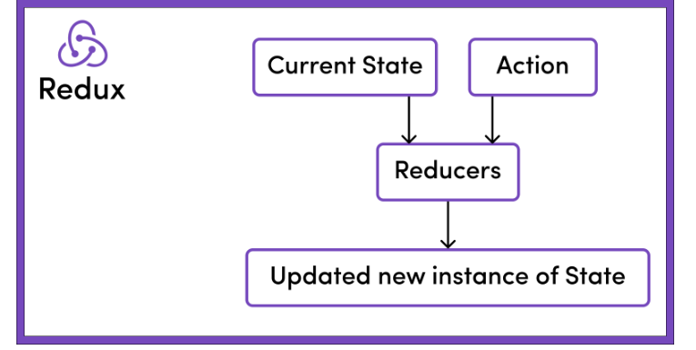

Reducer(current state,action) =🡺 new updated state

