Overview

Agile - Roles

Agile - Manifesto

Agile - Characteristics

Agile - Daily Standup

Agile - Definition of Done

Agile - Release Planning

Agile - Iteration Planning

Agile - Product Backlog

Agile - Useful Terms

Agile

Agile is a software development methodology to build a software incrementally using short iterations of 1 to 4 weeks so that the development process is aligned with the changing business needs. Instead of a single-pass development of 6 to 18 months where all the requirements and risks are predicted upfront, Agile adopts a process of frequent feedback where a workable product is delivered after 1 to 4-week iteration.

- Scrum is one of the ways to do agile

- Traditional software development lifecycle

- Agile Scrum Methodology

Scrum Roles

The scrum is a very specific and précised framework that is why it comprised on the following roles.

* Scrum Master
* Product Owner
* Scrum Team - Cross functional
* Stakeholders

**Scrum Master:**

* The Scrum Master is considered to be the top-dog in every organization because companies usually hire them and don’t treat them as permanent employ that is why they are with no authority.
* It is their duty to remove all the hindrance or obstruction in the way of achieving any goal.
* It is also their role to enforce scrum ceremonies and processes.
* They are the ones who commit to goals and deadlines on behalf of the team.

**Product Owner:**

* The product owner is responsible for conveying the vision of the stakeholders to the team.
* They have the authority to alter the scope.
* The Product Owners are responsible for the return on investment (ROI) that is why they occupy an authoritative position in the firm.
* Because they convey the vision of the stakeholders that is why they are the voice of the stakeholders.
* Not only with the team, but they also communicate with the stakeholders about progress and problems.

**Scrum Team:**

* The Scrum Team is responsible for all the activities that lead them towards their sprint goals.
* They have to work with the Scrum Master to prioritize the items from the product backlog in the sprint planning.
* Once committed, it is their responsibility to fulfil the commitment and deliver the agreed results on time with great quality.
* The Scrum Master is not responsible for keeping his team organized that is they it is the duty of the Scrum Team to get self-organized.
* They have to be agile in the office and have to attend every standup and other ceremonies.
* They have to participate in all the meetings despite their nature and have to ensure that all the findings of the meetings are getting practically addressed in the project.

**Stakeholders:**

* The Stakeholder has to keep a healthy relationship with the Product Owner in order to share every detail regarding his project.
* The Stakeholder is responsible for conveying his wishes and concerns to the product owner or else the product owner would not be responsible for his project quality and time duration.
* The Stakeholder has to provide regular input to queries from the Product Owner.
* Prioritizing the work affectively with the Product Owner is another job that the Stakeholder has to do to ensure his project development.
* Keep taking updates or keep giving updates regarding any change in the plans.

### Scrum Methodology

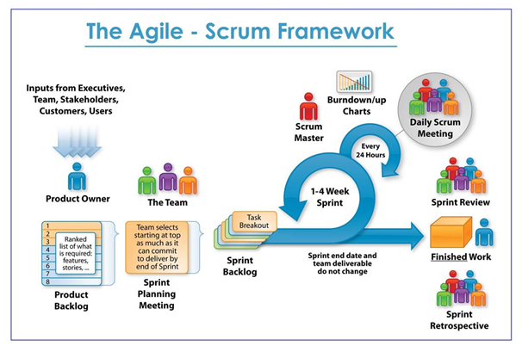

Ball sharing game.

### Scrum Team

Scrum team size - 7 +/- 2

Scrum team includes ….

Difference between Scrum team and Agile team…