Architecture

Reference: https://www.youtube.com/watch?v=2SICr5fRtT8&list=PL3mGAAf6tenXwzN303xLjy7ynuGDxRA0-&index=3

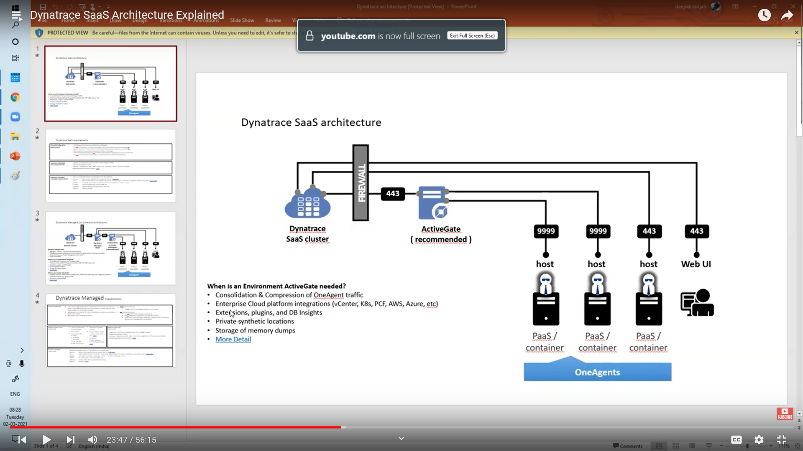

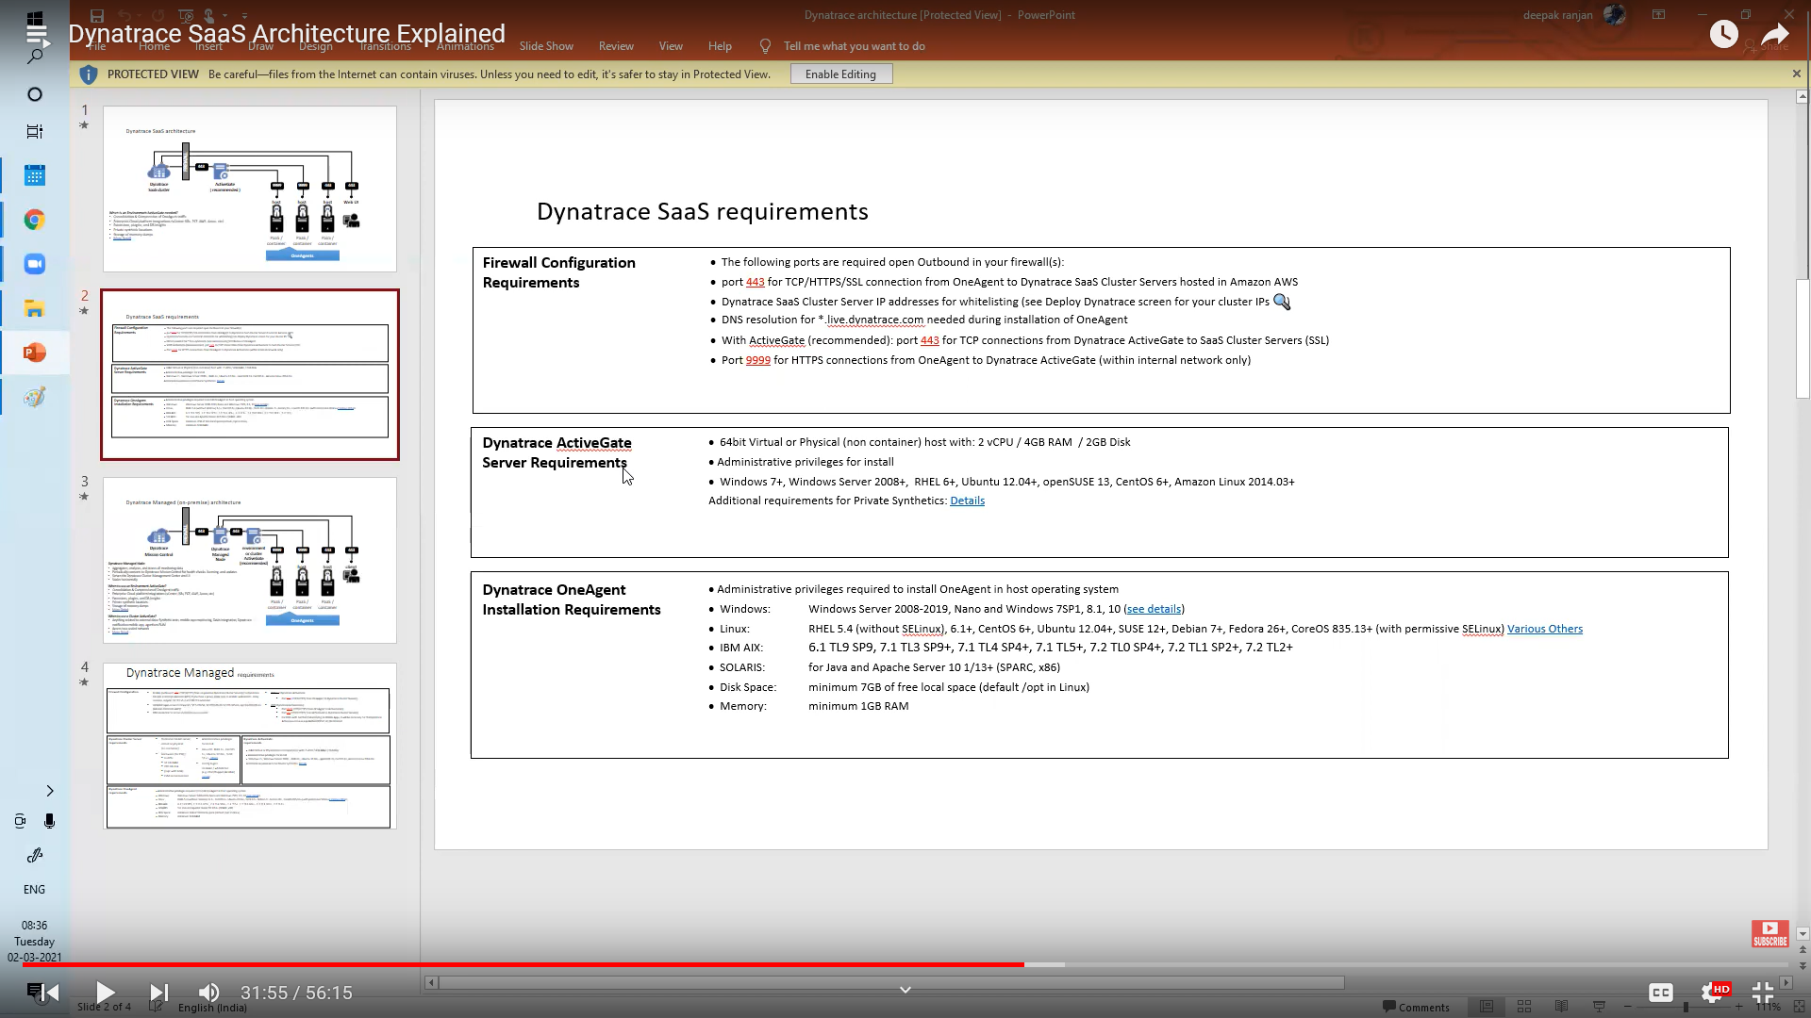

Two modes

Infra: CPU, memory, network, disk, process

e.g. db is only in infra mode. No internal details analysis for db.

All: internal application usage etc.

e.g. default on host

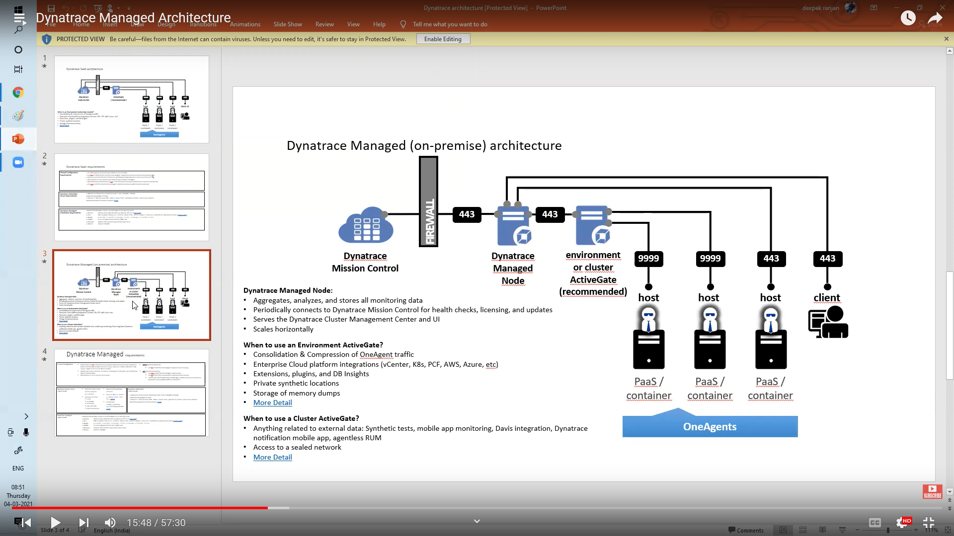

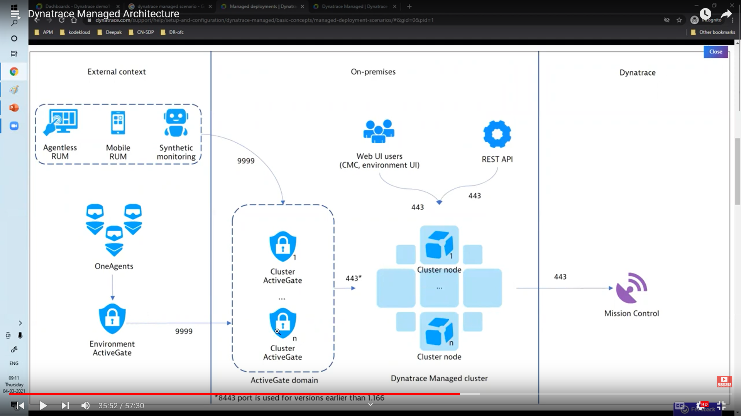

**OneAgent**

software agent

developed by Dynatrace

full-stack monitoring for

applications,

services,

infrastructure in hybrid, cloud-native, and on-premises environments. automatically discover and instrument applications, services, and infrastructure components

providing deep insights into application performance, dependencies, and user experience.

OneAgent

can be deployed in various ways

can be installed on

hosts,

containers, or virtual machines.

Kubernetes daemonset

or as a standalone process

for monitoring microservices running on various platforms.

automatically captures data at every layer of the application stack

from the front-end to the back-end, including network and infrastructure components.

provide real-time visibility into the health and performance of every component of an application, from the end-user experience to the underlying infrastructure.

One of the key benefits of OneAgent

provides AI-powered root-cause analysis.

I.e. automatically correlates data from all monitored components

to identify the root cause of any performance or availability issue. This allows teams to quickly identify and resolve issues before they impact end-users or critical business processes.

An environment active gate and a cluster active gate are both components of Dynatrace, a performance monitoring tool, but they serve different purposes.

An **environment active gate** is a software component that runs on a host within a monitored environment. It is responsible for collecting monitoring data from that environment and sending it to the Dynatrace server for analysis. Environment active gates are typically used in large or complex environments where multiple hosts need to be monitored. They are deployed as standalone instances and can be used to monitor multiple hosts within the same environment.

On the other hand, a **cluster active gate** is used in Dynatrace Managed to route traffic between the Dynatrace server and the monitored environment. It is responsible for securely transferring monitoring data from the environment to the Dynatrace server. A cluster active gate is a group of environment active gates that are clustered together for scalability and high availability. Cluster active gates are typically used in large-scale environments where high availability and scalability are critical.

In summary, an environment active gate is used for monitoring data collection from a specific environment, while a cluster active gate is used for routing monitoring data to the Dynatrace server from multiple environment active gates.

**CMC (Cluster Management Console),** is a web-based console that provides centralized management and monitoring capabilities for Dynatrace clusters. CMC allows administrators to manage Dynatrace components, such as the Dynatrace server, collector, and ActiveGate, in a centralized manner.

With CMC, administrators can perform tasks such as managing licenses, configuring security, monitoring performance, and managing components. CMC also provides a single point of entry for accessing all components in the Dynatrace cluster, including the Dynatrace server, collector, and ActiveGate.

One of the key benefits of CMC is that it simplifies cluster management by providing a unified view of all components in the cluster. This makes it easier to manage complex, distributed environments and ensures consistent configuration across all components.

CMC also provides comprehensive monitoring and alerting capabilities, allowing administrators to quickly identify and respond to performance and availability issues. CMC can be configured to send alerts when predefined thresholds are exceeded or when specific events occur.

Mission Control is a central hub for managing multiple Dynatrace environments, providing a single pane of glass for monitoring and managing all of your applications and infrastructure from a single location. Mission Control is designed to provide a unified view of all Dynatrace environments across an organization, enabling centralized administration, management, and monitoring of all environments.

With Mission Control, administrators can manage multiple Dynatrace environments, including Dynatrace Managed and Dynatrace SaaS environments, from a single interface. This includes configuring settings, managing user accounts, deploying OneAgent, and configuring integrations. Mission Control also provides a customizable dashboard that allows administrators to monitor the performance and health of all environments at a glance.

One of the key benefits of Mission Control is its ability to automate management tasks across multiple environments. This includes OneAgent updates, license management, and dashboard configuration. This automation helps ensure consistency across all environments, reduces the risk of errors, and frees up administrators to focus on more strategic tasks.

Mission Control also provides access to additional Dynatrace services, such as Managed Synthetic Monitoring and Managed Real User Monitoring. This allows organizations to easily add these services to their existing Dynatrace environments and take advantage of the full capabilities of the Dynatrace platform.

Overall, Mission Control is a powerful tool for managing and monitoring multiple Dynatrace environments. It provides a unified view of all environments, automates management tasks, and enables administrators to quickly identify and respond to performance and availability issues across the entire organization.