Hashing

In a huge database structure, it is very inefficient to search all the index values and reach the desired data. Hashing technique is used to calculate the direct location of a data record on the disk without using index structure.

In this technique, data is stored at the data blocks whose address is generated by using the hashing function. The memory location where these records are stored is known as data bucket or data blocks.

In this, a hash function can choose any of the column value to generate the address. Most of the time, the hash function uses the primary key to generate the address of the data block. A hash function is a simple mathematical function to any complex mathematical function. We can even consider the primary key itself as the address of the data block. That means each row whose address will be the same as a primary key stored in the data block.

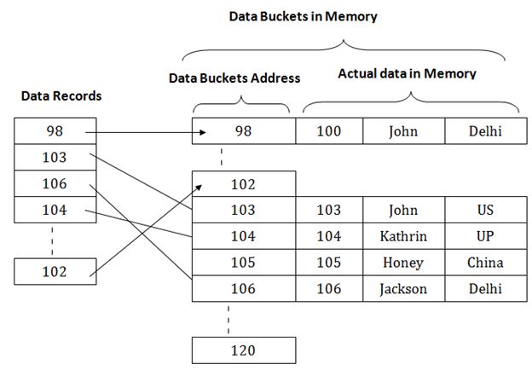

The above diagram shows data block addresses same as primary key value. This hash function can also be a simple mathematical function like exponential, mod, cos, sin, etc. Suppose we have mod (5) hash function to determine the address of the data block. In this case, it applies mod (5) hash function on the primary keys and generates 3, 3, 1, 4 and 2 respectively, and records are stored in those data block addresses.

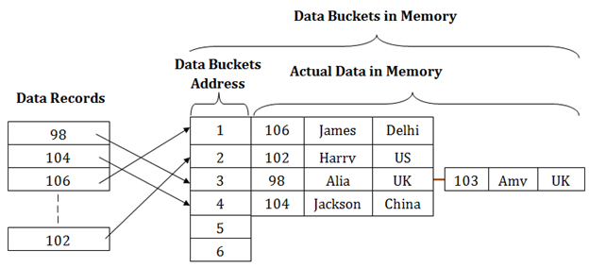

## Types of Hashing:

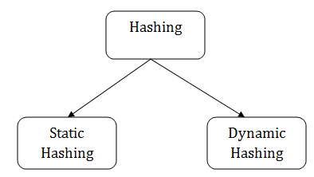

Static Hashing

In static hashing, the resultant data bucket address will always be the same. That means if we generate an address for EMP_ID =103 using the hash function mod (5) then it will always result in same bucket address 3. Here, there will be no change in the bucket address.

Hence in this static hashing, the number of data buckets in memory remains constant throughout. In this example, we will have five data buckets in the memory used to store the data.

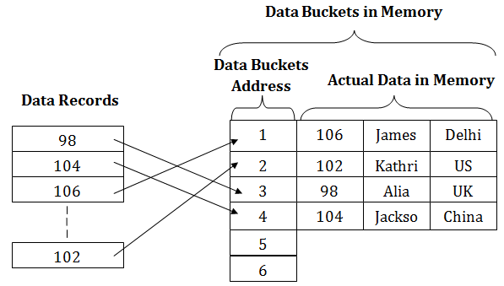

## Operations of Static Hashing

* **Searching a record**

When a record needs to be searched, then the same hash function retrieves the address of the bucket where the data is stored.

* **Insert a Record**

When a new record is inserted into the table, then we will generate an address for a new record based on the hash key and record is stored in that location.

* **Delete a Record**

To delete a record, we will first fetch the record which is supposed to be deleted. Then we will delete the records for that address in memory.

* **Update a Record**

To update a record, we will first search it using a hash function, and then the data record is updated.

If we want to insert some new record into the file but the address of a data bucket generated by the hash function is not empty, or data already exists in that address. This situation in the static hashing is known as **bucket overflow**. This is a critical situation in this method.

To overcome this situation, there are various methods. Some commonly used methods are as follows:

## 1. Open Hashing

When a hash function generates an address at which data is already stored, then the next bucket will be allocated to it. This mechanism is called as **Linear Probing**.

**For example:** suppose R3 is a new address which needs to be inserted, the hash function generates address as 112 for R3. But the generated address is already full. So the system searches next available data bucket, 113 and assigns R3 to it.

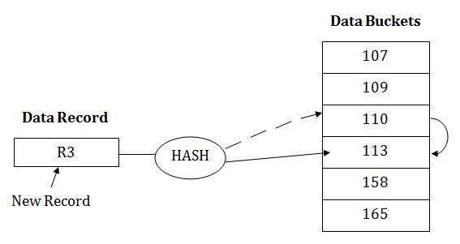

## 2. Close Hashing

When buckets are full, then a new data bucket is allocated for the same hash result and is linked after the previous one. This mechanism is known as **Overflow chaining**.

**For example:** Suppose R3 is a new address which needs to be inserted into the table, the hash function generates address as 110 for it. But this bucket is full to store the new data. In this case, a new bucket is inserted at the end of 110 buckets and is linked to it.

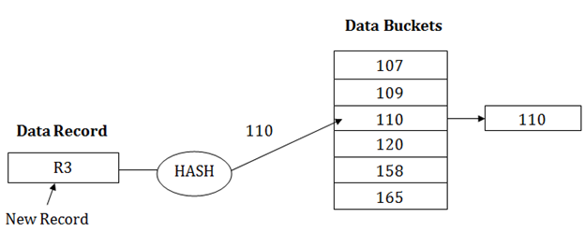

# Dynamic Hashing

* The dynamic hashing method is used to overcome the problems of static hashing like bucket overflow.
* In this method, data buckets grow or shrink as the records increases or decreases. This method is also known as Extendable hashing method.
* This method makes hashing dynamic, i.e., it allows insertion or deletion without resulting in poor performance.

## How to search a key

* First, calculate the hash address of the key.
* Check how many bits are used in the directory, and these bits are called as i.
* Take the least significant i bits of the hash address. This gives an index of the directory.
* Now using the index, go to the directory and find bucket address where the record might be.

## How to insert a new record

* Firstly, you have to follow the same procedure for retrieval, ending up in some bucket.
* If there is still space in that bucket, then place the record in it.
* If the bucket is full, then we will split the bucket and redistribute the records.

## For example:

Consider the following grouping of keys into buckets, depending on the prefix of their hash address:

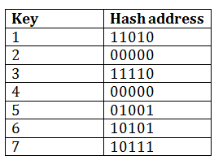

The last two bits of 2 and 4 are 00. So it will go into bucket B0. The last two bits of 5 and 6 are 01, so it will go into bucket B1. The last two bits of 1 and 3 are 10, so it will go into bucket B2. The last two bits of 7 are 11, so it will go into B3.

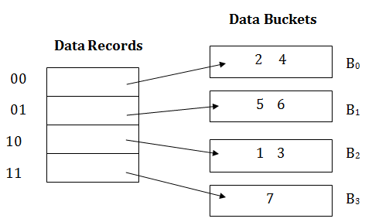

## Insert key 9 with hash address 10001 into the above structure:

* Since key 9 has hash address 10001, it must go into the first bucket. But bucket B1 is full, so it will get split.
* The splitting will separate 5, 9 from 6 since last three bits of 5, 9 are 001, so it will go into bucket B1, and the last three bits of 6 are 101, so it will go into bucket B5.
* Keys 2 and 4 are still in B0. The record in B0 pointed by the 000 and 100 entry because last two bits of both the entry are 00.
* Keys 1 and 3 are still in B2. The record in B2 pointed by the 010 and 110 entry because last two bits of both the entry are 10.
* Key 7 are still in B3. The record in B3 pointed by the 111 and 011 entry because last two bits of both the entry are 11.

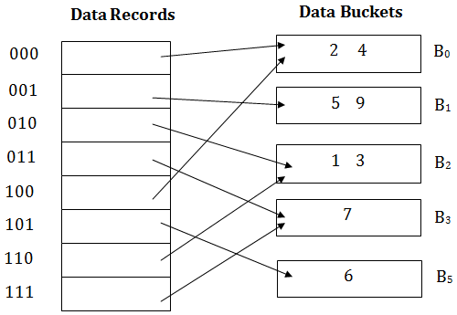

## Advantages of dynamic hashing

* In this method, the performance does not decrease as the data grows in the system. It simply increases the size of memory to accommodate the data.
* In this method, memory is well utilized as it grows and shrinks with the data. There will not be any unused memory lying.
* This method is good for the dynamic database where data grows and shrinks frequently.

## Disadvantages of dynamic hashing

* In this method, if the data size increases then the bucket size is also increased. These addresses of data will be maintained in the bucket address table. This is because the data address will keep changing as buckets grow and shrink. If there is a huge increase in data, maintaining the bucket address table becomes tedious.
* In this case, the bucket overflow situation will also occur. But it might take little time to reach this situation than static hashing.