SOBHA AlSiniya FZC
Microsoft 365 Integration with
OpenText Content Management
Azure (Microsoft Entra ID) and OpenText Configuration — User Guide

Application: OTCM_Teams _Integration
Environment: otcs.sa11-test.opentext.cloud (Test)
Version 1.0 | 15 September 2026
Internal use only

Contents
1. Purpose and Scope
1.1 Who should use this guide
1.2 Reference environment
2. Prerequisites
3. Configuration Overview
4. Part A — Azure (Microsoft Entra ID) Configuration
4.1 Application registration and details
4.2 Microsoft Graph API permissions
4.3 Expose an API configuration
4.4 Redirect URI configuration
4.5 Generate a client secret
5. Values to Carry Across to OpenText
6. Part B — OpenText Content Management Configuration
6.1 Open the Configure Tenant Information page
6.2 Complete the Tenant Information form
6.3 Verify and save
7. Verification and Troubleshooting
7.1 Post-configuration checklist
7.2 Common errors
8. Ongoing Maintenance
9. Appendix — Configuration Reference

1. Purpose and Scope
This guide describes the end-to-end configuration required to integrate Microsoft 365 (Office 365) with OpenText Content Management (Extended ECM / OTCM). It covers both halves of the integration:
- Azure side — registering and configuring the OTCM_Teams _Integration application in Microsoft Entra ID (Azure Active Directory): API permissions, exposed API scope, redirect URIs and the client secret.
- OpenText side — entering the resulting tenant, application and authentication values in the Configure Tenant Information page of OpenText Content Management, and verifying the connection to Office 365.
Once both halves are complete and the connection test succeeds, OpenText Content Management can authenticate against the Microsoft 365 tenant and enable Microsoft Teams and Office 365 integration features for end users.

1.1 Who should use this guide
This document is intended for Microsoft 365 / Entra ID administrators and OpenText Content Management administrators performing a first-time setup, re-configuring an existing integration, or rotating credentials.

1.2 Reference environment
Item | Value
Microsoft Cloud instance | Microsoft Cloud Worldwide
Entra ID tenant | SOBHA AlSiniya FZC
Azure application name | OTCM_Teams _Integration
OpenText Content Management URL | https://otcs.sa11-test.opentext.cloud
Supported account types | My organization only (single tenant)
Authentication type used | Client Secret

2. Prerequisites
Confirm the following before you begin. Missing any one of these will cause the configuration or the final connection test to fail.
# | Prerequisite | Notes
1 | Entra ID administrator access | An account with permission to create app registrations and to grant tenant-wide admin consent (Global Administrator, Application Administrator or Cloud Application Administrator).
2 | OpenText Content Management administrator access | An account able to open Admin → Configure Tenant Information in OpenText Content Management.
3 | Microsoft 365 licences | Valid licences covering Exchange Online, SharePoint Online, OneDrive and Microsoft Teams for the users who will use the integration.
4 | OpenText base URL confirmed | The exact HTTPS host name of the Content Management instance — it is used to build the Application ID URI and the redirect URLs.
5 | Network connectivity | The OpenText Content Management server must be able to reach Microsoft login and Microsoft Graph endpoints outbound over HTTPS (443).
6 | Change window / approval | Granting tenant-wide admin consent affects the whole tenant. Obtain approval before proceeding.

Order of work: Complete Part A (Azure) in full first. The values it produces — Tenant ID, Application ID and client secret — are the inputs to Part B (OpenText). Attempting the OpenText configuration first will fail the connection test.

3. Configuration Overview
The integration is completed in three stages:
Stage | Where | What is done | Section
Part A | Azure portal (Microsoft Entra ID) | Register the application, grant Microsoft Graph permissions, expose an API scope, add redirect URIs, generate a client secret. | 4
Handover | — | Collect the Tenant ID, Application (client) ID and client secret value. | 5
Part B | OpenText Content Management | Enter the collected values on the Configure Tenant Information page, verify the connection and save. | 6

In simple terms: the Azure app registration is the identity that OpenText uses to talk to Microsoft 365. Part A creates that identity and decides what it is allowed to do; Part B tells OpenText which identity to use and how to prove it.

4. Part A — Azure (Microsoft Entra ID) Configuration
All steps in this section are performed in the Azure portal at https://portal.azure.com under Microsoft Entra ID → App registrations → OTCM_Teams _Integration.

4.1 Application registration and details
If the application does not yet exist, create it first:
- In the Azure portal, open Microsoft Entra ID → App registrations → + New registration.
- Enter the name OTCM_Teams _Integration.
- Under Supported account types, select Accounts in this organizational directory only (single tenant).
- Leave the Redirect URI blank for now — it is added in section 4.4 — and click Register.
- Open the Overview page and record the identifiers shown under Essentials. These are needed in Part B.
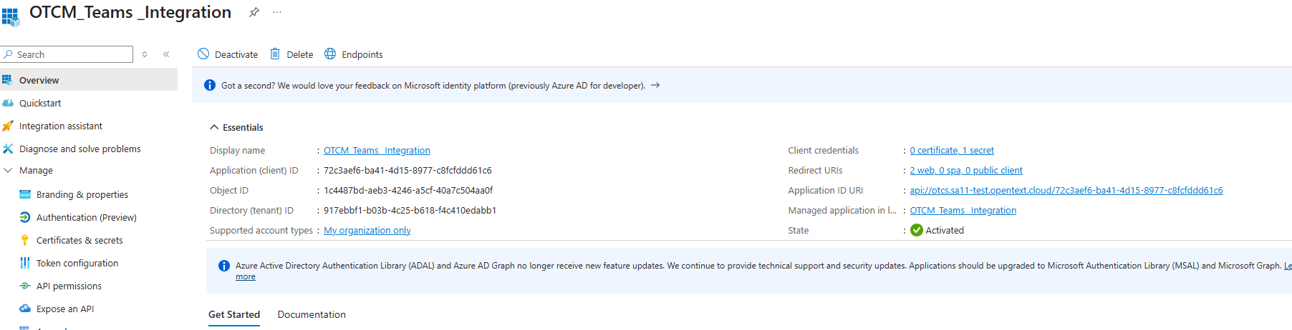
Figure 1 — Application Overview page showing the Essentials identifiers
Recorded values for this environment:
Field | Value | Used in OpenText?
Display name | OTCM_Teams _Integration | Yes — Name field
Application (client) ID | 72c3aef6-ba41-4d15-8977-c8fcfddd61c6 | Yes — Application ID field
Directory (tenant) ID | 917ebbf1-b03b-4c25-b618-f4c410edabb1 | Yes — Tenant field
Object ID | 1c4487bd-aeb3-4246-a5cf-40a7c504aa0f | No — reference only
Application ID URI | api://otcs.sa11-test.opentext.cloud/72c3aef6-ba41-4d15-8977-c8fcfddd61c6 | No — used by Azure
Supported account types | My organization only | No
State | Activated | No

4.2 Microsoft Graph API permissions
The application requires a defined set of Microsoft Graph permissions so that OpenText Content Management can sign users in and read the Microsoft 365 data it surfaces.
- Open the application and select API permissions from the left menu.
- Click + Add a permission → Microsoft Graph.
- Choose Delegated permissions and add each delegated permission listed in the table below.
- Click + Add a permission again, choose Application permissions, and add TeamMember.ReadWrite.All.
- Click Grant admin consent for SOBHA AlSiniya FZC and confirm.
- Confirm every row shows Granted for SOBHA AlSiniya FZC with a green tick in the Status column.
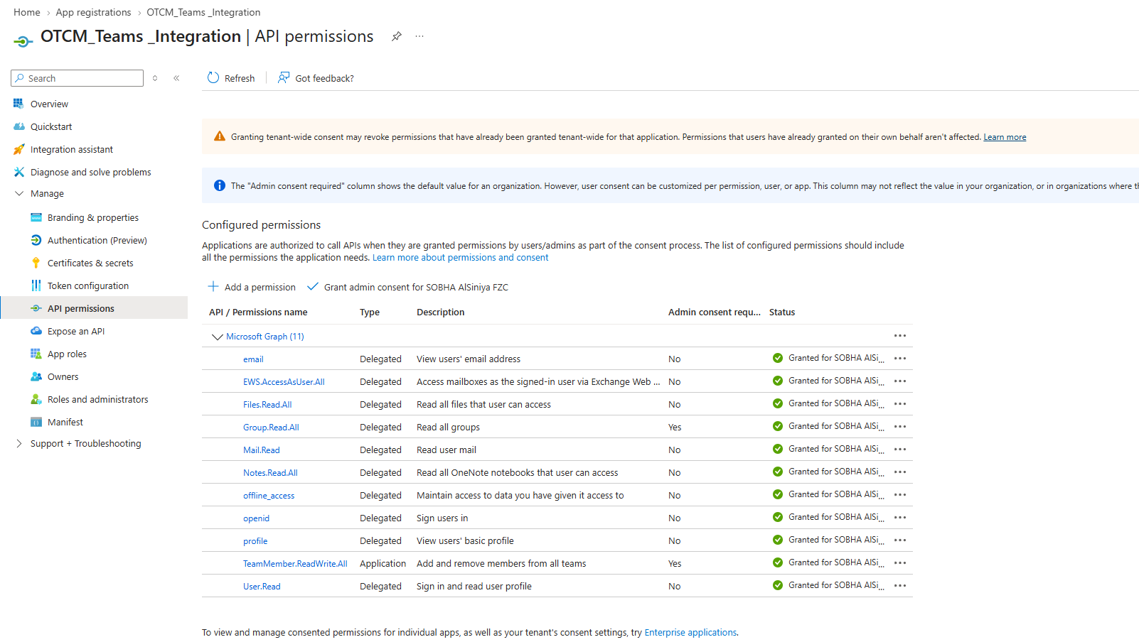
Figure 2 — Configured Microsoft Graph permissions, all granted
Permissions to configure (11 in total):
Permission | Type | Purpose | Admin consent required
email | Delegated | View users' email address | No
EWS.AccessAsUser.All | Delegated | Access mailboxes as the signed-in user via Exchange Web Services | No
Files.Read.All | Delegated | Read all files that the user can access | No
Group.Read.All | Delegated | Read all groups | Yes
Mail.Read | Delegated | Read user mail | No
Notes.Read.All | Delegated | Read all OneNote notebooks that the user can access | No
offline_access | Delegated | Maintain access to data the user has granted access to | No
openid | Delegated | Sign users in | No
profile | Delegated | View users' basic profile | No
TeamMember.ReadWrite.All | Application | Add and remove members from all teams | Yes
User.Read | Delegated | Sign in and read user profile | No

Important: Granting tenant-wide consent may revoke permissions previously granted tenant-wide for this application. Permissions users have already granted on their own behalf are not affected. Review the change with your Microsoft 365 team before clicking Grant admin consent.

4.3 Expose an API configuration
The application must expose its own API scope so that the OpenText Teams application can request a token for it.
- Select Expose an API from the left menu.
- Next to Application ID URI, click Set (or Edit if one already exists) and enter the URI in the form api://<opentext-host>/<application-client-id>.
- For this environment the value is:
api://otcs.sa11-test.opentext.cloud/72c3aef6-ba41-4d15-8977-c8fcfddd61c6
- Click + Add a scope and create a scope with these settings:
Scope setting | Value
Who can consent | Admins and users
Admin consent display name | Access OpenText Teams Integration
Admin consent description | Allows the application to access OpenText Teams Integration on behalf of the signed-in user.
User consent display name | Access OpenText Teams Integration
State | Enabled

- Click Add scope. No entry is required under Authorized client applications for this configuration.
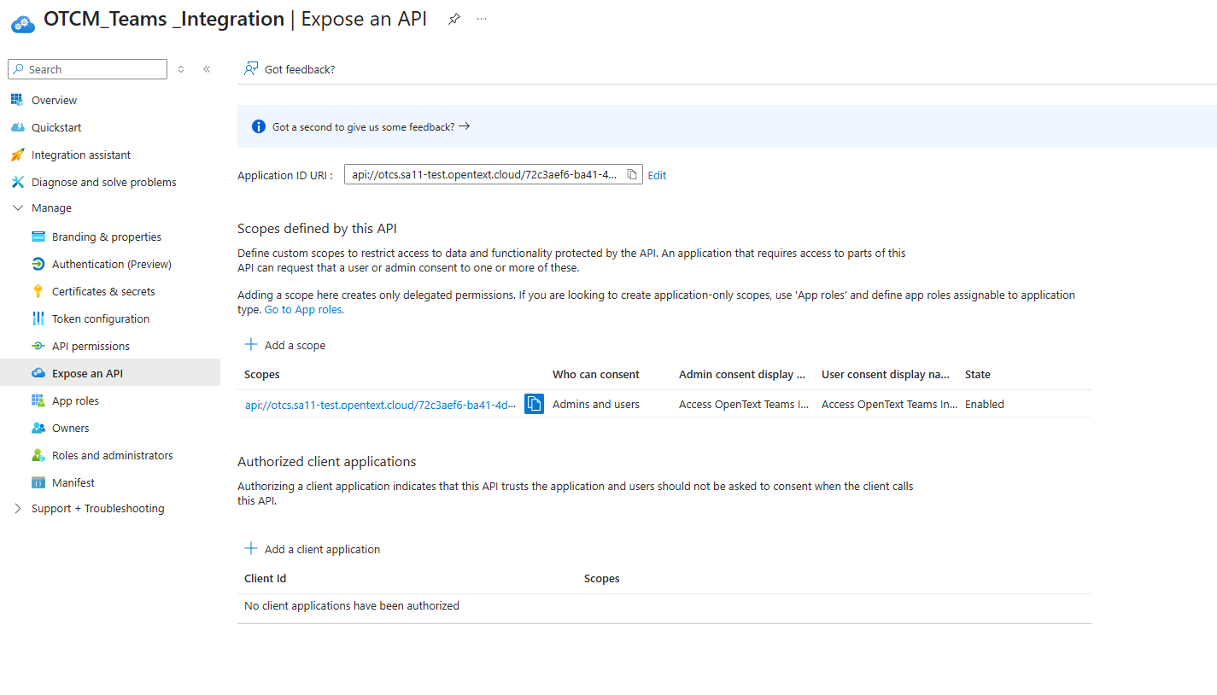
Figure 3 — Expose an API: Application ID URI and the enabled scope

4.4 Redirect URI configuration
Redirect URIs tell Microsoft Entra ID where to return the user and the token after a successful sign-in. Both OpenText endpoints below must be registered, and both must match the OpenText host name exactly.
- Select Authentication from the left menu.
- Click + Add Redirect URI and choose the platform type Web.
- Add the following two URIs:
https://otcs.sa11-test.opentext.cloud/cssupport/xecmoffice/teamsauthend.html
https://otcs.sa11-test.opentext.cloud/cssupport/xecmoffice/login.html
- Click Save and confirm both entries appear under Platform Type Web.
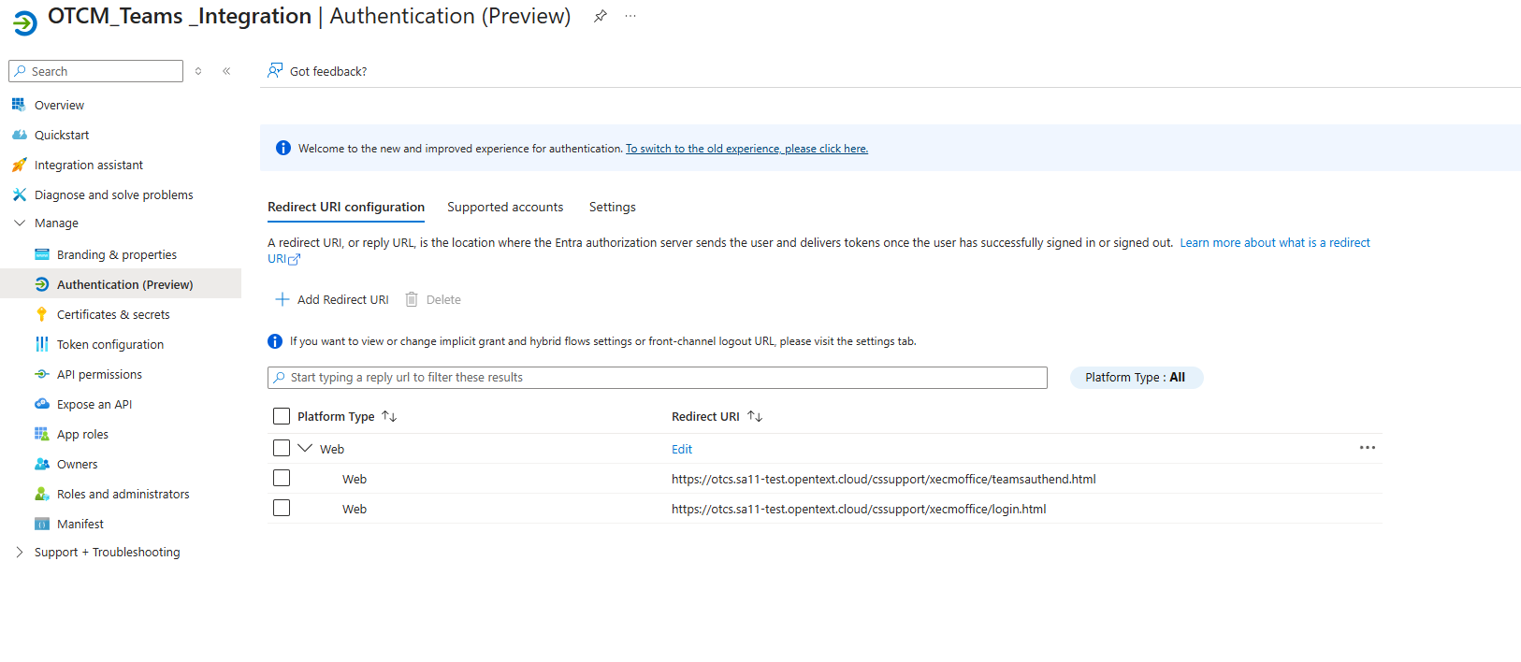
Figure 4 — Authentication: both Web redirect URIs registered

Tip: Redirect URIs are matched literally — a trailing slash, a different case or an http:// prefix will cause sign-in to fail with AADSTS50011 (redirect URI mismatch). Copy and paste rather than typing them.

4.5 Generate a client secret
The client secret is the credential OpenText Content Management uses to prove the application’s identity when requesting a token.
- Select Certificates & secrets from the left menu and open the Client secrets tab.
- Click + New client secret.
- Enter a description — for example OTCM_Team secret — and select an expiry period in line with your security policy.
- Click Add.
- Copy the Value immediately and store it securely. It is shown only once; after you leave the page it cannot be retrieved and a new secret must be generated.
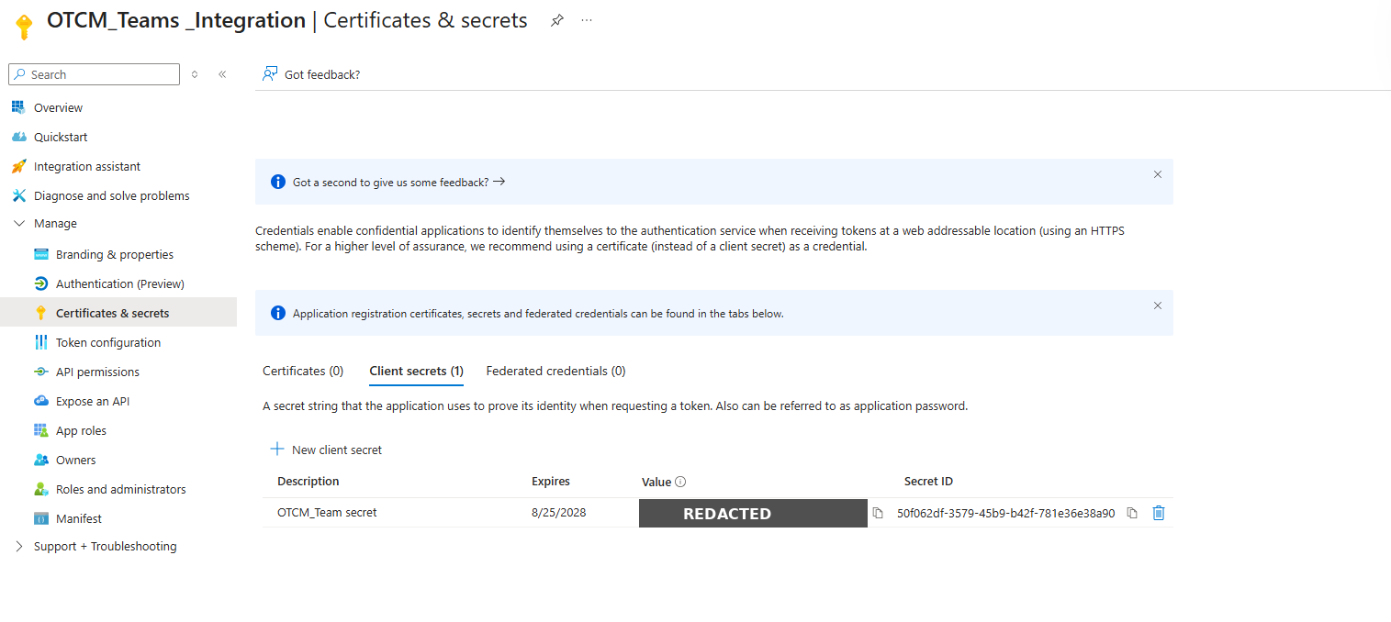
Figure 5 — Certificates & secrets: the generated client secret
Secret recorded for this environment:
Field | Value
Description | OTCM_Team secret
Secret Value | Redacted — held in the approved password vault, not reproduced in this document
Secret ID | 50f062df-3579-45b9-b42f-781e36e38a90
Expires | 25 August 2028

Security: The secret value is a password for your Microsoft 365 tenant. Do not circulate it in e-mail, chat or documentation — keep it in an approved password vault and share it only with the administrator performing the OpenText configuration. Diarise the expiry date; when the secret expires the integration stops working until a new secret is generated and re-entered in OpenText.

Certificate authentication is also supported and is recommended by OpenText for production environments. If you use a certificate instead of a secret, upload it on the Certificates tab of this page and select Certificate as the Authentication Type in section 6.

5. Values to Carry Across to OpenText
At the end of Part A you should have the following four values. Check them off before starting Part B.
Azure field | Value for this environment | OpenText field it maps to
Display name | OTCM_Teams _Integration | Name
Directory (tenant) ID | 917ebbf1-b03b-4c25-b618-f4c410edabb1 | Tenant
Application (client) ID | 72c3aef6-ba41-4d15-8977-c8fcfddd61c6 | Application ID
Client secret value | From the vault (see section 4.5) | Authentication Key

Check: Confirm the Tenant ID and Application ID are copied in full — 36 characters each including hyphens. A truncated identifier is the most common cause of a failed connection test.

6. Part B — OpenText Content Management Configuration
This section is performed in OpenText Content Management by an administrator, on the Configure Tenant Information page.

6.1 Open the Configure Tenant Information page
- Sign in to OpenText Content Management at https://otcs.sa11-test.opentext.cloud with an administrator account.
- From the top menu bar, open Admin and navigate to the Office 365 / Microsoft Teams integration settings.
- Select Configure Tenant Information. The page shown in Figure 6 opens.

6.2 Complete the Tenant Information form
Complete each field as described below. Fields marked with a red asterisk in the interface are mandatory.
Field | What to enter | Value for this environment
Microsoft Cloud Instance | The Microsoft cloud your tenant belongs to. Use Show Details to confirm or change it. | Microsoft Cloud Worldwide
Name | A descriptive label for this tenant configuration. Use the Azure application display name so the two stay aligned. | OTCM_Teams _Integration
Tenant | The Directory (tenant) ID copied from the Azure Overview page. | 917ebbf1-b03b-4c25-b618-f4c410edabb1
Application ID | The Application (client) ID copied from the Azure Overview page. | 72c3aef6-ba41-4d15-8977-c8fcfddd61c6
Authentication Type | Select Client Secret or Certificate (Recommended). This guide uses Client Secret, matching section 4.5. | Client Secret
Authentication Key | The client secret Value generated in section 4.5. Use Show Password to confirm it was pasted correctly, then clear the checkbox. | From the vault

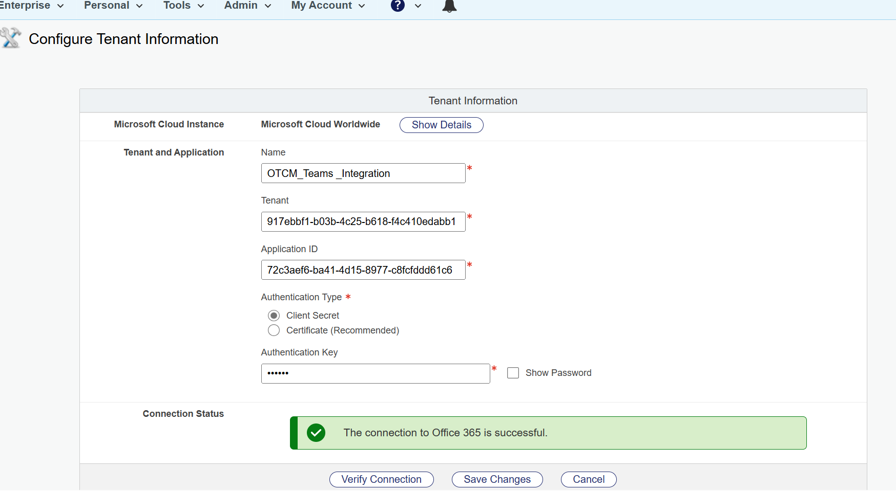
Figure 6 — OpenText Configure Tenant Information page with a successful connection

6.3 Verify and save
- Click Verify Connection.
- Wait for the Connection Status panel to return a result. A green banner reading "The connection to Office 365 is successful." confirms that the tenant, application ID and authentication key are correct and that the application has the permissions it needs.
- If the test fails, do not save. Correct the values using section 7 and test again.
- Once the test succeeds, click Save Changes. Use Cancel to discard the entries without saving.

Note: Verify Connection only tests the credentials — it does not save them. The configuration is not active until you click Save Changes.

7. Verification and Troubleshooting

7.1 Post-configuration checklist
# | Check | Expected result
1 | Azure — API permissions page | All 11 permissions listed, Status column shows "Granted for SOBHA AlSiniya FZC" with a green tick.
2 | Azure — Expose an API page | Application ID URI set; one scope listed with State = Enabled.
3 | Azure — Authentication page | Both Web redirect URIs present and spelled exactly as in section 4.4.
4 | Azure — Certificates & secrets | One active client secret, expiry date in the future.
5 | OpenText — Configure Tenant Information | Verify Connection returns the green success banner and the configuration has been saved.
6 | End-user test | A pilot user can sign in and see Microsoft 365 / Teams content surfaced in OpenText Content Management.

7.2 Common errors
Symptom | Likely cause | Resolution
Connection test fails immediately with an invalid client error | Client secret mistyped, expired, or the Secret ID was entered instead of the secret Value. | Re-copy the secret Value from the vault. If it has expired, generate a new secret (section 4.5) and re-enter it.
Connection test fails with an application-not-found error | Application ID or Tenant ID truncated or belongs to a different tenant. | Re-copy both GUIDs from the Azure Overview page; each must be 36 characters.
Sign-in fails with AADSTS50011 (redirect URI mismatch) | A redirect URI is missing, misspelled or uses a different host name or protocol. | Compare both URIs against section 4.4 character by character; correct and save in Azure.
Users prompted repeatedly to consent | Tenant-wide admin consent was not granted, or a permission was added after consent. | Return to API permissions and click Grant admin consent for SOBHA AlSiniya FZC.
Teams membership operations fail | TeamMember.ReadWrite.All is missing or was added as Delegated instead of Application. | Remove and re-add it as an Application permission, then grant admin consent again.
Integration stops working after a period of normal operation | The client secret has reached its expiry date. | Generate a new client secret in Azure and update the Authentication Key in OpenText, then re-test and save.
Connection test times out | The OpenText server cannot reach Microsoft endpoints outbound. | Check firewall and proxy rules allow HTTPS to Microsoft login and Graph endpoints.

8. Ongoing Maintenance
- Secret expiry — the client secret in this environment expires on 25 August 2028. Raise a reminder at least 30 days in advance. Generate the replacement secret in Azure first, then update the Authentication Key in OpenText and re-run Verify Connection before saving.
- Host name changes — if the OpenText Content Management URL changes, the Application ID URI (section 4.3) and both redirect URIs (section 4.4) must be updated to match, or sign-in will break.
- Permission changes — any permission added to the application later requires admin consent to be granted again.
- Move to certificate authentication — for production, consider replacing the client secret with a certificate, which OpenText marks as the recommended option on the Configure Tenant Information page.
- Access review — periodically review who holds the administrator accounts and who has access to the vault entry holding the secret.

9. Appendix — Configuration Reference
A single consolidated list of every value used in this integration.
Item | Value
Azure application name | OTCM_Teams _Integration
Application (client) ID | 72c3aef6-ba41-4d15-8977-c8fcfddd61c6
Object ID | 1c4487bd-aeb3-4246-a5cf-40a7c504aa0f
Directory (tenant) ID | 917ebbf1-b03b-4c25-b618-f4c410edabb1
Application ID URI | api://otcs.sa11-test.opentext.cloud/72c3aef6-ba41-4d15-8977-c8fcfddd61c6
Redirect URI 1 | https://otcs.sa11-test.opentext.cloud/cssupport/xecmoffice/teamsauthend.html
Redirect URI 2 | https://otcs.sa11-test.opentext.cloud/cssupport/xecmoffice/login.html
Client secret description | OTCM_Team secret
Client secret ID | 50f062df-3579-45b9-b42f-781e36e38a90
Client secret value | Held in the password vault — not reproduced here
Client secret expiry | 25 August 2028
Microsoft Cloud instance | Microsoft Cloud Worldwide
Authentication type | Client Secret
Graph permissions | email, EWS.AccessAsUser.All, Files.Read.All, Group.Read.All, Mail.Read, Notes.Read.All, offline_access, openid, profile, TeamMember.ReadWrite.All (Application), User.Read

End of document

