DocuSign Integration with OpenText
Configuration Procedure

Overview
This document describes the step-by-step procedure to integrate DocuSign with OpenText. It covers generating the Integration Key and Secret Key from the DocuSign Admin console, and configuring those credentials in the OpenText DocuSign Administration Settings so that OpenText can authenticate with, and send documents through, DocuSign.

Prerequisites
- Administrator access to the DocuSign account (Development or Production environment, as applicable).
- Administrator access to OpenText, with rights to modify DocuSign Administration Settings.

Step 1: Generate the Integration Key and Secret Key in DocuSign
The Integration Key and Secret Key identify the OpenText application to DocuSign and are required to configure the connection in Step 2. Generate them from the DocuSign Admin console as follows:
- Log in to DocuSign and go to Admin > Apps and Integration Keys.
- Click Add App and Integration Key.
- Enter an Application Name for the integration (for example, OTCM) and click Submit.
- DocuSign creates the app and generates an Integration Key for it. Open the app and generate a Secret Key.
- Note the API Account ID (shown under My Account Information), the Integration Key, and the Secret Key — all three are required in Step 2.
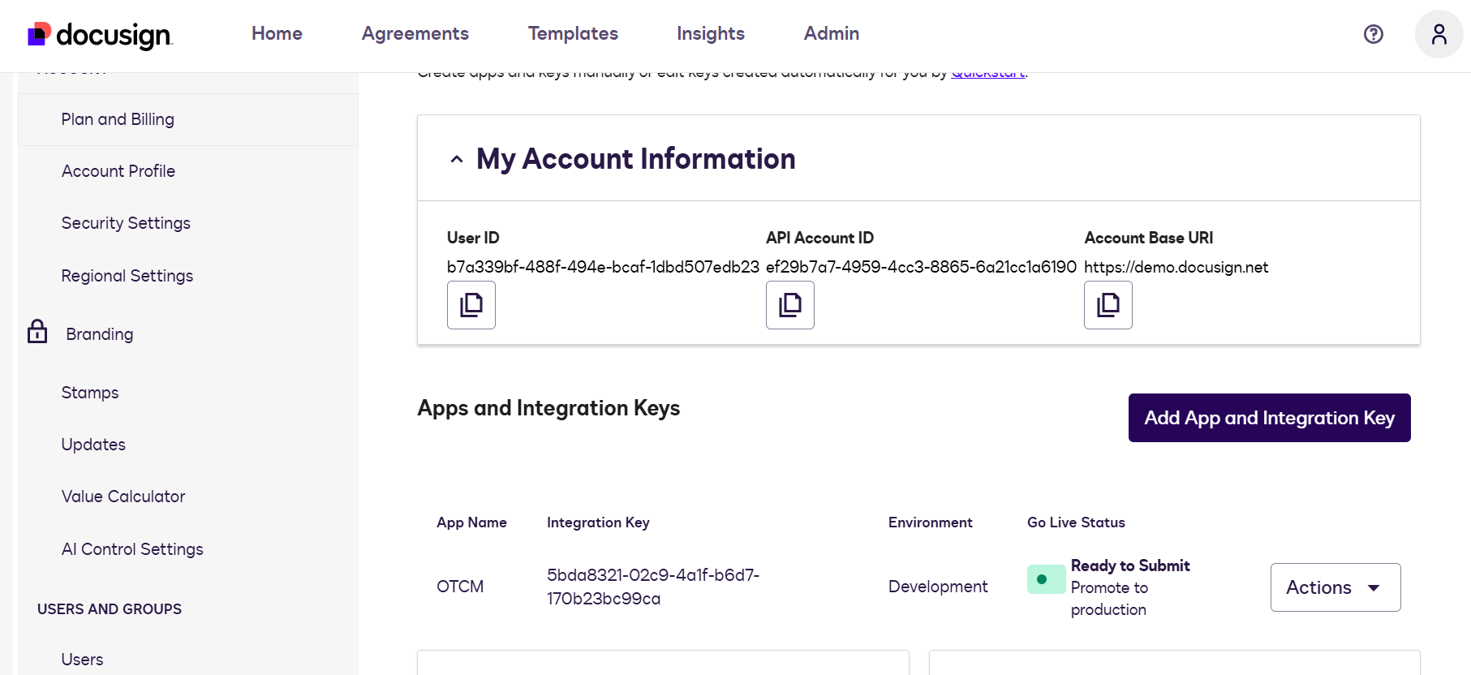
Figure 1: DocuSign Admin – My Account Information and Apps and Integration Keys
Note: Treat the Secret Key like a password. Do not share it outside the people configuring this integration, and store it securely once configuration is complete.

Step 2: Configure the DocuSign Administration Settings in OpenText
Once the Integration Key and Secret Key have been generated in DocuSign, enter them into OpenText so the two systems can authenticate with each other:
- In OpenText, go to Admin > DocuSign Administration Settings.
- In API Account ID, enter the API Account ID copied from the DocuSign My Account Information page.
- In Integration Key, enter the Integration Key generated in Step 1.
- In Authorization Endpoint URL, enter the Base URL for Authorization for the target DocuSign environment (for example, https://account-d.docusign.com/oauth/auth for the demo/sandbox environment).
- In Secret Key, enter the Secret Key generated in Step 1.
- If applicable, select Use Organization details.
- Click Test Connection to confirm that OpenText can successfully authenticate with DocuSign using the entered credentials.
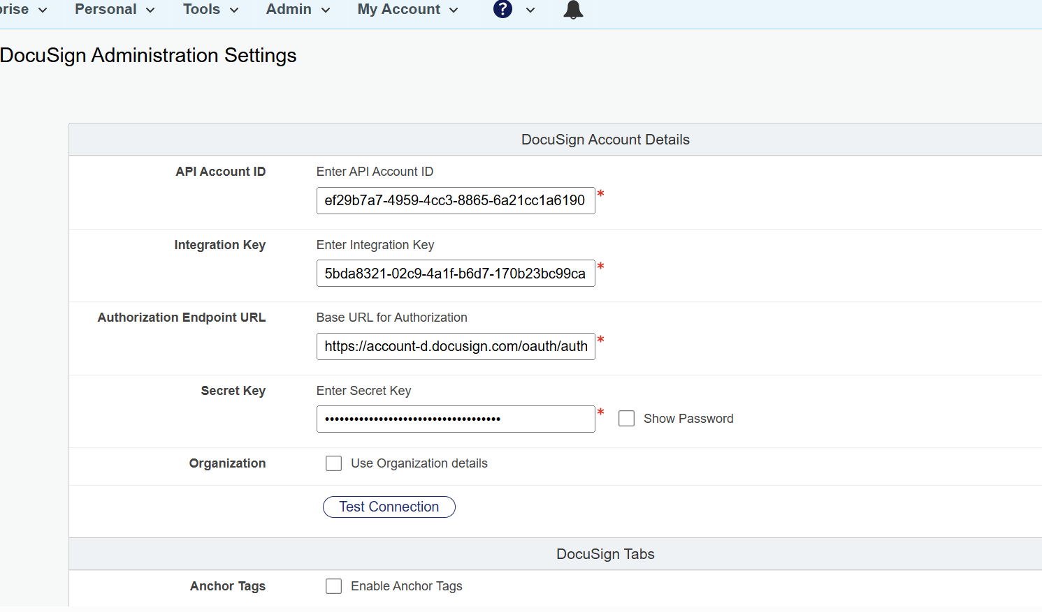
Figure 2: OpenText – DocuSign Administration Settings
Note: If Test Connection fails, re-check that the API Account ID, Integration Key, Secret Key, and Authorization Endpoint URL exactly match the values shown in DocuSign, and that the Integration Key's environment (Development/Production) matches the Authorization Endpoint URL used.

