# Cloud Computing Mini Project Report

Prepared By

**Pranav koktar 30**

**Mayur Pimpude 43**

**Deepak Prasad 44**

Subject In-charge

**Prof. Prerna Solanke**



**Department of Artificial Intelligence and Data Science**

**Vivekanand Education Society’s Institute of Technology**

**HAMC, Collector’s Colony, Chembur,**

**Mumbai-400074**

**University of Mumbai**

**(AY 2022-23)**

# Contents

### Abstract

### Introduction

### Proposed System (Architecture/ Framework)

1. **Hardware & Software requirement (Detail about CC service/tool used )**
2. **Experiment and Results**
3. **Conclusion and Future work.**

**Abstract:**

A real estate management site for buying and selling properties is an online platform that connects buyers and sellers of real estate. These sites allow users to search for properties based on location, price, and other criteria, and to view photos and detailed information about each property.

Users can also list their own properties for sale, set a price, and communicate with potential buyers. Real estate management sites typically offer additional features, such as mortgage calculators, property valuation tools, and access to real estate agents and brokers. The goal of these sites is to provide a streamlined and convenient way for buyers and sellers to connect and complete real estate transactions online. With the rise of e-commerce and the increasing popularity of online marketplaces, real estate management sites have become an important part of the real estate industry.

We will use aws EC2 service to deploy our backend which is IaaS and for frontend deployment we will use vercel which is PaaS. For the database we will use mongodb Atlas which is a DBaaS.

### 

### Introduction:

A real estate management site is a powerful online tool that provides buyers and sellers a seamless experience in the world of real estate. These sites serve as a platform that connects property buyers and sellers, making it easier for them to search, buy or sell properties from anywhere, anytime. With the help of advanced search features and detailed property listings, users can easily find properties that match their specific criteria such as location, price range, and other essential factors. These sites also allow users to view photos, videos, and detailed information about each property, helping them make informed decisions. Overall, real estate management sites provide a one-stop-shop for all real estate-related needs, simplifying the buying and selling process and making it more accessible for everyone.

**Proposed System (Architecture/ Framework)**

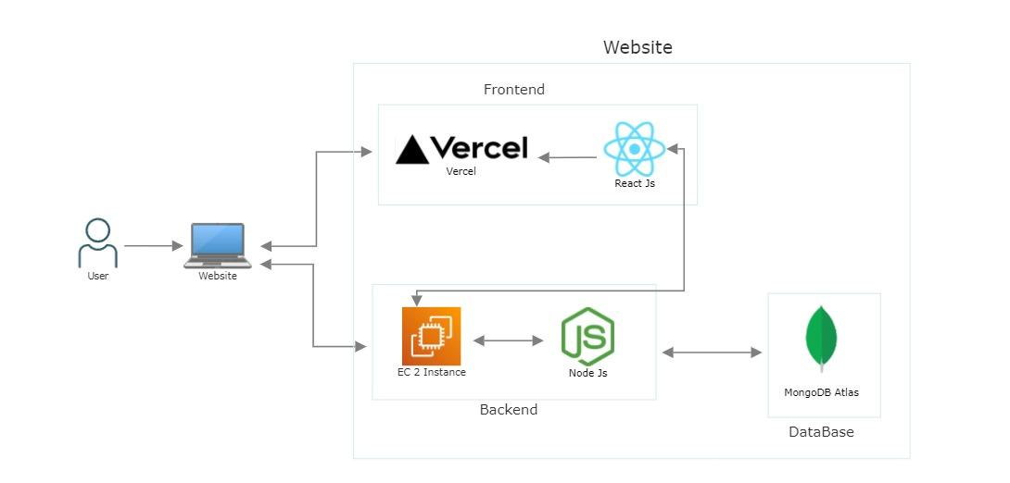

**Hardware & Software requirement:**

**Vercel**

PaaS - Platform as a Service  
Platform as a Service (PaaS) is a cloud computing model in which a third-party provider delivers hardware and software tools for application development and deployment to users over the internet. It allows developers to create and deploy applications without the complexity of building and maintaining the underlying infrastructure. PaaS offers a flexible and scalable platform that enables businesses to rapidly develop, test, and deploy applications without worrying about the underlying infrastructure.

It allows developers to host websites and web services that deploy instantly, and require no supervision and configuration.

A few of the main advantages of Vercel are fast refresh, flexible data fetching, and easy integration with Github.

**Mongodb**

Database as a service

Database as a Service (DBaaS) is a cloud computing model that provides users with access to a managed database service without the need to set up or maintain their own physical infrastructure. In other words, a third-party provider hosts and maintains the database, while users can focus on managing their data and applications. DBaaS offerings can include features such as automated backups, scalability, security, and performance monitoring.

MongoDB Atlas is a fully-managed cloud database that handles all the complexity of deploying, managing, and healing your deployments on

the cloud.

**EC2**

Infrastructure as a Service

Infrastructure as a Service (IaaS) is a cloud computing service model where the provider offers virtualized computing resources over the internet. This includes servers, storage, and networking capabilities that are managed and maintained by the cloud provider. IaaS allows businesses to avoid the expense and complexity of buying and managing their own physical servers and other infrastructure, while providing scalability and flexibility to meet changing business needs.

Amazon Elastic Compute Cloud is a web service that provides secure, resizable compute capacity in the cloud. It is designed to make web-scale cloud computing easier for developers.

**Google Authentication**

Google Authenticator is a software-based authenticator It implements two-step verification services using the Time-based .

One-time Password Algorithm and HMAC- based One-time Password algorithm, for authenticating users of software applications.

**Results:**

Our project is aimed at simplifying the process of finding a suitable house for interested buyers. We have incorporated a comprehensive database of houses that includes detailed information about the property, such as its price, location, amenities, and other relevant factors. In addition to this, we have included the contact information of the brokers handling the property, which facilitates easy communication between the buyer and the seller.

Our website has been designed to provide a seamless and user-friendly experience to our users. The user interface is simple, intuitive, and easy to navigate, which makes it easy for users to find the information they need quickly. We have taken care to ensure that the website is accessible to everyone, regardless of their technical expertise, making it a valuable resource for anyone looking to buy or sell property.

To develop our project, we have utilized various cloud-based services, which has enabled us to create a scalable and reliable platform. Our project is a prime example of a cloud computing mini project, which demonstrates the power and versatility of cloud-based technologies. By leveraging the cloud, we have been able to create a robust platform that can handle a large amount of data and traffic, ensuring a seamless user experience for our users.

**Conclusion and Future work:**

In conclusion, this project aims to simplify the process of finding and buying/selling properties by providing a user-friendly platform that connects buyers and sellers with detailed property listings and broker details. By utilizing cloud-based services, we have made the platform suitable for Cloud Computing mini project. With its easy-to-use interface, this platform can significantly improve the real estate management process by making it more accessible and convenient for all users.

Future work :

1. Filter based search.
2. Virtual tours of properties.
3. Live chat support to connect buyer.
4. Adding the Renting house section.
5. Share rent house (roomate) option.
6. Incorporating machine learning to provide more accurate property recommendations and pricing predictions.