**TEXT to SPEECH**

**PROBLEM STAEMENT**

In this project our goal is to acheive the problem of converting textual data into speech data.

**DESCRIPTION OVERVIEW**

Text-to-speech (TTS) technology reads aloud digital text. It can take words on computers, smartphones, tablets and convert them into audio.

We will be using Google Text to Speech commonly known as the gTTS API. It is very easy to use the library which converts the text entered, into an audio file which can be saved as a mp3 file. It supports several languages and the speech can be delivered in any one of the two available audio speeds, fast or slow.

**TECHNOLOGY USE**

Here we will be using **Anaconda Python 3.6 and GTTS.**

**INSTALLATION**

Installation of this project is pretty easy. Please do follow the following steps to create a virtual environment and then install the necessary packages in the following environment.

**In Pycharm it’s easy**

1. Create a new project.

2. Navigate to the directory of the project

3. Select the option to create a new new virtual environment using conda with python3.6

4. Finally create the project using used resources.

5. After the project has been created, install the necessary packages from requirements.txt file using the command pip install -r requirements.txt

**In Conda also it’s easy**

1. Create a new virtual environment using the command

conda create -n your_env_name python=3.6

2. Navigate to the project directory.

3. Install the necessary packages from requirements.txt file using the command

pip install -r requirements.txt

**TESTING IN LOCAL/API**

To run this project in your local system just run the file clientApp.py and webserver will start and landing page will open at <http://0.0.0.0:5000/>

Next Enter the Text in the left hand box and click on Predict button.

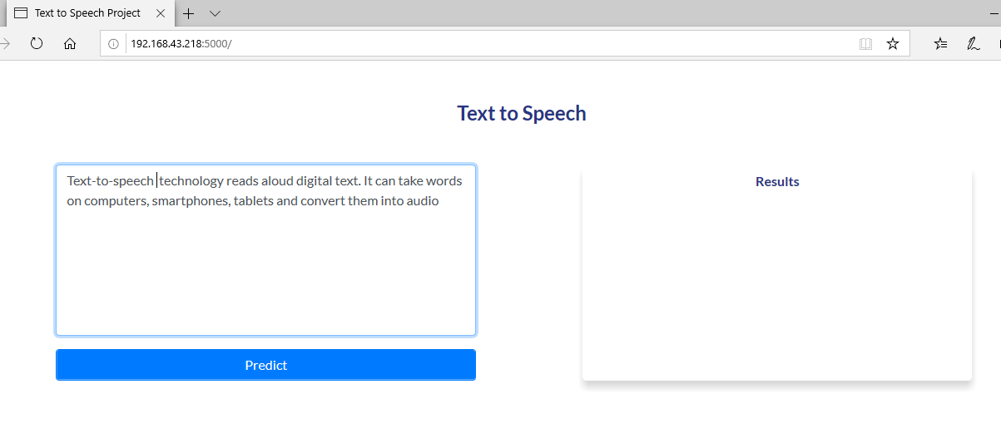

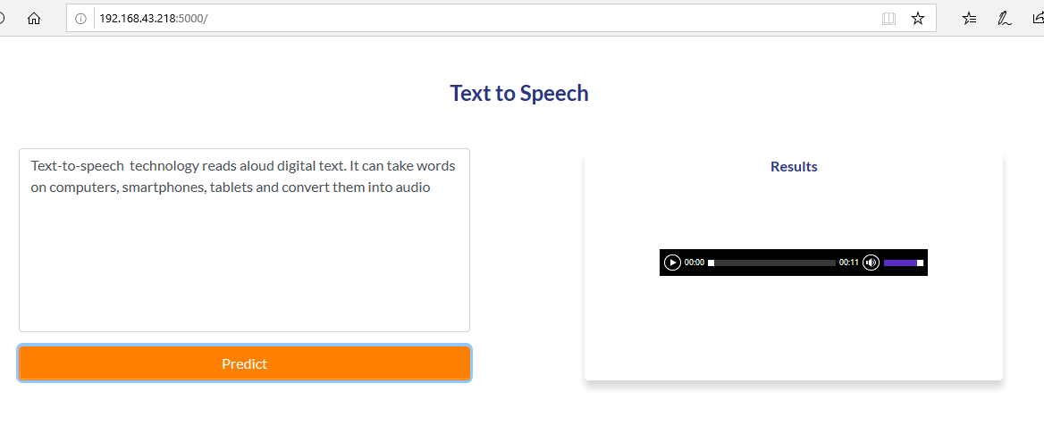Next you can listen the speech in the Results box.

**CONCLUSION**

Hence we have successfully converted digital text data data in audio data or speech.