JAVA
____________________________________________________________________________________

Q. What is JAVA?
__________________________________________________________________________________
Ans: JAVA is pure object oriented language

Q. What is Object oriented?
___________________________________________________________________________
Object oriented is a concept of programming based on four pillars and seven features.

Pillar of OOP
_______________________________________________________________
1. Polymorphism
2. Abstraction
3. Encapsulation
4. Inheritance

Feature of OOP
__________________________________________________________________________
1. Class 2. Object 3. Inheritance 4. Polymorphism 5. Data Abstraction and Encapsulation
6. Dynamic Binding 7.Message Passing.

If we want to work with JAVA we need to know how to create program in it and execute it.

Steps to work with JAVA Application
__________________________________________________________________________
1. Install JDK
Q. What is JDK?
________________________________________________________________________
JDK stands for Java Development Kit
Def: JDK is software cluster or it is group of software which provide environment to us to create and execute java application like as compiler , JVM etc
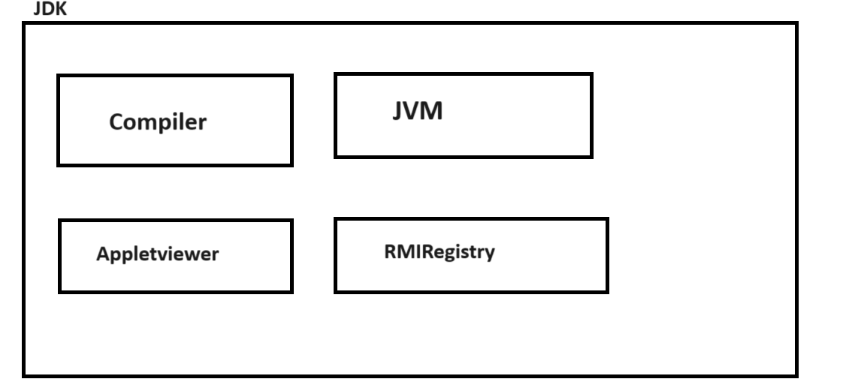

Q. What is compiler?
_________________________________________________________________
Compiler is application which is used for convert source to byte code in java

Q. What is byte code?
____________________________________________________________________________
Byte code is intermediate code which is converting in machine code with the help of JVM or Byte code is machine understandable code.

Q. What is JVM?
_____________________________________________________________________________
JVM Stands for Java Virtual Machine it is application which is used for convert your byte code in to machine code.

Note: if you want to download the JDK we have to use following links.
Java Downloads | Oracle India

2. Create Sample Application
______________________________________________________________________________
If we want to create program in java we have generalize syntax of Java Application.
Syntax:
access specifier class classname
{ public static void main(String x[])
{ write here your logics
}
}
Example with source code
public class TestFirst
{ public static void main(String x[])
{ System.out.println("good morning");
}
}

Description of above code
public class TestFirst: Here public is access specifier
Q. what is access specifier?
Access specifier is the some keywords which is responsible for apply restrictions on class and its member.

There are four types of access specifier in JAVA
a) public: public access specifier means member can access anywhere in application means within same package as well as outside of package.
b) private: private access specifier means member cannot access outside of class.
c) protected: protected access specifier means member can access only within child class.
d) default: default access specifier means member can access outside of class but within same package cannot access outside of package.
Note: we will discuss this access specifier in depth in classes and object chapter as well as in inheritance and package chapter.

class is keyword for class declaration purpose
TestFirst is class name and user can give any name to his class.

public static void main(String x[]): It is main function of java same like as main function in C or C++
Note: we will discuss main method in depth after 2 lectures.

System.out.println("good morning"): it is output statement of java like as printf() in c

Meaning of Above Statement
_________________________________________________________________________
System is class out is static reference of PrintStream class.
System and PrintStream maintain HAS-A relationship between them and println() is overloaded method which is used for display output on console or output window.
Note: we will discuss this meaning in inheritance chapter.

Note: you can use any text editor or different tools for develop java application.
Text Editor: notepad, notepad++ , sublimetext
Tools: VSCode , Eclipse, InteliJ IDE etc

Note: As a fresher for practice purpose we will use the notepad++ or notepad

3. Save Application: if we want to save program in java you can save in bin folder where JDK install and give class name and filename same with .java extension So as per our example our file name should TestFirst.java

4. Compile Application:
Q. What is compilation?
Compilation is process where we can convert source code in to byte code in JAVA.

How to compile JAVA program?
__________________________________________________________________________
If we want to compile your java program then we have some following steps.
a) Open Command prompt
start menu ----- search ----- command prompt.
b) Go where Java File Save
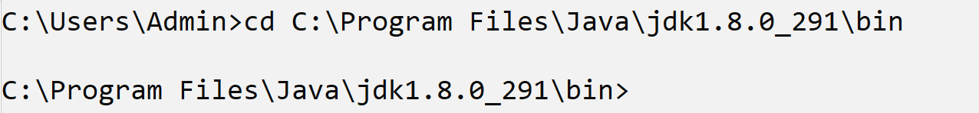
c) Type the command: javac filename.java
Example: javac TestFirst.java
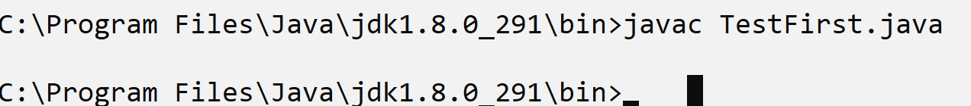
Note: if we think about above screen shot we have statement javac TestFirst.java means we compile java program successfully.
When your java program get compile successfully then java compiler create new file with extension .class and in this file contain your byte code.
Means after compilation of java code we have two files with extension .java and .class so .java file contain source code and .class file contain byte code.
As per our example.
TestFirst.java --- this file contain source code
TestFirst.class --- this file contain your byte code.
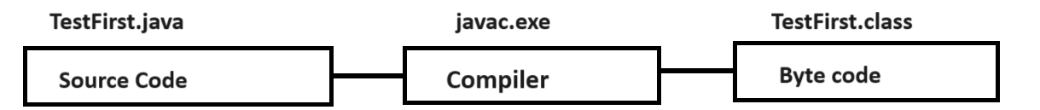

5. Run Application: if you want to run the program then we have to use following statement.
Sytax: java filename
Example: java TestFirst
