Example: WAP to create array of size 5 and calculate the sum of all values.
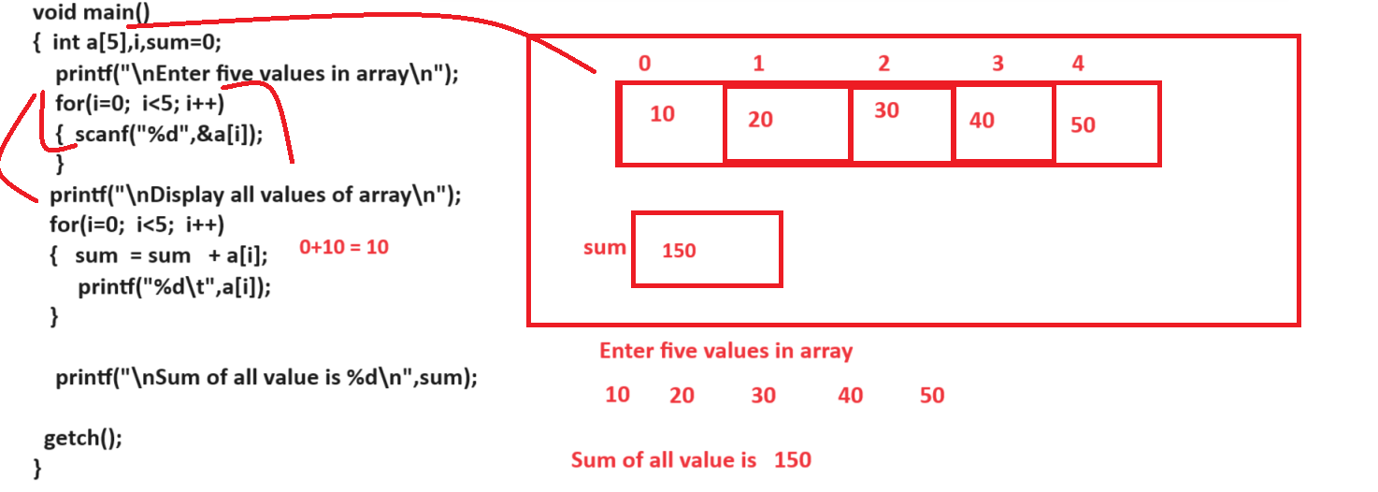

Example: WAP to input five values in array and find max value from array.
5 8 9 3 4
Output: max value is 9
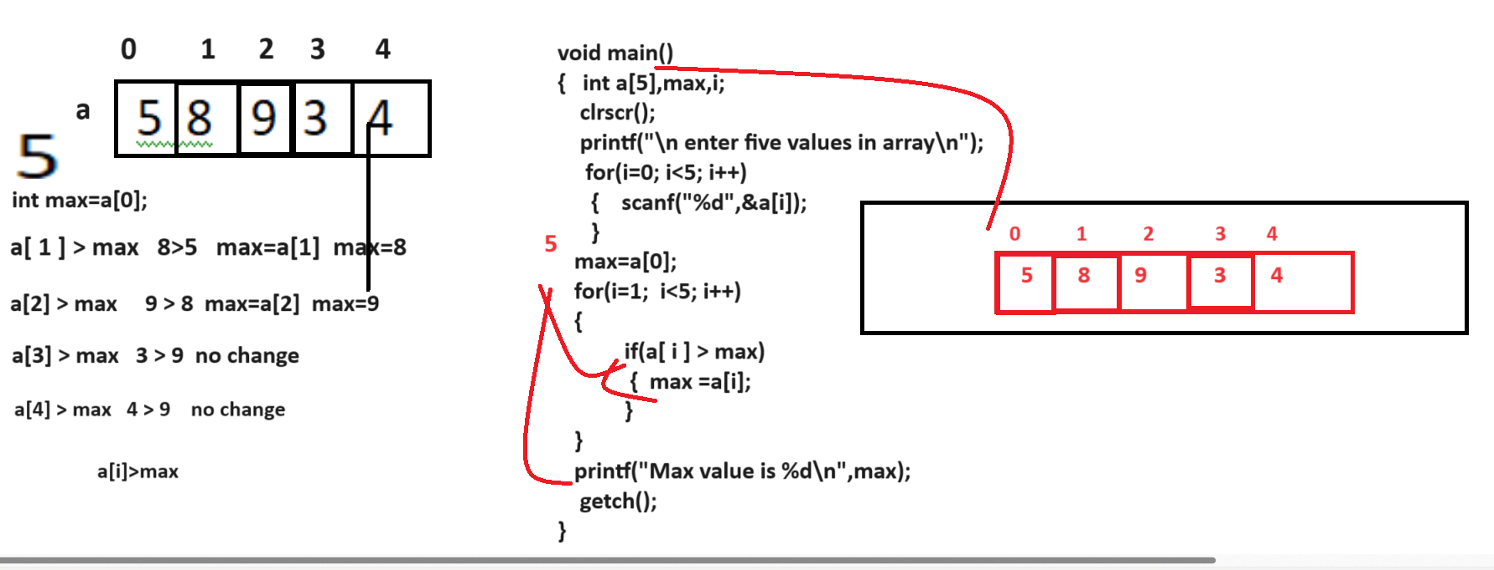

Example: WAP to create array size of 5 and store 5 values in it and search value in array
If we want to perform search using array we have two approaches
1. Linear Search: Linear search means we compare search key or search value with every element in array
2. Binary Search: Binary search means we divide array by 2 and compare search key value with mid element and if search key match with mid element then declare element found if search key is less than of mid element then perform search at left hand side and if search is greater than of mid element then perform search at right hand side array

Now we want to perform search using linear search algorithm

Algorithm of linear search
1. Declare array & store data in it
2. Input Search key
3. Set flag=0
4. Compare search key with every element in array
5. If Search key match with array value then set flag=1
and break the loop
6. Compare flag value outside of loop
if flag is 1 then show value found if flag is 0
Then show value not found
7. STOP.

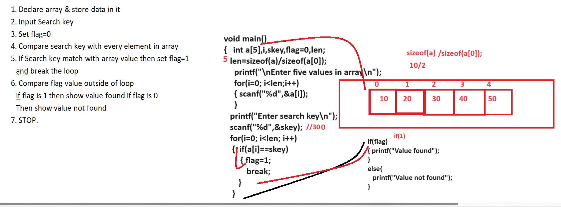

Algorithm for binary search
___________________________________________________________________
1. DECLARE Array and store values in it
2. SET two pointer on array first and last
3. DIVIDE array by 2 and find mid element
4. Input Search key value
5. Set flag=0
6. Compare Search key value with mid element
7. If Search key match with mid then set flag=1 and break the loop
8. If search key less than mid then search left side of mid and if search key is greater than mid then search at right side of mid
9. Repeat step 3,6,7,8 until complete array traverse
10. STOP
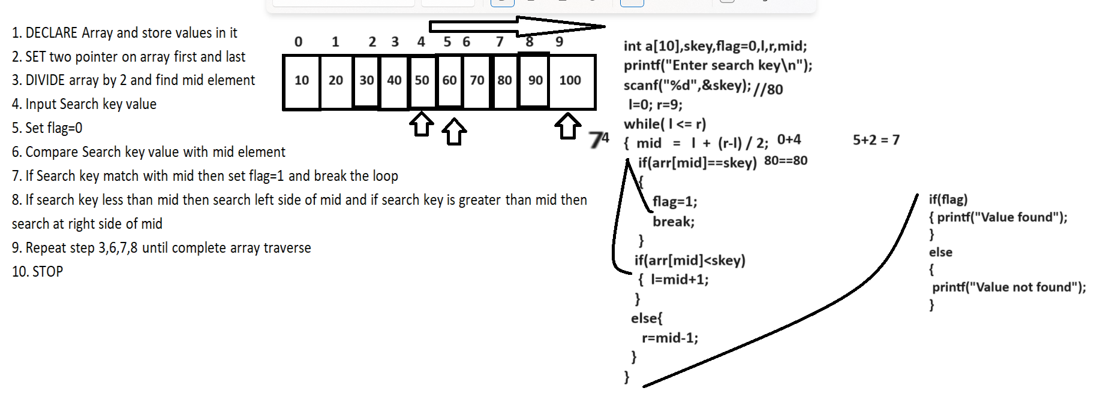

WAP to input five values in array and arrange data in ascending order.
_____________________________________________________________________________________
now we want to discuss about two algorithm for soritng
1. bubble sort
2. selection sort

Note: today we want to disucss about bubble sort algorithm

Bubble sort algorithm
__________________________________________________________
if we think about bubble sort algorithm we compare the previous with next index value and if previous index value is greater than next index value then perform swapping between two values means next index value on previous and previous index value on next index
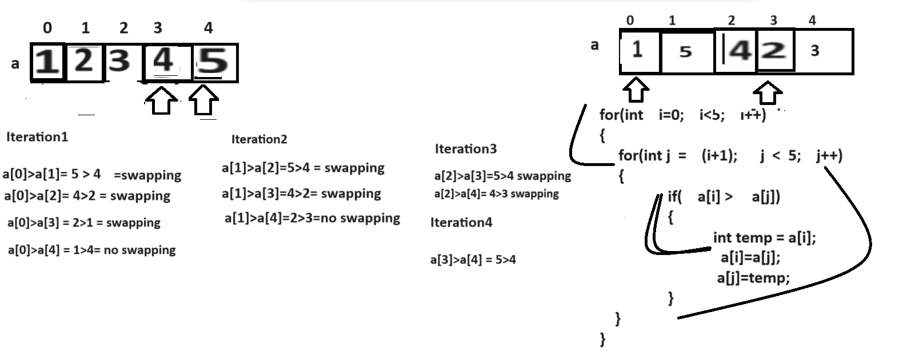

Complete source code with examples
#include<stdio.h>
#include<conio.h>
void main(){
int a[5],i,temp,j;
clrscr();
printf("\nEnter five values in array\n");
for(i=0;i<5;i++)
{ scanf("%d",&a[i]);
}
printf("\nDisplay array before sorting\n");
for(i=0;i<5;i++)
{ printf("%d\t",a[i]);
}
//apply sorting logics
for(i=0;i<5;i++)
{
for(j=(i+1);j<5;j++)
{
if(a[i]>a[j])
{
temp=a[i];
a[i]=a[j];
a[j]=temp;
}
}
}
printf("\nDisplay array after sorting\n");
for(i=0;i<5;i++)
{ printf("%d\t",a[i]);
}
getch();
}

Example: WAP to input five values in array and find the second highest value from array
1 9 13 4 19
Second highest value is 13

Example: WAP to input two arrays and check arra are anagram array or not
#include<stdio.h>
#include<conio.h>
void main(){
int a[5],b[5],i,temp,j;
int size;
clrscr();
size=sizeof(a)/sizeof(a[0]);
printf("\nEnter five values in array\n");
for(i=0;i<5;i++)
{ scanf("%d",&a[i]);
}
printf("\nEnter five value in array\n");
for(i=0;i<5;i++)
{ scanf("%d",&b[i]);
}
printf("\nDisplay array before sorting\n");
for(i=0;i<5;i++)
{ printf("%d\t",a[i]);
}
printf("\ndisplay second array before sorting\n");
for(i=0;i<5;i++)
{ printf("%d\t",b[i]);
}
//apply sorting logics
for(i=0;i<5;i++)
{
for(j=(i+1);j<5;j++)
{
if(a[i]>a[j])
{
temp=a[i];
a[i]=a[j];
a[j]=temp;
}
if(b[i]>b[j])
{
temp=b[i];
b[i]=b[j];
b[j]=temp;
}
}
}
printf("\nDisplay first array after sorting\n");
for(i=0;i<5;i++)
{ printf("%d\t",a[i]);
}
printf("\nDisplay second array after sorting\n");
for(i=0;i<5;i++)
{ printf("%d\t",b[i]);
}
//check anagram
int flag=1;
for(i=0;i<5;i++)
{
if(a[i]!=b[i])
{ flag=0;
break;
}
}
if(flag)
{ printf("Array is anagram");
}
else{
printf("Array is not anagram");
}
getch();
}

Example: WAP to declare array of size 6 and store 5 values in it and input the index and value and store value on specified index and shift previous values for that index by +1

