Loop
____________________________________________________________________

Q. what is loop?
__________________________________________________________
Loop means if we perform some task repeat again and again called as loop.
Example: Suppose consider we want to print good morning 100 times
Then we required to write printf() 100 times so writing printf() 100 times is not good
Approach so better way you can write single printf() and execute 100 times in this scenario we required to use loop
There are two types of loop
_____________________________________________________________________
1. Entry Control loop: entry control loop means first we check the condition and after that execute the loop called as entry control.

There are two types of entry control loop
a) While loop.
b) For loop
2. Exit Control loop: Exit control loop means first we execute the loop and after that check the condition called as exit control loop.
a) Do while loop.

If we want to work with any loop we required three important steps.
1. Initialization: starting of loop or decide from loop will be start
2. Condition: condition means decide how many times loop will be execute called as condition.
3. Increment or decrement: It is gap between every iteration in loop called as increment or decrement
Syntax of while loop
_____________________________________________________________________________
Initialization;
while ( condition )
{ write here your logics
Increment or decrement
}
Example:
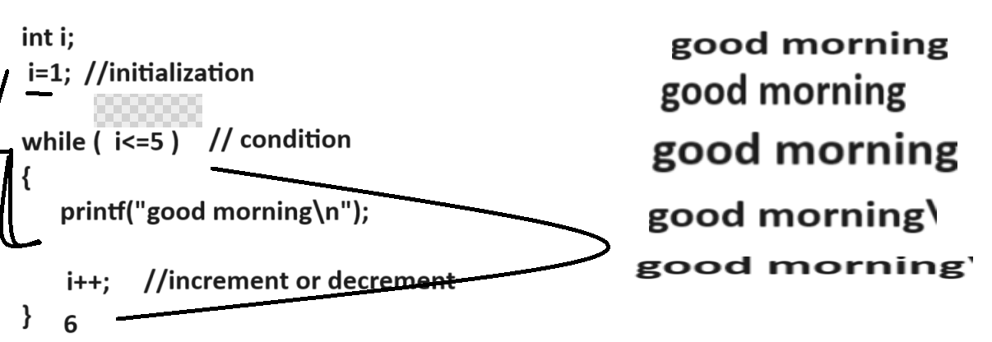
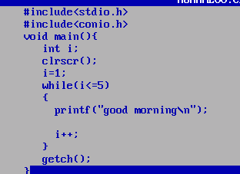

Example: WAP to input the number from keyboard and print its table.
5

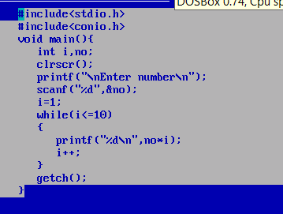
Example: WAP to input number and calculate its factorial.
5
Output: 120
1x2x3x4x5=120
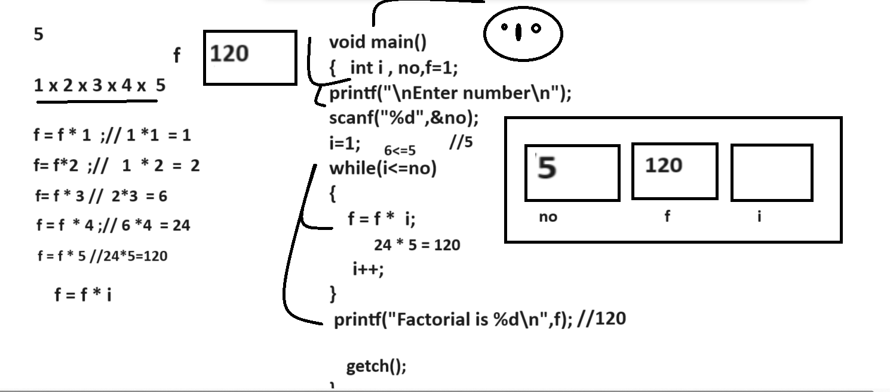

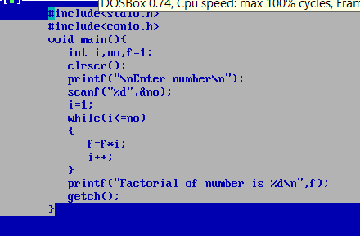
Example: WAP to input two values consider first as base , second as index and calculate its power.
5
3
3
5 = 5 x 5 x 5 = 125
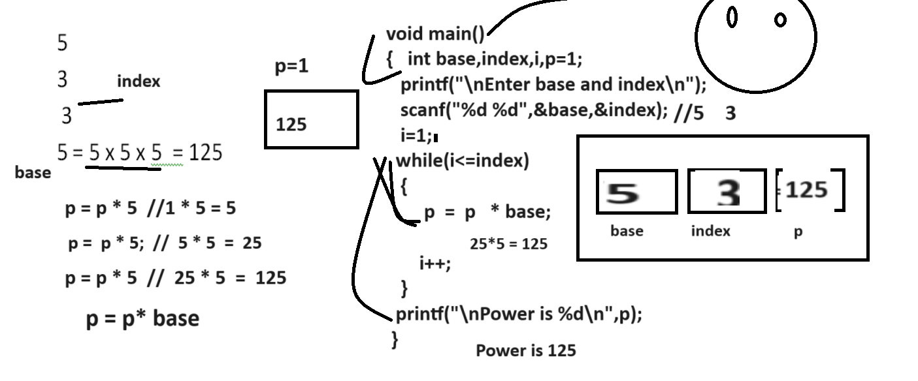

Example: WAP to input number and reverse it
Input: 123
Output: 321
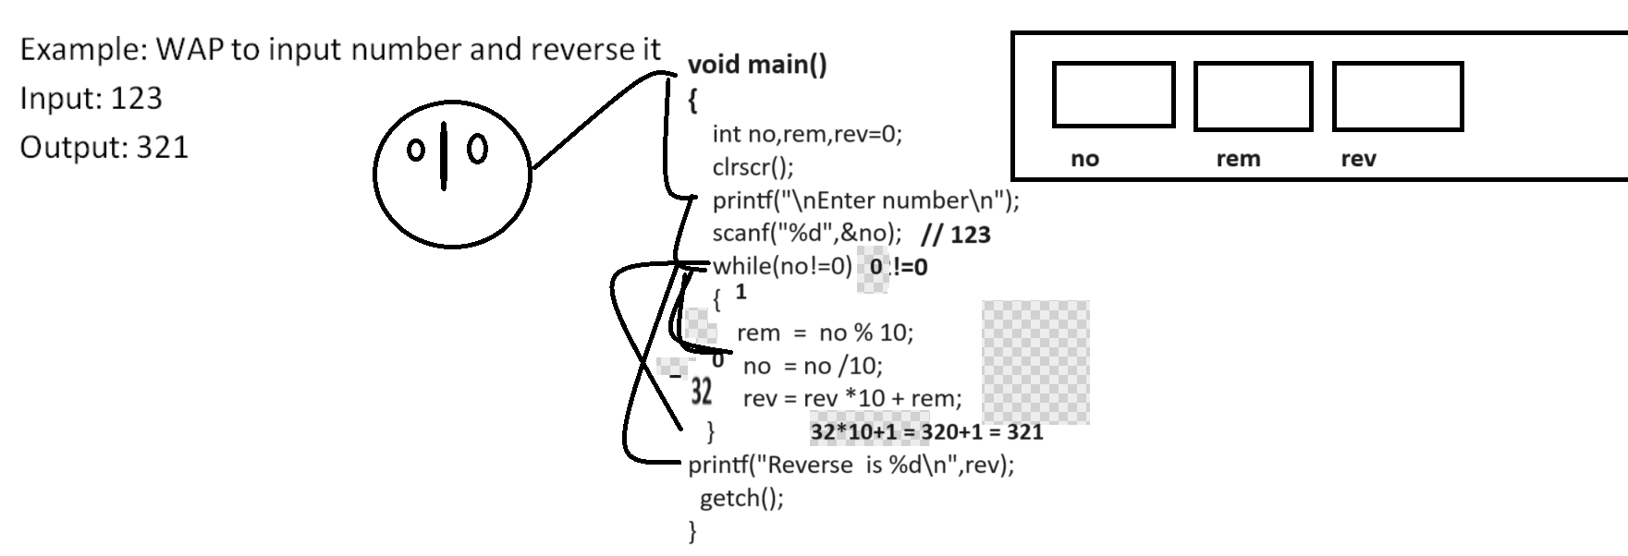

Example: WAP to input number and check number is perfect number or not?

6 = 1 2 3 = 1+2+3 = 6
8= 1 2 4 = 1 + 2 + 4 = 7
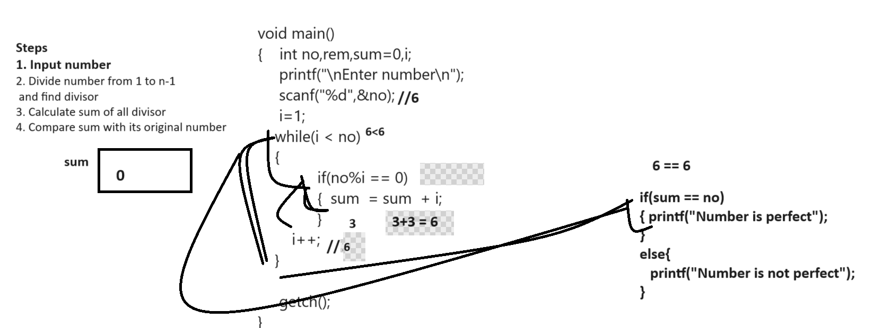

Example: WAP to input number and count its digit
Input: 1234
Output: Number of digit is 4
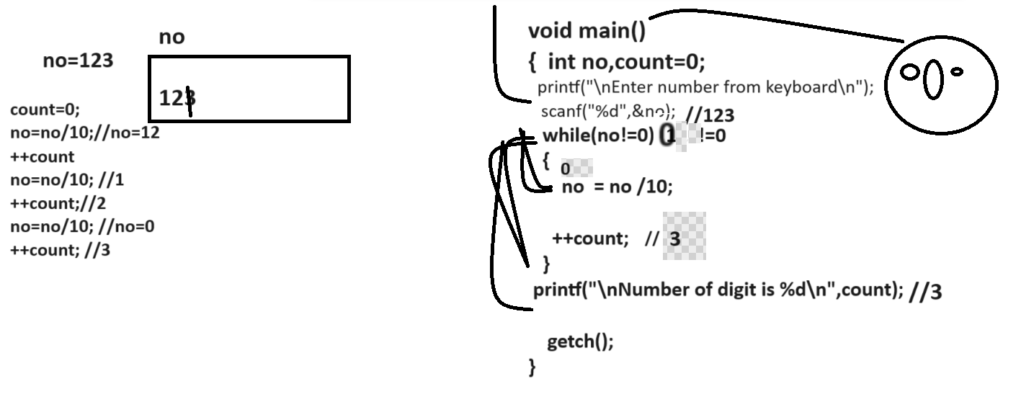

Example: WAP to input number from keyboard and check number is Armstrong or not
153 =
3 3 3
1 + 5 + 3 = 1 + 125 + 27 = 153

8208 =
4 4 4 4
8 + 2 + 0 + 8
3 3 3
123 = 1 + 2 + 3 = 1 + 8 + 27 = 36

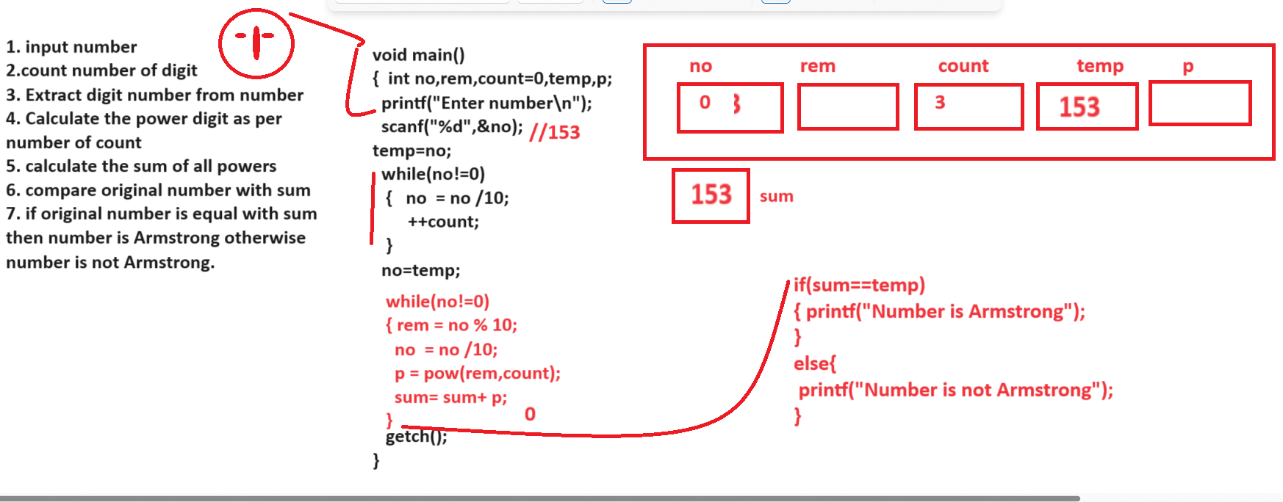

Example: WAP to input number and check number is duck number or not

Input Number: 1024 – this is your duck number
Input Number: 1234 – this is your not duck number.
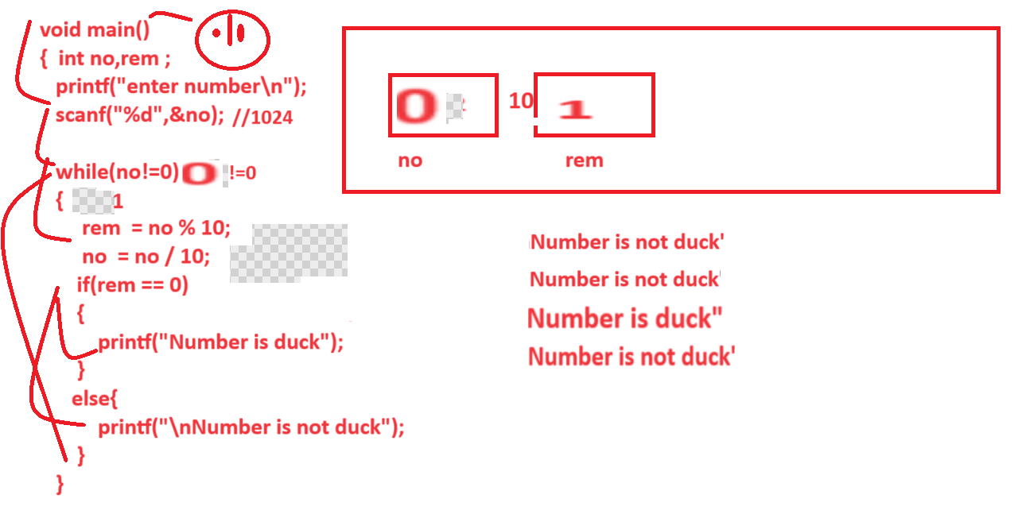
Note: if we think about above code we get output 3 times number is not duck and 1 time number is duck so it is not proper output program should display single time number is duck or either number is not duck so if we want to solve this problem we can use flag variable

Q. what is flag variable?
______________________________________________________________________
flag variable is a concept where we can declare variable in program and initialize 0 value in it and we check the condition in loop using single if and set its value as 1 and break the loop and after loop we check the condition using if else if flag variable value is 1 then consider condition is true if flag variable value is 0 then consider condition is false.

Q. Why we need to use flag variable?
________________________________________________________________________
Because if we use if else in loop then either if get executed or else get executed then we not get proper output so if we want to resolve this problem we can use flag variable concept.

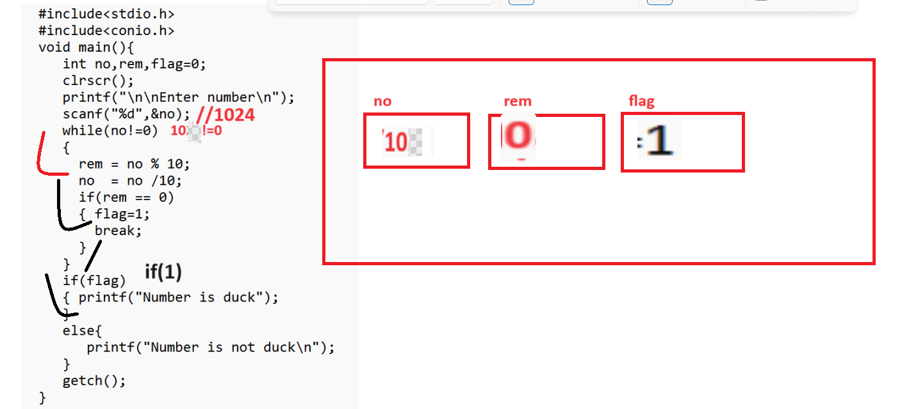

Example: WAP to input number and check digit present in number or not
Input: 12345
Enter digit for search
3
Output: Digit found
Enter digit for search
7
Output: digit not found

Source code
#include<stdio.h>
#include<conio.h>
void main(){
int no,rem,flag=0,sdigit;
clrscr();
printf("\n\nEnter number\n");
scanf("%d",&no);
printf("\nEnter the search digit value\n");
scanf("%d",&sdigit);
while(no!=0)
{
rem = no % 10;
no = no /10;
if(rem == sdigit)
{
flag=1;
break;
}

}
if(flag)
{ printf("Digit found");
}
else{
printf("Digit not found");
}

getch();
}

Example: WAP to input number and check number is prime or not
Example: 7 , 5 ,11,13 etc
#include<stdio.h>
#include<conio.h>
void main(){
clrscr();
int no,flag=0,rem,i;
printf("\nEnter number\n");
scanf("%d",&no);
i=2;
while(i<no)
{
if(no%i == 0)
{ flag=1;
break;
}
i++;
}
if(!flag) //!0 1
{ printf("prime");
}
else{
printf("No Prime");
}

getch();
}

