Pointer
__________________________________________________________________

Q. what is pointer?
________________________________________________________________
Pointer is a derived data type and which is used for allocate dynamic memory at program run time.

Q. what is derived data type?
___________________________________________________________________
Those data type acquire the properties from another data type for complete own meaning called
as derived data type.
Note: pointer can denote in programming by using *

Syntax to declare pointer
__________________________________________________________________________
Syntax: data type *variablename;
Example: int *ptr;
Here ptr is a pointer variable because we use * before ptr.

Q. what is dynamic memory allocation?
______________________________________________________________________________
Dynamic memory allocation means to decide how much memory required at program run time called as dynamic memory allocation.
Note: if we think about array it is static memory allocation means cannot modify its size at program run time directly

How pointers allocate dynamic memory?
____________________________________________________________________________
Pointer can allocate dynamic memory with the help of memory address.

Q. what is memory address?
_________________________________________________________________________________
Memory address is unique integer number or hexadecimal number provided by ram to every memory block called as memory address.

Can we see the memory address of variable?
___________________________________________________________________________
If we want to see the memory address of variable we have to use & operator.
& is memory address operator using this operator we can see the memory address or access memory address of variable.
Following Example show how we can access memory address
___________________________________________________________________________________
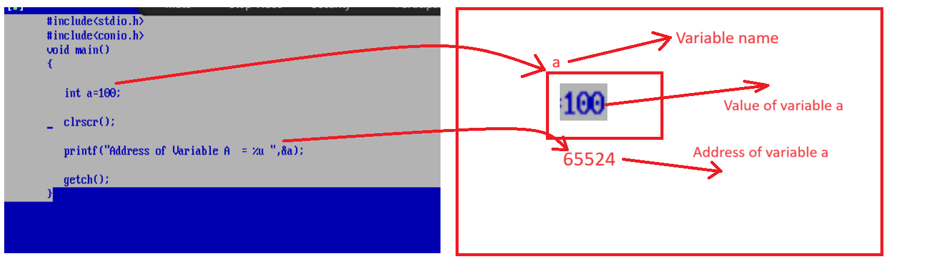

How we can store address of another variable in pointer variable?
__________________________________________________________________________________
If we want to store the address of another variable in pointer variable we have to use following syntax

Syntax: pointer variable =&normal variable;
Example: int *ptr,a=100;
ptr=&a; //here variable a can store address in ptr variable.

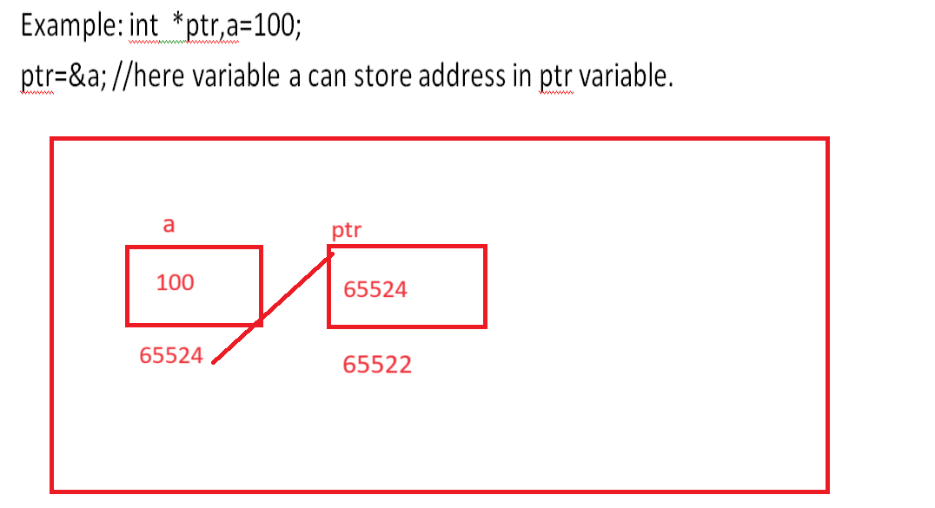

Important points related with pointer
1. Pointer always use another memory address and pointer has own different address.

2. Pointer can access the value whose address stored in just we need to use * with pointer at the time of value access

Note: * known as value at address operator or indirection operator.

3. If we increase or decrease pointer without *then pointer can shift on new block as operation and the block size is dependent on data of pointer

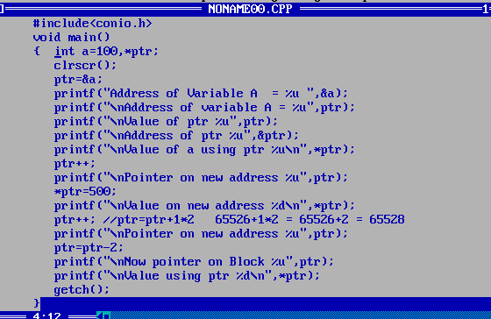

How to allocate dynamic or run time memory by using pointer
____________________________________________________________________________________
Note: when we not store any address in pointer then pointer contain by default address of some memory.

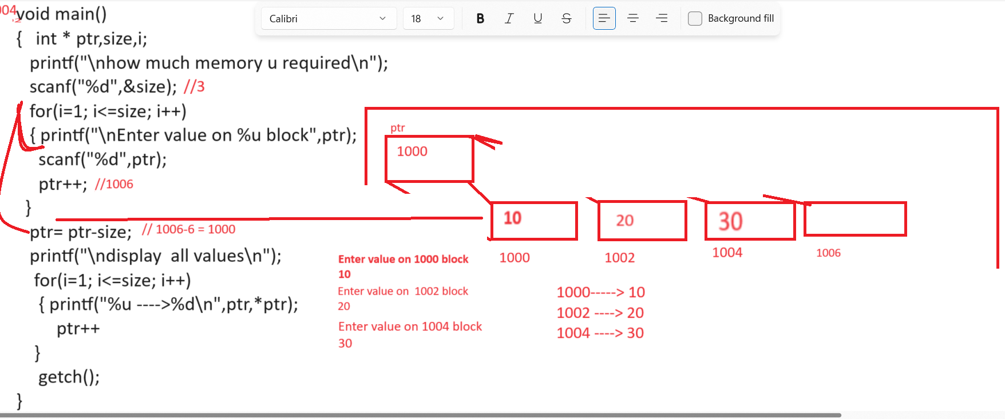
Q. what will be output of given code?
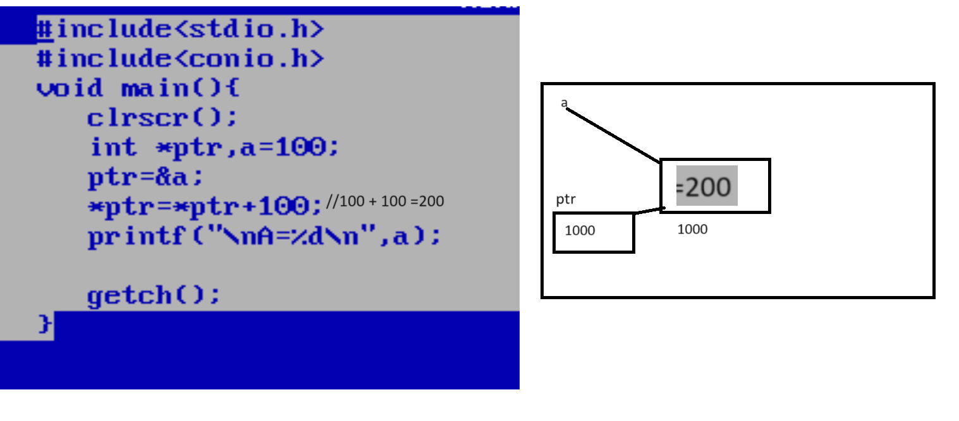

Q. what will be output given code?
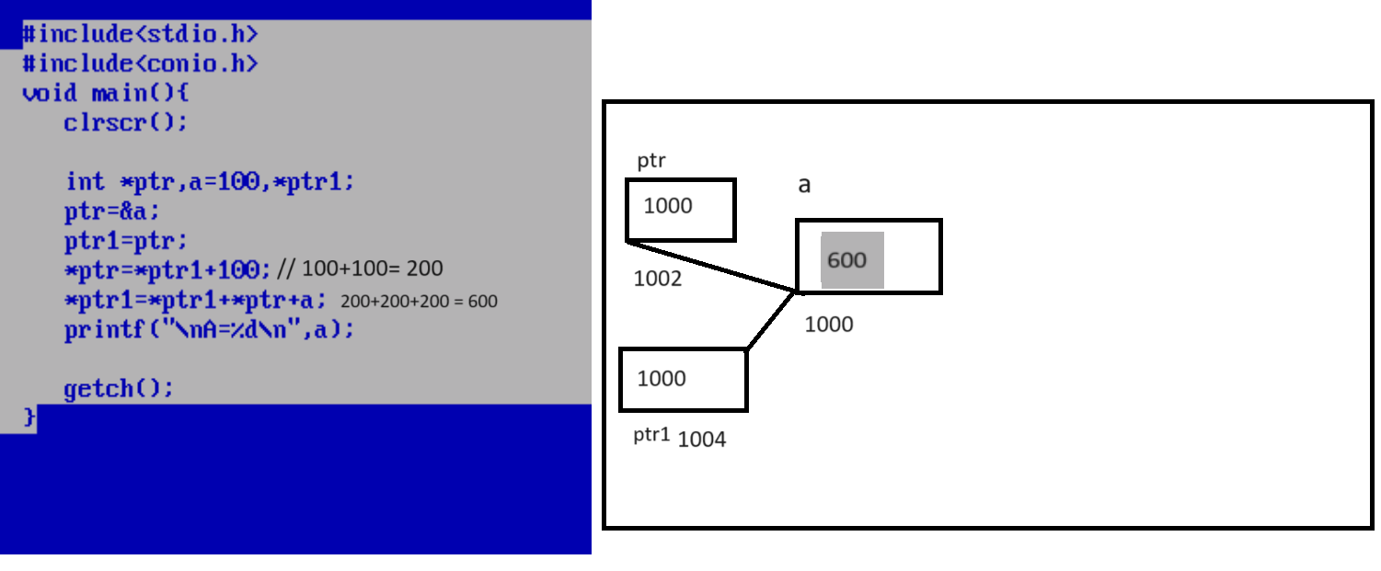

How to access array by using pointer or how to fetch data from array using pointer
__________________________________________________________________________
If we want to fetch data from array using pointer we have to store base address of array in pointer variable.

Q. what is base address?
__________________________________________________________________________
0th location address called as base address.

Q. How to get base address of array or how to fetch base address of array?
____________________________________________________________________________
if we want to get base address of array we have two ways
1. Use array without subscript or [] ?
int a[5]; //suppose it is your array.
printf(“%u”,a); //print base address
a – get base address of array
2. Use array like as
int a[5];//suppose consider we have array of size 5
&a[0];// we get base address of array.

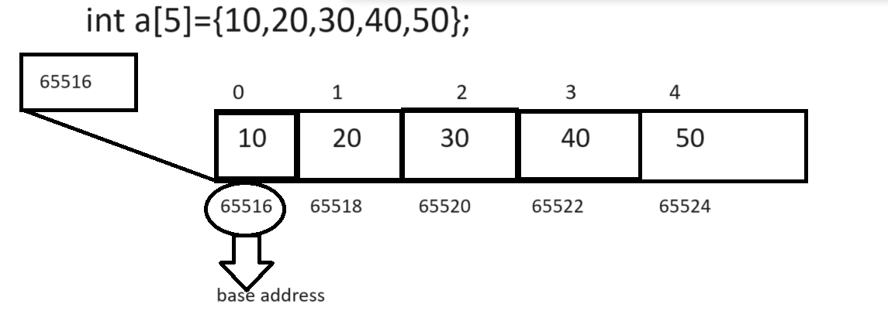
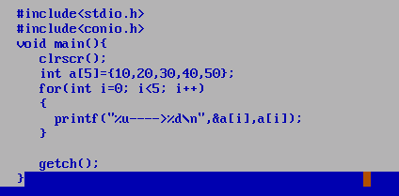
Output
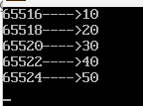

Access array using pointer
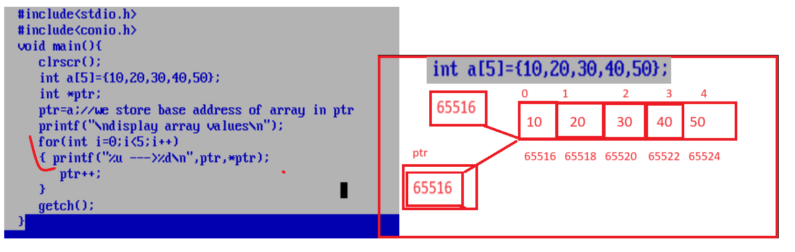

Q. what is meaning of arrayvariable[i]?
__________________________________________________________________________
base address + index
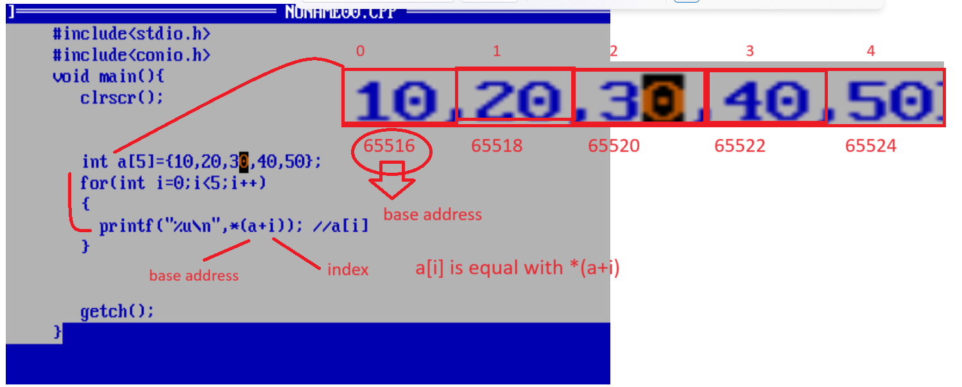

Q. what is meaning ofa[i] or i[a] or *(a+i) or *(i+a) or *(&a[i])?
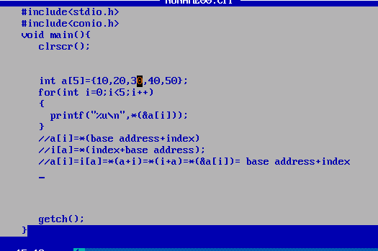

Q. why array index start from 0th location?
___________________________________________________________________________
because if we think array we fetch its data by using technique *(baseaddress+index*datatypesize)
and suppose consider if we start your array from 1st index and consider your base address is 65516
and if we fetch data from array by starting index 1 then your equatation like as
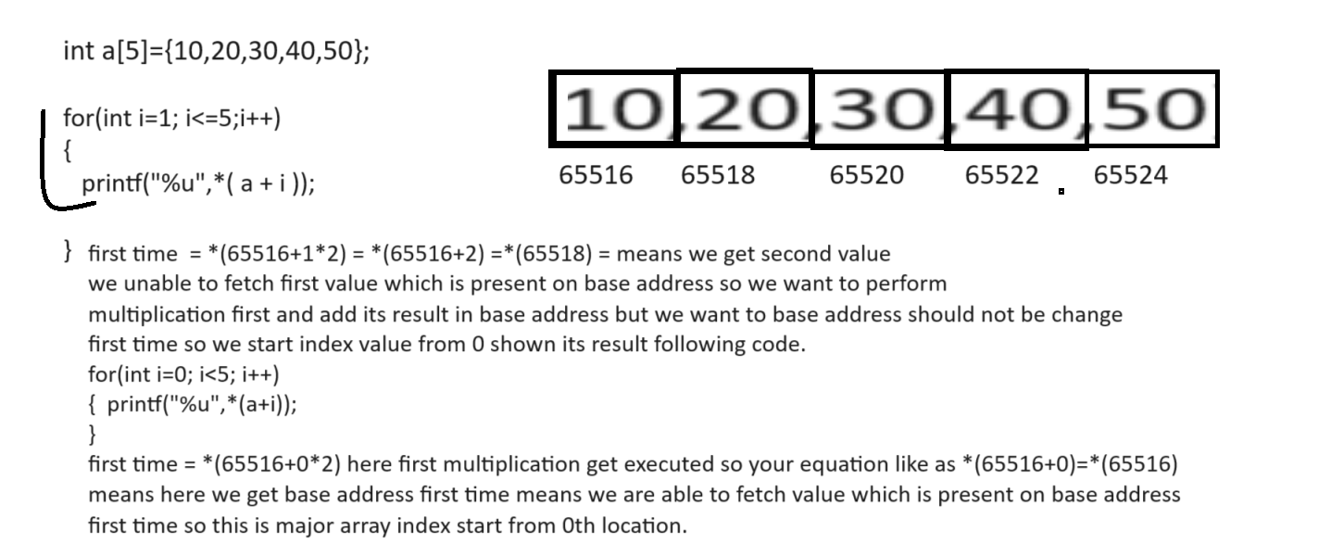
Q. what will be output of given code?
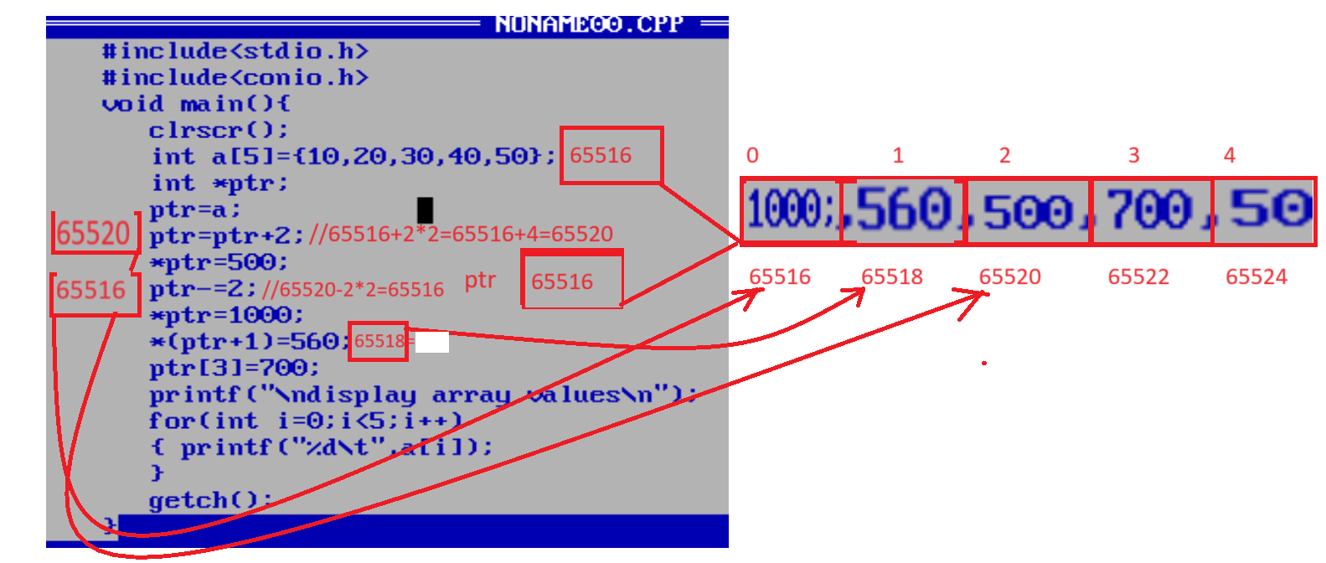
Types of pointer
____________________________________________________________
1. void pointer or generic pointer
________________________________________________________________________
void pointer is a generic pointer means void pointer can store any type of address in it or any data type address in it just we need to cast it as per the data type.

Syntax: void *pointername;
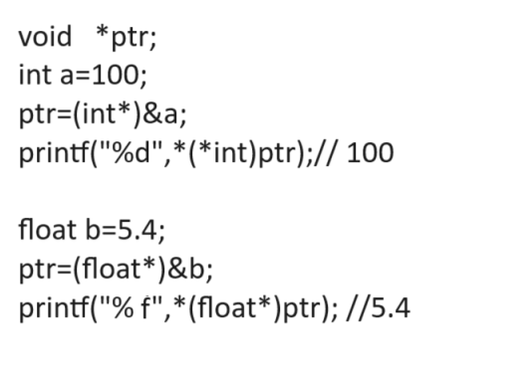
if we think about above code or screen short we have void pointer name as *ptr
and we have statement ptr=(int*)&a; here we convert ptr as integer pointer means we store integer variable address in ptr means you void pointer behave like as integer pointer here
and we have printf(“%d”,*(*int)ptr)); here ptr behave like as integer pointer because we cast ptr as int* and we have one more statement ptr=(float*)&b; means here your ptr work as float pointer here
means void pointer is generalize pointer or generic pointer which is able to work with any type of variable address at run time so void pointer known as generic pointer.
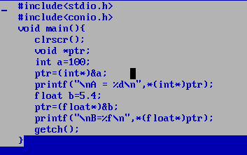

Q. what is purpose of void pointer?
noramally we use void pointer when we not confirm what kind of memory we required to allocate at run time.

Example: if we think about malloc(),calloc(),free() or realloc() this function accept as parameter void pointer and return void pointer.
Q. what is malloc?
malloc is a dynamic memory allocation function in c which is used for allocate memory at program run time and it is used for create dynamic array in c language.

Syntax: pointervariable=(void*)malloc(size);

if we think about above syntax malloc use the void * as return type means malloc can allocate memory of any type of data by using pointer just we need to convert malloc in to particular type of pointer
whose memory want to allocate.
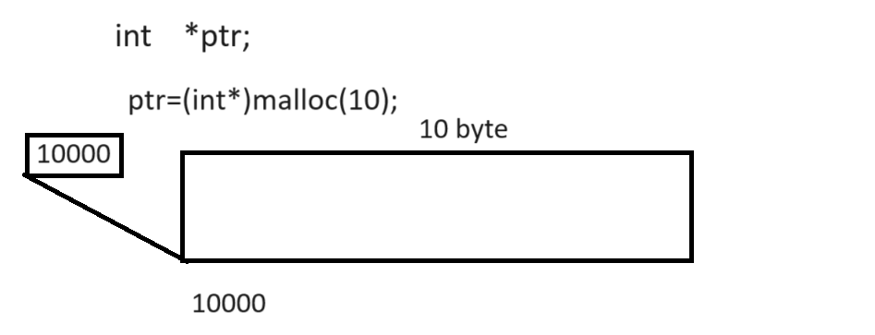
If we think about above diagram we have malloc function and we allocate its memory of size 10
means we have one block in memory of size 10 and its defualt value is garbage means if we divide this memory by 2 size then we have 5 block of memory
Example: we want to create dynamic array by using malloc function
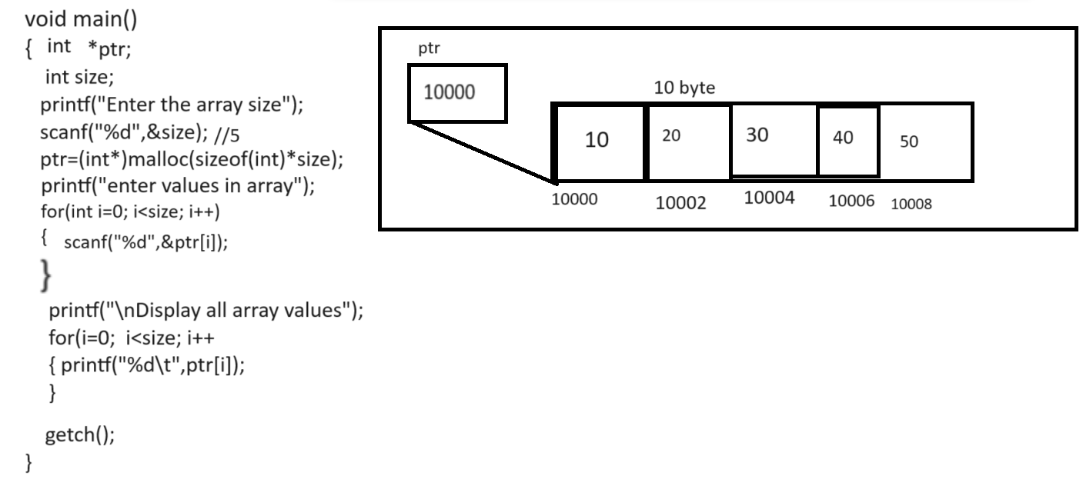

Example: WAP to create array by using malloc and find the max value from array.
#include<stdio.h>
#include<conio.h>
#include<stdlib.h>
void main(){
int *ptr,size,max;
clrscr();
printf("\nEnter size of array\n");
scanf("%d",&size);
ptr=(int*)malloc(sizeof(int)*size);
printf("\nEnter values in array\n");
for(int i=0;i<size;i++)
{ scanf("%d",&ptr[i]);
}
printf("\nDisplay all values\n");
for(i=0;i<size;i++)
{ printf("ptr[%d] ---->%d\n",i,ptr[i]);
}
max=ptr[0];
for(i=0;i<size;i++)
{
if(ptr[i]>max)
{ max=ptr[i];
}
}
printf("\nMax value from array %d\n",max);
getch();
}

realloc(): realloc() function is used for reallocate memory allocated by malloc function some time if we allocate memory using malloc and if we want to change memory or expand memory at program run time then we can realloc function.

Syntax: pointer=(void*)realloc(pointer,size);
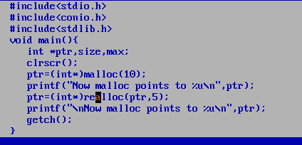

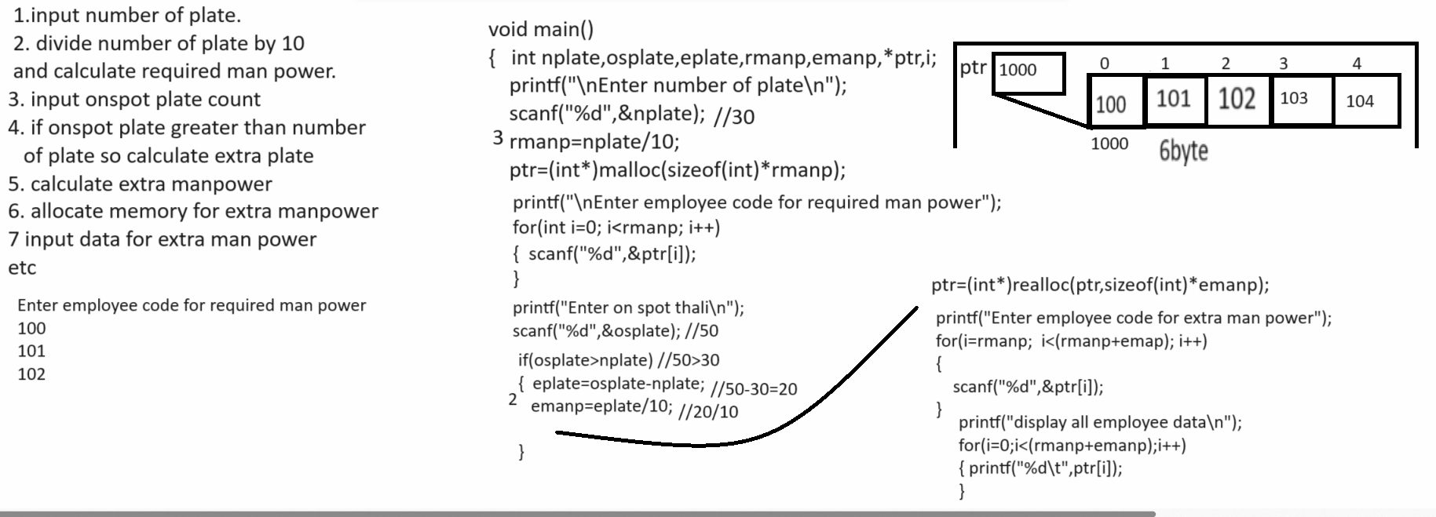

Example with source code.
#include<stdio.h>
#include<conio.h>
#include<stdlib.h>
void main(){
int nplate,osplate,eplate,rmanp,emanp,i,*ptr;
clrscr();
printf("\nEnter number of plate count\n");
scanf("%d",&nplate);
rmanp=nplate/10;
ptr=(int*)malloc(sizeof(int)*rmanp);
printf("\nEnter employee code for required man power\n");
for(i=0; i<rmanp;i++)
{ scanf("%d",&ptr[i]);
}
printf("\nEnter on splot plate\n");
scanf("%d",&osplate);
if(osplate>nplate)
{ eplate=osplate-nplate;
emanp=eplate/10;
ptr=(int*)realloc(ptr,sizeof(int)*emanp);
printf("\nEnter code for extra man power\n");
for(i=rmanp;i<(rmanp+emanp);i++)
{ scanf("%d",&ptr[i]);
}
printf("\nDisplay all employee data\n");
for(i=0;i<(rmanp+emanp);i++)
{ printf("%u---->%d\n",&ptr[i],ptr[i]);
}
}

getch();
}

void free(void*): this function is used for release the memory allocated by pointer
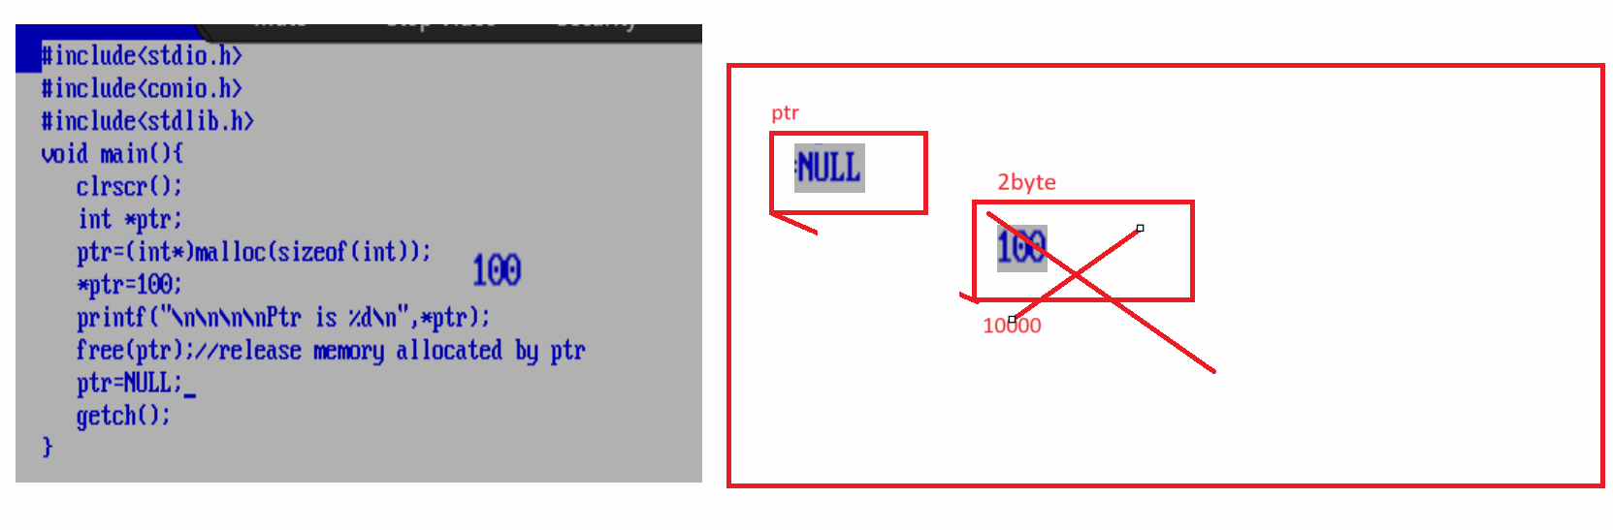
calloc function
__________________________________________________________________________
calloc() is a dynamic memory allocation which is used for allocate memory at run time but
allocate continious block of memory.

Syntax: pointer=(datatype*)calloc(n,size);
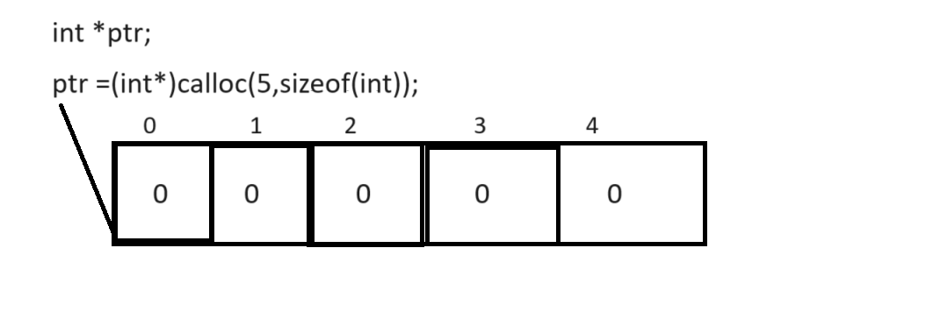
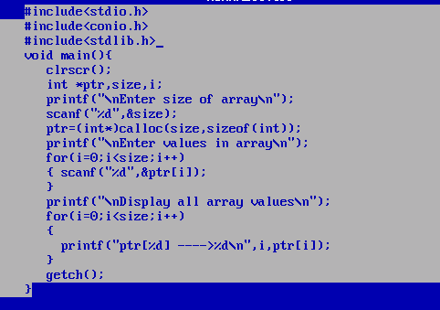

2. dangling of pointer : dangling of pointer means if we try to delete the memory of pointer using free function but pointer not release it called as dangling of pointer.
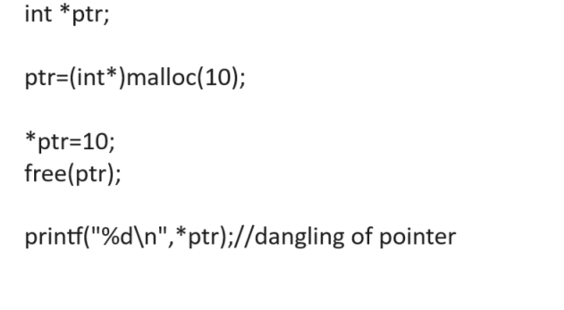
3. null pointer: null pointer means pointer cannot point to any memory called as null pointer.
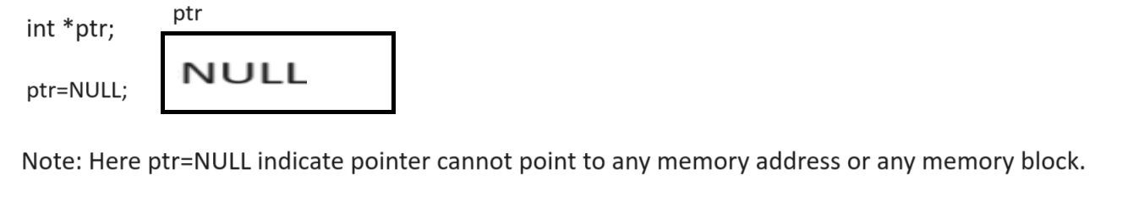

Note: given three types we will discuss later at the end of c language
4. far pointer
5. huge pointer
6.near pointer

Pointer of pointer
_________________________________________________________________________
Q. what is pointer of pointer?
__________________________________________________________________________
pointer of pointer means we can store address of another pointer in pointer called as pointer or pointer.

Syntax of Pointer of pointer
_______________________________________________________________________
datatype **variablename;

Example: int **ptr;
here we have two ** with ptr means your ptr can store two different addresses in it so it is pointer of
pointer.

Example using pointer of pointer
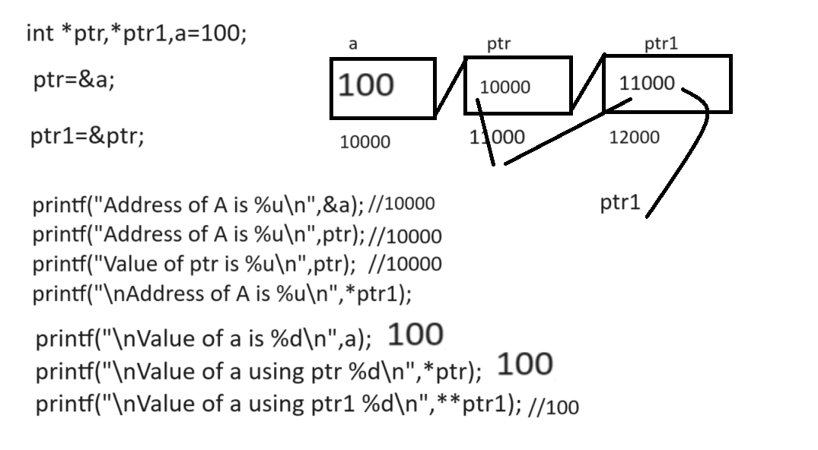
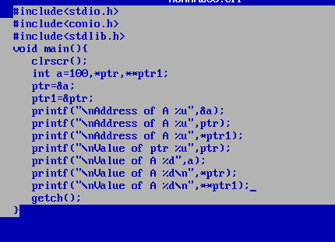

Note: if we think about two dimensional array we can access it using pointer like as
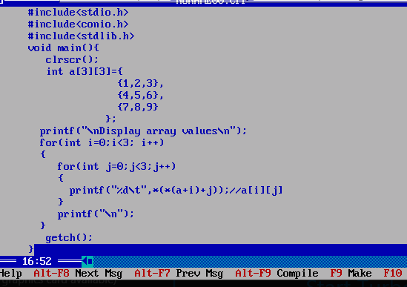

Q. what will be output of given code?
