Two dimensional arrays
_______________________________________________________________________
Two dimension array is used for create the matrix but it is not matrix internally
It is sequential memory management of array and every block has two digit indexes.

int a[3][3];
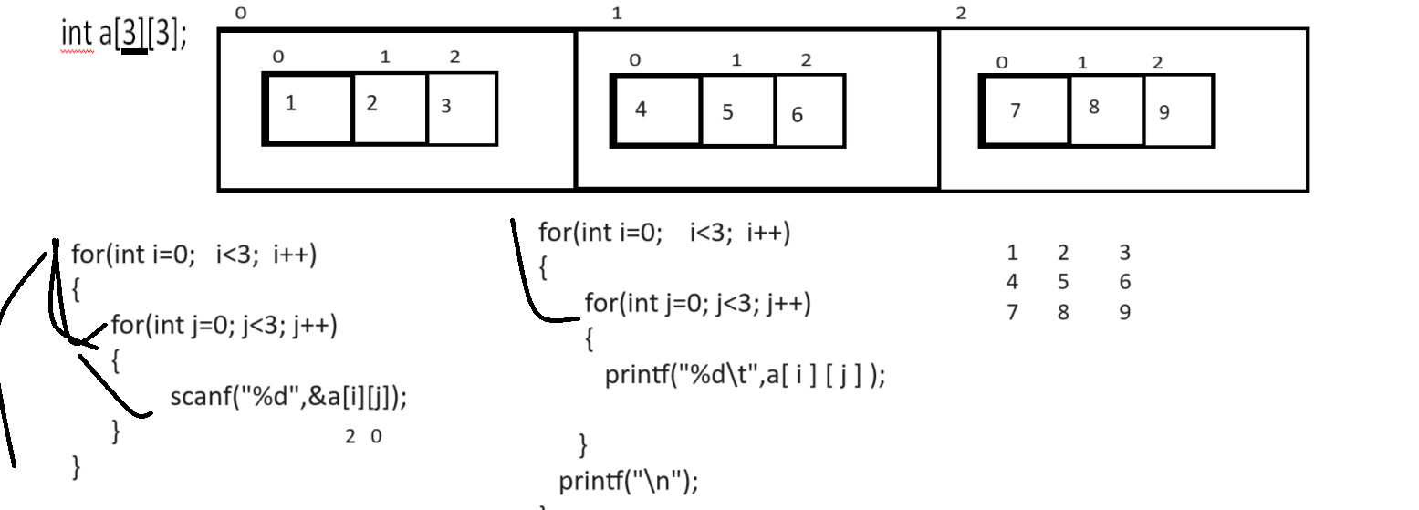
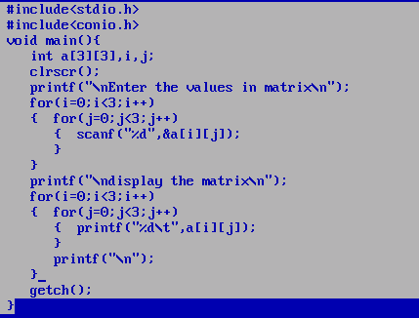

Example: WAP to create 3 x 3 matrixes and calculate the sum of every row
1 2 3 = 6
4 5 6 = 15
7 8 9 = 24
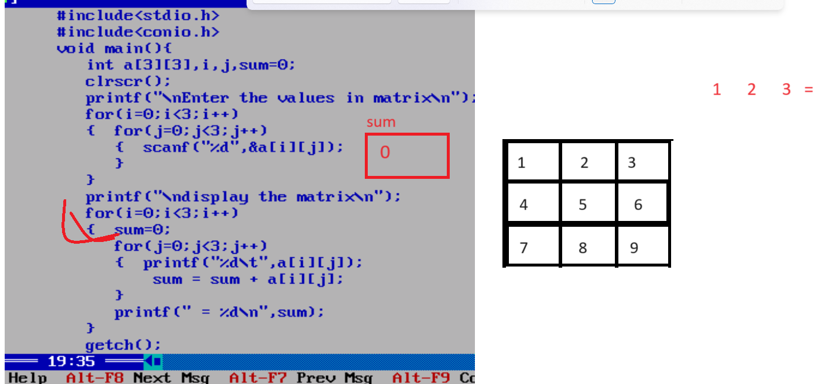

Example: WAP to create two matrix 3 x 3 and compare matrix are equal or not
#include<stdio.h>
#include<conio.h>
void main(){
int a[3][3],b[3][3],i,j,sum=0;
clrscr();
printf("\nEnter the values in first matrix\n");
for(i=0;i<3;i++)
{ for(j=0;j<3;j++)
{ scanf("%d",&a[i][j]);
}
}
printf("\nEnter the values in second matrix\n");
for(i=0;i<3;i++)
{
for(j=0;j<3;j++)
{
scanf("%d",&b[i][j]);
}
}
printf("\ndisplay first matrix\n");
for(i=0;i<3;i++)
{
for(j=0;j<3;j++)
{ printf("%d\t",a[i][j]);
}
printf("\n");
}
printf("\ndisplay second matrix\n");
for(i=0;i<3;i++)
{
for(j=0;j<3;j++)
{ printf("%d\t",b[i][j]);
}
printf("\n");
}
//logic for comparision
int flag=1;
for(i=0;i<3;i++)
{
for(j=0;j<3;j++)
{
if(a[i][j]!=b[i][j]){
flag=0;
break;
}
}
}
if(flag)
{ printf("Matrix are equal");
}
else{
printf("Matrix not equal");
}
getch();
}

Example: WAP to create 3 x 3 two matrixes and calculate its addition and store its result in third matrix and display it.
#include<stdio.h>
#include<conio.h>
void main(){
int a[3][3],b[3][3],c[3][3],i,j,sum=0;
clrscr();
printf("\nEnter the values in first matrix\n");
for(i=0;i<3;i++)
{ for(j=0;j<3;j++)
{ scanf("%d",&a[i][j]);
}
}
printf("\nEnter the values in second matrix\n");
for(i=0;i<3;i++)
{
for(j=0;j<3;j++)
{
scanf("%d",&b[i][j]);
}
}
printf("\ndisplay first matrix\n");
for(i=0;i<3;i++)
{
for(j=0;j<3;j++)
{ printf("%d\t",a[i][j]);
}
printf("\n");
}
printf("\ndisplay second matrix\n");
for(i=0;i<3;i++)
{
for(j=0;j<3;j++)
{ printf("%d\t",b[i][j]);
}
printf("\n");
}
//matrix addition logics
int flag=1;
for(i=0;i<3;i++)
{ for(j=0;j<3;j++)
{
c[i][j]=a[i][j]+b[i][j];
}

}
printf("\ndispay resultant matrix\n");
for(i=0;i<3;i++)
{
for(j=0;j<3;j++)
{
printf("%d\t",c[i][j]);
}
printf("\n");
}
getch();
}

Example: WAP to create 3 x 3 matrixes and perform matrix multiplication.
#include<stdio.h>
#include<conio.h>
void main(){
int a[3][3],b[3][3],c[3][3],i,j,sum=0;
clrscr();
printf("\nEnter the values in first matrix\n");
for(i=0;i<3;i++)
{ for(j=0;j<3;j++)
{ scanf("%d",&a[i][j]);
}
}
printf("\nEnter the values in second matrix\n");
for(i=0;i<3;i++)
{
for(j=0;j<3;j++)
{
scanf("%d",&b[i][j]);
}
}
printf("\ndisplay first matrix\n");
for(i=0;i<3;i++)
{
for(j=0;j<3;j++)
{ printf("%d\t",a[i][j]);
}
printf("\n");
}
printf("\ndisplay second matrix\n");
for(i=0;i<3;i++)
{
for(j=0;j<3;j++)
{ printf("%d\t",b[i][j]);
}
printf("\n");
}
//matrix addition logics
int flag=1;
for(i=0;i<3;i++)
{ for(j=0;j<3;j++)
{
int sum=0;
for(int k=0;k<3;k++)
{
sum = sum + a[i][k]*b[k][j];
}
c[i][j]=sum;
}
}
printf("\ndispay resultant matrix\n");
for(i=0;i<3;i++)
{
for(j=0;j<3;j++)
{
printf("%d\t",c[i][j]);
}
printf("\n");
}
getch();
}

