|  |  |
| --- | --- |
|  | **PES UNIVERSITY**  **(Established under Karnataka Act No. 16 of 2013)**  **100 Ft. Road, BSK III Stage, Bengaluru – 560 085**  **DEPARTMENT OF COMPUTER SCIENCE AND ENGINEERING** |

|  |  |  |
| --- | --- | --- |
| **Course Title: Image Processing and Data Visualization Using MATLAB** | | |
| **Course code: -UE19CS257B** | | |
| **Semester : 4th sem** | **Branch: CSE** | **Team Id: 11** |
| **SRN: PES1UG19CS593** | **Name: Yashwal S Kanchan** | |
| **SRN: PES2UG19CS225** | **Name: Mayuravarsha P** | |

**PROJECT REPORT**

**Problem Statement: Object Tracking**

This program just tracks all red, green and blue colored objects and draws a bounding box around them. This works on the difference between frames concept. Every frame in the video is returned as an rgb image on which we can do image processing stuff.. The tracking is done using image processing in Matlab.

**Objectives:**

To capture the video frames using video inputs and then tracking the object in real time using predominant colour of the object. The color is detected using the threshold provided.

**Description:**

The tracking of the objects is done by detecting the color of the object and then tracking its motion. Here we have chosen Red, Green and Blue as our primary colors for the project. Any color can be tracked.

The video frames are captured using the web camera, and the appropriate properties are set. When 100 frames are acquired, the acquisition stops.

If red colored object is to be tracked then, the snapshot of the current frame is taken and we have to subtract the red component.

From the grayscale image to extract the red components in the image. Use a median filter to filter out noise. The resulting grayscale image is converted into a binary image and then the pixels less than 300px is removed.

We then label all the connected components in the image and perform Blob Analysis. We then get a set of properties for each labelled region. Then the image is displayed.

This process is done to every frame. So collectively all the images form a video and hence the tracking of the object is shown.

**New Concept Learnt(Explanation):**

MATLAB provides various features and tools for image processing, analysis, visualization, conversion, etc.

BW = im2bw( I , level ) converts the grayscale **image** I to **binary image** BW , by replacing all pixels in the input **image** with luminance greater than level with the value 1 (white) and replacing all other pixels with the value 0 (black). This range is relative to the signal levels possible for the **image's** class.

Median filtering is employed to get rid of unwanted noise from the image whereas protective the originality of the image. Image is regenerate into grayscale image.

The method of analyzing an image that has undergone binarization processing is called "**blob analysis**". A **blob** refers to a lump. **Blob analysis** is image processing's most basic method for analyzing the shape features of an **object**, such as the presence, number, area, position, length, and direction of lumps.

**Learning Outcome:**

Detection of moving objects and motion-based tracking are important components of many computer vision applications, including activity recognition, traffic monitoring, and automotive safety. The problem of motion-based object tracking can be divided into two parts:

1. Detecting moving objects in each frame
2. Associating the detections corresponding to the same object over time

The detection of moving objects uses a background subtraction algorithm based on Gaussian mixture models. Morphological operations are applied to the resulting foreground mask to eliminate noise. Finally, blob analysis detects groups of connected pixels, which are likely to correspond to moving objects.

**Code:**

**redThresh = 0.24; % Threshold for red detection**

**greenThresh = 0.05; % Threshold for green detection**

**blueThresh = 0.15; % Threshold for blue detection**

**answer = questdlg('Which colour would you like to track?', ...**

**'Colour',...**

**'Red','Green','Blue','Red');**

**% Handle response**

**switch answer**

**case 'Red'**

**f = msgbox('Red objects shall be detected.')**

**colour = 1;**

**case 'Green'**

**f = msgbox('Green objects shall be detected.')**

**colour = 2;**

**case 'Blue'**

**f = msgbox('Blue objects shall be detected.')**

**colour = 3;**

**end**

**%f = msgbox('Operation Completed','Success');**

**%f = msgbox('Invalid Value', 'Error','error');**

**% Capture the video frames using the videoinput function**

**% You have to replace the resolution & your installed adaptor name.**

**vid = videoinput('winvideo',1);**

**% Set the properties of the video object**

**set(vid, 'FramesPerTrigger', Inf);**

**set(vid, 'ReturnedColorspace', 'rgb')**

**vid.FrameGrabInterval = 2;**

**%start the video aquisition here**

**start(vid)**

**% Set a loop that stop after 100 frames of aquisition**

**while(vid.FramesAcquired<=100)**

**% Get the snapshot of the current frame**

**data = getsnapshot(vid);**

**% Now to track red objects in real time**

**% we have to subtract the red component**

**% from the grayscale image to extract the red components in the image.**

**diff_im = imsubtract(data(:,:,colour), rgb2gray(data));**

**%Use a median filter to filter out noise**

**diff_im = medfilt2(diff_im, [3 3]);**

**% Convert the resulting grayscale image into a binary image.**

**diff_im = im2bw(diff_im,blueThresh);**

**% Remove all those pixels less than 300px**

**diff_im = bwareaopen(diff_im,300);**

**% Label all the connected components in the image.**

**bw = bwlabel(diff_im, 8);**

**% Here we do the image blob analysis.**

**% We get a set of properties for each labeled region.**

**stats = regionprops(bw, 'BoundingBox', 'Centroid');**

**% Display the image**

**imshow(data)**

**hold on**

**%This is a loop to bound the red objects in a rectangular box.**

**for object = 1:length(stats)**

**bb = stats(object).BoundingBox;**

**bc = stats(object).Centroid;**

**rectangle('Position',bb,'EdgeColor','y','LineWidth',2)**

**plot(bc(1),bc(2), '-m+')**

**a=text(bc(1)+25,bc(2), strcat('X: ', num2str(round(bc(1))), ' Y: ', num2str(round(bc(2)))));**

**set(a, 'FontName', 'Arial', 'FontWeight', 'bold', 'FontSize', 8, 'Color', 'black');**

**end**

**hold off**

**end**

**% Both the loops end here.**

**delete(findall(0));**

**%close(vid);**

**% Stop the video aquisition.**

**stop(vid);**

**% Flush all the image data stored in the memory buffer.**

**flushdata(vid);**

**%delete(vid);**

**%f = msgbox('Operation Completed','Success');**

**% Clear all variables**

**clear all**

**Output Screenshots**

Choosing colour to detect

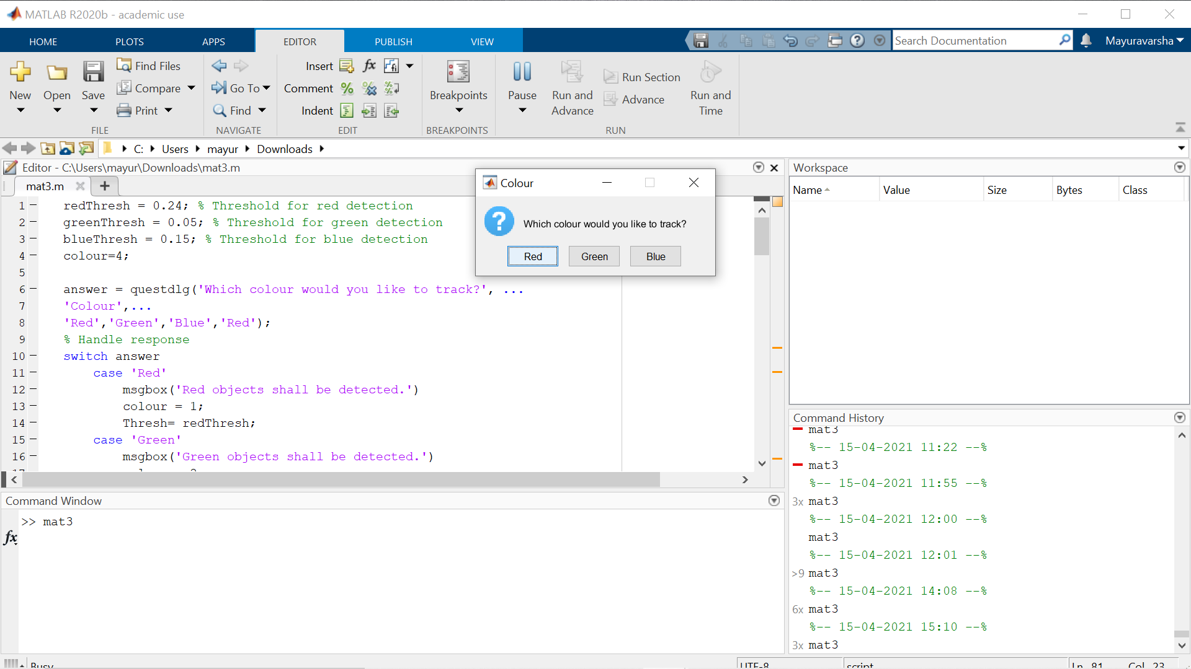

Detecting Red

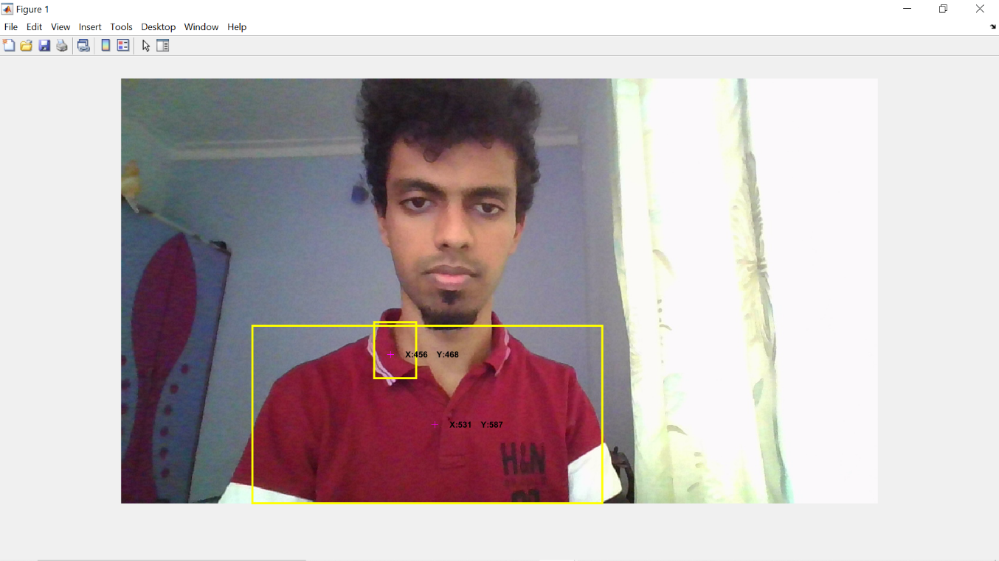

Detecting Blue

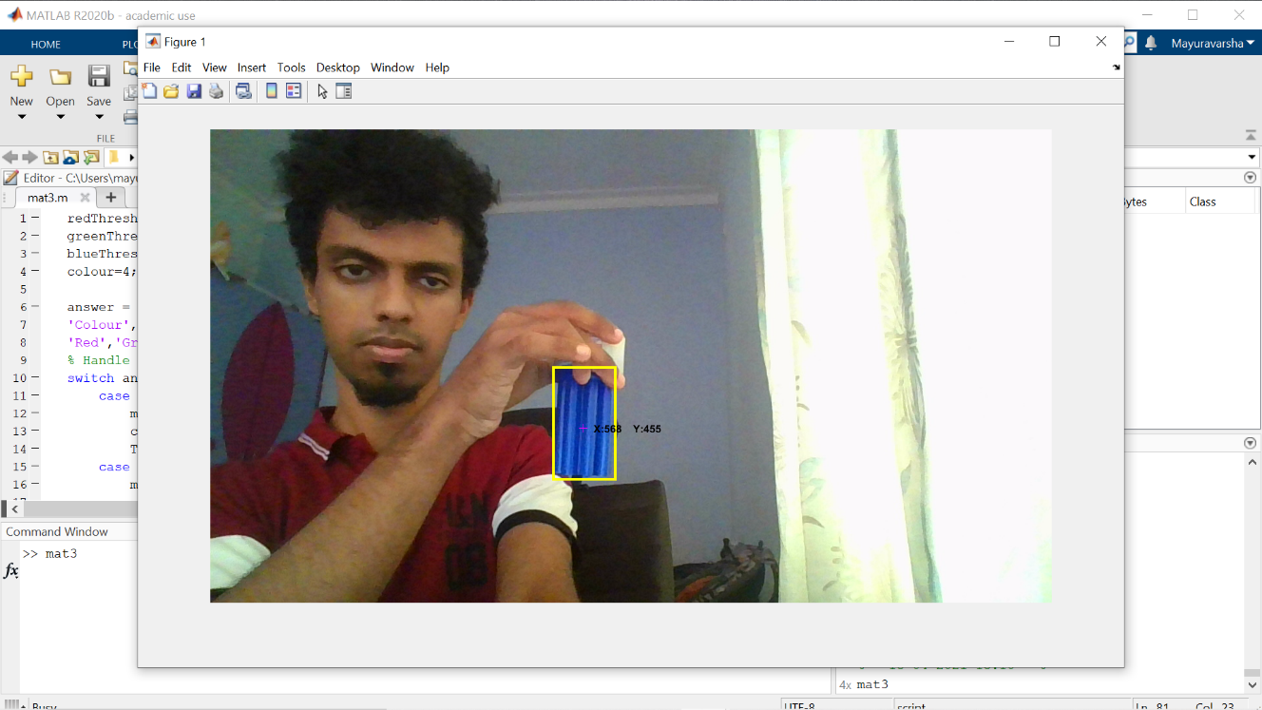

Detecting Green:

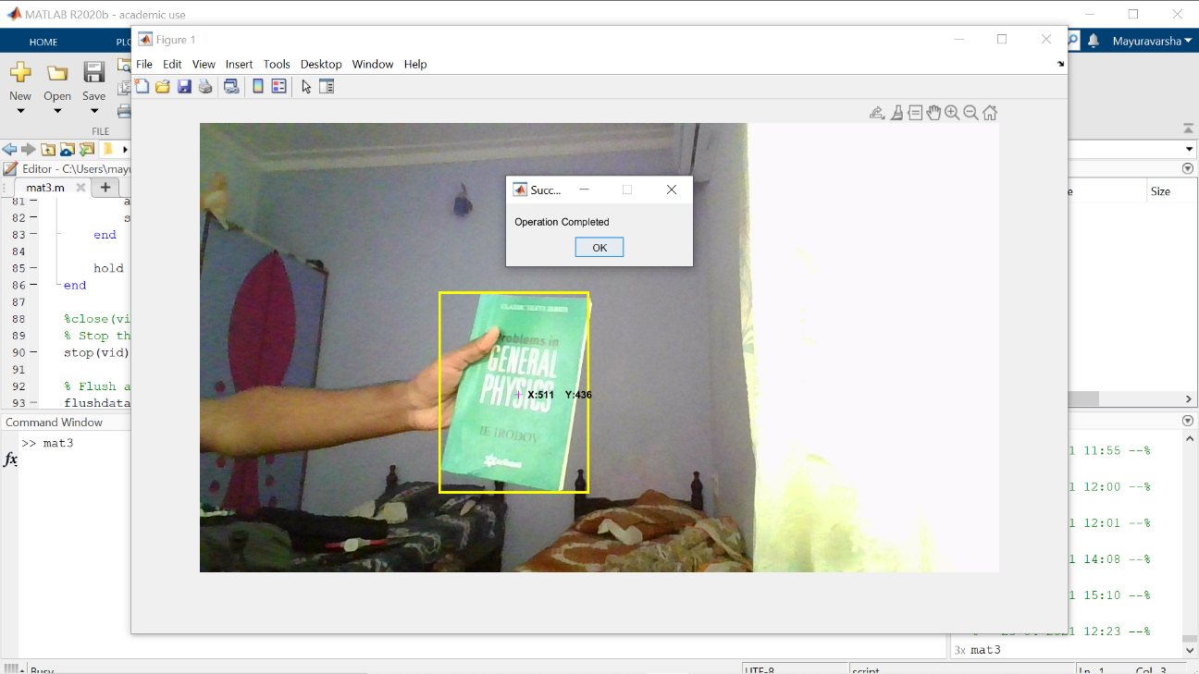

**Name and Signature of the Faculty**

**Revathi GP**