
PES University, Bengaluru

(Established under Karnataka Act 16 of 2013)

Department of Computer Science & Engineering
Session: Jan - May 2022

UE19CS353 – Object Oriented Analysis and Design with Java Theory ISA (Mini Project)

Report on
Memory Based Card Game

By:
Mayuravarsha P –PES2UG19CS225 Tushar Kalaskar – PES1UG19CS543 Vaibhav S – PES1UG19CS555
6th Semester I

- Project Description
In a memory game, a matrix consisting of many smaller boxes will be available, the user’s task will be to win the game by matching patterns on boxes. When the user clicks one box, it should show its pattern – if
the next box clicked on has a similar pattern, both boxes should remain
ﬂipped, and the score should be added. If the second box ﬂipped does not have a similar pattern, both boxes should stop showing their pattern.
There is a lot of scope in doing this, and a lot of possible improvements. For instance, there can be a way of storing the number of moves required as well as a leader board system for hosting folks that have the
best memory possible. Multiple levels like Easy and Hard mode are implemented as well.

- Analysis and Design Models

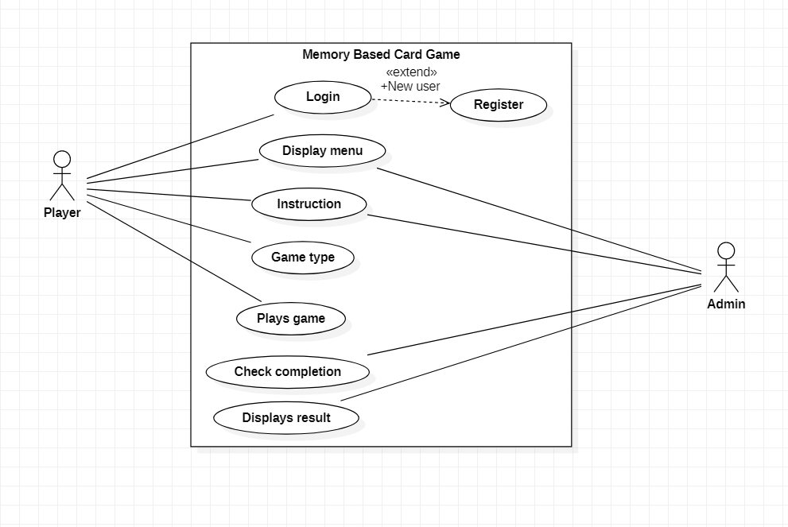
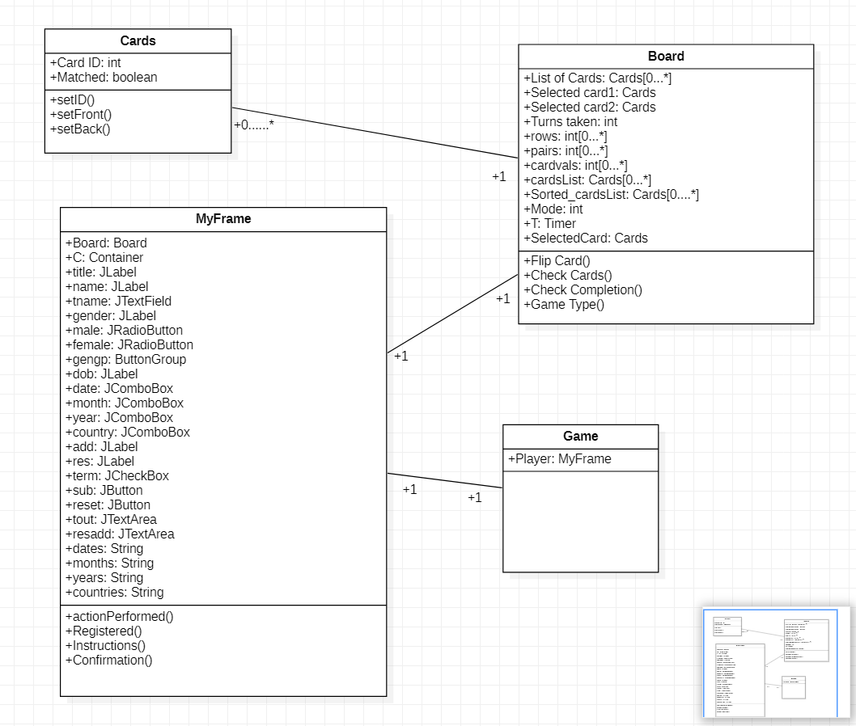
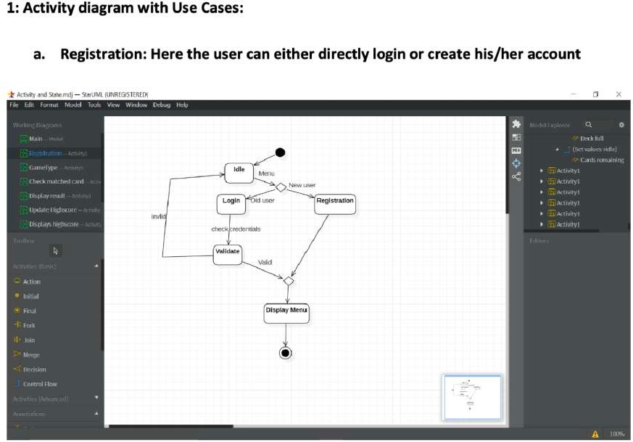

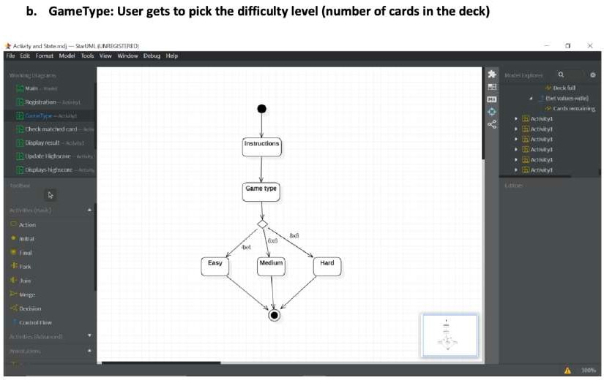

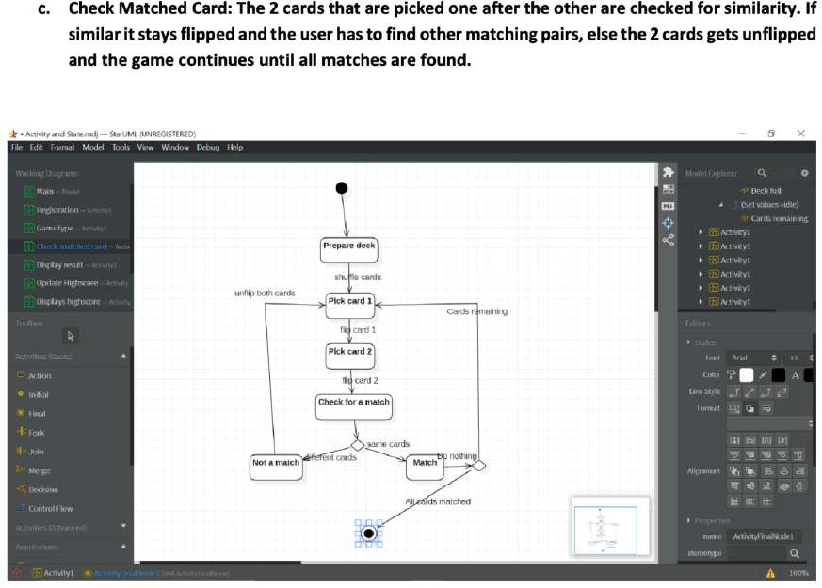

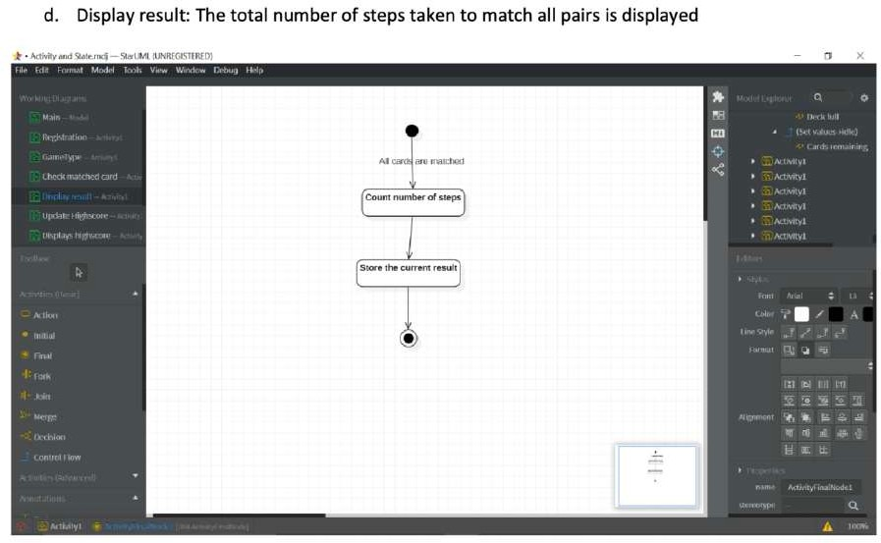

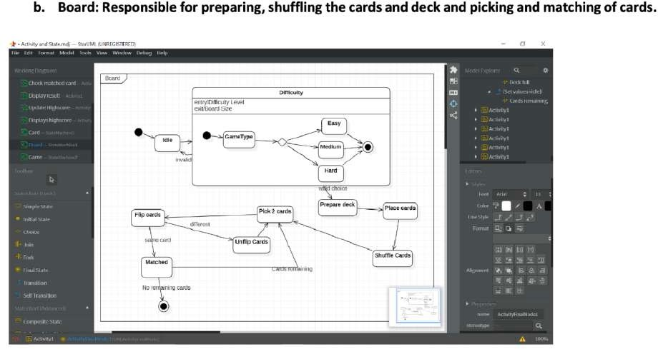

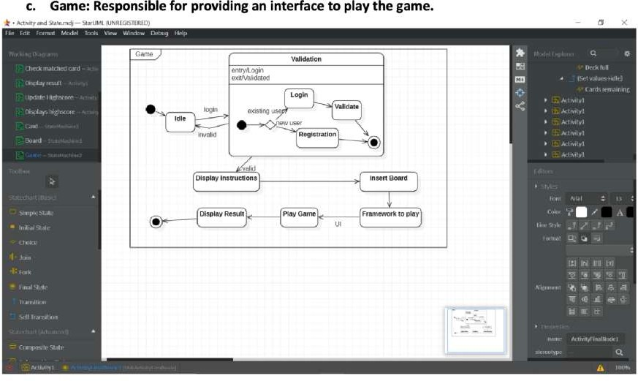

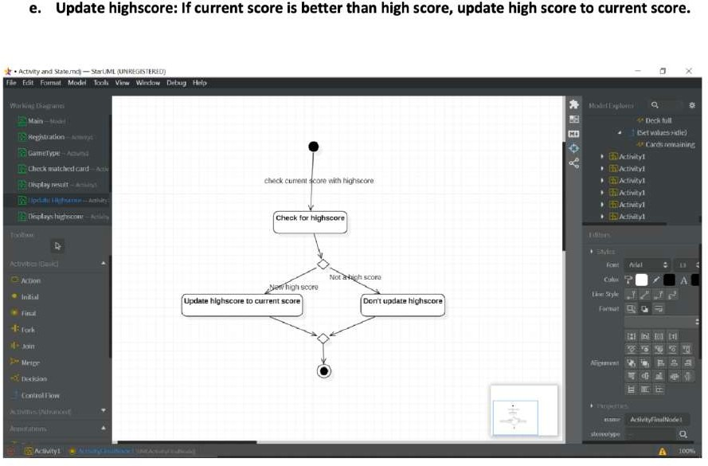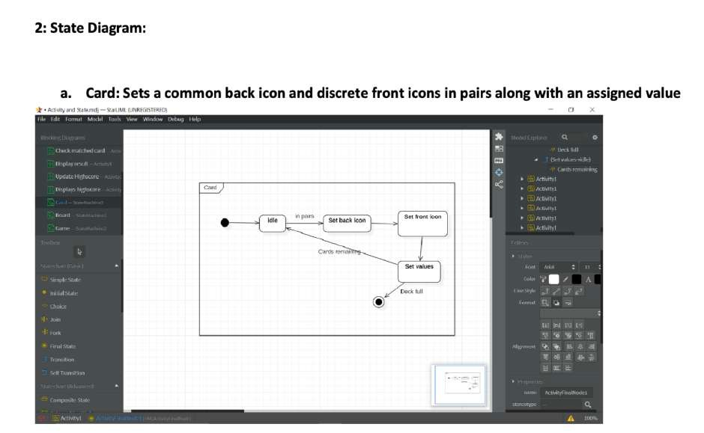

- Tools and Frameworks Used
  - SwingUI
  - Java.util
  - Java.awt
  - MVC
  - vscode

- Design Principles and Design Patterns Applied
- Design Patterns :
  - Singleton : only one instance of the board class is created.
  - Composite: Game class is composed of a hierarchy of classes board and card.

Design Principles :
- Single Responsibility Principle : card class is only responsible for cards on the board.
- Open /Closed Principle: It is open to extension(Multiple levels), Closed for modifications
- Application
- Can be used to enhance memory
- Playing this game can teach you to be a better person.
- It can make you a better problem solver

- Screenshots (3-4 important pages)

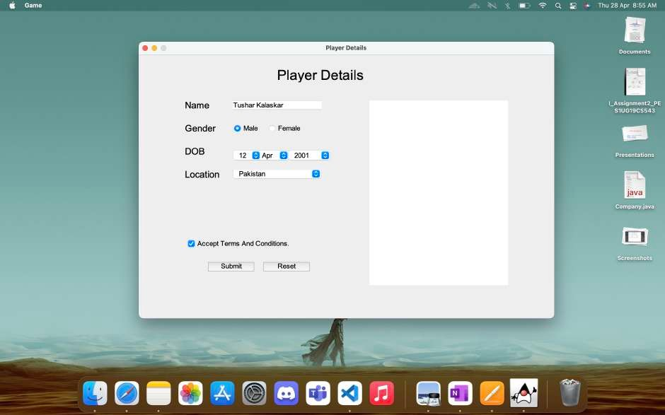

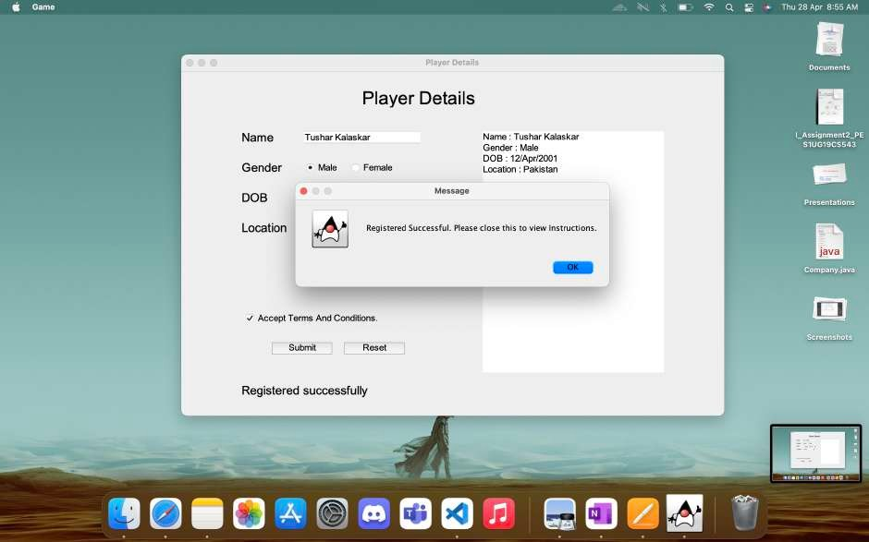

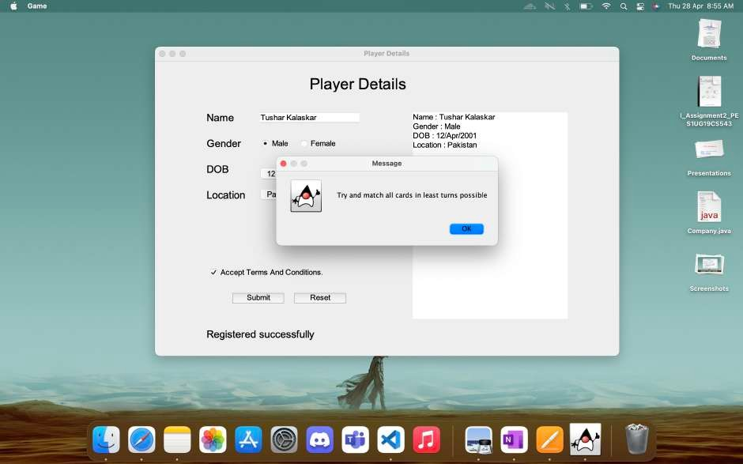



- Team member contributions
<<Table containing contributions of each team member>>

Teammate | Contribution
Mayuravarsha P (PES2UG19CS225) | Creating the board class and UML
Vaibhav S  (PES1UG19CS555) | Creating the board class and UML
Tushar Kalaskar (PES1UG19CS543) | Creating the Player Details class and UML

