Q.1 What is software? What is software engineering?

Ans :- Software is a set of instructions, data or programs used to operate computers and execute specific tasks. It is the opposite of hardware, which describes the physical aspects of a computer.

Software engineering is the process of developing, testing and deploying computer applications to solve real-world problems by adhering to a set of engineering principles and best practices.

Software Engineering is required due to the following reasons:

* To manage Large software
* For more Scalability
* Cost Management
* To manage the dynamic nature of software
* For better quality Management

- The necessity of software engineering appears because of a higher rate of progress in user requirements and the environment on which the program is working.

* *Huge Programming***:**It is simpler to manufacture a wall than to a house or building, similarly, as the measure of programming become extensive engineering has to step to give it a scientific process.
* *Adaptability***:**If the software procedure were not based on scientific and engineering ideas, it would be simpler to re-create new software than to scale an existing one.
* *Cost***:**As the hardware industry has demonstrated its skills and huge manufacturing has let down the cost of computer and electronic hardware. But the cost of programming remains high if the proper process is not adapted.
* *Dynamic Nature***:**The continually growing and adapting nature of programming hugely depends upon the environment in which the client works. If the quality of the software is continually changing, new upgrades need to be done in the existing one.
* *Quality Management***:**  Better procedure of software development provides a better and quality software product.

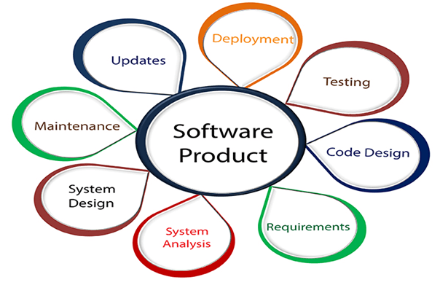

Fig.1

###

Q.2 Explain types of software?

Ans :- Main types of software.

- Application software

- System software

- Driver software

- Middleware software

- Programming software

The two main categories of software are application software and system software. An application is software that fulfils a specific need or performs tasks. System software is designed to run a computer's hardware and provides a platform for applications to run on top of.

**- Application software**

The most common type of software, application software is a computer software package that performs a specific function for a user, or in some cases, for another application. An application can be self-contained, or it can be a group of programs that run the application for the user. Examples of Modern Applications include office suites, graphics software, databases and database management programs, web browsers, word processors, software development tools, image editors and communication platforms. Ex:- Microsoft Office, Paint, PowerPoint etc.

**- System software**

These software programs are designed to run a computer's application programs and hardware. System software coordinates the activities and functions of the hardware and software.It controls the operations of the computer hardware and provides an environment or platform for all the other types of software to work in. The OS is the best example of system software; it manages all the other computer programs. -Other examples of system software include the firmware, computer language translators and system utilities. Ex:- Notepad ,Calculator etc.

**- Driver software**

Also known as device drivers, this software is often considered a type of system software. - Device drivers control the devices and peripherals connected to a computer, enabling them to perform their specific tasks. Every device that is connected to a computer needs at least one device driver to function. Examples include software that comes with any nonstandard hardware, including special game controllers, as well as the software that enables standard hardware, such as USB storage devices, keyboards, headphones and printers. Ex:- Audio Driver, Video Driver etc.

**- Middleware software**

The term middleware describes software that mediates between application and system software or between two different kinds of application software. For example, middleware enables Microsoft Windows to talk to Excel and Word. It is also used to send a remote work request from an application in a computer that has one kind of OS, to an application in a computer with a different OS. It also enables newer applications to work with legacy ones.

Ex:- database middleware, application server middleware.

**- programming software**

Computer programmers use programming software to write code. Programming software and programming tools enable developers to develop, write, test and debug other software programs. - Examples of programming software include assemblers, compilers, debuggers and interpreters.

Ex:- Turbo c, Eclipse, Sublime etc.

###

Q.3 What is SDLC? Explain each phase of SDLC.

A software life cycle model (also termed process model) is a pictorial and diagrammatic representation of the software life cycle. A life cycle model represents all the methods required to make a software product transit through its life cycle stages. It also captures the structure in which these methods are to be undertaken.

In other words, a life cycle model maps the various activities performed on a software product from its inception to retirement. Different life cycle models may plan the necessary development activities to phases in different ways. Thus, no element which life cycle model is followed, the essential activities are contained in all life cycle models though the action may be carried out in distinct orders in different life cycle models. During any life cycle stage, more than one activity may also be carried out.

Explain each phase of SDLC

SDLC Cycle represents the process of developing software. SDLC framework includes the following steps:

1. Planning and Requirement 2. Analysis 3. Designing the software

4. Developing the project 5. Testing 6. Deployment 7. Maintenance

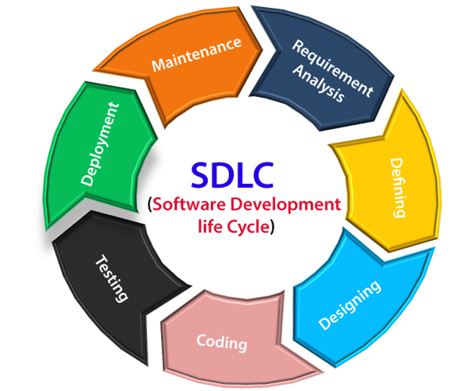

● **Stage1: Planning and requirement analysis**

**\*** Requirement Analysis is the most important and necessary stage in SDLC.

The senior members of the team perform it with inputs from all the stakeholders and domain experts or SMEs in the industry.

Planning for the quality assurance requirements and identifications of the risks associated with the projects is also done at this stage.

Business analyst and Project organizer set up a meeting with the client to gather all the data like what the customer wants to build, who will be the end user, what is the objective of the product. Before creating a product, a core understanding or knowledge of the product is very necessary.

Ex:- A client wants to have an application which concerns money transactions. In this method, the requirement has to be precise like what kind of operations will be done, how it will be done, in which currency it will be done, etc.

**● Stage2: Defining Requirements**

Once the requirement analysis is done, the next stage is to certainly represent and document the software requirements and get them accepted from the project stakeholders.

This is accomplished through "SRS"- Software Requirement Specification document which contains all the product requirements to be constructed and developed during the project life cycle.

● **Stage3: Designing the Software**

The next phase is about to bring down all the knowledge of requirements, analysis, and design of the software project. This phase is the product of the last two, like inputs from the customer and requirement gathering.

● **Stage4: Developing the project**

In this phase of SDLC, the actual development begins, and the programming is built. The implementation of design begins concerning writing code. Developers have to follow the coding guidelines described by their management and programming tools like compilers, interpreters, debuggers, etc. are used to develop and implement the code.

● **Stage5: Testing**

After the code is generated, it is tested against the requirements to make sure that the products are solving the needs addressed and gathered during the requirements stage.

During this stage, unit testing, integration testing, system testing, acceptance testing are done.

**● Stage6: Deployment**

Once the software is certified, and no bugs or errors are stated, then it is deployed.

Then based on the assessment, the software may be released as it is or with suggested enhancement in the object segment.

After the software is deployed, then its maintenance begins.

**● Stage7: Maintenance**

Once when the client starts using the developed systems, then the real issues come up and requirements to be solved from time to time.

This procedure where the care is taken for the developed product is known as maintenance.

###

Q.4 What is DFD? Create a DFD diagram on online shopping.

A data flow diagram (DFD) is a graphical or visual representation using a standardized set of symbols and notations to describe a business's operations through data movement. They are often elements of a formal methodology such as Structured Systems Analysis and Design Method (SSADM).

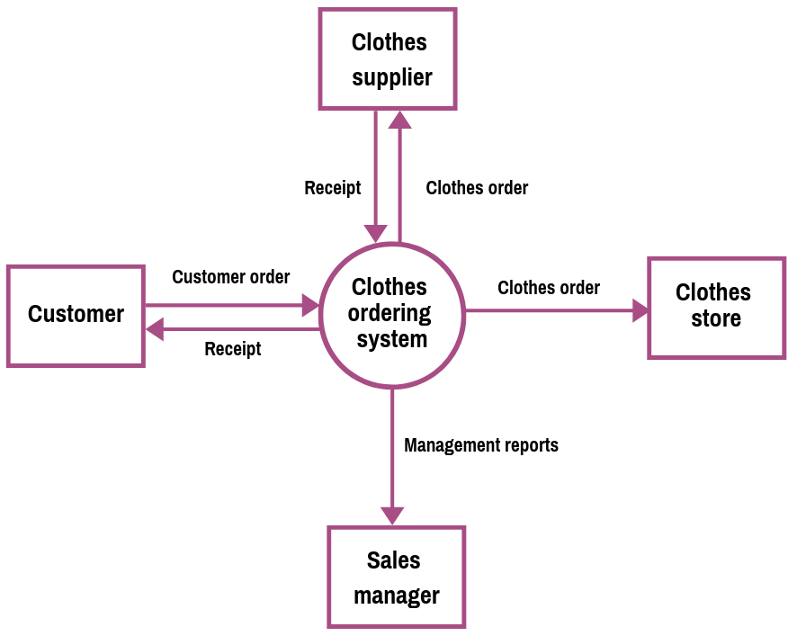

**Online shopping data flow diagram**

###

Q.5 What is Flow chart? Create a flowchart to make addition of two numbers.

Flowcharts are used to design and document simple processes or programs. Like other types of diagrams, they help visualize the process. Two of the many benefits are flaws and [bottlenecks](https://en.wikipedia.org/wiki/Bottleneck_(production)) may become apparent. Flowcharts typically use the following main symbols.

A flowchart is a picture of the separate steps of a process in sequential order. It is a generic tool that can be adapted for a wide variety of purposes, and can be used to describe various processes, such as a manufacturing process, an administrative or service process, or a project plan.

- **Types of flowchart**

* Document flowcharts.
* Data flowcharts.
* System flowcharts.
* Program flowchart.

Ex:-

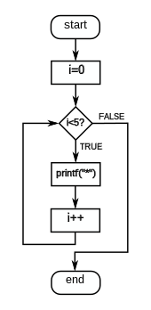

Fig . 1

## COMMONLY USED SYMBOLS IN DETAILED FLOWCHARTS

rectangle - flowchart process step One step in the process. The step is written inside the box. Usually, only one arrow goes out of the box.

arrow - flowchart flow direction  Direction of flow from one step or decision to another.

diamond - flowchart decision step Decision based on a question. The question is written in the diamond. More than one arrow goes out of the diamond, each one showing the direction the process takes for a given answer to the question. (Often the answers are "yes" and "no.")

semi-circle - flowchart delay or wait Delay or wait

circle - flowchart link to another page or flowchart Link to another page or another flowchart. The same symbol on the other page indicates that the flow continues there.

paralellogram - flowchart input or output  Input or output

flowchart document symbol Document

rounded rectangle or oval - flowchart start and end pointsAlternate symbols for start and end points

**\*** Make a flowchart to make addition of two numbers

Ex:-

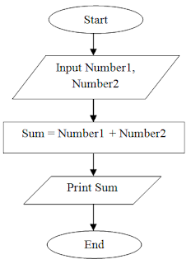

Fig. 2

###

Q.6 What is Use case Diagram? Create a use-case on online food ordering system.

Use-case diagrams describe the high-level functions and scope of a system. These diagrams also identify the interactions between the system and its actors. The use cases and actors in use-case diagrams describe what the system does and how the actors use it, but not how the system operates internally.

● Online food ordering system.

Registration

Login

Navigate menu

Select item

Admin

Add item

Remove item

Review order

Customer

Replace order

Pay for order

Receive for order

Update Menu

Restaurant employee

Receive Confirmation

Check out

fig.1. user case diagram

**Ex. Zomato, swiggy. Etc...**

**####**