Final Architecture Proposal: Physics-Distilled Decomposition Network
After reviewing multiple paradigms--including pure physics reconstruction and advanced signal decomposition--we have finalized a hybrid architecture that integrates the best of both worlds. This approach provides the rigorous physics-enforcement of a PINN, while ensuring fast, real-time inference suitable for embedded deployment on an NXP microcontroller.

1. The Two-Stage 'Knowledge Distillation' Architecture
A pure PINN requires calculating Point-by-Point physics derivatives using PyTorch Autograd. While mathematically perfect, this is far too slow and resource-intensive to run in real-time on an embedded NXP chip. Conversely, standard embedded Neural Networks (like 1D-CNNs) are blazing fast but don't know any physics, making them prone to memorizing noise.
To solve this, we use a Two-Stage 'Teacher-Student' architecture:
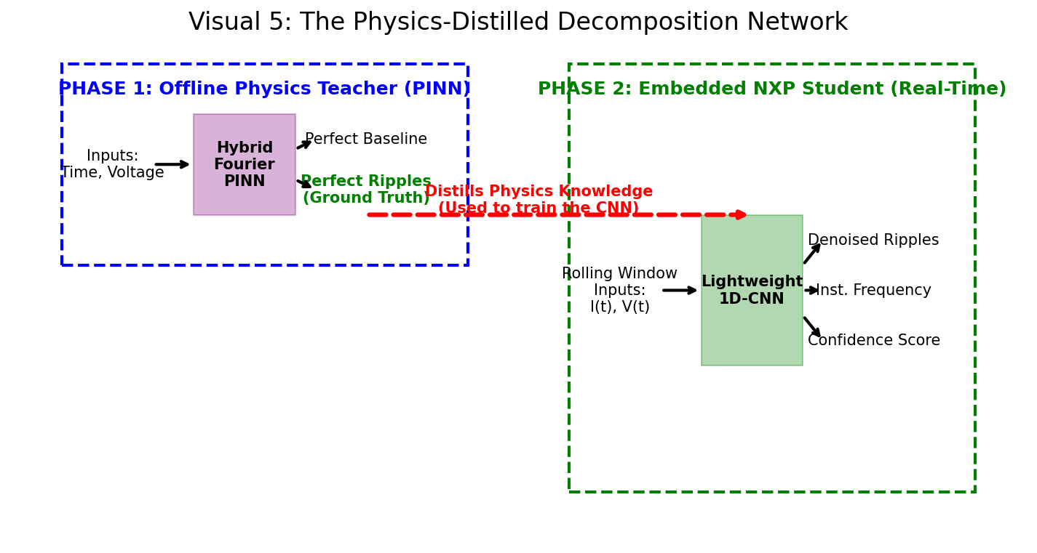

2. Phase 1: The Offline Physics Teacher (The PINN)
Model: Hybrid Fourier PINN (Multi-Layer Perceptron)
Inputs: Timestamp (t), Voltage (V)
Outputs: Baseline Current b(t), Ripples q(t)
How it works:
This model runs entirely offline on powerful lab computers. It takes raw test-bench data and acts as a physics solver. Because it uses Point-by-Point time inputs, it can use Automatic Differentiation (Autograd) to enforce the motor's ODE (V = L(di/dt) + Ri + E). It physically reconstructs the current from scratch, perfectly isolating the commutation ripples.
Purpose: It acts as an automated, self-supervised labeler. It creates perfect 'Ground Truth' ripple data without requiring a human to manually annotate the noise.

3. Phase 2: The Embedded Student (The NXP Deployment)
Model: Lightweight Decomposition Network (1D-CNN)
Inputs: A Rolling Window of Measured Current I(t) and Voltage V(t)
Outputs: Denoised Ripples, Instantaneous Frequency, Confidence Score
Signal Model: i(t) = b(t) + A(t)*q(t) + noise
How it works:
This is the model that actually flashes onto the NXP chip. Because it takes a rolling window of actual measured Current I(t), it operates instantly in real-time. It is explicitly designed to recognize the time-varying amplitude A(t) (since ripples change size under load) and track the varying commutation frequency.
Why it succeeds: Normally, this network would struggle to learn what a 'ripple' is. However, we train this Embedded Student using the perfect Ground Truth data generated by the Offline Teacher PINN. The embedded model essentially 'memorizes' the laws of physics that the PINN taught it, allowing it to run at a fraction of the computational cost while outputting highly reliable, physics-backed ripple counts.

4. Why This is the Ultimate Final Choice
1. Resolves the Input Feature Conflict: By using two stages, we get to use Time (t) to perfectly solve the physics offline, but use a rolling window of actual Current I(t) to do fast decomposition in real-time on the NXP chip.
2. Adds Deployment Metrics: The embedded signal model explicitly outputs Instantaneous Frequency and a Confidence Score. If the NXP chip reports low confidence during a massive transient spike, the system knows to pause counting, drastically improving reliability.
3. No Human Labeling: The entire pipeline remains 100% self-supervised. The PINN generates the labels, and the CNN learns them.

