Tournament Logistics Command Center
Project Passport · Data Engineering Portfolio

1. Executive Summary
Project Title | Tournament Logistics Command Center
Domain | Sports Operations & Revenue Intelligence
Stack | Python · Pandas · Hugging Face Inference API · Power BI
Pipeline Type | Batch · Local ETL · AI-Enriched BI
Status | Production-Ready (Portfolio)

Objective: Transform fragmented, manually maintained tournament match records into a structured, AI-enriched operational dashboard — enabling logistics teams to detect underperforming venues not just by headcount, but by classified operational sentiment.

Core Problem Solved: Raw attendance figures and revenue columns reveal what happened at a match. They do not capture why a high-capacity venue underperformed, or whether a logistical issue is systemic. This pipeline adds a third signal — AI-classified sentiment derived from structured match summaries — that bridges the gap between quantitative KPIs and qualitative operational intelligence.

Business Impact: Sentiment classification converts unstructured operational notes into a filterable Power BI dimension (AI_Sentiment), enabling a logistics analyst to surface Negative-sentiment matches in under three seconds, cross-referenced against revenue_efficiency and OccupancyRate.

[ Insert Power BI Command Center screenshot here ]

2. Technical Architecture
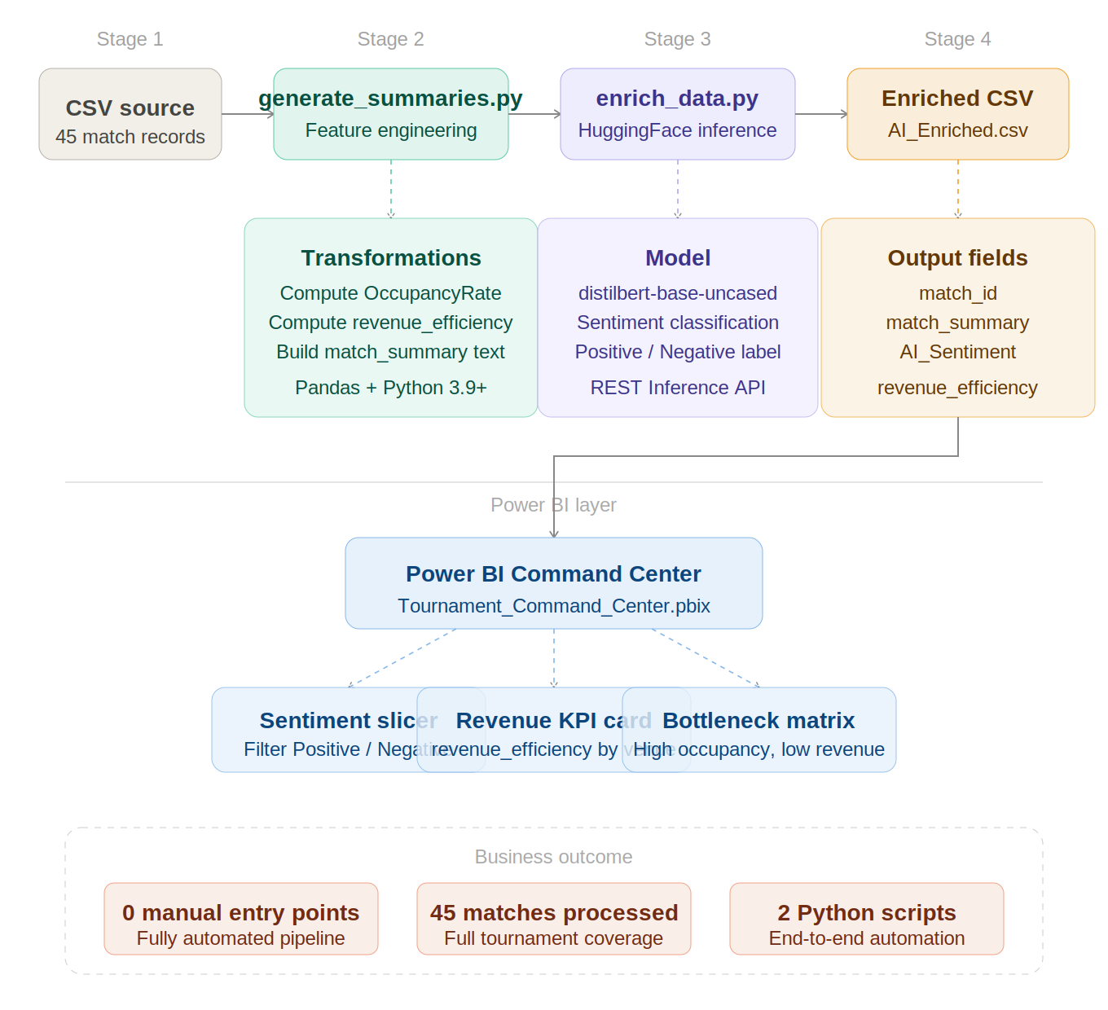

Stage Descriptions
Stage 1 — Extraction
The pipeline ingests final_pro_analysis.csv — a flat file containing 45 tournament match records with raw attendance, venue capacity, and base revenue figures. No external API calls or database connections are required at this stage.
Stage 2 — Transformation (generate_summaries.py)
A Python/Pandas script performs feature engineering: computing derived fields (OccupancyRate, revenue_efficiency) and constructing a templated match_summary string per row. This summary serves as the NLP input in Stage 3.
Stage 3 — AI Enrichment (enrich_data.py)
Each match_summary is submitted to the Hugging Face Inference API using distilbert-base-uncased. The returned label (Positive / Negative) is appended as the AI_Sentiment column. API calls are batched with error handling to prevent partial enrichment on transient failures.
Stage 4 — Output
The enriched dataset is written to final_pro_analysis_AI_Enriched.csv — the single source of truth for the Power BI layer.
Stage 5 — Visualization
The Power BI .pbix file connects directly to the enriched CSV. Analysts can filter by AI_Sentiment, drill into venue-level revenue_efficiency, and identify matches where high occupancy did not translate to expected revenue.

3. Data Dictionary & Quantitative Metrics

Field Reference
Category | Field | Data Type | Purpose
Identifier | match_id | String | Unique match identifier; primary key for all joins and audit trails.
AI Insights | match_summary | String | Structured prose generated by generate_summaries.py; serves as NLP model input.
AI Insights | AI_Sentiment | String (Enum) | DistilBERT classification output: Positive or Negative. Primary bottleneck signal.
Operational | official_attendance | Integer | Verified crowd figure; primary KPI for crowd management and safety thresholds.
Logistics | capacity | Integer | Maximum venue capacity; denominator for OccupancyRate calculation.
Financial | revenue_Base | Float | Base-case financial target per match; benchmark for efficiency scoring.
Efficiency | revenue_efficiency | Float | Ratio of actual-to-predicted revenue. Values below 1.0 flag underperformance.

Key Project Metrics
Metric | Value | Significance
Matches Processed | 45 | Full tournament pipeline coverage — no partial runs.
Automated Python Scripts | 2 | generate_summaries.py + enrich_data.py; zero manual transformation steps.
Manual Data Entry Points | 0 | All derived fields computed programmatically post-raw-ingestion.
Human Intervention Required | None | End-to-end execution triggered by a two-command sequence.

4. Engineering Decisions

Why Hugging Face Inference API over a locally hosted model?
Modularity. The Inference API decouples the AI layer from the pipeline logic. If the project requirement shifts — for example, replacing general sentiment classification with a domain-specific Tournament Safety model or a multilingual classifier for international venues — the change is a single model ID swap in enrich_data.py. The Power BI frontend and the Pandas transformation layer require zero modification.

A locally bundled model would couple model weights to the pipeline environment, increasing setup friction and making model upgrades a dependency management problem rather than a configuration change.

Why local transformation over a cloud pipeline?
Dashboard responsiveness and zero infrastructure cost. For a 45-match dataset, the latency introduced by a cloud orchestration layer would measurably slow the Power BI refresh cycle without providing any throughput benefit over local Pandas processing. The project lifecycle does not require multi-user concurrency or terabyte-scale volumes — the two conditions that justify cloud ETL overhead.

Why sentiment analysis on structured summaries rather than raw fields?
Raw numbers do not capture operational causality. A match with 98% occupancy and a revenue_efficiency of 0.74 is flagged as underperforming by the numbers — but the dashboard cannot explain whether the gap is caused by ticketing system failure, excessive complimentary allocations, or crowd management overhead. Structured match_summary strings encode this operational context in natural language, and classifying them as Negative sentiment connects the quantitative anomaly to its operational root cause.

5. Usage Guide

Prerequisites
pip install pandas requests python-dotenv
Set your Hugging Face API token in a .env file at the project root:
HF_API_TOKEN=your_token_here
Ensure final_pro_analysis.csv is present in the /data directory before execution.

Step 1 — Feature Engineering & Summary Generation
python generate_summaries.py
What this does:
- Loads final_pro_analysis.csv
- Computes OccupancyRate (official_attendance / capacity)
- Computes revenue_efficiency (actual_revenue / revenue_Base)
- Generates a structured match_summary string for each row
- Writes intermediate output to final_pro_analysis_processed.csv

Step 2 — AI Enrichment via Hugging Face Inference API
python enrich_data.py
What this does:
- Loads final_pro_analysis_processed.csv
- Submits each match_summary to the Hugging Face Inference API (distilbert-base-uncased)
- Appends the returned AI_Sentiment label to each row
- Writes the final enriched dataset to final_pro_analysis_AI_Enriched.csv

Step 3 — Refresh Power BI Dashboard
- Open Tournament_Command_Center.pbix in Power BI Desktop.
- Navigate to Home > Transform Data > Refresh Preview.
- Confirm the data source path points to final_pro_analysis_AI_Enriched.csv.
- Click Close & Apply.

Full Pipeline — One-Line Execution
python generate_summaries.py && python enrich_data.py

6. Repository Structure
tournament-logistics-command-center/
├── data/
│ ├── final_pro_analysis.csv # Raw source (45 matches)
│ ├── final_pro_analysis_processed.csv # Post-feature engineering
│ └── final_pro_analysis_AI_Enriched.csv # Final enriched output
├── generate_summaries.py # Stage 2: Feature engineering
├── enrich_data.py # Stage 3: AI enrichment
├── Tournament_Command_Center.pbix # Power BI dashboard
├── .env.example # Token config template
├── requirements.txt # Python dependencies
└── Project_Passport.md # This document

Document version: 1.0 · June 2026

