Topics: Descriptive Statistics and Probability

- Look at the data given below. Plot the data, find the outliers and find out $μ, σ, σ^{2}$

Name of company | Measure X
Allied Signal | 24.23%
Bankers Trust | 25.53%
General Mills | 25.41%
ITT Industries | 24.14%
J.P.Morgan & Co. | 29.62%
Lehman Brothers | 28.25%
Marriott | 25.81%
MCI | 24.39%
Merrill Lynch | 40.26%
Microsoft | 32.95%
Morgan Stanley | 91.36%
Sun Microsystems | 25.99%
Travelers | 39.42%
US Airways | 26.71%
Warner-Lambert | 35.00%

Answer:-

µ = 0.309766
$σ$ = 0.0268
$σ^{2}$ = 0.163708

Outlier is Morgan Stalnley of measure 91.36%

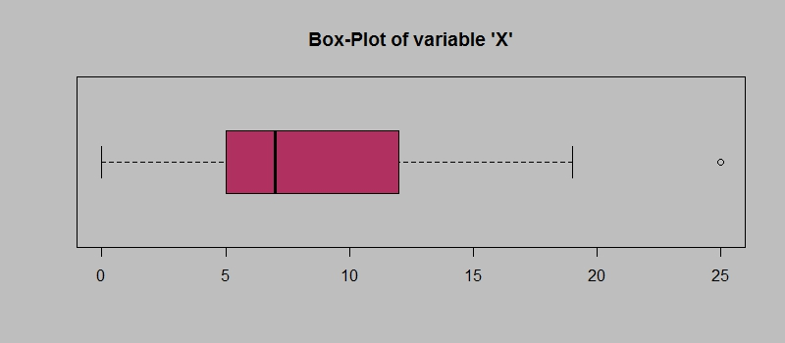
Answer the following three questions based on the box-plot above.
- What is inter-quartile range of this dataset? (please approximate the numbers) In one line, explain what this value implies.
Answer:-

IQR = 12-5
= 7
This represents the range which contains 50% of the data points.

- What can we say about the skewness of this dataset?
Answer:-
It is Right skewed Known as positive skewness

- If it was found that the data point with the value 25 is actually 2.5, how would the new box-plot be affected?
Answer:-
In acutal data 25 is represent as Outliet if this data is represnt as 2.5 then it will not considered an outlier.

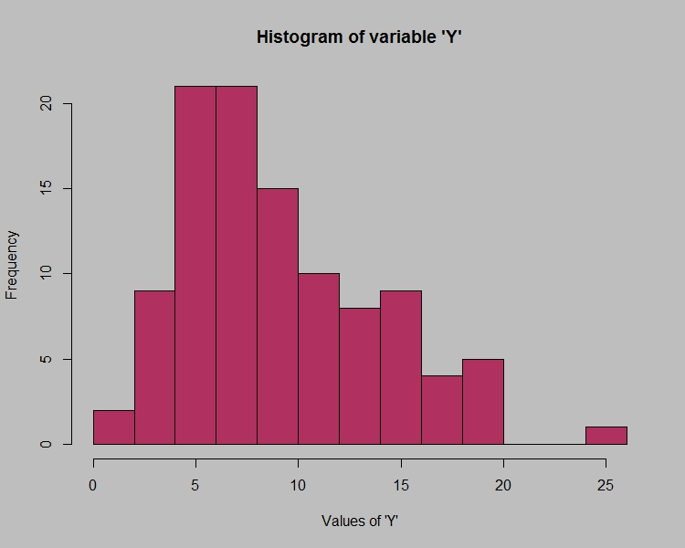

Answer the following three questions based on the histogram above.
- Where would the mode of this dataset lie?

Answer:-
Mode Lie in between 4 and 8 Value as frequency 20 .

- Comment on the skewness of the dataset.

Answer:-
Dataset is right skewed also known as positive skewness

- Suppose that the above histogram and the box-plot in question 2 are plotted for the same dataset. Explain how these graphs complement each other in providing information about any dataset.

Answer:-
There Outlier showing as 25, Box Plot and histogram showing Posistive Skewness ,Minimum value is 0 and maximum is 20.

- AT&T was running commercials in 1990 aimed at luring back customers who had switched to one of the other long-distance phone service providers. One such commercial shows a businessman trying to reach Phoenix and mistakenly getting Fiji, where a half-naked native on a beach responds incomprehensibly in Polynesian. When asked about this advertisement, AT&T admitted that the portrayed incident did not actually take place but added that this was an enactment of something that “could happen.” Suppose that one in 200 long-distance telephone calls is misdirected. What is the probability that at least one in five attempted telephone calls reaches the wrong number? (Assume independence of attempts.)
Answer:-

let us consider the probability of 1 call misdirected out of 200 as event A.
Probability of occurring of event A= 1/200
P(A)= 1/200

Probability of having at least one successful call will be
1-P(A)= 1-1/200
= 199/200
= 0.967

As every event is independent of other event the probability will be
1- (0.967)^5
0.02475 = 2% chance.

- Returns on a certain business venture, to the nearest $1,000, are known to follow the following probability distribution
x | P(x)
-2,000 | 0.1
-1,000 | 0.1
0 | 0.2
1000 | 0.2
2000 | 0.3
3000 | 0.1

- What is the most likely monetary outcome of the business venture?
Answer:-
The most likely monetary outcome of the business venture is P(x) = 0.3 for x(2000). So the outcome is 2000
- Is the venture likely to be successful? Explain
Answer:-
P(x>0) = 0.6
There is a 60% chance that the venture would yield profits or greater than expected returns. P(Incurring losses) is only 0.2. So the venture is likely to be successful.

- What is the long-term average earning of business ventures of this kind? Explain
Answer:-
Weighted average = x*P(x)
= 800
This means the average expected earnings over a long period of time would be 800 (including all losses and gains over the period of time)

- What is the good measure of the risk involved in a venture of this kind? Compute this measure

Answer:-

P(loss) = P(x= -2000)+P(x=-1000)
=0.2.
The risk associated with this venture is 20%.

