Activity | Data Type
Number of beatings from Wife | Discrete
Results of rolling a dice | Discrete
Weight of a person | Continuous
Weight of Gold | Continuous
Distance between two places | Continuous
Length of a leaf | Continuous
Dog's weight | Continuous
Blue Color | Discrete
Number of kids | Discrete
Number of tickets in Indian railways | Discrete
Number of times married | Discrete
Gender (Male or Female) | Discrete
Q1) Identify the Data type for the Following:

Q2) Identify the Data types, which were among the following
Nominal, Ordinal, Interval, Ratio.
Data | Data Type
Gender | Nominal
High School Class Ranking | Ordinal
Celsius Temperature | Interval
Weight | Ratio Scale
Hair Color | Nominal
Socioeconomic Status | Ratio
Fahrenheit Temperature | Interval
Height | Ratio
Type of living accommodation | Ordinal
Level of Agreement | Ratio
IQ(Intelligence Scale) | Interval
Sales Figures | Ratio
Blood Group | Nominal
Time Of Day | Interval
Time on a Clock with Hands | Interval
Number of Children | Nominal
Religious Preference | Nominal
Barometer Pressure | Interval
SAT Scores | Ratio
Years of Education | Ratio

Q3) Three Coins are tossed, find the probability that two heads and one tail are obtained?
Answer:-
→3/8
→HHT,HTH,THH

Q4) Two Dice are rolled, find the probability that sum is
- Equal to 1
- Less than or equal to 4
- Sum is divisible by 2 and 3

Answer:-

- There is no any possibility which sum is equal to one. Because they start with(1,1)

- (1,1),(1,2),(1,3),(2,1) ,(2,2) (3,1) = 6 outcomes, 6/36

- (1,1),(1,2),(1,3),(1,5),
(2,1),(2,2),(2,4),(2,6),
(3,1),(3,3),(3,5),(3,6),
(4,2),(4,4),(4,5),(4,6),
(5,1),(5,3),(5,4),(5,5),
(6,2),(6,3),(6,4),(6,6)

= 24/36
=2/3
Q5) A bag contains 2 red, 3 green and 2 blue balls. Two balls are drawn at random. What is the probability that none of the balls drawn is blue?

Answer:-

Total Case = 7! / 2!5!
=42/2
=21

Favourable Case = 5! / 2!3!
= 20/2
= 10
P = 10/21

Q6) Calculate the Expected number of candies for a randomly selected child
Below are the probabilities of count of candies for children (ignoring the nature of the child-Generalized view)
CHILD | Candies count | Probability
A | 1 | 0.015
B | 4 | 0.20
C | 3 | 0.65
D | 5 | 0.005
E | 6 | 0.01
F | 2 | 0.120
Child A – probability of having 1 candy = 0.015.
Child B – probability of having 4 candies = 0.20

Answer:-

Expected number of candies for randomly selected child
= (1*0.015)+ ( 4*0.20)+ (3*0.65)+ (5*0.005)+ (6*0.01) +(2*0.120)
=3.09

Q7) Calculate Mean, Median, Mode, Variance, Standard Deviation, Range & comment about the values / draw inferences, for the given dataset
- For Points,Score,Weigh>
Find Mean, Median, Mode, Variance, Standard Deviation, and Range and also Comment about the values/ Draw some inferences.S
Use Q7.csv file
Answer:
Points: -
Mean =3.558,
Median= 3.695,
Mode= “3.92”,
Variance= 0.2858
Standard deviation= 0.526.
Range = 2.17

Score:-
Mean= 3.07,
Median= 3.325,
Mode= “3.44”,
Variance= 0.957
Sandard deviation= 0.963
Range = 3.911

Weight: Mean= 17.763,
Median= 17.71,
Mode= “17.02”,
Variance= 3.193
Standard deviation= 1.758
Range = 8.4

Q8) Calculate Expected Value for the problem below
- The weights (X) of patients at a clinic (in pounds), are
108, 110, 123, 134, 135, 145, 167, 187, 199
Assume one of the patients is chosen at random. What is the Expected Value of the Weight of that patient?

Answer:
There are nine patient we choose one of the patient at random
Probability =1/9

The expected value of the weight of that patient =
Expected value = ∑ ( probability * Value )
=(1/9) ( 108 + 110 + 123 + 134 + 135 + 145 + 167 + 187 + 199)
= 145.333

Q9) Calculate Skewness, Kurtosis & draw inferences on the following data
Cars speed and distance
Use Q9_a.csv
Answer:-

Skewness for speed= -0.117,
The Skewnesss of Car speed is negative that’s why the left tail is longer
Skewness for distance= 0.806,
The Skewnes of Car distance is positive that’s why the right tail is longer

Kurtosis for speed = -0.508
Kurtosis for distance = 0.405

SP and Weight(WT)
Use Q9_b.csv
Answer:-
Skewness for SP= 1.611,
The Skewnes of Car distance is positive that’s why the right tail is longer

Skewness for WT= -0.614 ,
The Skewnesss of Weight is negative that’s why the left tail is longer

Kurtosis for SP = 2.977
Kurtosis for WT = 0.950
Q10) Draw inferences about the following boxplot & histogram

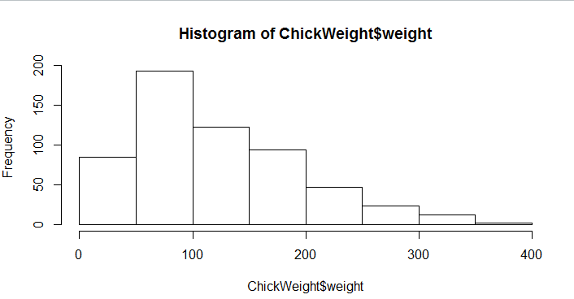

Answer:-
Maximum Weight in between 50-100 with frequency 200.
And least weight between 400 somewere around 0-10.
So the expected value the above distribution is 75.
The long tail towards right so it is right skewed It is positive skewness

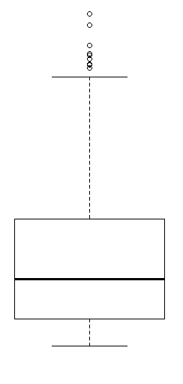

Answer:-
There is Outliers is showing far upper in box plot and Q1 Line is Showing 25% and Q3 is showing 75%

Q11) Suppose we want to estimate the average weight of an adult male in Mexico. We draw a random sample of 2,000 men from a population of 3,000,000 men and weigh them. We find that the average person in our sample weighs 200 pounds, and the standard deviation of the sample is 30 pounds. Calculate 94%,98%,96% confidence interval?
Answer:-
N=2000
S=30
X=2000

Confidence Interval 94% = (198.738325292158, 201.261674707842)

Confidence Interval 98% = (198.43943840429978, 201.56056159570022)

Confidence Interval 96% = (198.62230334813333, 201.37769665186667)

Q12) Below are the scores obtained by a student in tests
34,36,36,38,38,39,39,40,40,41,41,41,41,42,42,45,49,56
- Find mean, median, variance, standard deviation.

Answer:-
Mean | Median | Variance | Std Dev
41.168 | 41 | 22.477 | 4.741

- What can we say about the student marks?

Answer:-
Most of the student achieved 41 score, the lowest score is 34 and highest score is 56.

Q13) What is the nature of skewness when mean, median of data are equal?
Answer:-
The nature of skewness when mean, median of data are equal is Symmetric.

Q14) What is the nature of skewness when mean > median ?
Answer:-
The nature of skewness when mean > median Right skewed

Q15) What is the nature of skewness when median > mean?
Answer:-
The nature of skewness when median > mean Left Skewed.

Q16) What does positive kurtosis value indicates for a data ?
Answer:-
Positive kurtosis value indicates the data is notmally distributed and kurtosis value is 0.
Q17) What does negative kurtosis value indicates for a data?
Answer:-
The negative kurtosis value indicates the distribution is flat and has thin tails.

Q18) Answer the below questions using the below boxplot visualization.
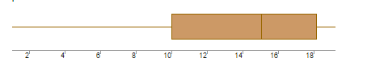
What can we say about the distribution of the data?
Answer:-

The BoxPlot is Showing the half of the the value is more than 10 and the median is 15, the Q1 is 10 and Q3 is 18.

What is nature of skewness of the data?
Answer:-
The medium is higher than mean so nature of skewness of the data left skewed.

What will be the IQR of the data (approximately)?
Answer:-
The IQR of the data = -8

Q19) Comment on the below Boxplot visualizations?
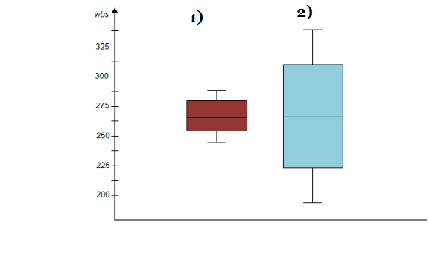
Draw an Inference from the distribution of data for Boxplot 1 with respect Boxplot 2.
Answer: -
Whisker length is high in boxplot 2 as compare to boxplot 1 and mean and median are equal hence distribution is symetrical.

Q 20) Calculate probability from the given dataset for the below cases

Data _set: Cars.csv
Calculate the probability of MPG of Cars for the below cases.
MPG <- Cars$MPG
  - P(MPG>38)
  - P(MPG<40)
  - P (20<MPG<50)
Answer:-
- P(MPG>38) = 0.3475939
- P(MPG<40) = 0.7293499
- P (20<MPG<50) = -0.8988689

Q 21) Check whether the data follows normal distribution
- Check whether the MPG of Cars follows Normal Distribution
Dataset: Cars.csv

- Check Whether the Adipose Tissue (AT) and Waist Circumference(Waist) from wc-at data set follows Normal Distribution
Dataset: wc-at.csv

Q 22) Calculate the Z scores of 90% confidence interval,94% confidence interval, 60% confidence interval
→
90% confidence interval =1.65
94% confidence interval = 1.55
60% confidence interval = 0.85

Q 23) Calculate the t scores of 95% confidence interval, 96% confidence interval, 99% confidence interval for sample size of 25

95% confidence interval = 1.96
96% confidence interval = 2.5
99% confidence interval = 2.47

Q 24) A Government company claims that an average light bulb lasts 270 days. A researcher randomly selects 18 bulbs for testing. The sampled bulbs last an average of 260 days, with a standard deviation of 90 days. If the CEO's claim were true, what is the probability that 18 randomly selected bulbs would have an average life of no more than 260 days
Hint:
rcode pt(tscore,df)
df degrees of freedom

Answer:-
CEO's claim that the sampled bulbs last an average of 260 days.
The probability that 18 randomly selected bulbs would have an average life of no more than 260 days

t = (260-270)/(90/sqrt(18))
= -0.471
Df = n-1
= 18-1
= 17
pt(-abs(t), df = 17)
P=0.321
Here P(0.321)>alpha(0.05), that’s why 32% probability that 18 randomly selected bulbs would have an average life of no more than 260 days.
CEO’s claims are false.

