DBMS PROJECT REPORT:

- TITLE: ‘Book My Ticket’

- ABSTRACT: Our project basically manages the ticket booking process of a
multiplex, providing an interface to the user to book movie tickets in
a more easy way. At the front end we have used JSwing and at the
back end My SQL server. The project proceeds through a sequence
of well-designed forms provided with validations to ensure
consistency, reliability and most importantly correctness of
information fed into the database.

- INTRODUCTION:
Through this project we present a comprehensive solution for ticket booking in
multiplexes. Theatre management system, an online ticket selling software that is
easy to understand, easy to use and offers the simplicity of fast point-and-click
service to the customers.
This powerful software program is specifically designed for theater owners,
to sell tickets online. This intuitive visual interface makes day-to-day aspects of
selling, exchanging, refunding, and reporting fast and easy for both the user and
administrators. Theatre management controls all back-end functionalities like,
movie details, ticket rate and show time, customer information and sales history
saved in a database, etc. Theatre admin manages the report details like counter
wise report, daily, weekly, monthly report and movie report etc.

- SCOPE : This project can be used to book tickets of a movie currently running in theatres. It provides flexibility to the user to select theatres, city and movie time of his choice.
Cinema-going is one of the most popular out-of-home cultural activities, affecting
a serious of social, economic and cultural phenomena in modern societies.
Cinemas are considered to be an integral part of cities and they contribute to the
definition of a local geography and identity. They also contribute to the
preservation of the collective memory, since they constitute a significant social
and cultural practice linked to a specific place, which acts as a common
reference or landmark for many individuals.

- SW/HW REQUIREMENTS:
    - Eclipse IDE
    - Java Compiler
    - Intel Processor i3
    - A RAM size of 1gb is used as it will provide fast reading & writing
capabilities.

User Module:
- User Registration
- User Register with Name, A Username (for logging in later), Password,
- Phone Number, E-mail address.
- User Login
- User Can Book the Ticket After Log in.
- User Login with User Name and Password.
- Forgot Password use for Retrieve Password.
- Check Availability
- After Login, User, Can Search Movie from Movie List.
- User Can Check Ticket Availability.
- User can also check the Movie Running Hours.
- If Ticket is Available User Can Book Ticket.
- Book Ticket.
- User can book ticket by specifying username and Phone Number.
- Then Select Number of Seats to Book.

Admin Control:
- Admin User Login.
- Admin User Login with Admin User Name and Password.
- Show Manage.
- Admin Can Change Show Name and Show Time.
- Movie Manage.
- Admin Can Add New Movie.
- Admin Can Edit Old Movie Details.
- Admin Can Delete Movie.
- Schedule Manage.
- Admin Can Add New Movie Schedule.
- Admin Can Edit Movie Schedule.
- Admin Can Delete Movie Schedule.

- Database Schema:

TABLE customer
+------------+-------------+------+-----+---------+-------+
| Field | Type | Null | Key | Default | Extra |
+------------+-------------+------+-----+---------+-------+
| username | varchar(20) | NO | PRI | NULL | |
| password | varchar(15) | YES | | NULL | |
| email_id | varchar(30) | YES | | NULL | |
| contact_no | varchar(10) | YES | | NULL | |
+------------+-------------+------+-----+---------+-------+

TABLE movie;
+--------------+-------------+------+-----+---------+-------+
| Field | Type | Null | Key | Default | Extra |
+--------------+-------------+------+-----+---------+-------+
| movie | varchar(20) | NO | PRI | NULL | |
| review | text | YES | | NULL | |
| release_date | date | YES | | NULL | |
+--------------+-------------+------+-----+---------+-------+

TABLE theatre;
+--------------+-------------+------+-----+---------+-------+
| Field | Type | Null | Key | Default | Extra |
+--------------+-------------+------+-----+---------+-------+
| theatre_id | varchar(10) | NO | PRI | NULL | |
| theatre_name | varchar(30) | YES | | NULL | |
| city | varchar(20) | YES | | NULL | |
| price_per_t | int(11) | YES | | NULL | |
+--------------+-------------+------+-----+---------+-------+

TABLE seats_booked;
+---------+-------------+------+-----+---------+-------+
| Field | Type | Null | Key | Default | Extra |
+---------+-------------+------+-----+---------+-------+
| show_id | varchar(20) | YES | MUL | NULL | |
| row | int(11) | YES | | NULL | |
| columns | int(11) | YES | | NULL | |
+---------+-------------+------+-----+---------+-------+

TABLE payment;
+--------------+-------------+------+-----+---------+-------+
| Field | Type | Null | Key | Default | Extra |
+--------------+-------------+------+-----+---------+-------+
| payment_id | varchar(20) | NO | PRI | NULL | |
| username | varchar(20) | YES | MUL | NULL | |
| price | int(11) | YES | | NULL | |
| payment_type | varchar(20) | YES | | NULL | |
+--------------+-------------+------+-----+---------+-------+

TABLE shows;
+--------------+-------------+------+-----+---------+-------+
| Field | Type | Null | Key | Default | Extra |
+--------------+-------------+------+-----+---------+-------+
| show_id | varchar(20) | NO | PRI | NULL | |
| theatre_id | varchar(10) | YES | MUL | NULL | |
| start_time | int(11) | YES | | NULL | |
| end_time | int(11) | YES | | NULL | |
| language | varchar(20) | YES | | NULL | |
| date_of_show | date | YES | | NULL | |
+--------------+-------------+------+-----+---------+-------+

TABLE movie_show;
+------------+-------------+------+-----+---------+-------+
| Field | Type | Null | Key | Default | Extra |
+------------+-------------+------+-----+---------+-------+
| show_id | varchar(20) | YES | MUL | NULL | |
| movie_name | varchar(20) | YES | MUL | NULL | |
+------------+-------------+------+-----+---------+-------+

- Database Normalisation:
      - 1 NF: Each table cell contains a single value. Each record is unique.

- ER- Diagram:

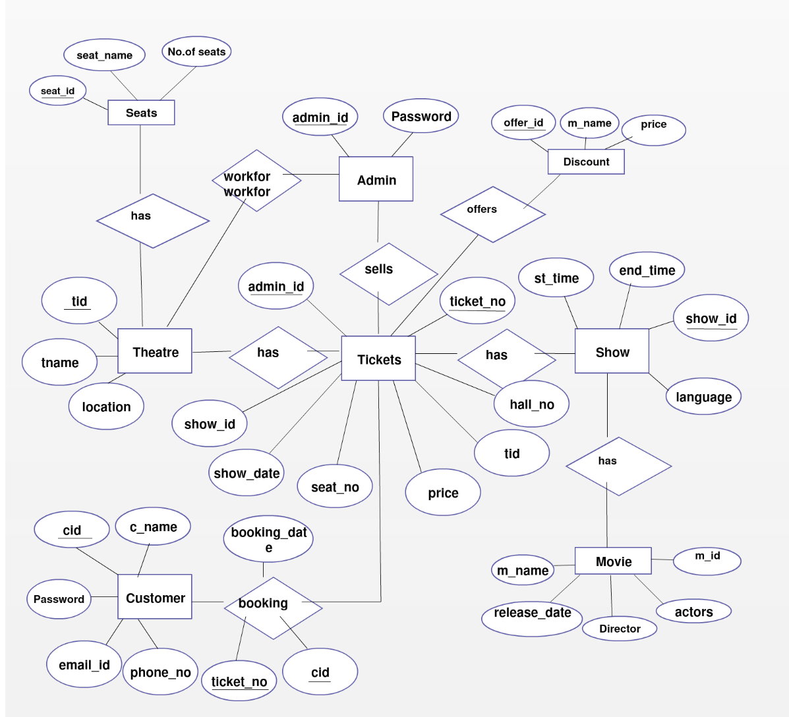

- GUI:
    - Used Jswing

- Testing:
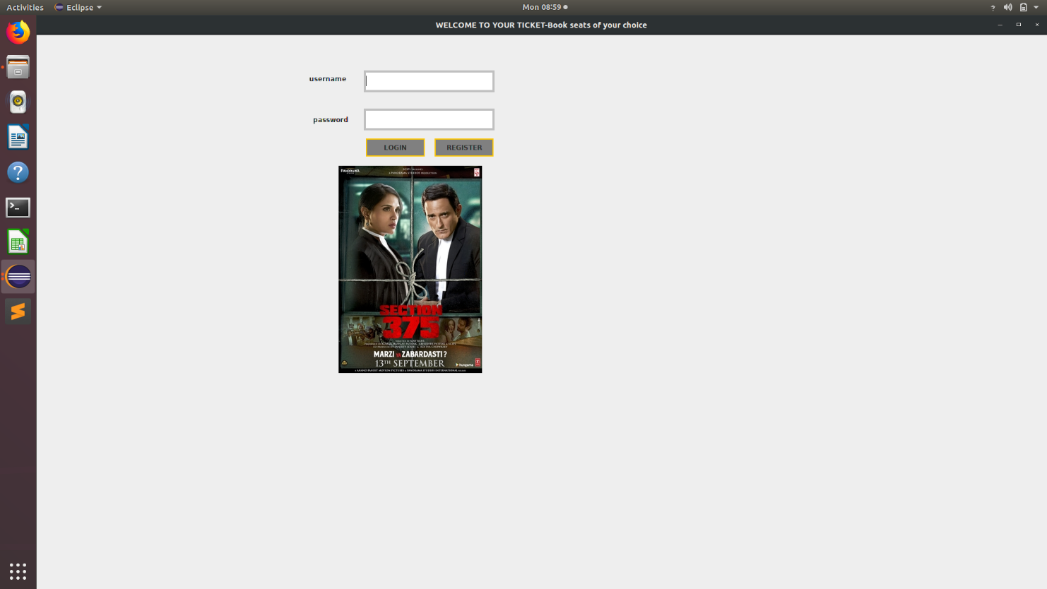

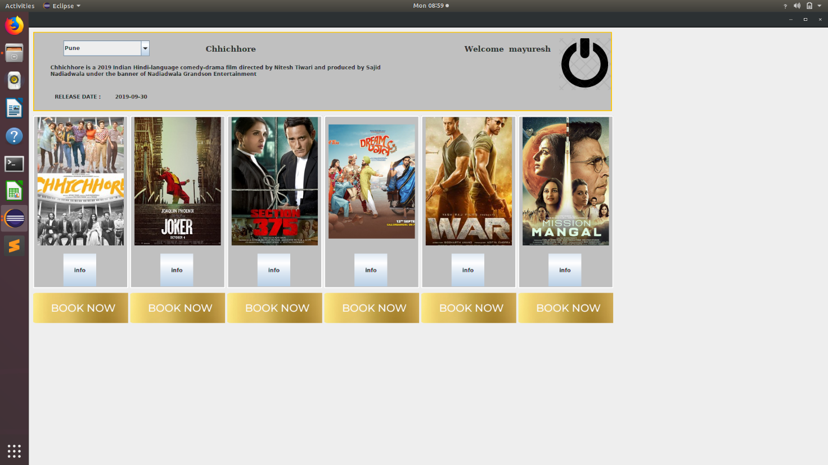

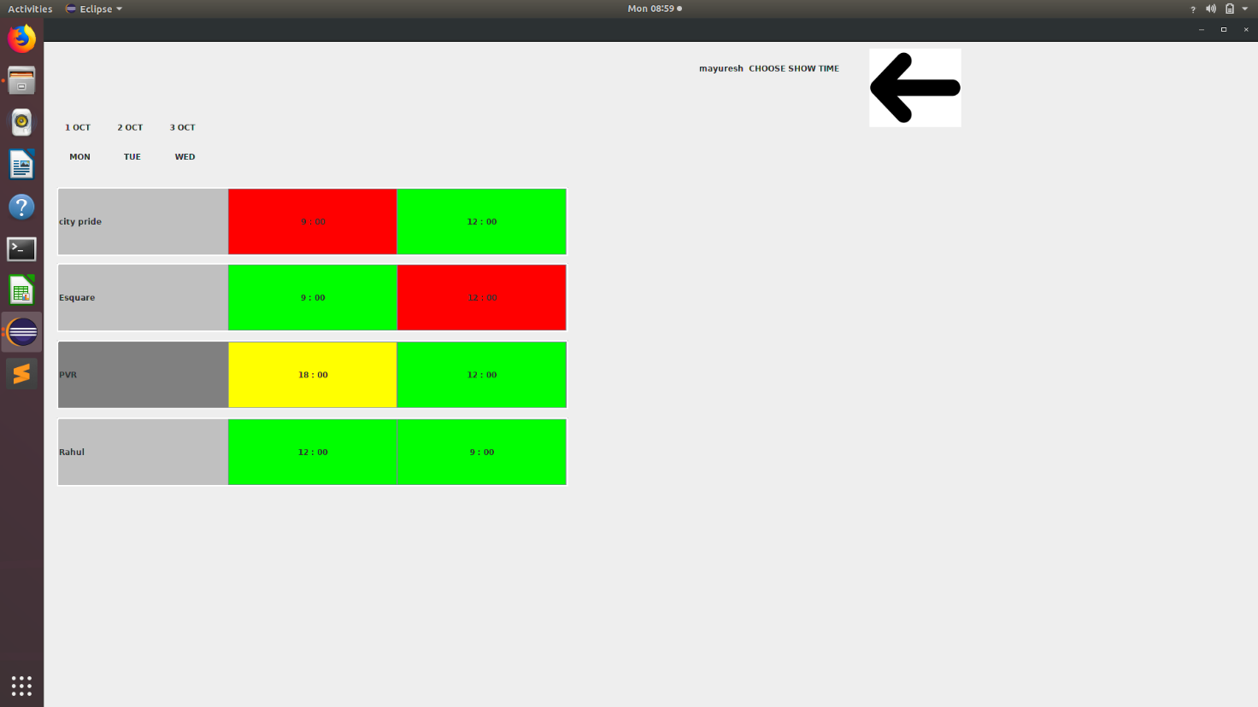

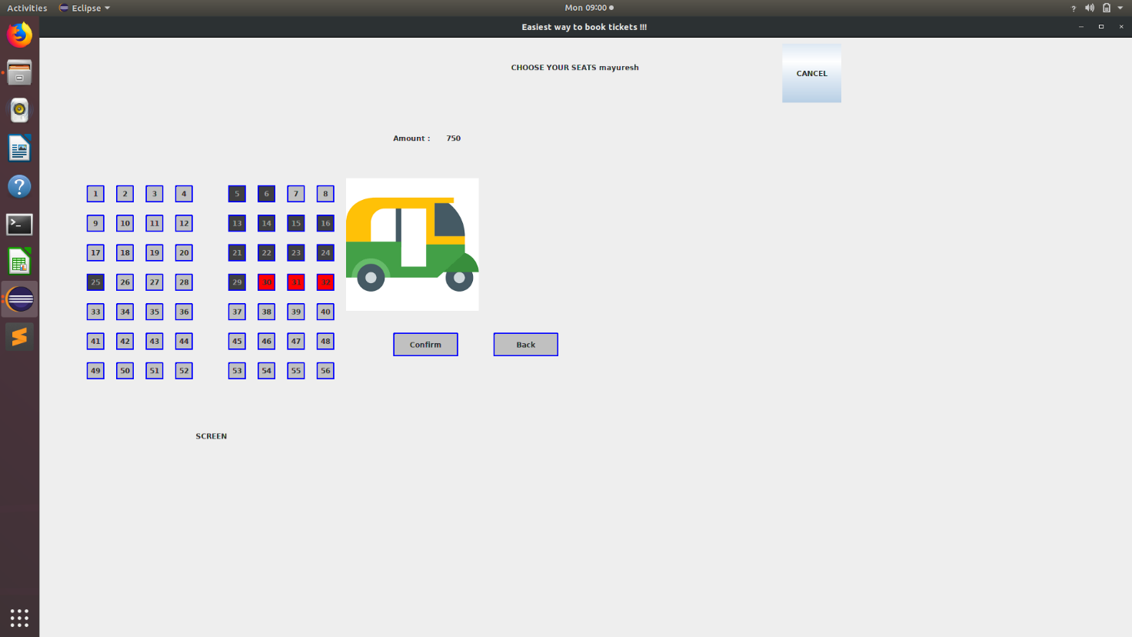

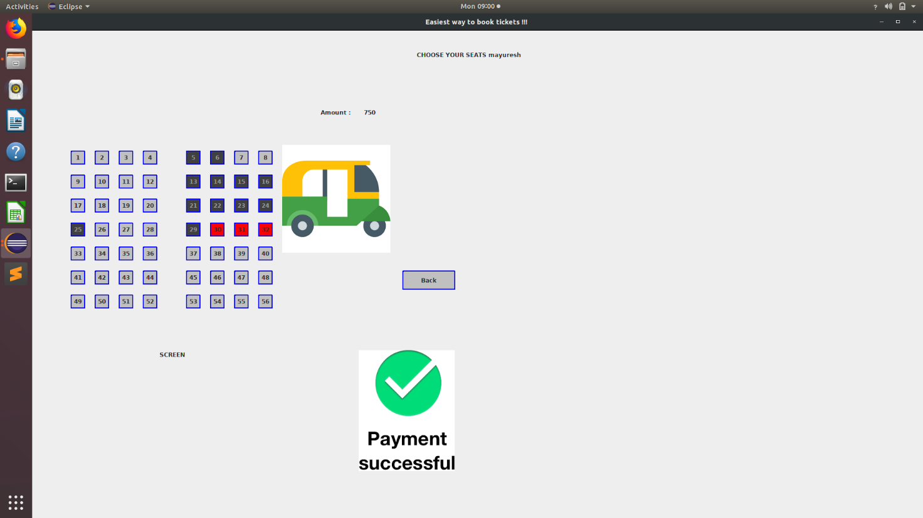

- Conclusion:
Nowadays, traditional reservation ways of cinema ticketing is dying. It’s new age
where technology dominates human life. With the software and technological
devices, exceptions are reduced and even terminated. Also, people prefer easy,
quick and safe way for every part of his life. This project is designed to meet the
requirements of a cinema ticket booking system. It has been developed in JSwing
and the database has been built in My SQL server keeping in mind the
specifications of the system.
In our project: with this cinema booking system; cinema companies can cater to
the needs of their customers. The relationship between cinema manager, employee, and customer satisfy a good communication to complete ticketing process. With this platform we developed, we are hoping to reduce time wasting, avoid misunderstandings, provide easy data flow, customer pleasure and less hard work. We believe that we have accomplished our goals and satisfied with the code we developed.

