Vehicle Rental Management System — Project Draft (OOPs)
Course: Object-Oriented Programming Duration: 12 Working Weeks
Guide: [Faculty Name]

Why This Project?
Vehicle rental services need to maintain vehicle records, availability, customer details, bookings, and rental bills. Managing these details manually can be slow and may cause mistakes. This project develops a simple Vehicle Rental Management System in C++ using object-oriented programming concepts to organize vehicle and user-related operations.

Goals of the Project
- Maintain vehicle details such as vehicle ID, name, price per day, and availability.
- Allow renters to add and remove vehicles and view the vehicle list.
- Allow customers to view vehicles, book vehicles, view bookings, return vehicles, and calculate rental bills.
- Calculate rental bills with or without a discount.
- Provide an admin panel to view vehicles, availability, bookings, renters, and customers.
- Apply OOP concepts that are actually implemented in the current source code.

Work Plan (Stages with OOP Concepts)

Stage 1: Design and Main Classes
What we do: Prepare the use-case diagram, sequence diagram, and class diagram, and create the main classes.
OOP idea: Encapsulation — the Vehicle class keeps its data members private and provides methods to access or update vehicle information. The database class keeps vehicleList private and provides operations to manage vehicles.
Goal: Establish the main classes and basic vehicle-management and user-role functionality.

Stage 2: Extending the Class Design
What we do: Add inheritance and class features needed by the system.
OOP idea: Inheritance — renter, customer, and admin are derived from the user base class and reuse common user details.
OOP idea: Access specifiers and constructors — private, protected, and public members control access; constructors initialize Vehicle and user-role objects.
OOP idea: Operator overloading — the stream insertion operator << is overloaded as a friend function to display Vehicle details.
OOP idea: Method overloading — billing functions support a normal bill and a discounted bill.
Goal: Connect the role classes and support object initialization, vehicle display, and billing.

Stage 3: Further OOP Features and Integration
What we do: Add further OOP features and integrate the renter, customer, and admin operations.
OOP idea: Stream operator overloading using a friend function — the overloaded << function accesses Vehicle details and formats them for output.
OOP idea: Nested class — database contains the nested Discount class, which applies a discount to the rental bill.
OOP idea: Static variable — database::vehicleCount stores a vehicle count shared by database objects.
OOP idea: Virtual function and abstraction — user declares displayUser() as a pure virtual function, and renter, customer, and admin provide role-specific implementations. This makes user an abstract class.
OOP idea: final keyword — admin is declared final, so it cannot be used as a base class; its displayUser() override is also final.
Note: Object slicing, static functions, the this pointer, virtual base classes, and standalone pointers to objects or derived classes are not described as implemented concepts because they are not demonstrated in the supplied source code.
Goal: Integrate the user-role menus, vehicle operations, and bill calculation into one menu-driven program.

Work Packages and Milestones
- WP1: Plan requirements and identify vehicle data and user roles.
- WP2: Create the main classes and establish the class structure.
- WP3: Implement vehicle listing, availability, booking, returning, and billing.
- WP4: Add inheritance, access control, constructors, friend output, and overloaded billing methods.
- WP5: Add the nested Discount class, static vehicle counter, and virtual display functions.
- WP6: Integrate the renter, customer, and admin menus and test the main flow.
- WP7: Prepare the project report and presentation.
The sample uses a 12-week timeline. Exact dates for this project were not provided, so the timeline on the final page uses week numbers. Weeks 9–12 are reserved for future stages that will be defined later.

Final Outcomes
- A menu-driven C++ Vehicle Rental Management System with renter, customer, and admin roles.
- Vehicle listing, availability checking, booking, returning, and booking-list functionality.
- Rental bill calculation with and without a discount.
- Implemented OOP features including encapsulation, inheritance, access specifiers, constructors, friend functions, operator and method overloading, a nested class, a static data member, an abstract class, virtual functions, and final.

Vehicle Rental Management System Project Time Schedule (12-week template)
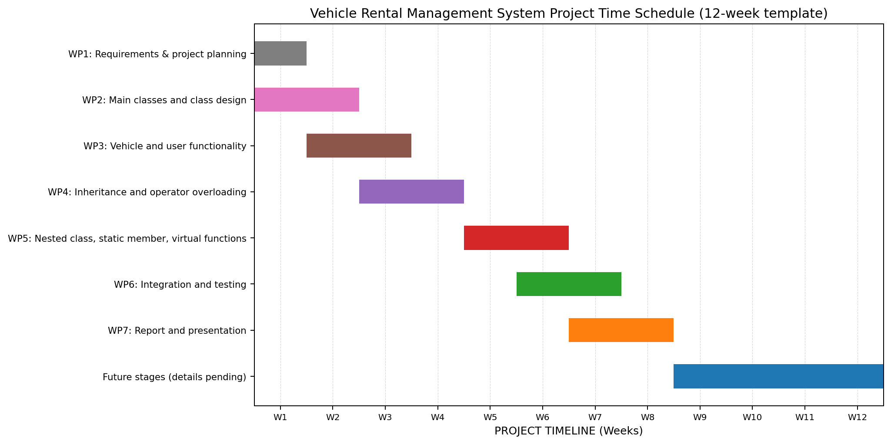
Figure 1: Vehicle Rental Management System timeline (week-based planning template).

