**TOPIC**

**FOREST FIRE DETECTION AND RECOVERY**

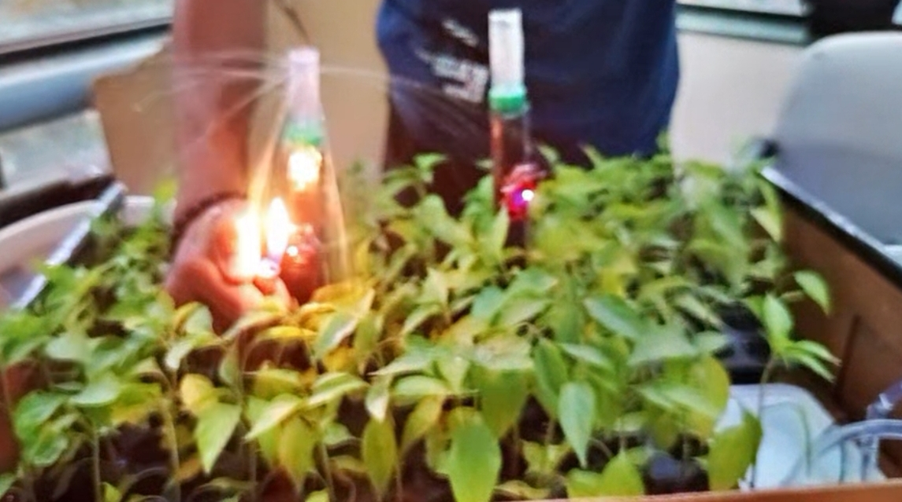

**Chapter 1 Introduction**

Forest fires pose a significant threat to the environment, ecosystems, and human settle- ments. Over the past decades, the frequency and intensity of forest fires have increased due to factors such as climate change, deforestation, and human activities. Forest fires not only destroy vast amounts of forest cover but also release massive amounts of carbon dioxide, contributing to global warming. Early detection of such fires, coupled with a rapid and efficient recovery response, is critical to minimize the damage caused.

Traditional fire detection methods, such as watchtowers and satellite surveillance, are often slow and inefficient in catching fires at their early stages. Furthermore, response teams are typically deployed manually, resulting in delayed firefighting efforts that allow fires to spread uncontrollably. Automated detection and recovery systems can significantly enhance fire management by providing real-time monitoring and immediate intervention. This project presents a Forest Fire Detection and Recovery System using Arduino, flame sensors, and water pump relays. The system is designed to detect forest fires in their initial stages and automatically trigger water pumps to extinguish them, ensuring a timely and efficient response. By integrating modern microcontroller technology with basic sensors and actuators, this system offers a low-cost and scalable solution for forest

fire management, particularly suited to remote areas with limited human resources.

The system’s design is simple yet effective, leveraging flame sensors to detect fire through infrared emissions and relays to control water pumps for fire suppression. In addition to basic detection and extinguishing functions, the system can be enhanced with wireless communication modules to notify authorities of fire incidents, allowing for quick human intervention if necessary.

With a focus on affordability and scalability, the system can be deployed in forests, wildlife reserves, and rural areas where fire hazards are common. Its modular design also allows for future improvements, such as the incorporation of temperature sensors and machine learning algorithms for improved accuracy, or solar panels for sustainable energy use in off-grid locations.

In summary, the proposed project addresses a critical environmental challenge by providing a technical solution for early detection and recovery in forest fire scenarios. This automated system not only ensures fast fire suppression but also reduces the reliance on manual monitoring and firefighting efforts, making it a valuable tool in mitigating the risks associated with forest fires.

**Chapter 2 Literature Review**

The development of automated forest fire detection and recovery systems has gained in- creased attention in recent years due to the growing frequency and intensity of wildfires. Research in this domain focuses on the use of various sensing technologies, microcon- trollers, and communication modules to develop real-time, cost-effective solutions that can provide rapid detection and suppression capabilities. This literature review examines the existing body of work related to forest fire detection, fire suppression systems, and the use of Arduino with flame sensors and water pumps for fire management.

Key technologies include:

* Ground-Based Sensors: Flame sensors detect infrared radiation emitted by flames, pro- viding early fire detection in remote environments. These sensors are cost-effective and work well for short-range detection in forested areas (Nugroho et al., 2017).
* Wireless Sensor Networks (WSN): WSNs enable real-time monitoring over large areas, but they require robust communication infrastructure, which may not be feasible in re- mote forests (Zhang et al., 2019).
* Machine Learning: AI and image-processing algorithms are being used for more ac- curate fire detection, but these systems are often complex and expensive (Huang et al., 2021).

Fire Suppression Systems Automated water-based suppression systems, controlled by re- lays, are widely used in response to detected fires. Relays enable Arduino to manage water pumps effectively. These systems have shown promise in reducing fire spread in small-scale setups (Singh et al., 2021). Arduino in Fire Detection and Suppression Arduino-based systems have been extensively researched for their flexibility and affordability. Flame sen- sors connected to Arduino detect fires and activate water pumps via relay modules. These systems are effective for small-scale, automated fire management, especially in rural areas (Nayak et al., 2019). However, challenges include false positives, limited sensor range, and ensuring a reliable water supply in forested areas. Combining multiple sensors and integrating IoT technologies can improve accuracy and monitoring (Yadav et al., 2020).

**Chapter 3**

**System Architecture**

### Overview

The system architefcture for the forest fire detection and recovery system is composed of three primary modules: the detection module, the control and processing module, and the response module. Each module works together to detect fires, process data, and trigger automatic fire suppression.

### System Components

The system architecture consists of the following key components:

* + - * **Flame Sensors: -** Detect infrared radiation emitted by fire flames.
      * **Arduino Microcontroller: -** Acts as the central processing unit, receiving data from the flame sensors and controlling the response (water pumps).
      * **Power Supply: -** To power the Arduino, sensors, and relays.
      * **Relay Modules: -** Act as electronic switches, receiving signals from the Arduino to activate the water pumps.
      * **Water Pumps: -** Pumps water from a reservoir or natural water source to douse the fire.
      * **Jumping wires: -** Connect the Arduino, sensors, relays, and other components together.
      * **Breadboard: -** Used for prototyping or soldering the final circuit connections.
      * **Arduino IDE: -** Used to write and upload the code to the Arduino board. The code includes logic for processing sensor data and controlling the relays. .

### System Flow: -

The system operates based on the following functional flow:

* + - * **Fire Detection:** Flame sensors deployed in the forest detect infrared emissions from a fire and send a digital HIGH signal to the Arduino when a fire is present.
      * **Data Processing:** The Arduino reads input from the flame sensors and determines if the fire detection threshold is met (e.g., if a flame sensor detects fire in its prox- imity). If a fire is detected, it activates the response mechanism by sending a signal to the relay modules.
      * **Fire Suppression:** The relay modules receive signals from the Arduino and acti- vate the water pumps. The pumps then spray water over the fire-affected area.
      * **Optional Alert:**If a GSM or IoT module is integrated, the system can send a real- time alert (via SMS or web platform) to forest management authorities or firefighters when the fire is detected, notifying them of the incident

### System Architecture Diagram

Below is a high-level representation of the system architecture:

Detection Module

Control & Pro-

cessing Module

Water Source (Reservoir)

Power Supply (Battery/Solar)

Water Pumps

Optional: GSM/IoT Module

Optional: Temp/Smoke Sensors

Relay Module

Arduino MCU

Flame Sensors

Response Module

### Circuit Diagram

The following diagram represents the hardware connections and components used in the Forest Fire Detetction and Recovery:

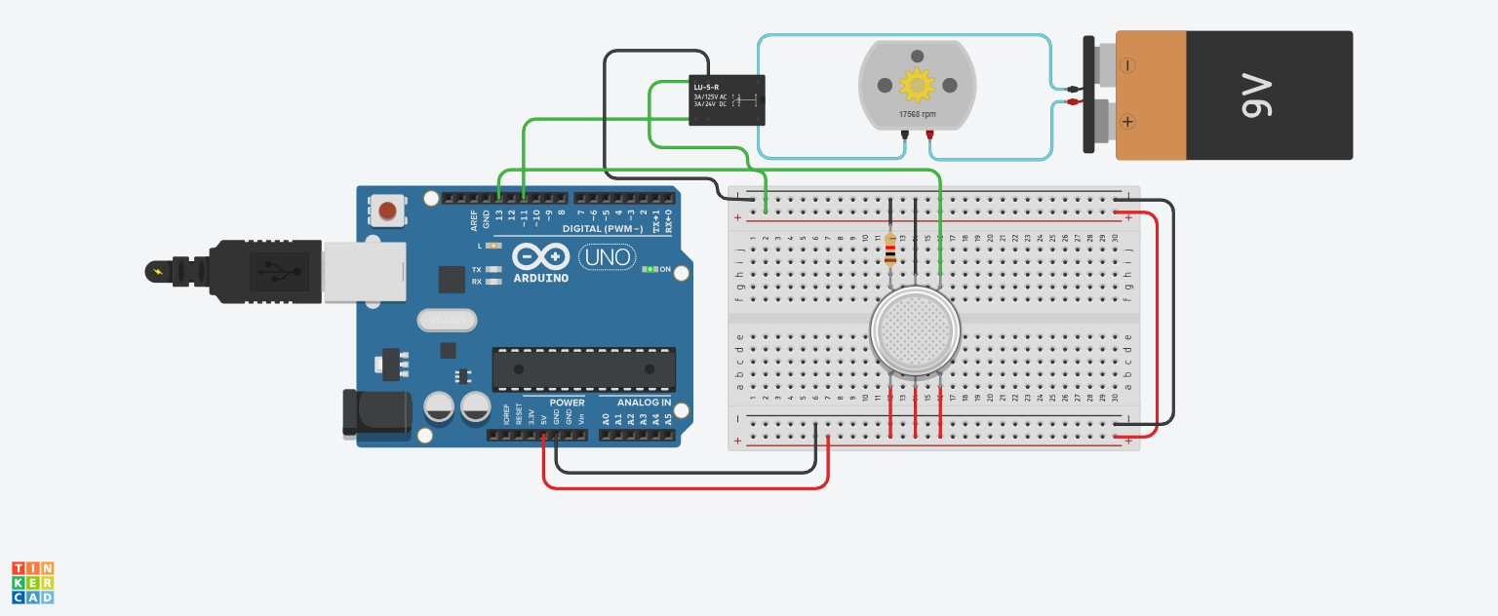

Figure 3.1: Forest Fire detector

### Circuit Diagram Description

The key components in the system include:

* + - * **Arduino Uno:** Acts as the central control unit.
      * **Relay Module:**Controls the high-power motor using a signal from the Arduino.
      * **Water Pump:** Controlled via a relay connected to pin 8 of the Arduino. It turns on when the flame is detected.
      * **Flame Sensor:**Detects environmental changes (e.g., smoke) and sends data to the Arduino.
      * **9V Battery:** Powers the motor through the relay.

**Chapter 4 Methodology**

## Hardware Components Setup and Connections

### Arduino Uno

The Arduino Uno serves as the central micro controller for this project This micro con- troller is used to read sensor data and control the relays The Arduino is the central control unit of the system. It processes data from the flame sensors and determines whether a fire is detected. It then controls the relay modules to activate the water pumps, which suppress the fire.

* + - * Digital Input Pins: Flame Sensor 1: D2
      * Digital Output Pins: Relay Module (Water Pump Control): D7
      * Connect the VCC pin of the Arduino to a 12V DC power supply.
      * Connect the GND pin of the Arduino to the ground.

### Flame Sensors

Flame sensors detect infrared (IR) light emitted by flames. When a fire is present, the sensor outputs a HIGH signal to the Arduino, indicating fire detection.Flame sensors are used to detect fire by sensing the infrared light produced by flames. They are the primary detection mechanism in this system.

* + - * Connect the flame sensors to the digital input pins of the Arduino. These will provide a HIGH signal to the Arduino when a fire is detected.
      * VCC: Connect to the 5V pin on the Arduino.
      * GND: Connect to the GND pin on the Arduino.
      * OUT: Connect to D2 on the Arduino

### Relay Modules

Relay modules are electronic switches that allow the Arduino to control high-power devices (like water pumps) with low-power signals.Each relay channel controls one water pump. The relay module can switch a high-power AC or DC load (water pump) based on the control signal from the Arduino. Relays act as a bridge between the low-power control system (Arduino) and high-power components (water pumps).The relay module is used to control the activation of the water pumps. When a fire is detected, the Arduino sends a HIGH signal to the relay, which closes the circuit and turns on the connected water pump. When the Arduino detects a fire, it sends a signal to the relay to close the circuit, turning on the pump. Once the fire is extinguished, the relay opens the circuit, stopping the pump.

* + - * Connect the relay modules to the digital output pins of the Arduino. When the Arduino receives a HIGH signal from the flame sensors, it will send a HIGH signal to the relays, which will turn on the water pumps.
      * VCC: Connect to the 5V pin on the Arduino.
      * GND: Connect to the GND pin on the Arduino.
      * IN1: Connect to D7 on the Arduino (to control the first water pump).

### Water Pumps

Water pumps are mechanical devices that move water from a reservoir to the target area (where the fire is detected) using electrical power.The water pumps are the primary response mechanism of the system. When a fire is detected, the water pump is activated to spray water onto the affected area, helping to douse the fire.The water pump is connected to the relay module. When the relay is activated by the Arduino, the pump draws water from the reservoir and sprays it over the fire area.

Connect one wire of the water pump to the NO terminal of the relay module. Connect the other wire of the pump to the positive terminal of the power supply.

### Power Supply

The power supply provides energy to the Arduino, sensors, relays, and pumps. The system can either use direct AC power, batteries, or solar panels, depending on the setup.Ensures continuous power to all components of the system, especially in remote areas where conventional power sources may not be available.

### Jumping Wires

These are used to connect various components (Arduino, flame sensors, relay modules, etc.) together on a breadboard or soldered circuit.Male-to-male, male-to-female, and female-to-female jumper wires are used, depending on the type of connection.

## Software Development

The software component of this project involves writing the program (sketch) that runs on the Arduino, controlling how the system detects fires, triggers water pumps, and communicates alerts. The Arduino program will read sensor inputs, make decisions based on the sensor data, and control the output devices (relays controlling water pumps). This code is typically written in C/C++ using the Arduino IDE.

### Initialization

The first step in the software is to define the necessary pin numbers and initialize the hardware components. This includes setting up the flame sensor, relays, and buzzer.

* + - * Define the pins used for connecting sensors, relays and buzzer.
      * Setup Function:The setup() function runs once when the Arduino is powered on or reset. In this function, we initialize the pins, set up communication with optional modules, and configure the relays.

##### Code Snippet:

const int flameSensor1 = 13; // Pin for flame sensor const int relayPin1 = 11; // Pin for relay

const int buzzerPin = 9; // Pin connected to the buzzer

void setup() { pinMode(flameSensor1, INPUT); pinMode(relayPin1, OUTPUT);

pinMode(buzzerPin, OUTPUT); // Set the buzzer pin as an output digitalWrite(relayPin1, LOW); // Initialize relay as LOW digitalWrite(buzzerPin, LOW);

Serial.begin(9600);

}

### Flame Detection Monitoring

The flame detection sensor is continuously monitored to track the current flame. It senses the flame and accordingly perform the tasks or operations assigned based on conditions.

* + - * The flame sensor detects the flame.
      * Main Loop Function: The loop() function runs continuously. It reads data from the flame sensors, checks if a fire is detected, and controls the relay accordingly.

##### Code Snippet:

void loop() {

int flameValue1 = digitalRead(flameSensor1); if (flameValue1 == HIGH) {

Serial.println("Flame detected."); digitalWrite(relayPin1, LOW); // Turn off relay delay(500); // Wait for 0.5 seconds tone(buzzerPin, 1000); // Play a 1 kHz tone delay(1000);

}

## Testing and Evaluation of the System’s Perfor- mance

Once the Forest Fire Detection and Recovery System has been developed and assembled, it is essential to thoroughly test and evaluate its performance to ensure that it operates effectively in real-world conditions. The testing phase includes assessing the functional- ity of each component, the system’s reliability, and its response time in detecting and extinguishing fires. Below is a detailed approach to testing and evaluation.

### Individual Component Testing

The first step is to verify whether each of the components successfully works and performs the assigned task or operations. This involves checking the following:

1. **Flame sensors:**Test each flame sensor by exposing it to a controlled flame (e.g., a lighter or candle) at varying distances to verify that it detects fire accurately. Ensure the sensor outputs a logical HIGH (indicating fire detection) and LOW (no fire) consistently under different lighting conditions.
2. **Relay Modules:**Manually trigger the relay using a simple code to verify that it switches ON and OFF properly, thereby controlling the water pump.
3. **Water Pump**Test the water pump independently by applying a control signal to the relay and ensuring that water is being sprayed when the pump is activated.

**Chapter 5 Conclusion**

## Summary of the Project’s Achievements and Re- sults

The Forest Fire Detection and Recovery System successfully addresses the critical need for early fire detection and automated response in forested areas. The project utilized Arduino, flame sensors, relay modules, and water pumps to create an autonomous system capable of detecting fire and mitigating it through automated water dispersion.

* + - **Accurate Fire Detection:** The system effectively uses flame sensors to detect fire outbreaks in real time, triggering the necessary response.
    - **Automated Response:** Upon fire detection, the system automatically activates the water pumps via the relay modules, ensuring quick action to control the fire.
    - **Scalability and Modularity:** The design allows for easy scaling, with multiple sensors and pumps being added depending on the area to be covered.
    - **Optional Remote Alerts:** The system can be enhanced with GSM or IoT modules to send alerts to remote users, making it suitable for larger, unmanned forest areas.
    - **Low-cost Solution:** By using inexpensive and widely available components, the system offers a cost-effective solution to forest fire detection and suppression for a large scale implementation.

## Future Work or Improvements

While the project achieved its primary objectives, there are several areas for future work and improvements that could enhance the system’s functionality:

* + - **Integration with IoT:** Incorporating IoT capabilities could enable remote mon- itoring and control via a mobile application or web interface, allowing users to manage their indoor climate from anywhere.
    - **Advanced Control Algorithms:** Implementing machine learning algorithms could enhance the system’s ability to predict and adapt to user preferences, optimizing energy consumption further.
    - **Multiple Sensors:** Adding multiple temperature sensors in different locations could allow for more accurate temperature monitoring and regulation throughout larger spaces.
    - **User Customization:** Providing a user-friendly interface for setting custom tem- perature thresholds and schedules could improve user experience and system flexi- bility.
    - **Energy Monitoring:** Integrating an energy consumption monitoring feature could provide users with insights into their energy usage, promoting more informed deci- sions about their heating and cooling habits.

The project successfully demonstrates an efficient, cost-effective approach to auto- mated fire detection and response in forest areas. Through its modular design, the system can be scaled, upgraded, and integrated with future technologies. Its real-time detection and quick response capabilities ensure that it can play a vital role in mitigating forest fires, protecting both wildlife and natural resources.

# Chapter 6 References

1. Arduino Official Documentation. (n.d.). Arduino Reference. Retrieved from https:

[//www.arduino.cc/reference/en/](http://www.arduino.cc/reference/en/)

1. Temperature Sensors. (n.d.). Types of Temperature Sensors and Their Applica- tions. Retrieved from [https://www.ni.com/en-us/innovations/white-papers/](http://www.ni.com/en-us/innovations/white-papers/) 06/types-of-temperature-sensors.html
2. Kurylo, J., Ozdermir, B., Akca, F. (2017). Forest fire detection system using wireless sensor network. In International Conference on Computer and Applications (ICCA), IEEE.
3. Malik, A. K., Sehgal, V. K., Kumar, N., Chopra, P. (2018). Arduino based forest fire detection and monitoring system: Issues, challenges and approach. International Journal of Advanced Research in Computer Science, 9(2), 284-288.
4. Mart´ınez-de Dios, J. R., Ollero, A. (2004). A fire detection and monitoring system for outdoor environments. Sensors and Actuators B: Chemical, 102(1), 164-170.
5. Pournazari, S., Malek, M. R., Attari, M. A. (2017). Design and implementation of an automatic fire suppression system. Fire Technology, 53(3), 1063-1086
6. Sattar, S. A., Khan, A., Rehman, A., Shafiq, H. (2019). Design of automatic irriga- tion system using Arduino and GSM module. Journal of Electrical and Electronic Engineering, 7(3), 19-23