**Module 1: Effective Communication**

**Task:** Write professional emails based on any 5 of the following scenarios. Ensure clarity,

conciseness, and a formal tone

1. **Thank you Email**

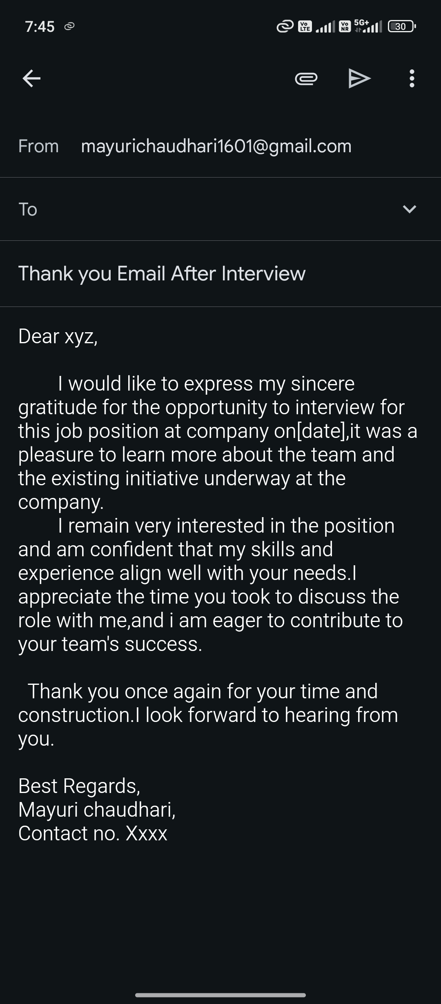

**2.Letter of Apology**

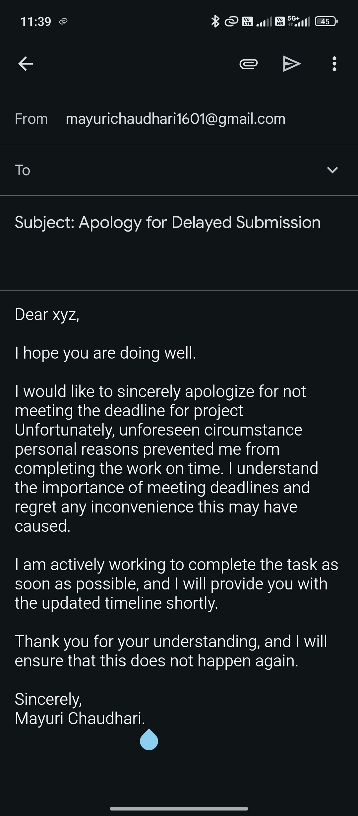

**3.Asking for a Raise in Salary**

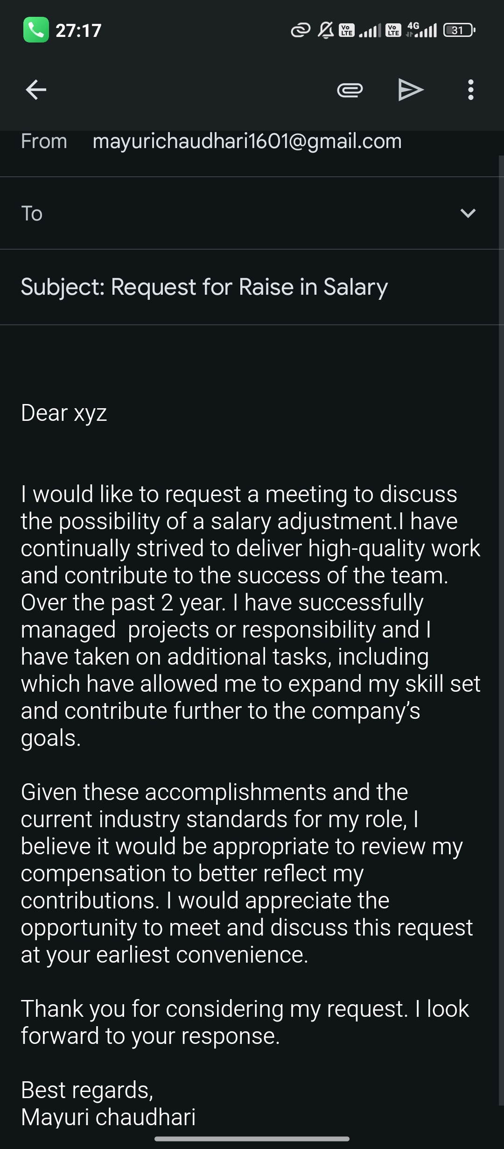

**4. Email to your Boss About a Problem(Requesting help)**

**.** 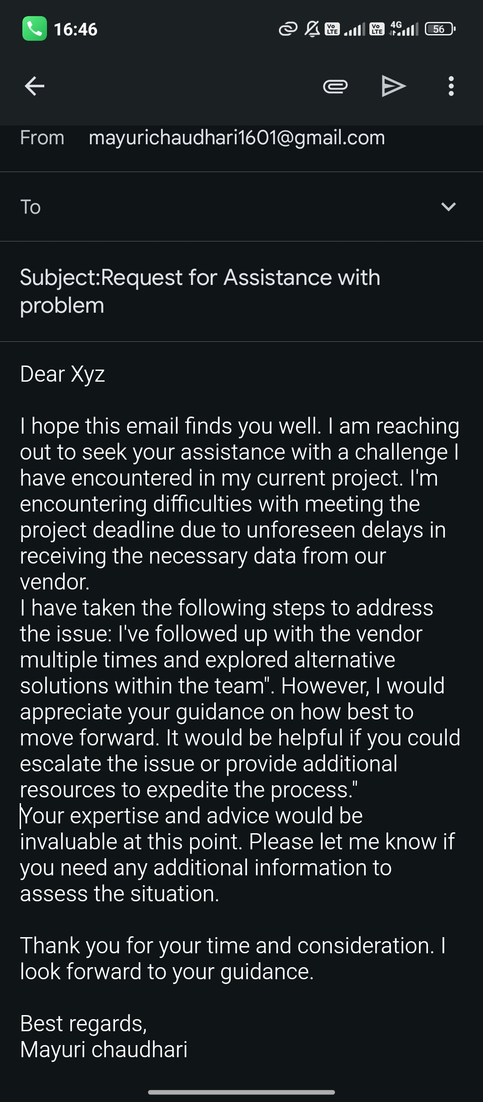

**5. Resignation Email**

