Practical 5:-
Assignment and practice of AI Image Generator

Task 1: Comparative Research:-
Criteria | DALL·E 3 |  | Midjourney).

Image Quality | High detail and coherence; strong lighting & composition, though sometimes slightly less polished in realism | Cinematic, richly detailed, highly realistic with dramatic lighting and depth

Prompt Accuracy | Very high—faithfully follows prompt details and elements | Strong, but can drift from exact prompt in favor of artistic mood/style

Style Flexibility | Wide style range (photorealism, cartoons, paintings, emojis) but fewer advanced controls | Extensive style control (model versions, Niji anime, style/character references, region editing)

Usability | Integrated into ChatGPT, Bing Image Creator, and API; very beginner-friendly | Initially Discord-based, now has advanced web editor with panning, zoom, inpainting, etc.

Licensing & Terms | Users own outputs; full commercial rights even on free tier; simple terms | Paid users own outputs (with conditions); commercial use requires proper plan; facing legal challenges

Best For | Accuracy, ease of use, clear ownership | Artistic depth, customization, cinematic visualsc
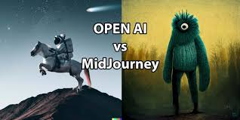

Task 2 :-Visual Design Project

- Create a poster for a fictional event or product

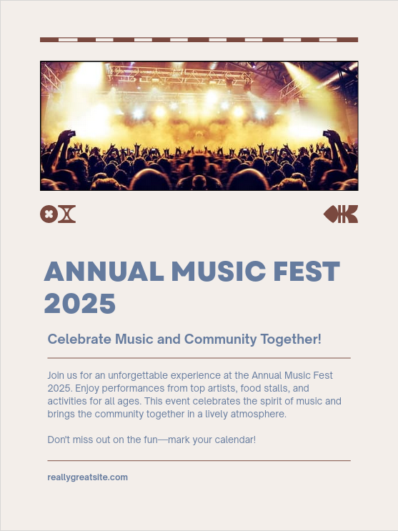

Theme: Celebrate Music Together – Building Community Through Sound

Concept
A vibrant, inclusive music festival where people of all ages come together to enjoy live performances, dance, and cultural exchange. The focus is not just on music but on togetherness, diversity, and community spirit.

Key Visual Elements for AI Image Generation
Use in DALL·E or Canva AI:
- Main Poster Scene
"Large open-air stage with live band, colorful lights, fireworks, diverse crowd of happy people dancing together, night sky, vibrant and festive atmosphere"
- Community Vibes Scene
"People from different cultures playing instruments together in a park, children dancing, street food stalls, joyful summer day"
- Unity Moment Scene
"Hands of people holding glowing wristbands raised in the air at a concert, stage lights in the background, cinematic mood"

Sample Slogan Ideas
- One Stage, One Beat, One Community
- Music Unites Us All
- Feel the Rhythm, Share the Joy

Color & Style Guide
- Colors: Electric blue, neon pink, warm gold, and deep purple.
- Style: Bright, energetic, with a mix of realism and artistic light effects.

