**Online Event Platform**

**Table Of Content**

|  |  |
| --- | --- |
| **Sr.no** | **Description** |
| 1) | Problem Description |
| 2) | Requirements |
| 3) | Technologies |
| 4) | Use Case Diagrams |
| 5) | Class Diagram |
| 6) | Sequence Diagram |
| 7) | Future Scope |

**Problem Statement:**

The objective is to create a dynamic website that effectively informs students about upcoming events in their chosen geographical area, ensuring a seamless and personalized user experience while providing reliable and real-time event information.

**Features:**

* Students will be updated about upcoming events
* Students can add events on website but with the permission of authorities
* Students can subscribe to our website and get updates from mail as well
* Students can filter out events on the basis of categories
* Featured events which are mostly booked by people are shown at front page
* Students can search events on the basis of radius as well.

**Technologies**

**Frontend Technology:**

1. React js
2. Bootstrap

**Backend Technology:**

1. Firebase
2. AWS

**Use Case Diagram:**

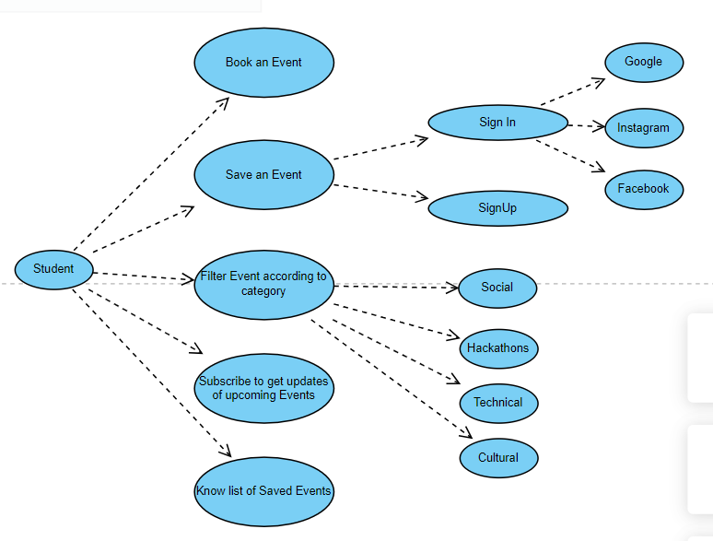

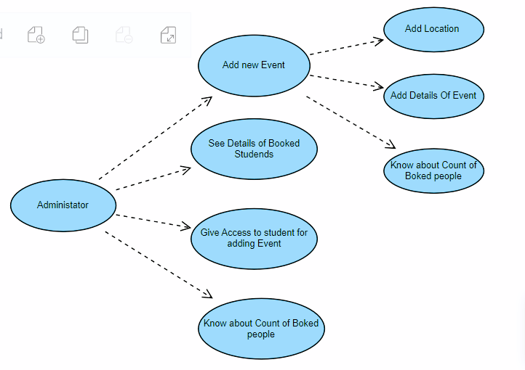

**Class Diagram:**

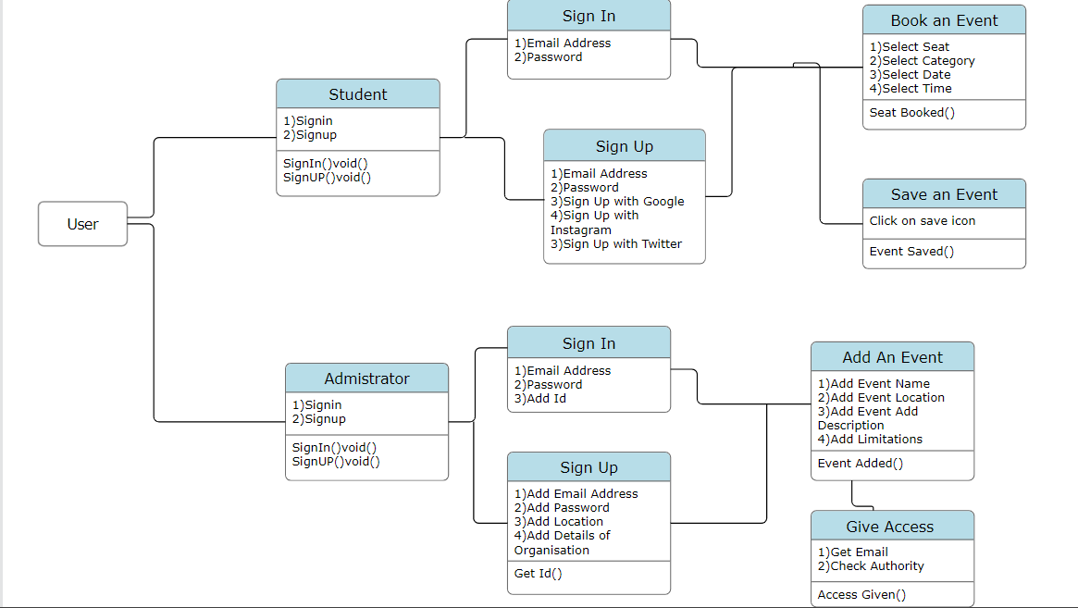

**Sequence Diagram:**

1)For Student/Volunteer

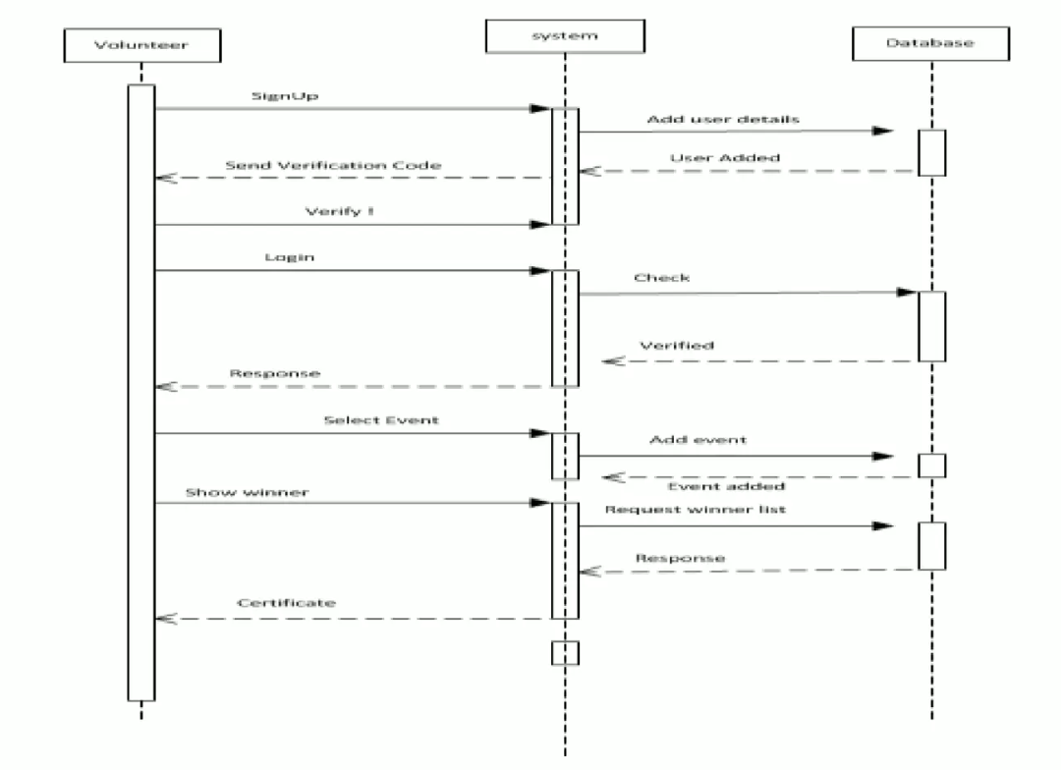

2)For Administrator

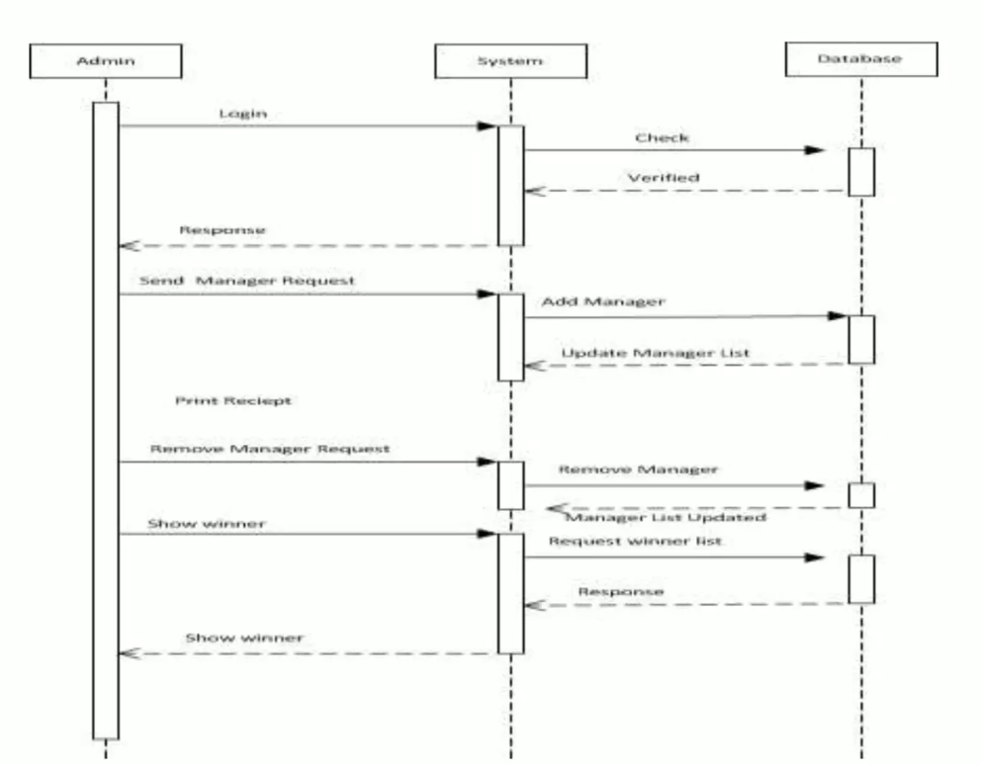

Future Scope

**Enhanced User Experience:**

Continuously improve the website's user interface and functionality to ensure a seamless and engaging experience for users. Implement features like personalized event recommendations, interactive maps, and intuitive event filtering.

**Mobile App Integration:**

Develop dedicated mobile apps for various platforms to expand the reach and accessibility of the website. This will allow users to stay updated on events while on the go.

**Real-time Updates:**

Implement real-time event updates and notifications, such as push notifications, to keep users informed about last-minute changes, cancellations, or newly added events.

**Social Integration:**

Integrate social media platforms to allow users to easily share and promote events. Implement social login options to streamline registration and enhance user engagement.

**Ticketing and Registration:**

Provide a comprehensive ticketing and registration system to allow event organizers to manage ticket sales and attendees. Implement secure payment gateways and QR code-based ticketing for seamless event entry.