**Experiment-1: Program to calculate Mean, Median and Mode for individual series.**

#include<stdio.h>

void Mean()

{

int length, i;

float arr[10], sum=0, AM;

printf("\nEnter the length : ");

scanf("%d",&length);

printf("\nEnter numbers to calculate arithmetic mean : ");

for(i=0; i<length; i++)

{

scanf("%f",&arr[i]);

}

for(i=0; i<length; i++)

{

sum = sum + arr[i];

}

AM = sum / length;

printf("\nArithmetic mean of Individual Series is %0.2f\n",AM);

}

void Median()

{

int i, j, n, temp, term, term1, term2;

int x[50];

float median;

printf("\nEnter the length : ");

scanf("%d",&n);

printf("\nEnter the values for which median to be calculated : ");

for(i=0; i<n; i++)

{

scanf("%d",&x[i]);

}

//Sort the array in ascending order

for(i=0; i<n-1; i++)

{

for(j=i+1; j<n; j++)

{

if(x[i] > x[j])

{

temp = x[i];

x[i] = x[j];

x[j] = temp;

}

}

}

//Data after sorting

printf("\nData after sorting : ");

for(i=0; i<n; i++)

{

printf("%d ",x[i]);

}

//Calculate Median

if(n%2==0)

{

term1 = n/2;

term2 = n/2+1;

median = (x[term1-1]+x[term2-1])/2;

}

else

{

term = (n+1)/2;

median = x[term-1];

}

printf("\nMedian of the above data is %0.2f\n",median);

}

void Mode()

{

int n, i, j, x[20], count, maxCount=0, mode=0;

printf("\nEnter the length : ");

scanf("%d",&n);

printf("\nEnter the values : ");

for(i=0; i<n; i++)

{

scanf("%d",&x[i]);

}

//Maximum value

for(i=0; i<n; i++)

{

count =0;

for(j=0; j<n; j++)

{

if(x[j] == x[i])

{

count++;

}

}

if(count > maxCount)

{

maxCount = count;

mode = x[i];

}

}

printf("\nMode of the given data is %d", mode);

}

int main()

{

int choice;

printf("\n|----------------------------------------------------------|");

printf("\n|Mean, Median & Mode for individual series|");

printf("\n|---------------------------------------------------------|");

printf("\n| 1) Mean |");

printf("\n| 2) Median |");

printf("\n| 3) Mode |");

printf("\n| 4) Exit |");

printf("\n|---------------------------------------------------------|");

do

{

printf("\nEnter the choice which operation you want to perform : ");

scanf("%d",&choice);

switch(choice)

{

case 1:

Mean();

break;

case 2:

Median();

break;

case 3:

Mode();

break;

case 4:

printf("\nExit!!");

break;

default:

printf("\nINVALID CHOICE! Please choose valid operation!");

break;

}

}while(choice!=4);

return 0;

}

**Experiment-1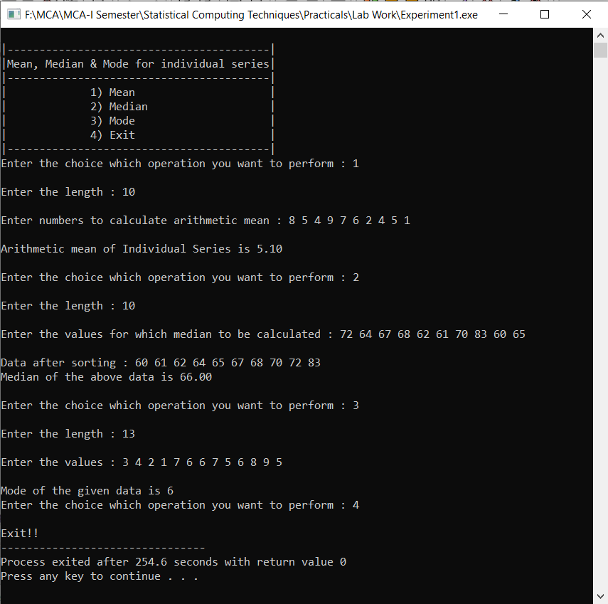 - Output:**

**Experiment-2: Program to calculate Mean, Median and Mode for discrete series**

#include<stdio.h>

void Mean()

{

int length, i;

int x[10], f[10], fx[10];

float sum_f=0, sum_fx=0, AM;

printf("\nEnter the number : ");

scanf("%d",&length);

//Enter x

printf("\nEnter values of x : ");

for(i=0; i<length; i++)

{

scanf("%d",&x[i]);

}

//Enter frequencies (f)

printf("\nEnter the frequencies : ");

for(i=0; i<length; i++)

{

scanf("%d",&f[i]);

sum_f += f[i];

}

//Calculate fx

for(i=0; i<10; i++)

{

fx[i] = f[i] * x[i];

sum_fx += fx[i];

}

//Print Data

printf("\nData : ");

printf("\n x | f | fx");

for(i=0; i<length; i++)

{

printf("\n %d | %d | %d", x[i], f[i], fx[i]);

}

//Arithmetic Mean of Discrete Series

AM = sum_fx / sum_f;

printf("\nArithmetic Mean of the Discrete Series is %0.2f\n",AM);

}

void Median()

{

int i, j, temp, n, row, CF, c_f, c_x;

int x[20], f[20], cf[20], sum_f=0;

float term;

printf("\nEnter the length : ");

scanf("%d",&n);

printf("\nEnter the values for x : ");

for(i=0; i<n; i++)

{

scanf("%d",&x[i]);

}

printf("\nEnter the values for f : ");

for(i=0; i<n; i++)

{

scanf("%d",&f[i]);

sum_f += f[i];

}

//Sort the array x in ascending order

for(i=0; i<n-1; i++)

{

for(j=i+1; j<n; j++)

{

if(x[i] > x[j])

{

temp = x[i];

x[i] = x[j];

x[j] = temp;

temp = f[i];

f[i] = f[j];

f[j] = temp;

}

}

}

//Calculate cumulative frequency

cf[0] = f[0];

for(i=0; i<n; i++)

{

cf[i+1] = f[i+1] + cf[i];

}

printf("\nData after sorting : ");

printf("\n x | f | CF");

for(i=0; i<n; i++)

{

printf("\n %d | %d | %d", x[i], f[i], cf[i]);

}

//Calculate median

term = (sum_f + 1)/2;

printf("\nTerm : %0.2f",term);

for(i=0; i<n; i++)

{

if(term>cf[i])

{

row = i;

CF = cf[i+1];

c_f = f[i+1];

c_x = x[i+1];

}

}

printf("\nCummulative frequency just greater than the term %0.2f : %d",term, CF);

printf("\nCorresponding frequency : %d",c_f);

printf("\nCorresponding value of x : %d",c_x);

printf("\nHence, the median of the given data is %d",c_x);

}

void Mode()

{

int n, i, j, x[i], f[i], mode=0, maxNum=0;

printf("\nEnter the length : ");

scanf("%d",&n);

printf("\nEnter the values for x : ");

for(i=0; i<n; i++)

{

scanf("%d",&x[i]);

}

printf("\nEnter the values for f : ");

for(i=0; i<n; i++)

{

scanf("%d",&f[i]);

}

printf("\nData : ");

printf("\n x | f");

for(i=0; i<n; i++)

{

printf("\n %d | %d", x[i], f[i]);

}

//Maximum value

for(i=1; i<n; i++)

{

if(f[i] > maxNum)

{

maxNum = f[i];

mode = x[i];

}

}

printf("\nIt is visible that variable %d has the highest frequency value of %d", mode, maxNum);

printf("\nHence, the mode of the given data is %d", mode);

}

int main()

{

int choice;

printf("\n|---------------------------------------------------------|");

printf("\n| Mean, Median & Mode for discrete series |");

printf("\n|---------------------------------------------------------|");

printf("\n| 1) Mean |");

printf("\n| 2) Median |");

printf("\n| 3) Mode |");

printf("\n| 4) Exit |");

printf("\n|---------------------------------------------------------|");

do

{

printf("\nEnter the choice which operation you want to perform : ");

scanf("%d",&choice);

switch(choice)

{

case 1:

Mean();

break;

case 2:

Median();

break;

case 3:

Mode();

break;

case 4:

printf("\nExit!!");

break;

default:

printf("\nINVALID CHOICE! Please choose valid operation!");

break;

}

}while(choice!=4);

return 0;

}

**Experiment-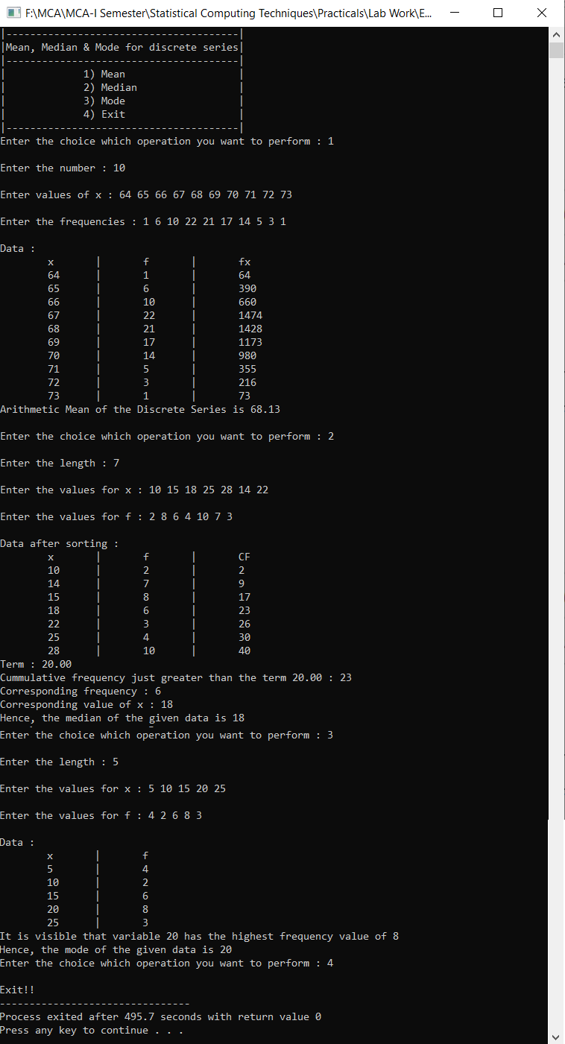2 - Output:**

**Experiment-3: Program to calculate Mean, Median and Mode for continuous series**

#include<stdio.h>

void Mean()

{

int length, i, l[10], u[10], f[10], x[10];

float fx[10], sum_fx=0, sum_f=0, AM;

//Enter the length

printf("\n Enter the number : ");

scanf("%d",&length);

//Enter lower limits

printf("\n Enter the lower limits : ");

for(i=0; i<length; i++)

{

scanf("%d",&l[i]);

}

//Enter upper limits

printf("\nEnter the upper limits : ");

for(i=0; i<length; i++)

{

scanf("%d",&u[i]);

}

//Enter frequency

printf("\nEnter the frequencies : ");

for(i=0; i<length; i++)

{

scanf("%f",&f[i]);

sum_f += f[i];

}

//Calculate mid-point (x) and sum_x

for(i=0; i<length; i++)

{

x[i] = (u[i] + l[i]) / 2;

}

//Calculate fx and sum_fx

for(i=0; i<length; i++)

{

fx[i] = f[i] * x[i];

sum_fx += fx[i];

}

//Print Data

printf("\nData : ");

printf("\n Class | f | x | fx");

for(i=0; i<length; i++)

{

printf("\n %d-%d | %d | %d | %f", l[i], u[i], f[i], x[i], fx[i]);

}

//Arithmetic Mean of continuous series

AM = sum_fx / sum_f;

printf("\nArithmetic Mean for continuous series is %0.2f\n",AM);

}

void Median()

{

int n, i, row, CF, c_l, c_u, c_f, h, l[20], u[20];

float f[20], cf[20];

float sum_f=0, term=0, median=0;

printf("\nEnter the length : ");

scanf("%d",&n);

printf("\nEnter the lower limits : ");

for(i=0; i<n; i++)

{

scanf("%d",&l[i]);

}

printf("\nEnter the upper limits : ");

for(i=0; i<n; i++)

{

scanf("%d",&u[i]);

}

printf("\nEnter the values for f : ");

for(i=0; i<n; i++)

{

scanf("%f",&f[i]);

sum_f += f[i];

}

//Calculate cumulative frequency

cf[0] = f[0];

for(i=0; i<n; i++)

{

cf[i+1] = f[i+1] + cf[i];

}

printf("\nData : ");

printf("\n Class | f | CF");

for(i=0; i<n; i++)

{

printf("\n %d-%d | %0.2f | %0.2f", l[i], u[i], f[i], cf[i]);

}

h = u[0] - l[0];

term = sum_f/2;

for(i=0; i<n; i++)

{

if(term>cf[i])

{

row = i;

CF = cf[i];

c_f = f[i+1];

c_l = l[i+1];

c_u = u[i+1];

}

}

printf("\nHere, N/2 : %f", term);

printf("\nMedian class : %d-%d", c_l, c_u);

printf("\nLower limit : %d", c_l);

printf("\nCummulative frequency : %0.2f",CF);

printf("\nFrequency : %0.2f", c_f);

printf("\ni : %d", h);

median = c_l + ((term - CF) / c_f) * h;

printf("\nHence, median of the given data is %0.2f",median);

}

void Mode()

{

int n, i, j, row, c_l, c_u, c_f0, c_f1, c_f2, h, maxNum=0;

int l[20], u[20], f[20];

float mode=0;

printf("\nEnter the length : ");

scanf("%d",&n);

printf("\nEnter the lower limits : ");

for(i=0; i<n; i++)

{

scanf("%d",&l[i]);

}

printf("\nEnter the upper limits : ");

for(i=0; i<n; i++)

{

scanf("%d",&u[i]);

}

printf("\nEnter the values for f : ");

for(i=0; i<n; i++)

{

scanf("%d",&f[i]);

}

printf("\nData : ");

printf("\n Class | f ");

for(i=0; i<n; i++)

{

printf("\n %d-%d | %d ", l[i], u[i], f[i]);

}

h = u[0] - l[0];

//Maximum frequency

for(i=1; i<n; i++)

{

if(f[i] > maxNum)

{

maxNum = f[i];

c_f0 = f[i];

row = i;

c_l = l[i];

c_u = u[i];

c_f1 = f[i-1];

c_f2 = f[i+1];

}

}

printf("\nMaximum frequency is %d", c_f0);

printf("\nHence, modal class : %d-%d", c_l, c_u);

printf("\nLower limit : %d", c_l);

printf("\nf(0) : %d",c_f0);

printf("\nf(0-1) : %d",c_f1);

printf("\nf(0+1) : %d",c_f2);

printf("\ni : %d",h);

int a = c_f0 - c_f1;

int b = 2 * c_f0 - c_f1 - c_f2;

mode = c_l + a / (float)b * h;

printf("\nAs calculated, the mode of given data is %0.2f", mode);

}

int main()

{

int choice;

printf("\n|------------------------------------------------------------|");

printf("\n| Mean, Median & Mode for continuous series|");

printf("\n|------------------------------------------------------------|");

printf("\n| 1) Mean |");

printf("\n| 2) Median |");

printf("\n| 3) Mode |");

printf("\n| 4) Exit |");

printf("\n|----------------------------------------------------------|");

do

{

printf("\nEnter the choice which operation you want to perform : ");

scanf("%d",&choice);

switch(choice)

{

case 1:

Mean();

break;

case 2:

Median();

break;

case 3:

Mode();

break;

case 4:

printf("\nExit!!");

break;

default:

printf("\nINVALID CHOICE! Please choose valid operation!");

break;

}

}while(choice!=4);

return 0;

}

**Experiment-3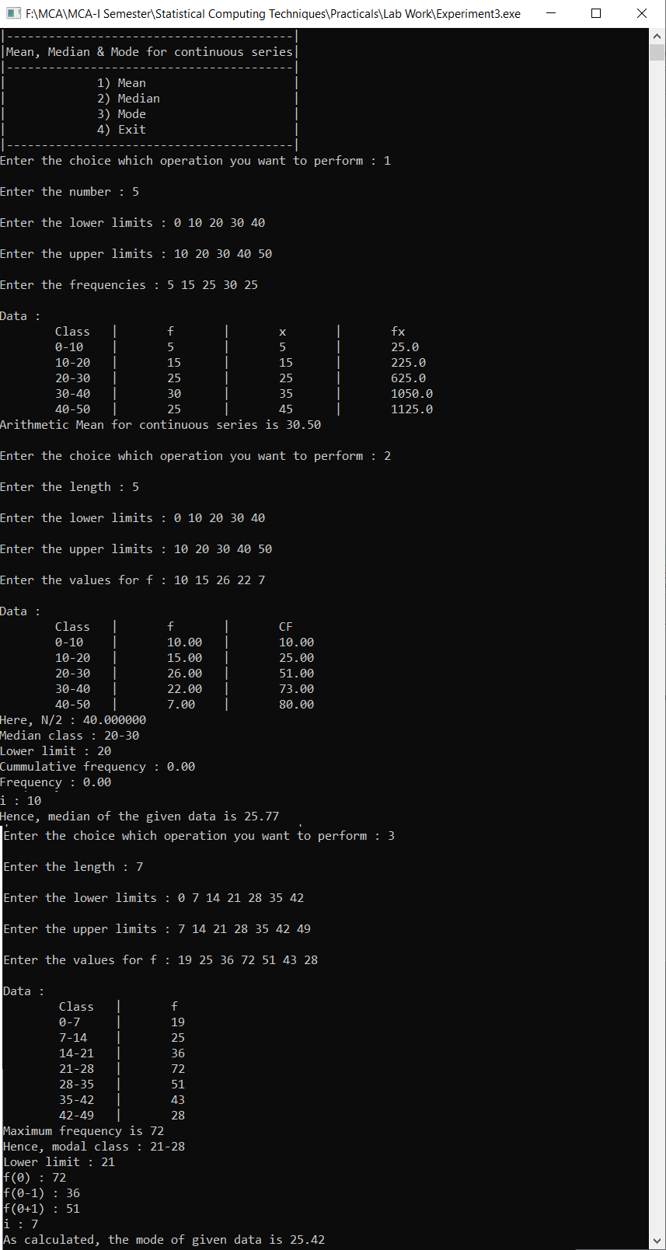 - Output:**

**Experiment-4: Program to calculate Geometric and Harmonic mean for discrete series.**

#include<stdio.h>

#include<math.h>

void GeometricMean()

{

int n, i;

float x[20], f[20], logx[20], f_logx[20], sum_f=0, sum_flogx=0, GM=0, val, l, al;

//Enter length

printf("\nEnter the length of series : ");

scanf("%d",&n);

//Enter values of x

printf("Enter values of x : ");

for(i=0; i<n; i++)

{

scanf("%f",&x[i]);

}

//Enter frequencies

printf("Enter frequencies : ");

for(i=0; i<n; i++)

{

scanf("%f",&f[i]);

sum_f += f[i];

}

//Log values of x i.e. log(x)

for(i=0; i<n; i++)

{

logx[i] = log10(x[i]);

}

//Calculate flog(x) and sum of flog(x)

for(i=0; i<n; i++)

{

f_logx[i] = f[i] * logx[i];

sum_flogx += f_logx[i];

}

//Print data

printf("\nData : ");

printf("\n x | f | logx | flogx ");

for(i=0; i<n; i++)

{

printf("\n %0.3f | %0.3f | %0.4f | %0.4f ", x[i], f[i], logx[i], f_logx[i]);

}

//Print sum of flogx

printf("\nSum of flogx : %0.4f",sum_flogx);

//Calculate Geometric Mean

val = sum_flogx / sum_f;

GM = pow(10, val);

printf("\nGeometric Mean of the above data is %0.3f\n",GM);

}

void HarmonicMean()

{

int n, i;

float x[20], f[20], fx[20], sum_f=0, sum_fx=0, HM;

//Enter length

printf("\nEnter the length of series : ");

scanf("%d",&n);

//Enter values of x

printf("\nEnter values of x : ");

for(i=0; i<n; i++)

{

scanf("%f",&x[i]);

}

//Enter frequencies

printf("\nEnter frequencies : ");

for(i=0; i<n; i++)

{

scanf("%f",&f[i]);

sum_f += f[i];

}

//Calculate f/x

for(i=0; i<n; i++)

{

fx[i] = f[i] / x[i];

sum_fx += fx[i];

}

//Print data

printf("\nData : ");

printf("\n x | f | f/x");

for(i=0; i<n; i++)

{

printf("\n %0.3f | %0.3f | %0.3f ", x[i], f[i], fx[i]);

}

//Harmonic Mean

HM = sum_f / sum_fx;

printf("\nHarmonic Mean is %0.3f\n",HM);

}

int main()

{

int choice;

printf("\n|--------------------------------------------------|");

printf("\n| GM and HM for discrete series |");

printf("\n|--------------------------------------------------|");

printf("\n| 1) Geometric Mean |");

printf("\n| 2) Harmonic Mean |");

printf("\n| 3) Exit |");

printf("\n|-------------------------------------------------|");

do

{

printf("\nEnter the choice which operation you want to perform : ");

scanf("%d",&choice);

switch(choice)

{

case 1:

GeometricMean();

break;

case 2:

HarmonicMean();

break;

case 3:

printf("\nExit!!");

break;

default:

printf("\nINVALID CHOICE! Please choose valid operation!");

break;

}

}while(choice!=4);

return 0;

}

**Experiment-4 - Output:**

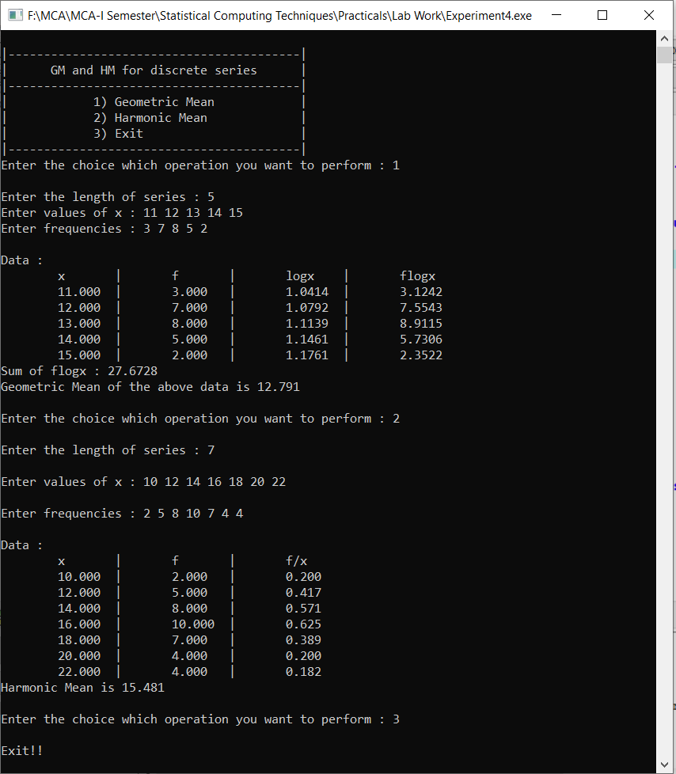

**Experiment-5: Program to calculate mean deviation from mean, median and mode in continuous series**

#include<stdio.h>

void MD_Mean()

{

int n, i, l[20], u[20], x[20], f[20], fx[20], x_mean[20], fx_mean[20], mean=0;

float MD=0, sum_f=0, sum_fx=0, sum_fx_mean=0;

printf("\nEnter the length : ");

scanf("%d",&n);

printf("\nEnter the lower limits : ");

for(i=0; i<n; i++)

{

scanf("%d",&l[i]);

}

printf("\nEnter the upper limits : ");

for(i=0; i<n; i++)

{

scanf("%d",&u[i]);

}

printf("\nEnter the values for f : ");

for(i=0; i<n; i++)

{

scanf("%d",&f[i]);

sum_f += f[i];

}

for(i=0; i<n; i++)

{

x[i] = (u[i] + l[i]) / 2;

fx[i] = f[i] * x[i];

sum_fx += fx[i];

}

mean = sum_fx / sum_f;

for(i=0; i<n; i++)

{

x_mean[i] = abs(x[i] - mean);

}

for(i=0; i<n; i++)

{

fx_mean[i] = f[i] * x_mean[i];

sum_fx_mean += fx_mean[i];

}

printf("\nData : ");

printf("\n Class | f | x | fx | u | fu");

for(i=0; i<n; i++)

{

printf("\n %d-%d | %d | %d | %d | %d | %d",l[i], u[i] , f[i], x[i], fx[i], x_mean[i], fx_mean[i]);

}

MD = sum_fx_mean / sum_f;

printf("\nMean deviation from mean of the above data is %0.2f",MD);

}

void MD_Median()

{

int n, i, row, CF, c_l, c_u, c_f, h;

int l[20], u[20], f[20], x[20], cf[20], x_median[20], fx_median[20], median=0;

float MD=0, sum_f=0, term=0, sum_fx_median=0;

printf("\nEnter the length : ");

scanf("%d",&n);

printf("\nEnter the lower limits : ");

for(i=0; i<n; i++)

{

scanf("%d",&l[i]);

}

printf("\nEnter the upper limits : ");

for(i=0; i<n; i++)

{

scanf("%d",&u[i]);

}

printf("\nEnter the values for f : ");

for(i=0; i<n; i++)

{

scanf("%d",&f[i]);

sum_f += f[i];

}

//Calculate cumulative frequency

cf[0] = f[0];

for(i=0; i<n; i++)

{

cf[i+1] = f[i+1] + cf[i];

}

h = u[0] - l[0];

term = sum_f/2;

for(i=0; i<n; i++)

{

if(term>cf[i])

{

row = i;

CF = cf[i];

c_f = f[i+1];

c_l = l[i+1];

c_u = u[i+1];

}

}

median = c_l + ((term - CF) / c_f) * h;

printf("\nHence, median of the given data is %d",median);

//Mid-point

for(i=0; i<n; i++)

{

x[i] = (u[i] + l[i]) / 2;

}

for(i=0; i<n; i++)

{

x_median[i] = abs(x[i] - median);

}

for(i=0; i<n; i++)

{

fx_median[i] = f[i] * x_median[i];

sum_fx_median += fx_median[i];

}

printf("\nData : ");

printf("\n Class | f | CF | x | u | fu");

for(i=0; i<n; i++)

{

printf("\n %d-%d | %d | %d | %d | %d | %d", l[i], u[i], f[i], cf[i], x[i], x_median[i], fx_median[i]);

}

MD = sum_fx_median / sum_f;

printf("\nMean deviation from median for the given data is %0.2f",MD);

}

void MD_Mode()

{

int n, i, j, row, c_l, c_u, c_f0, c_f1, c_f2, h, maxNum=0;

int l[20], u[20], f[20], x[20], x_mode[20], fx_mode[20], mode=0;

float MD=0, sum_f=0, term=0, sum_fx_mode=0;

printf("\nEnter the length : ");

scanf("%d",&n);

printf("\nEnter the lower limits : ");

for(i=0; i<n; i++)

{

scanf("%d",&l[i]);

}

printf("\nEnter the upper limits : ");

for(i=0; i<n; i++)

{

scanf("%d",&u[i]);

}

printf("\nEnter the values for f : ");

for(i=0; i<n; i++)

{

scanf("%d",&f[i]);

sum_f += f[i];

}

h = u[0] - l[0];

//Maximum frequency

for(i=1; i<n; i++)

{

if(f[i] > maxNum)

{

maxNum = f[i];

c_f0 = f[i];

row = i;

c_l = l[i];

c_u = u[i];

c_f1 = f[i-1];

c_f2 = f[i+1];

}

}

//Calculate mode

int a = c_f0 - c_f1;

int b = 2 * c_f0 - c_f1 - c_f2;

mode = c_l + a / (float)b * h;

printf("\nAs calculated, the mode of given data is %d", mode);

//Mid-point

for(i=0; i<n; i++)

{

x[i] = (u[i] + l[i]) / 2;

}

for(i=0; i<n; i++)

{

x_mode[i] = abs(x[i] - mode);

}

for(i=0; i<n; i++)

{

fx_mode[i] = f[i] * x_mode[i];

sum_fx_mode += fx_mode[i];

}

printf("\nData : ");

printf("\n Class | f | x | u | fu");

for(i=0; i<n; i++)

{

printf("\n %d-%d | %d | %d | %d | %d", l[i], u[i], f[i], x[i], x_mode[i], fx_mode[i]);

}

MD = sum_fx_mode / sum_f;

printf("\nMean deviation from mode for the given data is %0.2f", MD);

}

int main()

{

int choice;

printf("\n|-----------------------------------------------------------------------------------------|");

printf("\n| Mean Deviation from Mean, Median & Mode for continuous series|");

printf("\n|-----------------------------------------------------------------------------------------|");

printf("\n| 1) Mean Deviation from Mean |");

printf("\n| 2) Mean Deviation from Median |");

printf("\n| 3) Mean Deviation from Mode |");

printf("\n| 4) Exit |");

printf("\n|-----------------------------------------------------------------------------------------|");

do

{

printf("\nEnter the choice which operation you want to perform : ");

scanf("%d",&choice);

switch(choice)

{

case 1:

MD_Mean();

break;

case 2:

MD_Median();

break;

case 3:

MD_Mode();

break;

case 4:

printf("\nExit!!");

break;

default:

printf("\nINVALID CHOICE! Please choose valid operation!");

break;

}

}while(choice!=4);

return 0;

}

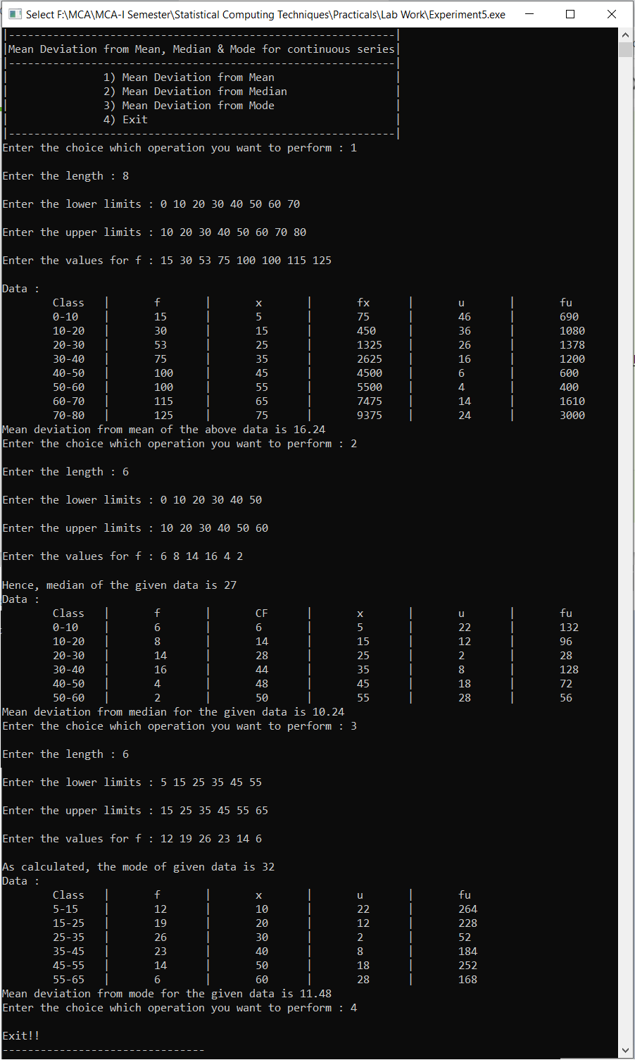**Experiment-5 - Output:**

**Experiment-6: Program to calculate standard deviation for continuous series by step-deviation method**

#include<stdio.h>

#include<math.h>

int main()

{

int n, i, a_mean, h;

int l[20], up[20], x[20], f[20], fx[20], u[20], uu[20], fu[20], fuu[20];

float SD=0, sum_f=0, sum_fu=0, sum_fuu=0, val=0;

printf("\nEnter the length : ");

scanf("%d",&n);

printf("\nEnter the lower limits : ");

for(i=0; i<n; i++)

{

scanf("%d",&l[i]);

}

printf("\nEnter the upper limits : ");

for(i=0; i<n; i++)

{

scanf("%d",&up[i]);

}

h = up[0] - l[0];

printf("\nEnter the values for f : ");

for(i=0; i<n; i++)

{

scanf("%d",&f[i]);

sum_f += f[i];

}

//Mid-point

for(i=0; i<n; i++)

{

x[i] = (up[i] + l[i]) / 2;

}

printf("\nAssume mean : ");

scanf("%d",&a_mean);

//Calculate u, fu, sum_fu, u2, fu2, sum_fu2

for(i=0; i<n; i++)

{

u[i] = (x[i] - a_mean) / h;

fu[i] = f[i] * u[i];

sum_fu += fu[i];

uu[i] = u[i] * u[i];

fuu[i] = f[i] * uu[i];

sum_fuu += fuu[i];

}

printf("\nData : ");

printf("\n Class | f | x | u | u*u | fu | fu*u");

for(i=0; i<n; i++)

{

printf("\n %d-%d | %d | %d | %d | %d | %d | %d", l[i], up[i], f[i], x[i], u[i], uu[i], fu[i], fuu[i]);

}

val = (sum_fuu / sum_f) - ((sum_fu / sum_f) * (sum_fu / sum_f));

SD = sqrt(val) * h;

printf("\nStandard deviation for the given data is %0.2f", SD);

return 0;

}

**Experiment-6 - Output:**

