A

Project Report on

**AI-Powered E-commerce Product Recommendation System**

Presented by Miss. Mustare Mayuri Mr. Sumthankar Nakul

Mr. Gulam Mujtaba Quadri

[BTech. CSE]

Computer Science and Engineering 2024-2025

Guided By

**Miss. Pande Nikita**

(Department of Computer Science and Engineering)

**Submitted to**



**Intel® Unnati Program**

**Table of Contents**

|  |  |
| --- | --- |
| **Content** | **Page. No** |
| **1. Introduction** | **1** |
| * 1.1 Background | 1 |
| * 1.2 Purpose & Objectives | 1 |
| **2. Working of the Algorithm** | **2** |
| * 2.1 Gathering Information | 2 |
| * 2.2 Data Cleaning & Preprocessing | 2 |
| * 2.3 Recognition of Patterns | 2 |
| * 2.4 Generation of Suggestions | 2 |
| * 2.4.1 Behavior of the User | 3 |
| * 2.4.2 Association Rules (Market Basket Analysis) | 3 |
| * 2.5 Dynamic Price Calculation | 3 |
| * 2.6 User Interface & Visualization | 3 |
| * 2.7 Final Product Recommendations & Checkout | 3 |
| **3. Technical Stack of the Project** | **4** |
| * 3.1 Frontend: User Interface with Streamlit | 4 |
| * 3.2 Backend: Business Logic in Python | 4 |
| * 3.3 Data Handling: Pandas for Processing | 4 |
| * 3.4 Visualization: Matplotlib & Plotly | 4 |
| * 3.5 Database: CSV Files for Data Storage | 5 |
| * 3.6 AI-Powered Recommendation Algorithm | 5 |
| **4. Impact & Benefits** | **6** |
| * 4.1 Enhanced User Experience | 6 |
| * 4.2 Data-Driven Sales Strategy | 6 |
| * 4.3 Improved Decision-Making Based on Insights | 6 |
| * 4.4 GST Calculation & Compliance Automation | 6 |
| **5. Conclusion & Future Enhancements** | **7** |
| * 5.1 Conclusion | 7 |
| * 5.2 Future Enhancements | 7 |
| * 5.2.1 Real-Time User Behavior Monitoring | 7 |
| * 5.2.2 AI Chatbot for Product Support | 7 |
| * 5.2.3 External API Support for Price Updates | 7 |
| * 5.2.4 Enhanced Machine Learning Models | 7 |
| * 5.2.5 Multi-Platform Support | 7 |
| **6. References** | **8** |

**List of Figures**

|  |  |
| --- | --- |
| **Figure** | **Page. No** |
| 2. Workflow Diagram | 2 |

# Introduction

In the contemporary digital era, shopping websites contain millions of different items, making product searching a daunting task for users. At the same time, businesses also suffer from problems related to getting their products advertised to the correct audience. Artificial Intelligence (AI), can assist in solving these problems making itself one of the key components in improving the e–commerce experience.

Our AI powered E-commerce Product Recommendation System makes online shopping easier by providing intelligent suggestions. This system leverages AI to personalize product recommendations by analyzing purchase data, identifying trending items, and customizing suggestions for every user. Customers get to find the best products and businesses get to improve customer engagement and sales by using AI and data-driven recommendations.

* 1. **Background:** Every day, online marketplaces create a significant amount of data. If not properly analyzed, this data will be left undone. Unlike modern AI strategies that can customize recommendations according to behavior changes, traditional e-commerce suggestions were based on preset recommendations. Our system rectify this problem by providing tailored suggestions in real time based on prior purchases and current market activities.
  2. **Purpose & Objectives:** The main objective of our system is smart product recommendation that will enrich the user shopping experience. The primary goals of this project are as follows:

Assisting users in finding important and currently popular products at the lowest amount of work possible.

* + - Using sales data analysis to target the best-selling items.
    - Giving users tailored recommendations depending on their shopping habits.
    - Using smart insights to make engaging customers and increasing sales effortless.
    - Maintaining accurate pricing transparent by adding real-time GST charges.
    - This system eases the process of online shopping for users and marketing it for business making it easier, data oriented and more efficient.

# Working of the Algorithm

The recommendation system leverages artificial intelligence to follow a precise procedure to study purchase activity of users, determine the best selling items and make wise suggestions. The algorithm functions in several vital stages:

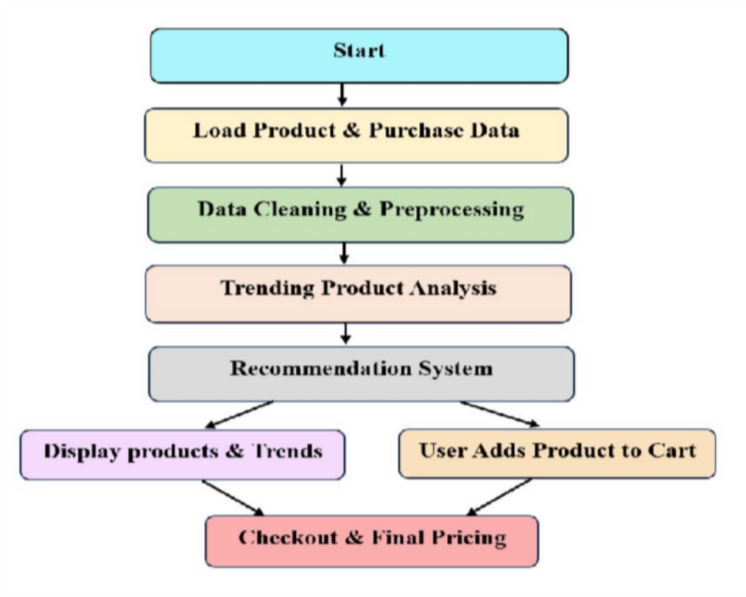

## Fig. 2. Workflow Diagram

* 1. **Gathering Information:**

The data system utilizes records of purchases, user’s navigation activities together with the products information from already existing databases. The dataset helps track patterns and suggest appropriate actions.

## Data Cleaning & Preprocessing:

* + - The dataset might have some omissions or some repeats which have to be sorted out.
    - The items are placed into groups depending on their features such as brand, type of goods, and price.
    - Tampered records and data that do not match the focus of the research are filtered out.

## Recognition of Patterns:

* + - The system checks the counts of sales done for every single item.
    - It pinpoints the most trending items through studying previously recorded sales data.
    - It plots a dynamic bar chart that shows the identified best-selling items.

## Generation of Suggestions:

The user suggestions are developed on the basis of:

* **2.4.1 Behavior of the user:** Suggestions are based on items bought together by like-minded users.

Type of Suggestion: While a user browses some item under certain class, items within the same range or other related items selected are also displayed.

* **2.4.2 Association Rules (Market Basket Analysis):** If a substantial number of buyers purchase A and also B, the system automatically

## Dynamic Price Calculation:

The system makes an automatic 18% GST calculation to facilitate price transparency.

The real-time updated total cost enables users to make informed decisions while making a purchase.

## User Interface & Visualization:

An interactive interface constructed on Streamlit enables easy user navigation through recommendations. Users can effortlessly select recommended products as they are showcased in bar charts.

User engagement is responsive, so all recommendations are intended to be automatically updated throughout the user session.

## Final Product Recommendations & Checkout:

The system automates suggestion completion with observed purchasing activity of the user.

Customers are able to load products into their shopping carts and see the order amount with the included Goods and Services Tax (GST).

Before completing the purchase, users are provided with clear details about the order to ensure there are no misunderstandings.

# ​Technical Stack of the Project

The project incorporates various modern technologies and frameworks to increase efficiency, scalability, and simplicity. The technical stack includes:

* 1. **Frontend:** User Interface with Streamlit

Streamlit is a modern framework written in Python which enables Users to develop interactive UI components in Web Applications and is capable of rapidly building UIs .

It can easily be implemented with minimal code necessary for deployment and a bang, up it goes. Furthermore, it provides support for updates and data visualization in real time.

The Key Features Implemented in Streamlit Include:

* + - Shows off multiple trending products through bar chart displays.
    - Provides a friendly zone interface clean and easy to implement a product recommendation.
    - Supports interactive product selection and checkout feature.
  1. **Backend:** Business Logic Done in Python

Machine Learning, web development, and data processing are just some pieces of the rich library for python. Backend Functionality consists of:

* + - Data Processing: Uses Pandas for various dataset handling.
    - Recommendation Algorithm: Does an analysis towards user's preference purchases.
    - Price Calculation: Automatically set the price amount incorporating the 18% GST tax.
  1. **Data Handling:** Data Processing Using Pandas.

Provides support for manipulation masters of structured data analysis. Key Features in Pandas Used include:

* + - Data Cleansing ridded of missing and inconsistent values:
    - Turned raw purchase records into a structured format during data transformation.
    - Extracts list of displayed products and orders during sorting and filtering
  1. **Visualization:** Matplotlib & Plotly for Graphs:

Matplotlib is a popular Python library for dynamic and static visualization. Plotly has interactive chart support, increasing the level of engagement in product trend analysis.

Features Implemented:

* + - Bar Charts: Visualize products that are currently trending with update in real time.
    - Category-Based Insights: Present top-selling items in a category.
    - User Interaction: Allows customers to explore suggestions visually.
  1. **Database:** CSV Files for Data Storage:

As the project mostly deals with the analysis of structured sales data, CSV files provide ease and flexibility. CSV format provides ease of integration with Pandas for quick data retrieval and processing.

How Data is Managed?

* + - Product Database: Stores product information such as name, category, and price.
    - Purchase History: Tracks customer purchases for trend analysis.
    - User Preferences: Stores product choices for customized recommendations.

## AI-Powered Recommendation Algorithm

Core Concept:

* + - Employing sales trend analysis and market basket analysis to determine recommended products.
    - Uses a ranking approach to indicate most appropriate items.

Recommendation Approaches Applied:

* + - Collaborative Filtering: Identifies the users with similar patterns of buying.
    - Content-Based Filtering: Presumes products having similarity in terms of categories.
    - Top-Selling Trends: Makes suggestions based on frequent sales as a whole.

# ​Impact & Benefits

The deployment of this AI-based recommendation system has several benefits for customers and businesses alike. It improves online shopping experiences, enhances sales efficiency, and offers useful insights for decision-making. The following are the detailed effects and advantages of the system.

## Enhanced User Experience

* + - Personalized Recommendations: Users are given product recommendations that are specific to their interests and previous purchases.
    - Improved Navigation: Simplified online shopping experience through intuitive UI design and convenient product exploration.
    - Quicker Decision-Making: Customers can easily discover best-rated and best-selling products without prolonged searching.

## Data-Driven Sales Strategy

* + - Maximized Inventory Management: Companies can stock best-selling products based on consumer shopping behavior.
    - Targeted Marketing Campaigns: Insight from data aids in running promotional schemes and advertisements around trending products.
    - Greater Customer Retention: Personalized experiences promote repeat business and sustained engagement.

## Improved Decision-Making Based on Insights

* + - Dynamic Sales Reports: Owners can study product trends and make price adjustments accordingly.
    - Visual Product Trends: Graphical displays assist in comprehending seasonal shopping patterns.
    - AI-Powered Predictions: Upcoming purchase trends can be predicted, allowing companies to remain ahead of market needs.

## GST Calculation & Compliance Automation

* + - Correct Tax Calculations: Guarantees that all products show accurate final prices with 18% GST added.
    - Transparent Customer Pricing: Ensures customers comprehend tax-inclusive prices prior to buying.
    - Compliance with Regulations: Facilitates tax administration for businesses through the automation of the GST application process.

# ​Conclusion & Future Enhancements

## Conclusion

The AI-Powered E-commerce Recommendation System has been able to change the way online consumers find products by utilizing AI-powered insights. Through the analysis of buying patterns and customer tendencies, the system offers customized suggestions and maximizes user interaction. The use of AI, data visualization, and automated GST calculation provides both business efficiency and a hassle-free user experience.

In addition, this system not just simplifies product discovery but also equips businesses with data-driven decision- making abilities. Through insights on user behavior and sales trends, businesses can maximise their marketing efforts, enhance inventory management, and adapt their offerings to suit customer needs efficiently. With AI evolving further, the recommendation system can increasingly drive higher levels of personalization, render shopping experiences more compelling and intuitive, and drive long-term customer loyalty and business expansion.

## Future Enhancements

The system can be enhanced further by adding more features and extending its capabilities. The following future advancements will improve its performance:

### 5.2.1 Real-Time User Behavior Monitoring

Implement monitoring mechanisms to review real-time user interactions. Dynamically update recommendations according to browsing history.

### 5.2.2 AI Chatbot for Product Support

Implement an AI chatbot to offer product suggestions and facilitate users in making a purchase Implement voice-based shopping assistance for improved accessibility.

### 5.2.3 External API Support for Price Updates

Integrate with third-party APIs to retrieve current product prices from different vendors. Compare prices in real-time and offer the best value to customers

### 5.2.4 Enhanced Machine Learning Models

Integrate deep learning models to enhance the accuracy of recommendations. Train the models on a larger dataset to learn varied buying habits.

### 5.2.5 Multi-Platform Support

Expand the system to support mobile apps and browser extensions.

# References

* Aggarwal, C. C. (2016). Recommender Systems: The Textbook. Springer.
* Ricci, F., Rokach, L., & Shapira, B. (2015). Recommender Systems Handbook. Springer.
* Linden, G., Smith, B., & York, J. (2003). Amazon.com Recommendations: Item-to-Item Collaborative Filtering. IEEE Internet Computing.
* Chen, L., Wu, W., & He, L. (2020). Personalized E-commerce Recommendation Systems: A Review and Future Directions. International Journal of Information Management.
* Forrester Research. (2021). AI in E-commerce: Driving Personalization and Sales Growth.