An Internship Report
Of
AI and Machine Learning
Submitted
To
School of Computer Science and Engineering
IILM University, Greater Noida, U.P.
In partial fulfilment of the requirement of degree of
B-Tech (CSE)

By
Roll Number of Student:- 25SCS1003002425
Name of Student: MAYURI SHARMA
Batch: 2025–29

CANDIDATE'S DECLARATION
I, MAYURI SHARMA, do hereby declare that the internship report titled “Machine Learning Internship” has been completed by me to fulfil the requirement for the award of the degree of Bachelor of Technology in Computer Science and Engineering. The work presented in this report is based on the learning activities and tasks undertaken during my internship with InAmigos Foundation. I have used references wherever required and have not knowingly reproduced material from any other source without acknowledgement. I affirm that this report is my own work and has not been submitted to any other institute for any degree or diploma requirement, and I shall be solely responsible for any kind of copyright violation in this regard.
Signature:-

Student Name: MAYURI SHARMA

Roll No.: 25SCS1003002425

ACKNOWLEDGEMENT
I am using this opportunity to express my gratitude to everyone who supported me throughout the Internship Program. I am thankful for their guidance, constructive feedback and encouragement during the completion of this work. The internship provided me with an opportunity to understand the foundations of Artificial Intelligence and Machine Learning through simple, practical learning activities.
I would like to thank InAmigos Foundation for providing me the opportunity to undertake a Machine Learning Internship and for assigning learning tasks that helped me explore fundamental concepts, real-life applications and beginner-friendly Machine Learning tools. I am also thankful to my institute, IILM University, Greater Noida, and the faculty of the School of Computer Science and Engineering for their continuous support and encouragement.
I express my gratitude to my parents for their blessings and support.
Signature:

Student Name: MAYURI SHARMA

Roll No.: 25SCS1003002425

TABLE OF CONTENTS
1. Candidate's Declaration i
2. Acknowledgement ii
3. Internship Completion Certificate -
4. Internship Offer Letter -
5. Project Description 1
5.1 Introduction 1
5.2 Organization Profile 1
5.3 Internship Objectives 2
5.4 Task 1 – Understanding AI & Machine Learning 2
5.5 Task 2 – How Machines Learn 3
5.6 Task 3 – Machine Learning Model Exploration 4
5.7 Task 4 – AI & ML in the Real World 5
5.8 Overall Learning Outcomes 8
6. Bibliography/References 8

INTERNSHIP COMPLETION CERTIFICATE
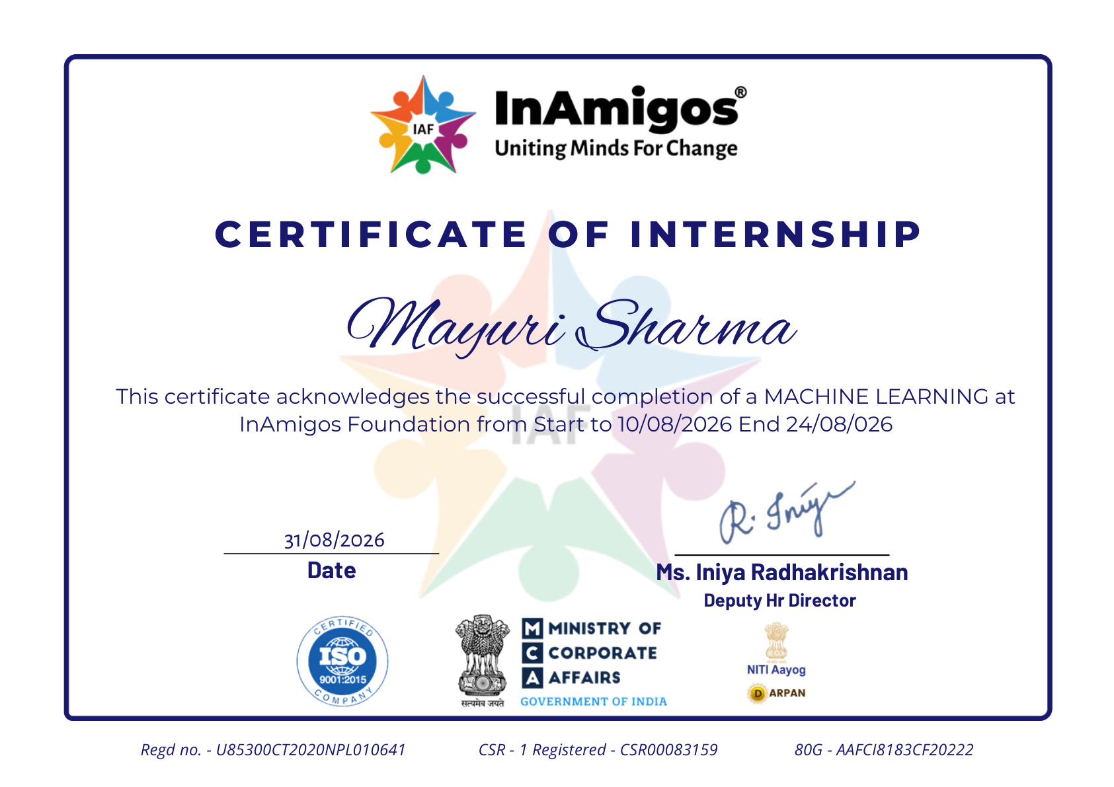

Internship Offer Letter
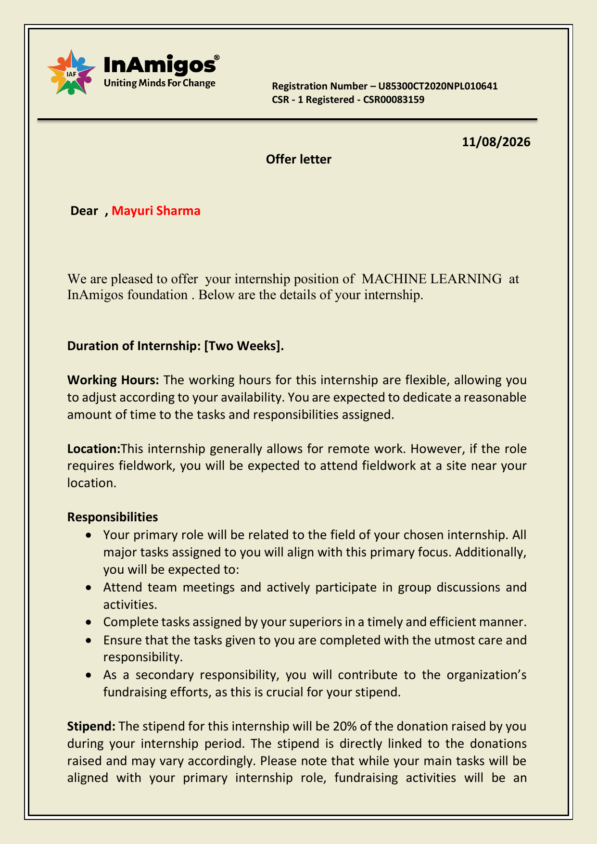

5. PROJECT DESCRIPTION
5.1 Introduction
This report presents a detailed account of the Machine Learning Internship undertaken by Mayuri Sharma at InAmigos Foundation. The internship offer letter dated 11/08/2026 identifies the internship position as MACHINE LEARNING and specifies a duration of two weeks. The internship generally allows remote work with flexible working hours, while the assigned responsibilities are aligned with the selected internship field.
The learning activities documented in this report focus on four beginner-friendly tasks: understanding core Artificial Intelligence and Machine Learning concepts, exploring how machines learn from examples, exploring a no-code/low-code Machine Learning platform, and identifying practical real-world problems that can be improved using AI or ML. The objective is to build a clear conceptual foundation rather than to claim advanced model development or production deployment.
5.2 Organization Profile
InAmigos Foundation is the organization named in the internship offer letter. The offer letter states that the internship is generally remote, with fieldwork possible when required. It also states that interns are expected to attend team meetings, participate in group discussions and activities, complete assigned tasks responsibly and on time, and maintain professionalism, confidentiality and compliance with foundation policies. The offer letter also describes a stipend arrangement linked to donations raised; fundraising is stated to be optional for achieving a completion certificate.
The organization-specific information included here is limited to what is available in the provided offer letter. No additional organizational claims have been added without supporting material.
5.3 Internship Objectives
- Build a basic understanding of Artificial Intelligence, Machine Learning and major learning paradigms.
- Understand, through simple examples, how Machine Learning systems use data and examples to make predictions or decisions.
- Explore a beginner-friendly no-code/low-code Machine Learning platform and understand the general model-training workflow.
- Identify practical problems where AI or ML can support people, organizations and everyday services.
- Develop the ability to explain Machine Learning concepts in simple, accurate and professional language.
5.4 Task 1 – Understanding AI & Machine Learning
Objective: To build a basic understanding of how Artificial Intelligence and Machine Learning work. The following concepts form a simple progression from the broad idea of AI to different ways in which Machine Learning systems can learn.
Concept | Simple Explanation | Example
Artificial Intelligence (AI) | A broad field of computing concerned with building systems that can perform tasks that normally require human-like intelligence, such as understanding language, recognizing patterns or making decisions. | A voice assistant can understand a spoken request and respond to it.
Machine Learning (ML) | A subset of AI in which a system learns patterns from data and uses those patterns to make predictions or decisions instead of being programmed with every rule explicitly. | An email service can learn from examples of spam and non-spam messages to classify new emails.
Deep Learning | A branch of Machine Learning that uses multi-layer neural networks to learn complex patterns, especially from large or high-dimensional data. | A deep-learning image model can learn visual patterns useful for recognizing objects in photographs.
Supervised Learning | A learning approach in which the model is trained using examples that contain both input data and the correct output or label. | A model can learn from past house records with known prices and then estimate the price of a new house.
Unsupervised Learning | A learning approach in which the data does not contain predefined labels, so the system looks for useful patterns or groups on its own. | A business can group customers into segments based on similarities in their purchasing behaviour.
Reinforcement Learning | A learning approach in which an agent interacts with an environment and learns by receiving rewards or penalties for its actions. | A game-playing agent can learn which actions lead to higher scores by repeatedly interacting with the game.
Simple relationship: Artificial Intelligence is the broadest area; Machine Learning is one way of building AI systems; Deep Learning is a specialized approach within Machine Learning. Supervised, unsupervised and reinforcement learning describe different ways a Machine Learning system can learn from data or interaction.
5.5 Task 2 – How Machines Learn
Machine Learning systems learn patterns from examples and use them to make predictions or decisions.
1. Movie Recommendations — learns from watch history and ratings to suggest movies a user may enjoy.
2. Spam Email Detection — learns from examples of spam and normal emails to classify new messages.
3. Face Recognition — learns visual patterns from example face images to support identity or similarity decisions.
5.6 Task 3 – Machine Learning Model Exploration
Tool: Google Teachable Machine, a beginner-friendly no-code/low-code Machine Learning platform.
Demonstration: Face-with-Mask classification using the categories “With Mask” and “Without Mask”.
Workflow: provide example images → train the model → test it with a new face image → observe the predicted class.
Learning: The activity demonstrated how labelled examples can train a simple image-classification model.
Note: No accuracy percentage or measured result is claimed because no numerical experiment record was provided.
5.7 Task 4 – AI & ML in the Real World
AI and ML can improve real-world activities through prediction, classification and automation.
1. Healthcare Support
AI/ML can assist with medical-image analysis and risk prediction. Challenges include accuracy, privacy and human oversight.
2. Fraud Detection
ML can identify unusual transaction patterns and flag possible fraud. False alarms and changing fraud patterns are challenges.
3. Traffic Management
AI/ML can analyse traffic data to predict congestion and support route or signal decisions.
4. Personalized Education
ML can analyse learning activity and recommend suitable practice or content. Privacy and fairness are important.
5. Agricultural Monitoring
AI can analyse crop images and sensor data to identify possible crop stress or disease. Weather and data quality affect performance.
5.8 Overall Learning Outcomes
- Understood the distinction between Artificial Intelligence, Machine Learning and Deep Learning.
- Learned the basic ideas behind supervised, unsupervised and reinforcement learning.
- Understood that Machine Learning systems depend on examples and data to learn useful patterns.
- Explored a beginner-friendly no-code/low-code workflow for training and testing a simple Machine Learning model.
- Learned why data quality, representativeness, privacy, fairness and human oversight matter in practical AI systems.
- Identified five real-world problem areas where AI/ML can provide decision support or automation while also recognizing important limitations.
Overall, the internship activities provided a beginner-level foundation for understanding how Machine Learning moves from data and examples to predictions or decisions. The tasks also highlighted that successful AI applications depend not only on algorithms, but also on suitable data, responsible use, evaluation and human oversight.
6. BIBLIOGRAPHY/REFERENCES
1. InAmigos Foundation, “Internship Offer Letter,” dated 11/08/2026, provided as part of the internship materials.
2. Google, “Teachable Machine,” official no-code Machine Learning learning platform.
3. IBM, “What is Artificial Intelligence (AI)?”, educational reference.
4. IBM, “What is Machine Learning?”, educational reference.
5. Google for Developers, “Machine Learning Crash Course,” introductory reference.
6. National Institute of Standards and Technology (NIST), “Artificial Intelligence Risk Management Framework.”

