**Lab-3**

**1.Write a query to display the first day of the month (in datetime format) three months before the current month. Sample current date : 2014-09-03 Expected result : 2014-06-01**

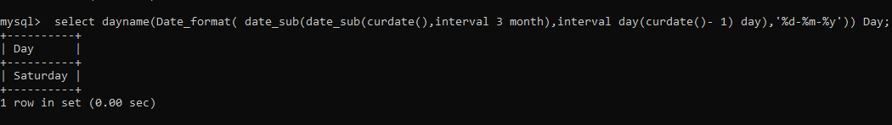

**2.Write a query to display the last day of the month (in datetime format) three months before the current month.**

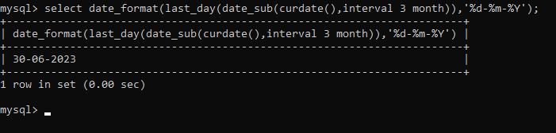

**3. Write a query to get the distinct Mondays from hiredate in emp tables**

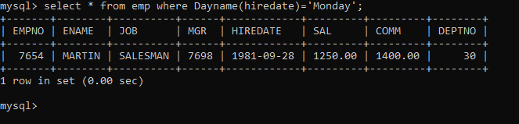

**4.Write a query to get the first day of the current year.**

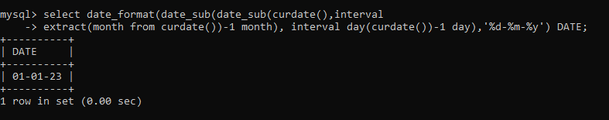

**5. Write a query to get the last day of the current year.**