Maven-Hibernate-Eclipse
Step1: open eclipse-ide
Step2:Click on New, Select File,Select Maven Project.
Step-3
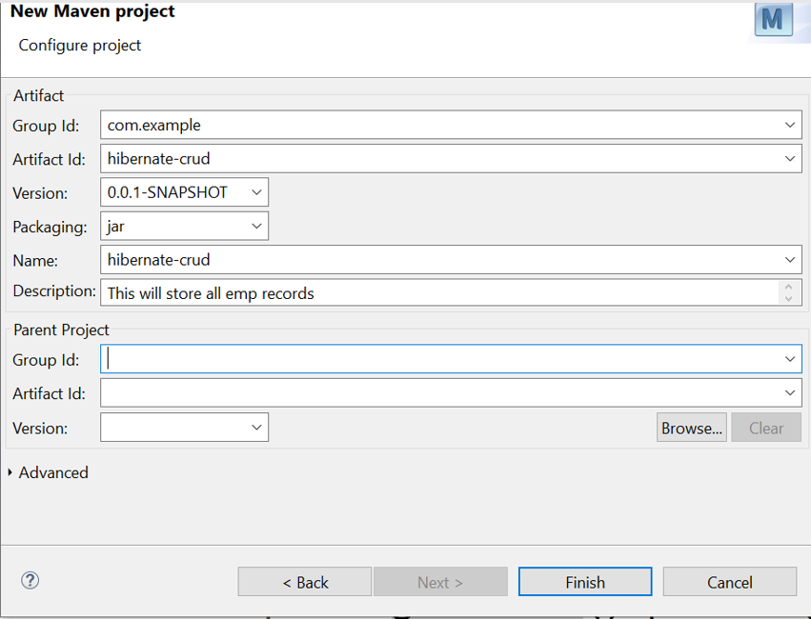
Step-4:
Click on Finish.
Step:5 Open pom.xml .This pom.xml file control the Entire project.
Step6:Update the dependency in pom.xml
Step6.1:In the google type Maven Hibernate dependency
Select version 7.1.8
Select Maven
Select dependencies
Copy the the dependencies AND Paste in pom.xml

Step7: https://mvnrepository.com/artifact/org.hibernate/hibernate-core/7.1.8.Final
Step 8:Verify whether the dependency has been included in project or not
Step 9:How to verify
9.1 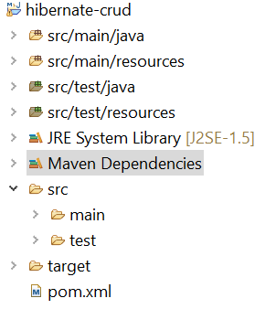

S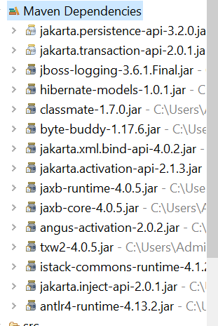

Step10:
Open the following link
https://www.tutorialspoint.com/hibernate/hibernate_configuration.htm
copy the doc type and paste in the configuaration file.
Step11:

Create the following files in src/main/java.
Create Employee.java
Create Empsave1.java

import java.util.List;
import java.util.Scanner;

import org.hibernate.Query;
import org.hibernate.Session;
import org.hibernate.SessionFactory;
import org.hibernate.Transaction;
import org.hibernate.cfg.Configuration;

public class EmpSave1{
public static void main(String[] args) {
// Load Hibernate Configuration

//Configuration cfg = new Configuration().configure();
//SessionFactory sf = cfg.buildSessionFactory();
// Session session = sf.openSession();

Configuration cfg = new Configuration();
cfg.configure("/hibernate.cfg.xml");
// cfg.addAnnotatedClass(Emp.class); // Ensure Hibernate knows about Emp
SessionFactory sf = cfg.buildSessionFactory();
Session session = sf.openSession();
Scanner sc = new Scanner(System.in);

while (true) {
System.out.println("\n1. Insert Employee");
System.out.println("2. Display Employee by ID");
System.out.println("3. Delete Employee");
System.out.println("4. Update Employee");
System.out.println("5. Display All Employees");
System.out.println("6. Exit");
System.out.print("Enter your choice: ");
int option = sc.nextInt();

switch (option) {
case 1:
// Insert Employee
System.out.print("Enter Ename: ");
sc.nextLine();
String ename = sc.nextLine();
System.out.print("Enter Salary: ");
double sal = sc.nextDouble();
sc.nextLine();
System.out.print("Enter Designation: ");
String desig = sc.nextLine();

Employee emp = new Employee(0,ename,sal,desig);
Transaction tx = session.beginTransaction();
session.save(emp);
tx.commit();
System.out.println("Employee Inserted Successfully.");
break;

case 2:
// Display Employee
System.out.print("Enter Employee ID: ");
int eid = sc.nextInt();
Employee e = session.get(Employee.class, eid);
if (e != null) {
System.out.println(e);
} else {
System.out.println("Employee not found!");
}
break;

case 3:
// Delete Employee
System.out.print("Enter Employee ID to Delete: ");
eid = sc.nextInt();
e = session.get(Employee.class, eid);
if (e != null) {
tx = session.beginTransaction();
session.delete(e);
tx.commit();
System.out.println("Employee Deleted Successfully.");
} else {
System.out.println("Employee not found!");
}
break;

case 4:
// Update Employee
System.out.print("Enter Employee ID to Update: ");
eid = sc.nextInt();
e = session.get(Employee.class, eid);
if (e != null) {
System.out.print("Enter New Ename: ");
sc.nextLine();
ename = sc.nextLine();
System.out.print("Enter New Salary: ");
sal = sc.nextDouble();
sc.nextLine();
System.out.print("Enter New Designation: ");
desig = sc.nextLine();

e.setEname(ename);
e.setEsal(sal);
e.setDesig(desig);

tx = session.beginTransaction();
session.update(e);
tx.commit();
System.out.println("Employee Updated Successfully.");
} else {
System.out.println("Employee not found!");
}
break;

case 5:
// Display All Employees
Query query = session.createQuery("FROM Employee");
List<Employee> empList = query.list();
System.out.println("\n******** Employee List ********");
for (Employee empObj : empList) {
System.out.println(empObj);
}
System.out.println("********************************");
break;

case 6:
// Exit
System.out.println("Exiting...");
session.close();
sf.close();
sc.close();
System.exit(0);

default:
System.out.println("Invalid Option! Try Again.");
}
}
}

}

Create Employee.java

public class Employee {
private int eid;
private String ename;
private double esal;
private String desig;

public Employee() {
super();
// TODO Auto-generated constructor stub
}

public Employee(int eid, String ename, double esal, String desig) {
super();
this.eid = eid;
this.ename = ename;
this.esal = esal;
this.desig = desig;
}

public int getEid() {
return eid;
}

public void setEid(int eid) {
this.eid = eid;
}

public String getEname() {
return ename;
}

public void setEname(String ename) {
this.ename = ename;
}

public double getEsal() {
return esal;
}

public void setEsal(double esal) {
this.esal = esal;
}

public String getDesig() {
return desig;
}

public void setDesig(String desig) {
this.desig = desig;
}

@Override
public int hashCode() {
final int prime = 31;
int result = 1;
result = prime * result + ((desig == null) ? 0 : desig.hashCode());
result = prime * result + eid;
result = prime * result + ((ename == null) ? 0 : ename.hashCode());
long temp;
temp = Double.doubleToLongBits(esal);
result = prime * result + (int) (temp ^ (temp >>> 32));
return result;
}

@Override
public boolean equals(Object obj) {
if (this == obj)
return true;
if (obj == null)
return false;
if (getClass() != obj.getClass())
return false;
Employee other = (Employee) obj;
if (desig == null) {
if (other.desig != null)
return false;
} else if (!desig.equals(other.desig))
return false;
if (eid != other.eid)
return false;
if (ename == null) {
if (other.ename != null)
return false;
} else if (!ename.equals(other.ename))
return false;
if (Double.doubleToLongBits(esal) != Double.doubleToLongBits(other.esal))
return false;
return true;
}

@Override
public String toString() {
return "Employee [eid=" + eid + ", ename=" + ename + ", esal=" + esal + ", desig=" + desig + "]";
}

}
Emp.hbm.xml:
<?xml version = "1.0" encoding = "utf-8"?>
<!DOCTYPE hibernate-mapping PUBLIC
"-//Hibernate/Hibernate Mapping DTD//EN"
"http://www.hibernate.org/dtd/hibernate-mapping-3.0.dtd">
<hibernate-mapping>
<class name="Employee" table="emp">
<id name="eid">
<generator class="increment"/>
</id>
<property name="ename"/>
<property name="esal"/>
<property name="desig"/>

</class>
</hibernate-mapping>

Hibernate.cfg.xml

<?xml version='1.0' encoding='UTF-8'?>
<!DOCTYPE hibernate-configuration PUBLIC
"-//Hibernate/Hibernate Configuration DTD 5.3//EN"
"http://hibernate.org/dtd/hibernate-configuration-3.0.dtd">
<hibernate-configuration>
<session-factory>
<property name="connection.driver_class">com.mysql.jdbc.Driver</property>
<property name="connection.url">jdbc:mysql://localhost:3306/empdb</property>
<property name="connection.username">root</property>
<property name="connection.password"></property>
<property name="hibernate.dialect">org.hibernate.dialect.MySQL8Dialect</property>
<property name="hbm2ddl.auto">update</property>
<property name="show_sql">true</property>

<mapping resource="Emp.hbm.xml"/>
</session-factory>
</hibernate-configuration>

Pom.xml
<project xmlns="http://maven.apache.org/POM/4.0.0" xmlns:xsi="http://www.w3.org/2001/XMLSchema-instance" xsi:schemaLocation="http://maven.apache.org/POM/4.0.0 https://maven.apache.org/xsd/maven-4.0.0.xsd">
<modelVersion>4.0.0</modelVersion>
<groupId>com.example</groupId>
<artifactId>hibernate-crud</artifactId>
<version>0.0.1-SNAPSHOT</version>
<name>hibernate-crud</name>
<description>This will store all emp records</description>
<dependencies>
<!-- https://mvnrepository.com/artifact/org.hibernate/hibernate-core -->
<dependency>
<groupId>org.hibernate</groupId>
<artifactId>hibernate-core</artifactId>
<version>5.6.15.Final</version>
</dependency>
<!-- https://mvnrepository.com/artifact/mysql/mysql-connector-java -->
<dependency>
<groupId>mysql</groupId>
<artifactId>mysql-connector-java</artifactId>
<version>8.0.30</version>
</dependency>
</dependencies>
</project>

