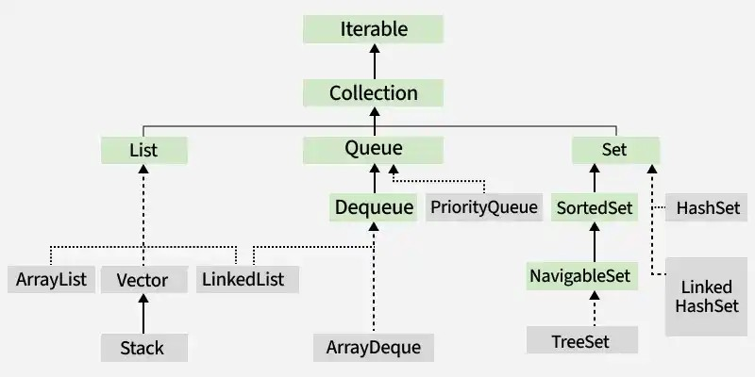

ArrayList
Category | Method Signature | Example Syntax | Description
➕ Add | boolean add(E e) | list.add(10); | Adds element at end
 | void add(int index, E element) | list.add(1, 50); | Inserts at specific index
📥 Access | E get(int index) | list.get(0); | Gets element at index
🔄 Update | E set(int index, E element) | list.set(1, 100); | Replaces element
❌ Remove | E remove(int index) | list.remove(2); | Removes by index
 | boolean remove(Object o) | list.remove(Integer.valueOf(10)); | Removes by value
🔍 Search | boolean contains(Object o) | list.contains(20); | Checks element exists
 | int indexOf(Object o) | list.indexOf(20); | First occurrence index
 | int lastIndexOf(Object o) | list.lastIndexOf(20); | Last occurrence index
📏 Size | int size() | list.size(); | Number of elements
 | boolean isEmpty() | list.isEmpty(); | Checks empty
🧹 Clear | void clear() | list.clear(); | Removes all elements
📦 Bulk Ops | boolean addAll(Collection c) | list.addAll(list2); | Adds all elements
 | boolean removeAll(Collection c) | list.removeAll(list2); | Removes common elements
 | boolean retainAll(Collection c) | list.retainAll(list2); | Keeps common elements
🔁 Convert | Object[] toArray() | list.toArray(); | Converts to array
🔃 Sorting | void sort(Comparator c) | list.sort(null); | Sorts list
🔄 Iterator | Iterator<E> iterator() | list.iterator(); | For traversal

Vector
Category | Method Signature | Example Syntax | Description
➕ Add | void add(E e) | v.add(10); | Adds element
 | void add(int index, E element) | v.add(1, 20); | Inserts at index
📥 Access | E get(int index) | v.get(0); | Gets element
🔄 Update | E set(int index, E element) | v.set(1, 50); | Replaces element
❌ Remove | E remove(int index) | v.remove(1); | Removes by index
 | boolean remove(Object o) | v.remove(10); | Removes by value
🔍 Search | boolean contains(Object o) | v.contains(10); | Checks element
📏 Size | int size() | v.size(); | Number of elements
🧹 Clear | void clear() | v.clear(); | Removes all
🔁 Iterate | Enumeration elements() | v.elements(); | Old traversal
 | Iterator<E> iterator() | v.iterator(); | Modern traversal

Linked List
Category | Method Signature | Example Syntax | Description
➕ Add | boolean add(E e) | list.add(10); | Adds element
 | void addFirst(E e) | list.addFirst(5); | Adds at beginning
 | void addLast(E e) | list.addLast(20); | Adds at end
📥 Access | E get(int index) | list.get(0); | Gets element
 | E getFirst() | list.getFirst(); | First element
 | E getLast() | list.getLast(); | Last element
❌ Remove | E remove() | list.remove(); | Removes first
 | E removeFirst() | list.removeFirst(); | Removes first
 | E removeLast() | list.removeLast(); | Removes last
🔍 Search | boolean contains(Object o) | list.contains(10); | Checks element
📏 Size | int size() | list.size(); | Number of elements
🧹 Clear | void clear() | list.clear(); | Removes all
🔁 Queue Ops | boolean offer(E e) | list.offer(10); | Adds (queue style)
 | E poll() | list.poll(); | Removes head
 | E peek() | list.peek(); | Views head

Stack
Category | Method Signature | Example Syntax | Description
➕ Push | E push(E item) | stack.push(10); | Adds element (top)
❌ Pop | E pop() | stack.pop(); | Removes top element
👀 Peek | E peek() | stack.peek(); | Views top element
🔍 Search | int search(Object o) | stack.search(10); | Position from top
📏 Size | int size() | stack.size(); | Number of elements
🧹 Clear | void clear() | stack.clear(); | Removes all
🔁 Check | boolean empty() | stack.empty(); | Checks empty
🔁 Iterate | Iterator<E> iterator() | stack.iterator(); | Traversal

ArrayDeque
Category | Method Signature | Example Syntax | Description
➕ Add | void add(E e) | dq.add(10); | Adds element (tail)
 | void addFirst(E e) | dq.addFirst(5); | Adds at front
 | void addLast(E e) | dq.addLast(20); | Adds at end
🔁 Offer | boolean offer(E e) | dq.offer(10); | Adds (queue style)
 | boolean offerFirst(E e) | dq.offerFirst(5); | Adds at front
 | boolean offerLast(E e) | dq.offerLast(20); | Adds at end
❌ Remove | E remove() | dq.remove(); | Removes head
 | E removeFirst() | dq.removeFirst(); | Removes front
 | E removeLast() | dq.removeLast(); | Removes end
 | E poll() | dq.poll(); | Removes head (null safe)
 | E pollFirst() | dq.pollFirst(); | Removes front
 | E pollLast() | dq.pollLast(); | Removes end
👀 Peek | E peek() | dq.peek(); | Views head
 | E peekFirst() | dq.peekFirst(); | Views front
 | E peekLast() | dq.peekLast(); | Views end
🔍 Search | boolean contains(Object o) | dq.contains(10); | Checks element
📏 Size | int size() | dq.size(); | Number of elements
🧹 Clear | void clear() | dq.clear(); | Removes all
🔁 Iterate | Iterator<E> iterator() | dq.iterator(); | Forward traversal
 | Iterator<E> descendingIterator() | dq.descendingIterator(); | Reverse traversal

PriorityQueue
Category | Method Signature | Example Syntax | Description
➕ Add | boolean add(E e) | pq.add(10); | Inserts element
 | boolean offer(E e) | pq.offer(20); | Inserts (preferred)
❌ Remove | E remove() | pq.remove(); | Removes head
 | boolean remove(Object o) | pq.remove(10); | Removes specific element
 | E poll() | pq.poll(); | Removes min (null safe)
👀 Peek | E element() | pq.element(); | Views head
 | E peek() | pq.peek(); | Views min element
🔍 Search | boolean contains(Object o) | pq.contains(10); | Checks element
📏 Size | int size() | pq.size(); | Number of elements
🧹 Clear | void clear() | pq.clear(); | Removes all
🔁 Iterate | Iterator<E> iterator() | pq.iterator(); | Traversal (not sorted)
⚙️ Extra | Comparator comparator() | pq.comparator(); | Returns comparator

====================================================================================================================================

TreeSet
Category | Method Signature | Example Syntax | Description
➕ Add | boolean add(E e) | tset.add(10); | Adds element (sorted order)
❌ Remove | boolean remove(Object o) | tset.remove(10); | Removes element
🔍 Search | boolean contains(Object o) | tset.contains(10); | Checks element
📏 Size | int size() | tset.size(); | Number of elements
🧹 Clear | void clear() | tset.clear(); | Removes all
📥 Access | E first() | tset.first(); | Smallest element
 | E last() | tset.last(); | Largest element
🔼 Navigation | E higher(E e) | tset.higher(10); | Next greater element
 | E lower(E e) | tset.lower(10); | Next smaller element
 | E ceiling(E e) | tset.ceiling(10); | ≥ element
 | E floor(E e) | tset.floor(10); | ≤ element
🔁 Iterate | Iterator<E> iterator() | tset.iterator(); | Forward traversal
 | Iterator<E> descendingIterator() | tset.descendingIterator(); | Reverse traversal

TreeSet
Category | Method Signature | Example Syntax | Description
➕ Add | boolean add(E e) | tset.add(10); | Adds element (sorted order)
❌ Remove | boolean remove(Object o) | tset.remove(10); | Removes element
🔍 Search | boolean contains(Object o) | tset.contains(10); | Checks element
📏 Size | int size() | tset.size(); | Number of elements
🧹 Clear | void clear() | tset.clear(); | Removes all
📥 Access | E first() | tset.first(); | Smallest element
 | E last() | tset.last(); | Largest element
🔼 Navigation | E higher(E e) | tset.higher(10); | Next greater element
 | E lower(E e) | tset.lower(10); | Next smaller element
 | E ceiling(E e) | tset.ceiling(10); | ≥ element
 | E floor(E e) | tset.floor(10); | ≤ element
🔁 Iterate | Iterator<E> iterator() | tset.iterator(); | Forward traversal
 | Iterator<E> descendingIterator() | tset.descendingIterator(); | Reverse traversal

HashSet
Category | Method Signature | Example Syntax | Description
➕ Add | boolean add(E e) | set.add(10); | Adds element (no duplicates)
❌ Remove | boolean remove(Object o) | set.remove(10); | Removes element
🔍 Search | boolean contains(Object o) | set.contains(10); | Checks element
📏 Size | int size() | set.size(); | Number of elements
🧹 Clear | void clear() | set.clear(); | Removes all
📦 Bulk Ops | boolean addAll(Collection c) | set.addAll(list); | Adds all elements
 | boolean removeAll(Collection c) | set.removeAll(list); | Removes common elements
 | boolean retainAll(Collection c) | set.retainAll(list); | Keeps common elements
🔁 Iterate | Iterator<E> iterator() | set.iterator(); | Traversal

LinkedHashSet
Category | Method Signature | Example Syntax | Description
➕ Add | boolean add(E e) | lhs.add(10); | Adds element (insertion order)
❌ Remove | boolean remove(Object o) | lhs.remove(10); | Removes element
🔍 Search | boolean contains(Object o) | lhs.contains(10); | Checks element
📏 Size | int size() | lhs.size(); | Number of elements
🧹 Clear | void clear() | lhs.clear(); | Removes all
📦 Bulk Ops | boolean addAll(Collection c) | lhs.addAll(list); | Adds all elements
 | boolean removeAll(Collection c) | lhs.removeAll(list); | Removes common elements
 | boolean retainAll(Collection c) | lhs.retainAll(list); | Keeps common elements
🔁 Iterate | Iterator<E> iterator() | lhs.iterator(); | Maintains insertion order

Set
Category | Method Signature | Example Syntax | Description
➕ Add | boolean add(E e) | set.add(10); | Adds element (no duplicates)
 | boolean addAll(Collection c) | set.addAll(list); | Adds all elements
❌ Remove | boolean remove(Object o) | set.remove(10); | Removes element
 | boolean removeAll(Collection c) | set.removeAll(list); | Removes common elements
 | boolean retainAll(Collection c) | set.retainAll(list); | Keeps common elements
🔍 Search | boolean contains(Object o) | set.contains(10); | Checks element exists
📏 Size | int size() | set.size(); | Number of elements
 | boolean isEmpty() | set.isEmpty(); | Checks empty
🧹 Clear | void clear() | set.clear(); | Removes all elements
🔁 Iterate | Iterator<E> iterator() | set.iterator(); | For traversal
 | for-each loop | for(int x : set) | Easy traversal
🔄 Convert | Object[] toArray() | set.toArray(); | Converts to array
⚖️ Compare | boolean equals(Object o) | set1.equals(set2); | Checks equality
🔢 Special | E first() (TreeSet) | tset.first(); | First element
 | E last() (TreeSet) | tset.last(); | Last element
 | E higher(E e) (TreeSet) | tset.higher(10); | Next greater element
 | E lower(E e) (TreeSet) | tset.lower(10); | Next smaller element

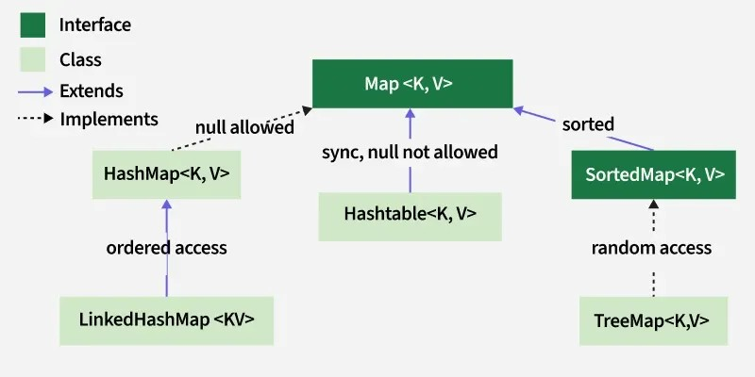

HashMap Methods
Category | Method Signature | Example Syntax | Description
➕ Put | V put(K key, V value) | map.put(1, "A"); | Inserts key-value pair
 | void putAll(Map m) | map.putAll(map2); | Copies all mappings
📥 Get | V get(Object key) | map.get(1); | Returns value for key
 | V getOrDefault(Object key, V def) | map.getOrDefault(2, "X"); | Returns default if key absent
❌ Remove | V remove(Object key) | map.remove(1); | Removes mapping by key
 | boolean remove(Object k, Object v) | map.remove(1, "A"); | Removes only if match
🔍 Search | boolean containsKey(Object key) | map.containsKey(1); | Checks key exists
 | boolean containsValue(Object value) | map.containsValue("A"); | Checks value exists
Size | int size() | map.size(); | Number of entries
 | boolean isEmpty() | map.isEmpty(); | Checks empty
🔄 Replace | V replace(K key, V value) | map.replace(1, "B"); | Replaces value
 | boolean replace(K k, V old, V new) | map.replace(1, "A", "B"); | Replace if match
🔁 Iterate | Set<K> keySet() | map.keySet(); | Returns all keys
 | Collection<V> values() | map.values(); | Returns all values
 | Set<Map.Entry<K,V>> entrySet() | map.entrySet(); | Returns key-value pairs
🧹 Clear | void clear() | map.clear(); | Removes all entries
⚙️ Compute | V compute(K key, BiFunction f) | map.compute(1,(k,v)->v+"X"); | Updates value dynamically
 | V putIfAbsent(K key, V value) | map.putIfAbsent(2,"C"); | Adds only if absent

LinkedHashMap
Category | Method Signature | Example Syntax | Description
➕ Put | V put(K key, V value) | map.put(1, "A"); | Inserts key-value pair (maintains order)
📥 Get | V get(Object key) | map.get(1); | Returns value
❌ Remove | V remove(Object key) | map.remove(1); | Removes entry
🔍 Search | boolean containsKey(Object key) | map.containsKey(1); | Checks key
 | boolean containsValue(Object value) | map.containsValue("A"); | Checks value
📏 Size | int size() | map.size(); | Number of entries
🧹 Clear | void clear() | map.clear(); | Removes all
🔁 Iterate | Set<K> keySet() | map.keySet(); | All keys
 | Collection<V> values() | map.values(); | All values
 | Set<Map.Entry<K,V>> entrySet() | map.entrySet(); | Key-value pairs
⚙️ Extra | V getOrDefault(Object k,V d) | map.getOrDefault(2,"X"); | Default value
 | V putIfAbsent(K k,V v) | map.putIfAbsent(2,"B"); | Insert if absent

HashTable
Category | Method Signature | Example Syntax | Description
➕ Put | V put(K key, V value) | ht.put(1, "A"); | Inserts entry (synchronized)
📥 Get | V get(Object key) | ht.get(1); | Returns value
❌ Remove | V remove(Object key) | ht.remove(1); | Removes entry
🔍 Search | boolean containsKey(Object key) | ht.containsKey(1); | Checks key
 | boolean contains(Object value) | ht.contains("A"); | Checks value (old method)
📏 Size | int size() | ht.size(); | Number of entries
🧹 Clear | void clear() | ht.clear(); | Removes all
🔁 Iterate | Enumeration<K> keys() | ht.keys(); | Keys traversal (old)
 | Enumeration<V> elements() | ht.elements(); | Values traversal
⚙️ Extra | V putIfAbsent(K k,V v) | ht.putIfAbsent(2,"B"); | Insert if absent
 | boolean remove(K k,V v) | ht.remove(1,"A"); | Remove if match

TreeMap
Category | Method Signature | Example Syntax | Description
➕ Put | V put(K key, V value) | tmap.put(1, "A"); | Inserts (sorted by key)
📥 Get | V get(Object key) | tmap.get(1); | Returns value
❌ Remove | V remove(Object key) | tmap.remove(1); | Removes entry
🔍 Search | boolean containsKey(Object key) | tmap.containsKey(1); | Checks key
📏 Size | int size() | tmap.size(); | Number of entries
🧹 Clear | void clear() | tmap.clear(); | Removes all
📥 Access | K firstKey() | tmap.firstKey(); | Smallest key
 | K lastKey() | tmap.lastKey(); | Largest key
🔼 Navigation | K higherKey(K key) | tmap.higherKey(10); | Next greater key
 | K lowerKey(K key) | tmap.lowerKey(10); | Next smaller key
 | K ceilingKey(K key) | tmap.ceilingKey(10); | ≥ key
 | K floorKey(K key) | tmap.floorKey(10); | ≤ key
🔁 Iterate | Set<K> keySet() | tmap.keySet(); | Keys
 | Set<Map.Entry<K,V>> entrySet() | tmap.entrySet(); | Entries
⚙️ Extra | Comparator comparator() | tmap.comparator(); | Comparator used

