Mini Project Report
On

“Carbon Emission Calculator”
Submitted To

NMIMS
Mukesh Patel School of Technology Management & Engineering, Shirpur



Submitted By

- Mayuri Pawar (70022300258 )

Under The Guidance of

Prof. Sachin Bhandari Sir

Department of Computer Engineering YEAR 2024-25

Project Title:- Carbon Emission Calculator

TABLES:

- User_Profile: Stores user information including name, email, and location.
- Transportation: Captures transportation-related activity such as vehicle type and distance.
- Energy_Consumption: Records home or commercial energy consumption activities.
- Waste_Management: Tracks types and amounts of waste generated.
- Industrial_Activity: Logs industrial processes and emissions.
- Emission_Factor: Holds standard emission factor values per unit of activity.
- Emission_Record: Stores calculated emissions based on activity and emission factor.
- Sustainability_Program: Lists environmental programs users can enroll in.
- User_Program: Bridge table linking users with sustainability programs (many-to-many).

Relationships and Cardinalities
- User_Profile (1) to Transportation (M)
- User_Profile (1) to Energy_Consumption (M)
- User_Profile (1) to Waste_Management (M)
- User_Profile (1) to Industrial_Activity (M)
- Transportation (1) to Emission_Record (M)
- Energy_Consumption (1) to Emission_Record (M)
- Waste_Management (1) to Emission_Record (M)
- Industrial_Activity (1) to Emission_Record (M)
- Emission_Factor (1) to Emission_Record (M)
- User_Profile (M) to Sustainability_Program (M) via User_Program

ER DIAGRAM

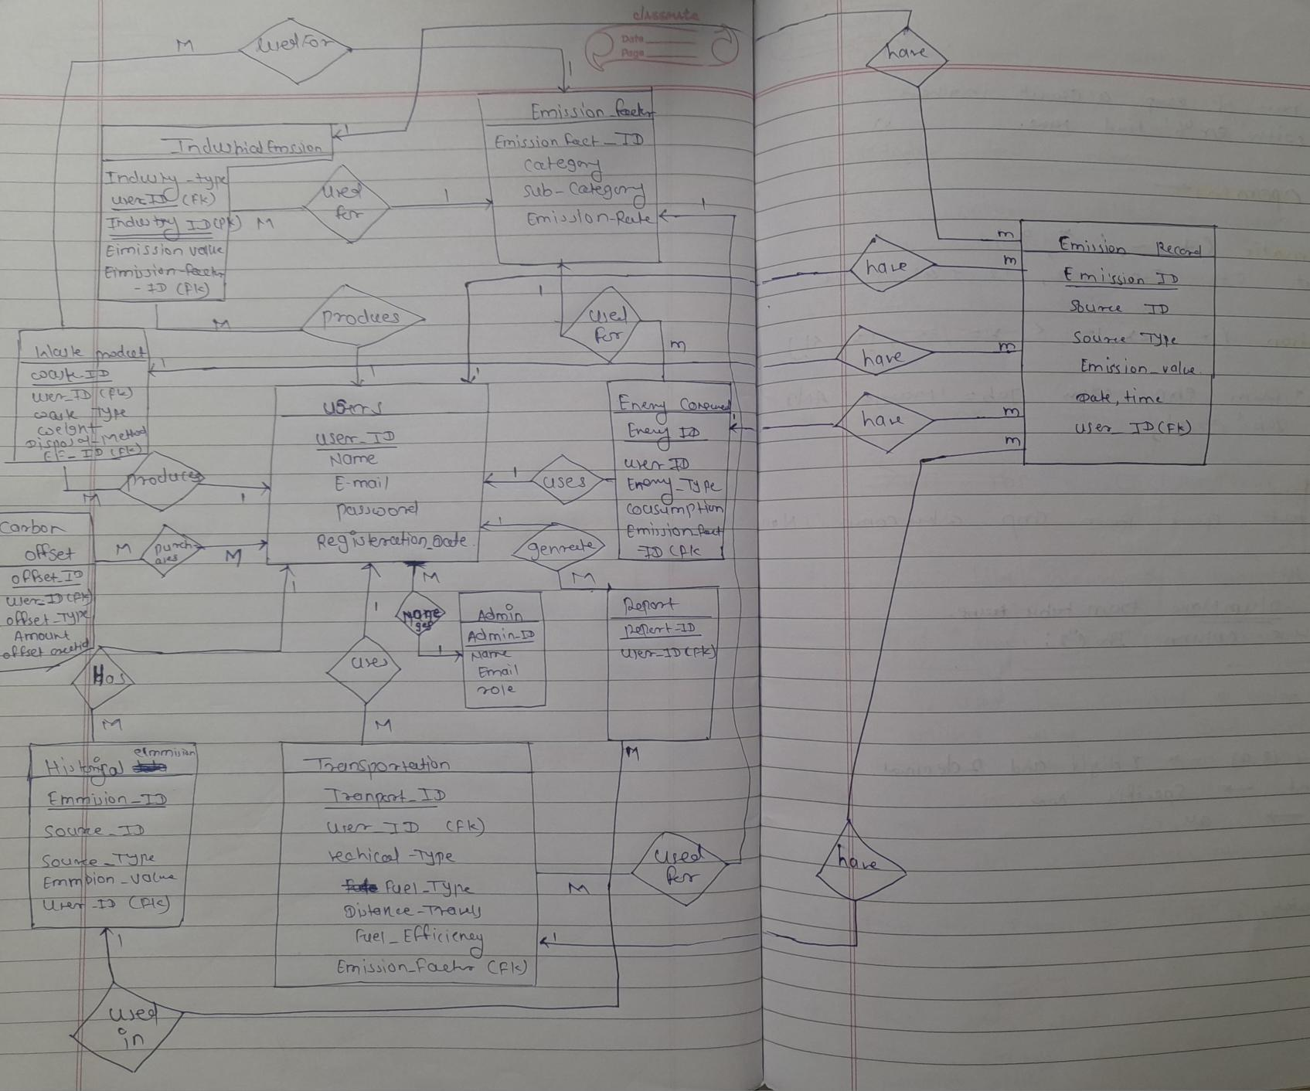

Queries:-
create database CarbonEmissionDB;
USE CarbonEmissionDB;
-- Create User_Profile table
CREATE TABLE User_Profile (
User_ID INT IDENTITY(1,1) PRIMARY KEY,
Full_Name NVARCHAR(100) NOT NULL,
Email NVARCHAR(100),
Location NVARCHAR(100)
);
-- Create Transportation table
CREATE TABLE Transportation (
Transport_ID INT IDENTITY(1,1) PRIMARY KEY,
User_ID INT,
Vehicle_Type NVARCHAR(50),
Distance_KM FLOAT,
Date DATE,
FOREIGN KEY (User_ID) REFERENCES User_Profile(User_ID)
);
-- Create Energy_Consumption table
CREATE TABLE Energy_Consumption (
Energy_ID INT IDENTITY(1,1) PRIMARY KEY,
User_ID INT,
Energy_Source NVARCHAR(50),
Consumption_KWH FLOAT,
Date DATE,
FOREIGN KEY (User_ID) REFERENCES User_Profile(User_ID)
);
-- Create Waste_Management table
CREATE TABLE Waste_Management (
Waste_ID INT IDENTITY(1,1) PRIMARY KEY,
User_ID INT,
Waste_Type NVARCHAR(50),
Waste_Weight_KG FLOAT,
Date DATE,
FOREIGN KEY (User_ID) REFERENCES User_Profile(User_ID)
);

-- Create Industrial_Activity table
CREATE TABLE Industrial_Activity (
Industry_ID INT IDENTITY(1,1) PRIMARY KEY,
User_ID INT,
Activity_Type NVARCHAR(50),
Emission_Produced FLOAT,
Date DATE,
FOREIGN KEY (User_ID) REFERENCES User_Profile(User_ID)
);
-- Create Emission_Factor table
CREATE TABLE Emission_Factor (
Factor_ID INT IDENTITY(1,1) PRIMARY KEY,
Source_Type NVARCHAR(50),
Emission_Per_Unit FLOAT,
Unit NVARCHAR(20)
);
-- Create Carbon_Offset table
CREATE TABLE Carbon_Offset (
Offset_ID INT IDENTITY(1,1) PRIMARY KEY,
User_ID INT,
Offset_Type NVARCHAR(50),
Offset_Amount FLOAT,
Date DATE,
FOREIGN KEY (User_ID) REFERENCES User_Profile(User_ID)
);
-- Sample User_Profile data
INSERT INTO User_Profile (Full_Name, Email, Location)
VALUES
('John Doe', 'john.doe@email.com', 'New York'),
('Jane Smith', 'jane.smith@email.com', 'Los Angeles'),
('Bob Johnson', 'bob.johnson@email.com', 'Chicago');
-- Sample Emission_Factor data
INSERT INTO Emission_Factor (Source_Type, Emission_Per_Unit, Unit)
VALUES
('Car', 0.12, 'kg CO2/km'),
('Bus', 0.05, 'kg CO2/km'),
('Train', 0.03, 'kg CO2/km'),
('Airplane', 0.25, 'kg CO2/km'),
('Electricity', 0.5, 'kg CO2/kWh'),
('Natural Gas', 0.2, 'kg CO2/kWh'),
('Solar', 0.0, 'kg CO2/kWh'),
('Waste', 2.0, 'kg CO2/kg');
-- Sample Transportation data
INSERT INTO Transportation (User_ID, Vehicle_Type, Distance_KM, Date)
VALUES
(1, 'Car', 50.0, '2023-01-15'),
(1, 'Bus', 20.0, '2023-01-20'),
(2, 'Car', 30.0, '2023-01-10'),
(2, 'Train', 100.0, '2023-01-25'),
(3, 'Car', 25.0, '2023-01-05'),
(3, 'Airplane', 500.0, '2023-01-30');
-- Sample Energy_Consumption data
INSERT INTO Energy_Consumption (User_ID, Energy_Source, Consumption_KWH, Date)
VALUES
(1, 'Electricity', 200.0, '2023-01-15'),
(1, 'Natural Gas', 100.0, '2023-01-20'),
(2, 'Electricity', 150.0, '2023-01-10'),
(2, 'Solar', 50.0, '2023-01-25'),
(3, 'Electricity', 180.0, '2023-01-05'),
(3, 'Natural Gas', 120.0, '2023-01-30');
-- Sample Waste_Management data
INSERT INTO Waste_Management (User_ID, Waste_Type, Waste_Weight_KG, Date)
VALUES
(1, 'General', 5.0, '2023-01-15'),
(1, 'Recycling', 2.0, '2023-01-20'),
(2, 'General', 4.0, '2023-01-10'),
(2, 'Compost', 1.5, '2023-01-25'),
(3, 'General', 6.0, '2023-01-05'),
(3, 'Recycling', 3.0, '2023-01-30');
-- Sample Carbon_Offset data
INSERT INTO Carbon_Offset (User_ID, Offset_Type, Offset_Amount, Date)
VALUES
(1, 'Tree Planting', 50.0, '2023-01-25'),
(2, 'Renewable Energy Credits', 30.0, '2023-01-15'),
(3, 'Carbon Offset Program', 40.0, '2023-01-20');
-- Create Carbon Footprint View
CREATE VIEW Carbon_Footprint_View AS
SELECT
up.User_ID,
up.Full_Name,
up.Location,
COALESCE(SUM(t.Distance_KM * ef_t.Emission_Per_Unit), 0) as Transport_Emissions,
COALESCE(SUM(ec.Consumption_KWH * ef_e.Emission_Per_Unit), 0) as Energy_Emissions,
COALESCE(SUM(wm.Waste_Weight_KG * ef_w.Emission_Per_Unit), 0) as Waste_Emissions,
COALESCE(SUM(ia.Emission_Produced), 0) as Industrial_Emissions,
COALESCE(SUM(co.Offset_Amount), 0) as Offset_Amount,
(
COALESCE(SUM(t.Distance_KM * ef_t.Emission_Per_Unit), 0) +
COALESCE(SUM(ec.Consumption_KWH * ef_e.Emission_Per_Unit), 0) +
COALESCE(SUM(wm.Waste_Weight_KG * ef_w.Emission_Per_Unit), 0) +
COALESCE(SUM(ia.Emission_Produced), 0) -
COALESCE(SUM(co.Offset_Amount), 0)
) as Net_Emissions
FROM User_Profile up
LEFT JOIN Transportation t ON up.User_ID = t.User_ID
LEFT JOIN Emission_Factor ef_t ON t.Vehicle_Type = ef_t.Source_Type
LEFT JOIN Energy_Consumption ec ON up.User_ID = ec.User_ID
LEFT JOIN Emission_Factor ef_e ON ec.Energy_Source = ef_e.Source_Type
LEFT JOIN Waste_Management wm ON up.User_ID = wm.User_ID
LEFT JOIN Emission_Factor ef_w ON 'Waste' = ef_w.Source_Type
LEFT JOIN Industrial_Activity ia ON up.User_ID = ia.User_ID
LEFT JOIN Carbon_Offset co ON up.User_ID = co.User_ID
GROUP BY up.User_ID, up.Full_Name, up.Location;
-- Show all users with their net emissions
SELECT * FROM Carbon_Footprint_View ORDER BY Net_Emissions DESC;
-- Show emissions by location
SELECT
Location,
COUNT(User_ID) as UserCount,
SUM(Transport_Emissions) as Total_Transport_Emissions,
SUM(Energy_Emissions) as Total_Energy_Emissions,
SUM(Waste_Emissions) as Total_Waste_Emissions,
SUM(Net_Emissions) as Total_Net_Emissions
FROM Carbon_Footprint_View
GROUP BY Location
ORDER BY Total_Net_Emissions DESC;
-- Top emitters with ranking
SELECT
User_ID,
Full_Name,
Net_Emissions,
CASE
WHEN Net_Emissions > 1000 THEN 'Very High'
WHEN Net_Emissions > 500 THEN 'High'
WHEN Net_Emissions > 200 THEN 'Medium'
WHEN Net_Emissions > 0 THEN 'Low'
ELSE 'Carbon Negative'
END as Emission_Category,
RANK() OVER (ORDER BY Net_Emissions DESC) as Emission_Rank
FROM Carbon_Footprint_View
ORDER BY Net_Emissions DESC;
GUI:-
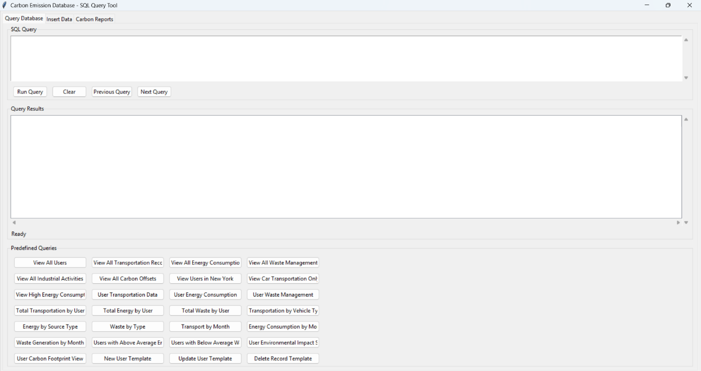

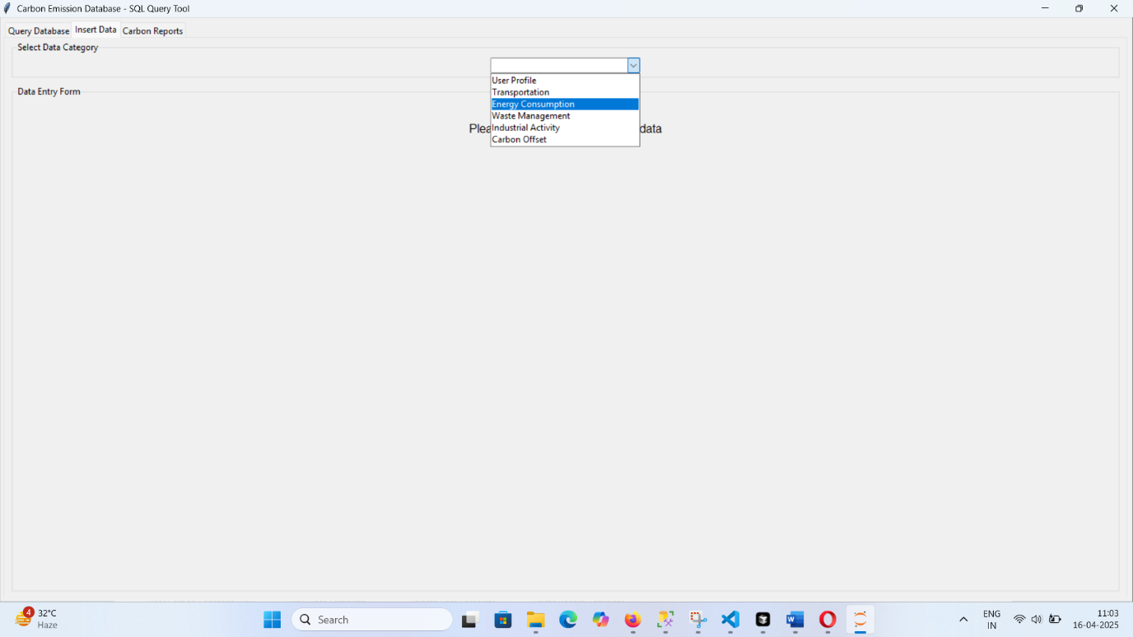

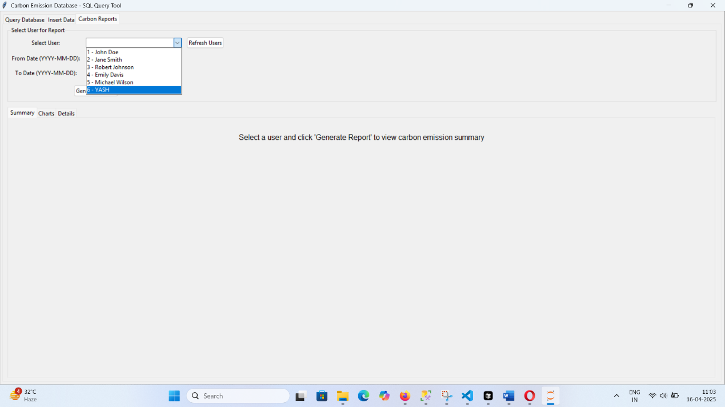

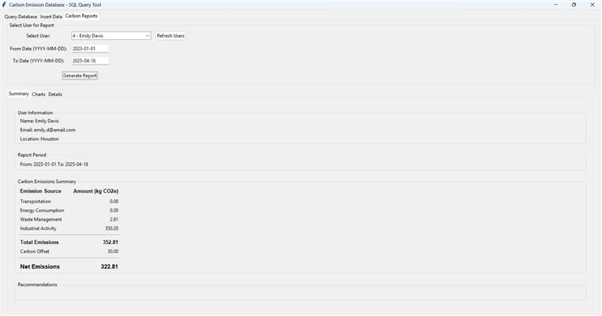

Conclusion

The Carbon Emission Calculator represents a comprehensive solution for carbon footprint management. It successfully combines database technology with an intuitive user interface to provide valuable insights for environmental decision-making. The application serves as both a practical tool for carbon monitoring and a demonstration of advanced database concepts and SQL impleme

