DBMS PROJECT

PROJECT TOPIC : CARBON EMMISION CALCULATOR

# Carbon Emission Calculator - User Manual

Welcome to the Carbon Emission Calculator! This application helps you track, analyze, and reduce your carbon footprint through detailed emissions tracking and personalized recommendations.

The application will open with three main tabs at the top of the window:
- Query Database
- Insert Data
- Carbon Reports

## Recording Your Carbon Emissions

### Creating Your User Profile
1. Click on the "Insert Data" tab
2. Select "User Profile" from the data category dropdown
3. Enter your personal information:
- Full Name
- Email Address
- Location (city name)
4. Click "Submit"
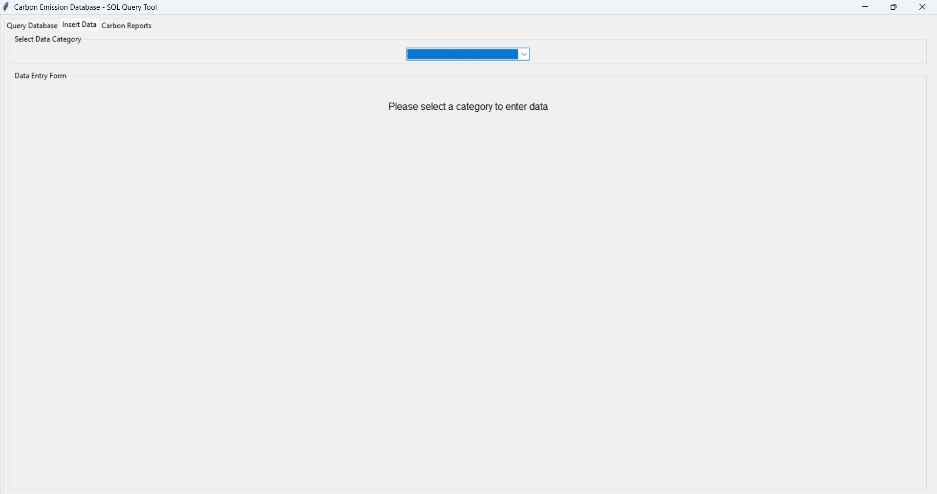

### Recording Transportation Activities

1. Click on the "Insert Data" tab
2. Select "Transportation" from the data category dropdown
3. Enter your travel details:
- Select your user ID from the dropdown
- Choose your vehicle type (Car, Bus, Train, Airplane)
- Enter the distance traveled in kilometers
- Select the date of travel
4. Click "Submit"

### Recording Energy Consumption
1. Click on the "Insert Data" tab
2. Select "Energy Consumption" from the data category dropdown
3. Enter your energy usage:
- Select your user ID
- Choose the energy source (Electricity, Natural Gas, etc.)
- Enter consumption in kilowatt-hours (kWh)
- Select the date
4. Click "Submit"

### Recording Waste Management
1. Click on the "Insert Data" tab
2. Select "Waste Management" from the data category dropdown
3. Enter waste details:
- Select your user ID
- Choose waste type (General, Recycling, Compost)
- Enter weight in kilograms
- Select the date
4. Click "Submit"

### Recording Carbon Offsets
1. Click on the "Insert Data" tab
2. Select "Carbon Offset" from the data category dropdown
3. Enter your offset activities:
- Select your user ID
- Choose offset type (Tree Planting, Renewable Energy Credits, etc.)
- Enter offset amount in kg CO2e
- Select the date
4. Click "Submit"

## Viewing Your Carbon Footprint Report
1. Click on the "Carbon Reports" tab
2. Select your name from the user dropdown
- If you don't see your name, click "Refresh Users"
3. Set the date range for your report:
- From Date (format: YYYY-MM-DD)
- To Date (format: YYYY-MM-DD)
4. Click "Generate Report"

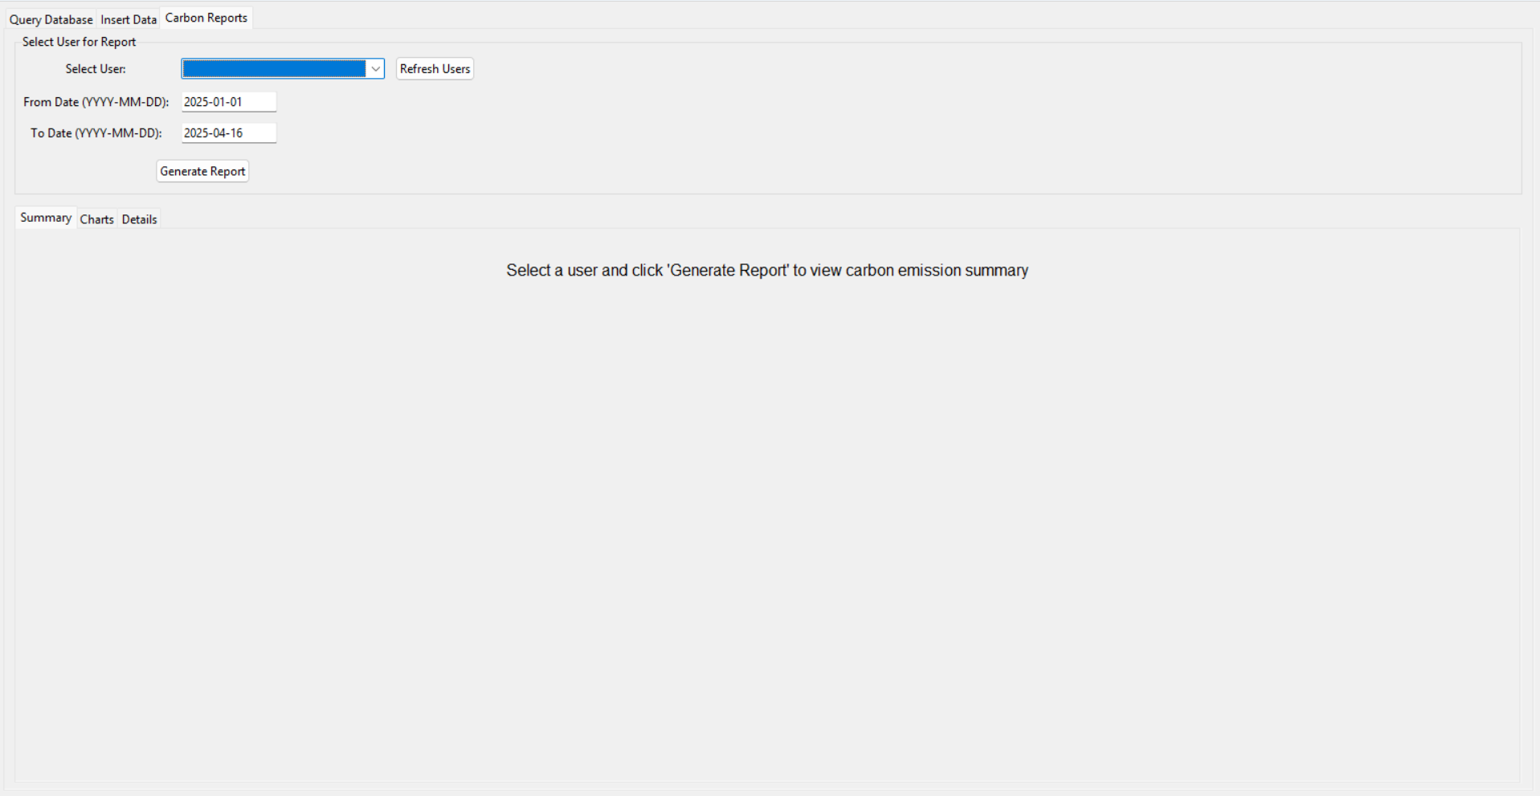

### Understanding Your Report
#### Summary Tab
- View your personal information
- See total emissions by category (Transportation, Energy, Waste, Industrial)
- Review your carbon offsets
- Calculate your net emissions
- Read personalized recommendations for reducing your carbon footprint

#### Charts Tab
- View a pie chart showing your emission sources
- Compare your total emissions vs. carbon offsets
- See transportation breakdown by vehicle type
- View energy consumption by source type

#### Details Tab
- Access detailed tables of all your recorded activities
- View exact emissions for each activity
- Sort data by clicking on column headers

## Analyzing Carbon Data
For a deeper analysis of your carbon footprint, use the "Query Database" tab:
1. Click on predefined query buttons such as:
- "User Environmental Impact Summary"
- "Total Transportation by User"
- "Energy Consumption by Month"

2. Click "Run Query" to view results
Useful queries for personal tracking:
- "Transport by Month" - Track your transportation emissions over time
- "Energy by Source Type" - See which energy sources produce the most emissions
- "User Carbon Footprint View" - View your complete carbon footprint summary
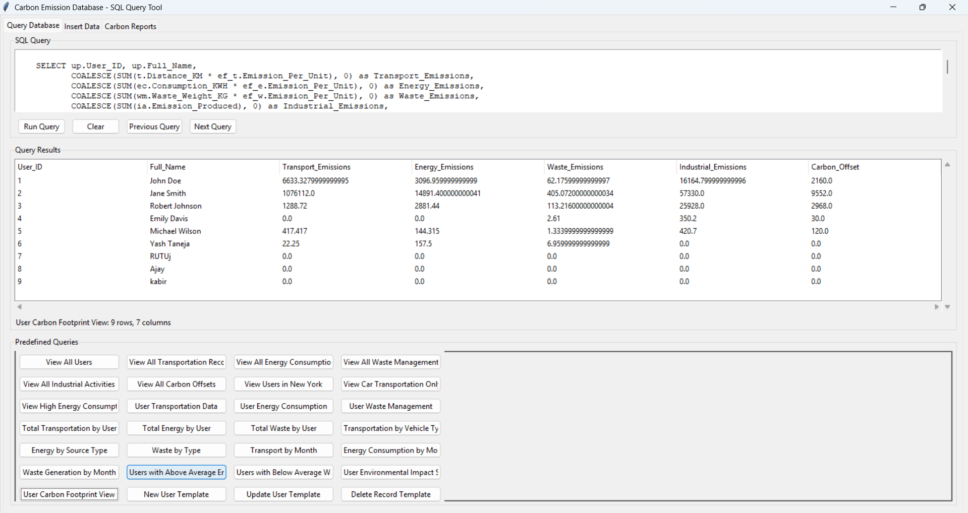

## Tips for Reducing Your Carbon Footprint

Based on your reports, consider these actions:
### Transportation
- Use public transportation when possible
- Combine trips to reduce unnecessary travel
- Consider carpooling or switching to electric vehicles

### Energy
- Switch to energy-efficient appliances
- Install LED lighting
- Explore renewable energy options
- Improve home insulation

### Waste
- Recycle and compost regularly
- Choose products with minimal packaging
- Donate or repurpose items instead of disposing them

### Carbon Offsets
- Invest in tree planting programs
- Purchase renewable energy credits
- Support carbon capture technologies
Remember
Regular data entry leads to more accurate reports and better recommendations. Try to record your activities at least weekly for the best results.

