# Kubernetes

Kubernetes is a container management technology developed in Google lab to manage containerized applications in different kinds of environments such as physical, virtual, and cloud infrastructure. It is an open source system which helps in creating and managing containerization of applications.

# Features of Kubernetes

Following are some of the important features of Kubernetes.

* Continues development, integration and deployment
* Containerized infrastructure
* Application-centric management
* Auto-scalable infrastructure
* Environment consistency across development testing and production
* Loosely coupled infrastructure, where each component can act as a separate unit
* Higher density of resource utilization
* Predictable infrastructure which is going to be created

# Kubernetes - Node Components

Following are the key components of Node server which are necessary to communicate with Kubernetes master.

## Docker

The first requirement of each node is Docker which helps in running the encapsulated application containers in a relatively isolated but lightweight operating environment.

Command to install Docker

sudo apt-get install docker-ce docker-ce-cli containerd.io docker-compose-plugin

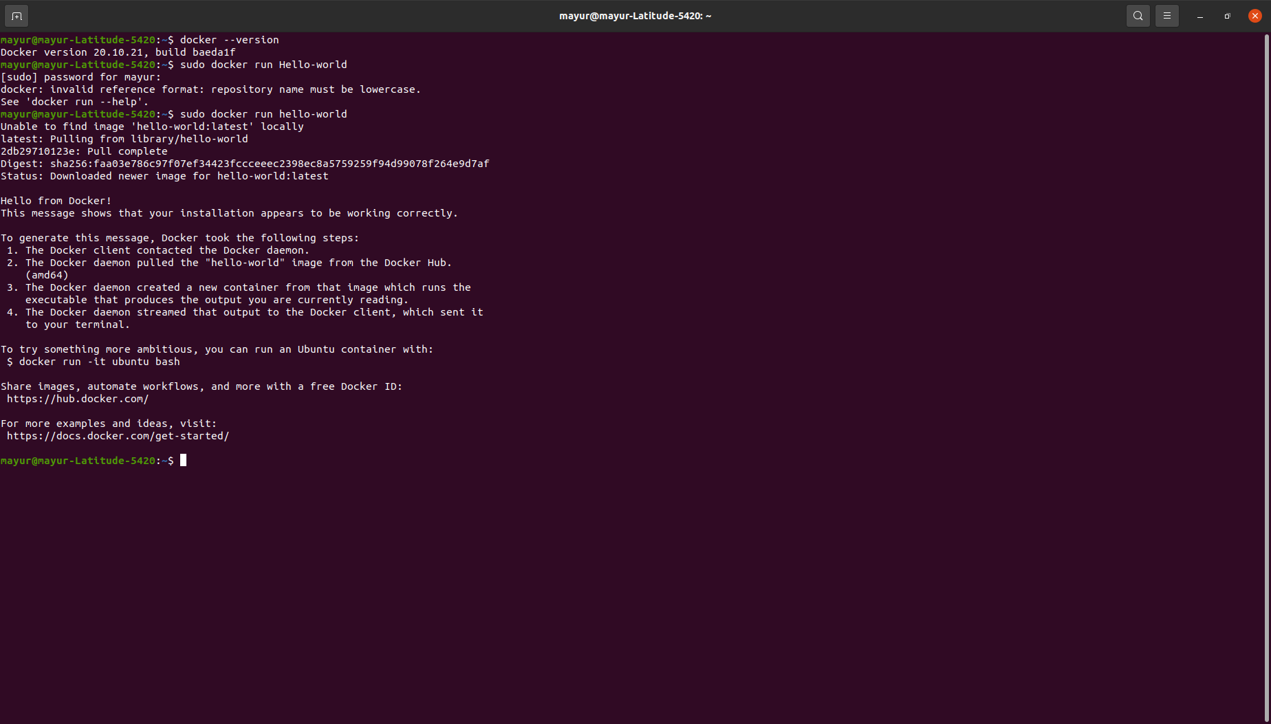*Installation of Docker*

## Kubectl

This is a small service in each node responsible for relaying information to and from control plane service. This communicates with the master component to receive commands and work. The kubelet process then assumes responsibility for maintaining the state of work and the node server. It manages network rules, port forwarding, etc.

Command to install Kubectl

sudo install -o root -g root -m 0755 kubectl /usr/local/bin/kubectl

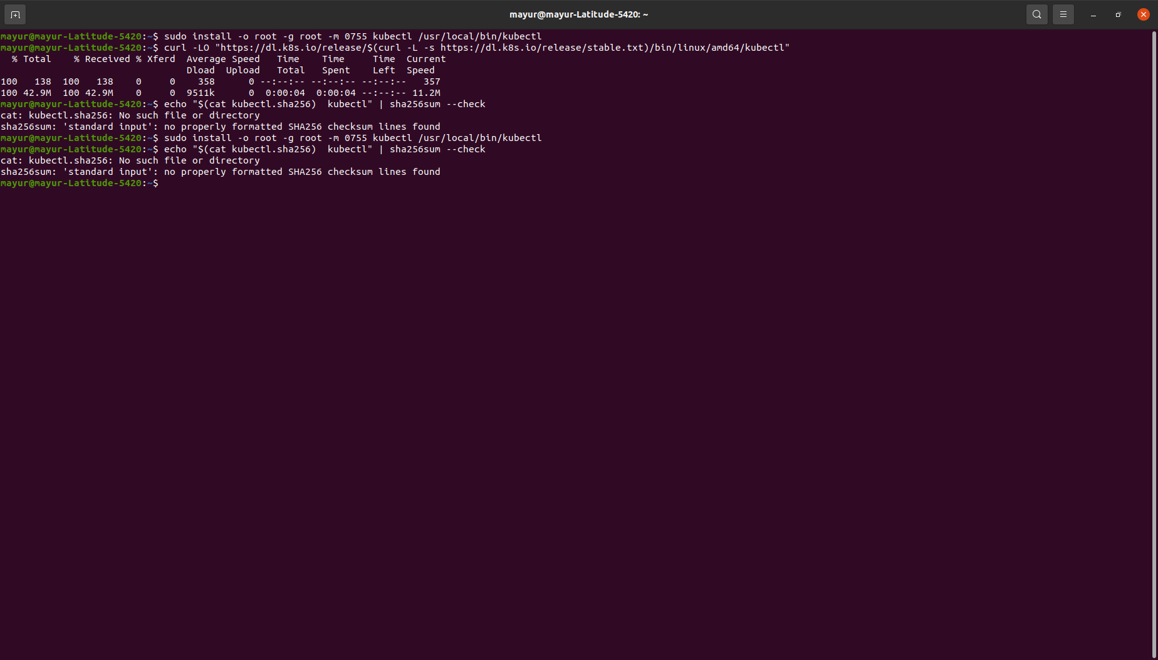

*Installation of Kubectl*

## Minikube

* Minikube is a lightweight Kubernetes implementation that creates a VM on your local machine and deploys a simple cluster containing only one node.
* The Minikube CLI provides basic bootstrapping operations for working with your cluster, including start, stop, status, and delete.

Command to install Minikube

curl -LO https://storage.googleapis.com/minikube/releases/latest/minikube-linux-amd64 sudo install minikube-linux-amd64 /usr/local/bin/minikube

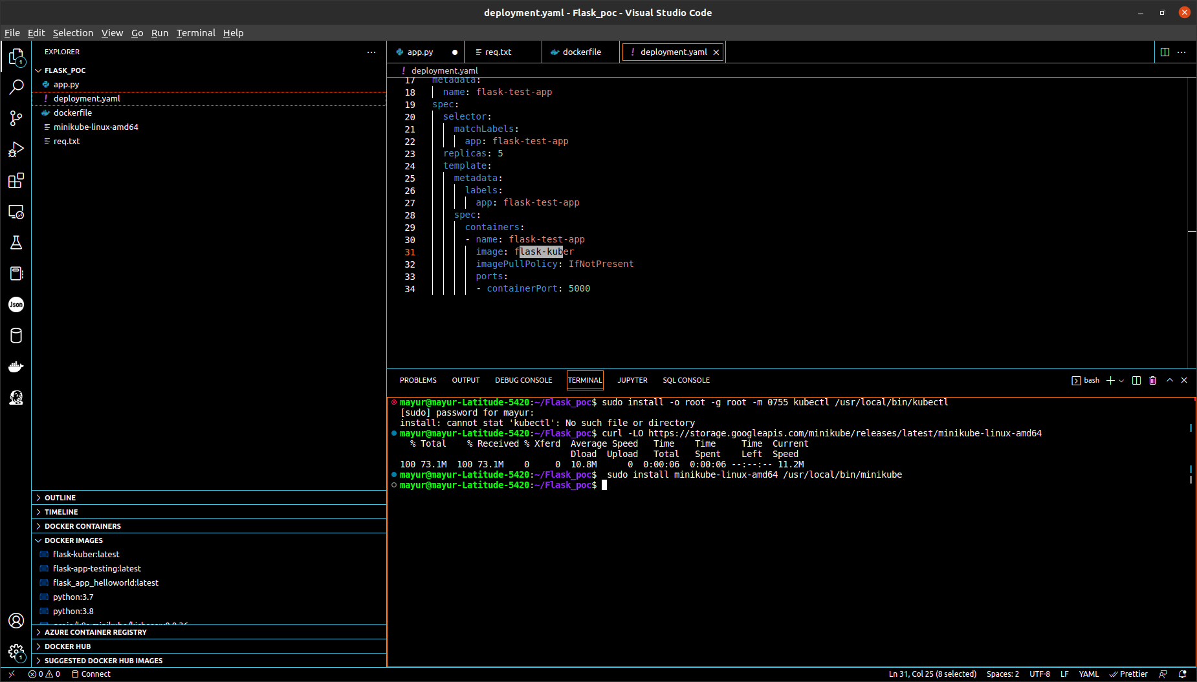

*Installation of Minikube*

## Terms of Kubernetes

**Control plane:** The collection of processes that control Kubernetes nodes. This is where all task assignments originate.

**Nodes:** These machines perform the requested tasks assigned by the control plane.

**Pod:** A group of one or more containers deployed to a single node. All containers in a pod share an IP address, IPC, hostname, and other resources. Pods abstract network and storage from the underlying container. This lets you move containers around the cluster more easily.

**Replication controller:** This controls how many identical copies of a pod should be running somewhere on the cluster.

**Service:** This decouples work definitions from the pods. Kubernetes service proxies automatically get service requests to the right pod—no matter where it moves in the cluster or even if it’s been replaced.

**Kubelet:** This service runs on nodes, reads the container manifests, and ensures the defined containers are started and running.

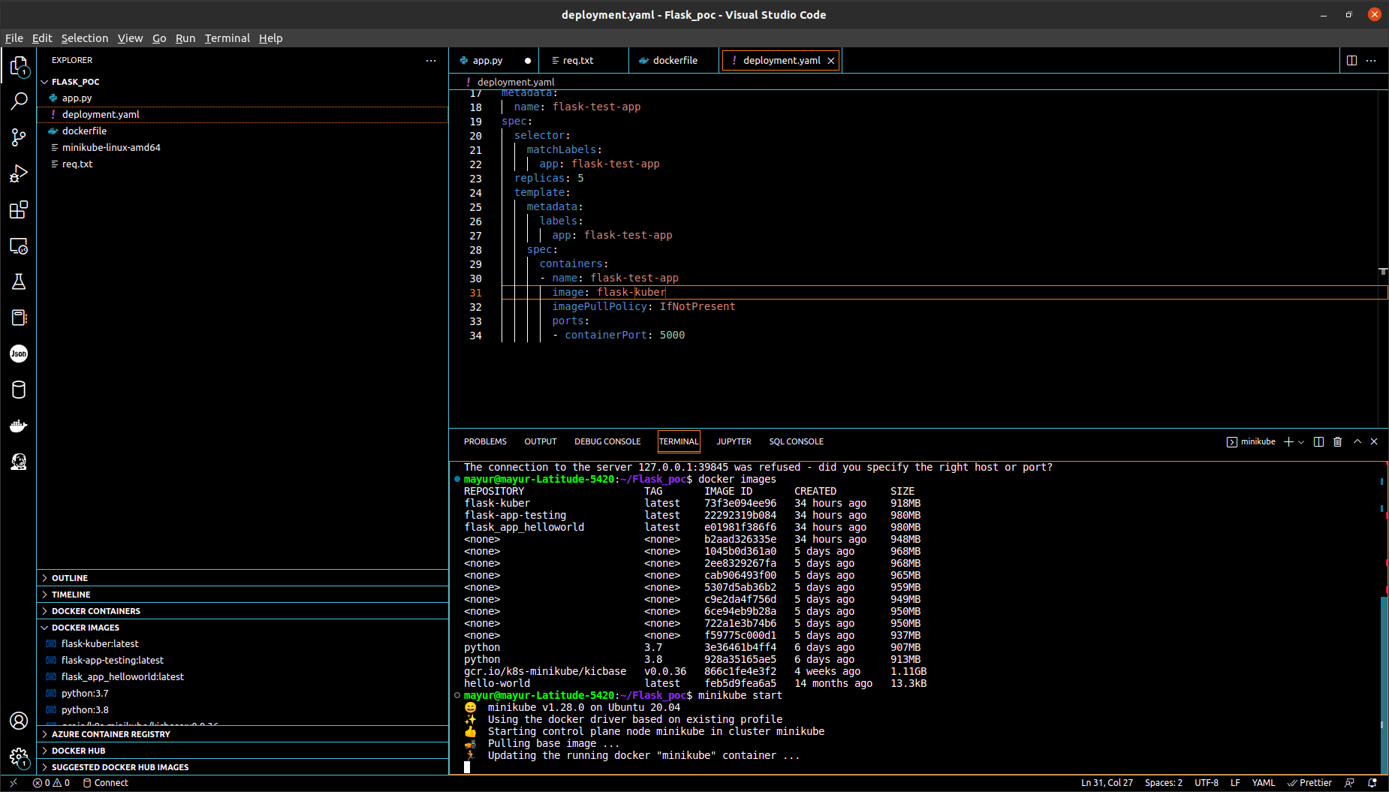**kubectl:** The command line configuration tool for Kubernetes.