**1**. Download vechile sales data -> <https://github.com/shashank-mishra219/Hive-Class/blob/main/sales_order_data.csv>



**2**. Store raw data into hdfs location

**Command** – hdfs dfs -put ‘sales_order_data.csv’ ‘/tmp’

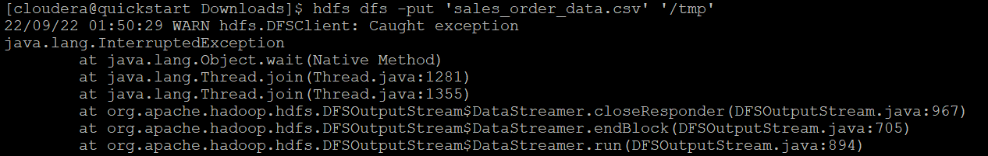



**3.** Create a internal hive table "sales_order_csv" which will store csv data sales_order_csv .. make sure to skip header row while creating table

**Command -**

create table sales_order_csv

(

ORDERNUMBER int,

QUANTITYORDERED int,

PRICEEACH float,

ORDERLINENUMBER int,

SALES float,

STATUS string,

QTR_ID int,

MONTH_ID int,

YEAR_ID int,

PRODUCTLINE string,

MSRP int,

PRODUCTCODE string,

PHONE string,

CITY string,

STATE string,

POSTALCODE string,

COUNTRY string,

TERRITORY string,

CONTACTLASTNAME string,

CONTACTFIRSTNAME string,

DEALSIZE string

)

row format delimited

fields terminated by ','

tblproperties("skip.header.line.count"="1");

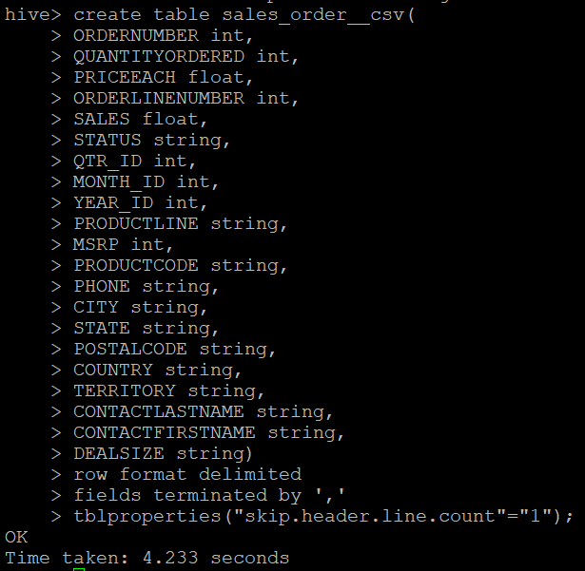

**4.** Load data from hdfs path into "sales_order_csv"

**Command –**

load data inpath ‘/tmp/sales_order_data.csv’ into table sales_order_csv;

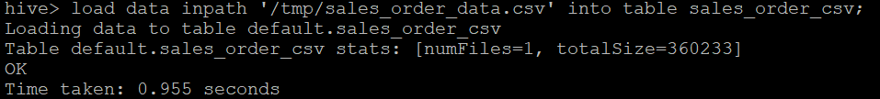

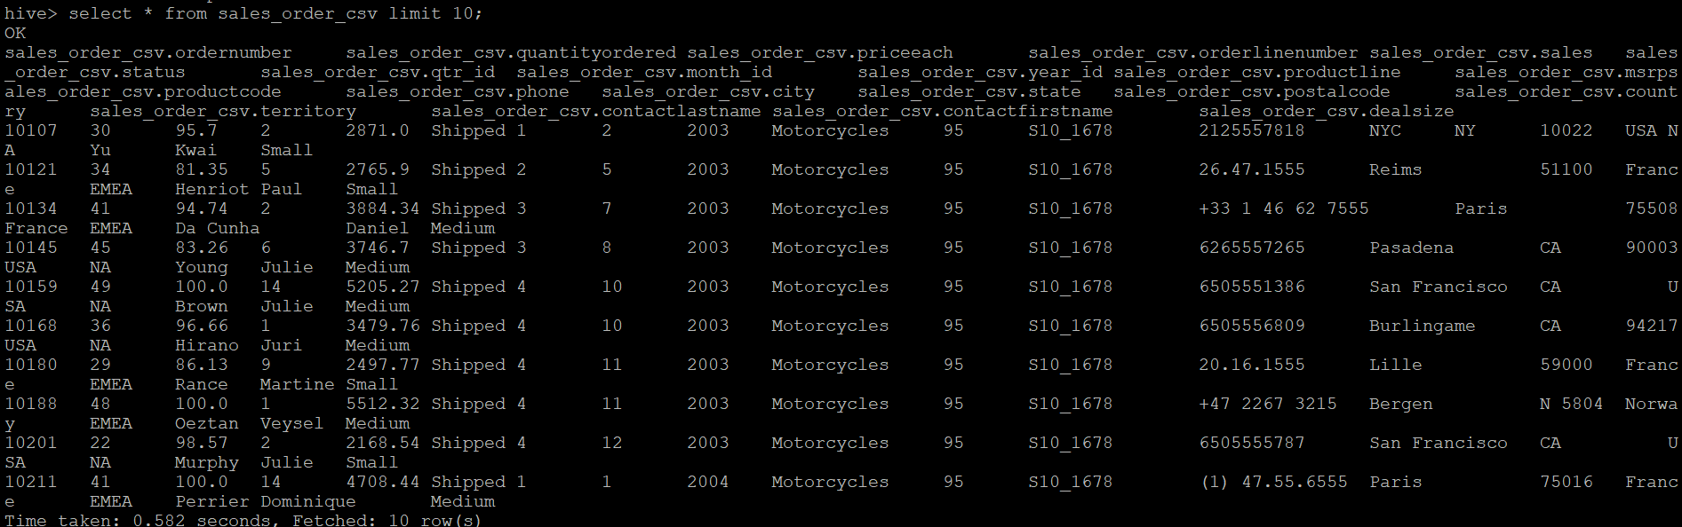

5. Create an internal hive table which will store data in ORC format "sales_order_orc"

**Command –**

create table sales_order_orc

(

ORDERNUMBER int,

QUANTITYORDERED int,

PRICEEACH float,

ORDERLINENUMBER int,

SALES float,

STATUS string,

QTR_ID int,

MONTH_ID int,

YEAR_ID int,

PRODUCTLINE string,

MSRP int,

PRODUCTCODE string,

PHONE string,

CITY string,

STATE string,

POSTALCODE string,

COUNTRY string,

TERRITORY string,

CONTACTLASTNAME string,

CONTACTFIRSTNAME string,

DEALSIZE string

)

stored as orc;

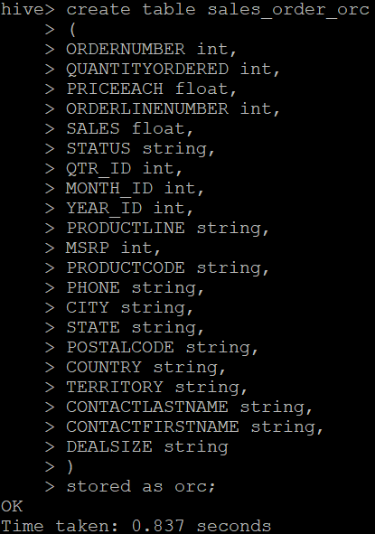

6. Load data from "sales_order_csv" into "sales_order_orc"

**Command -**

 from sales_order_csv insert overwrite table sales_order_orc select *;

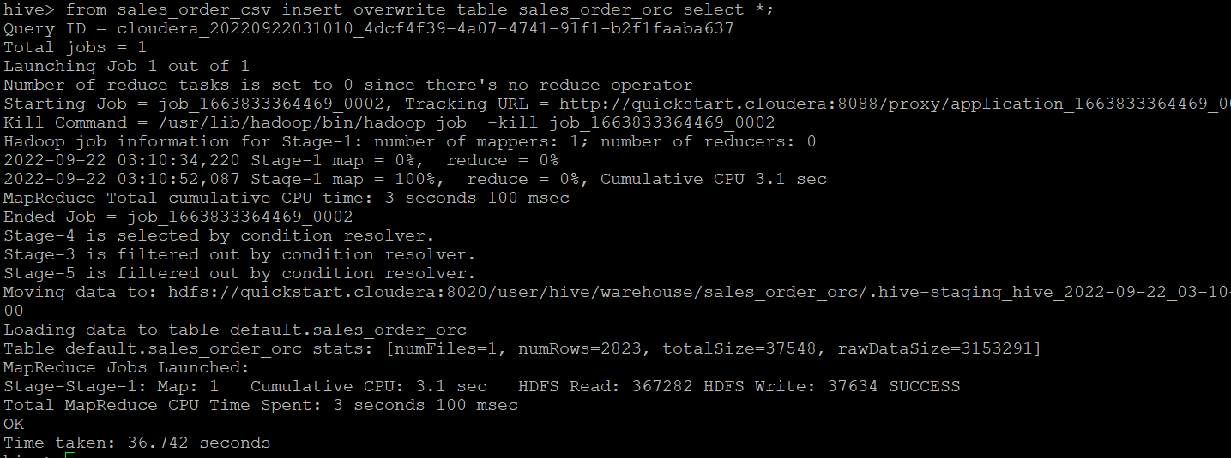

**Perform below menioned queries on "sales_order_orc" table :**

**a. Calculate total sales per year**

select sum(sales)as Total_Sales,year_id as Year from sales_order_orc group by year_id;

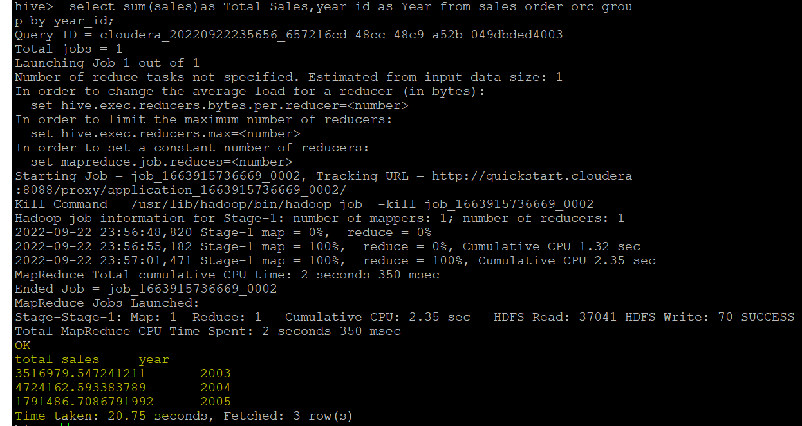

**b. Find a product for which maximum orders were placed –**

select count(ordernumber) as Max_Order ,productline as Product from sales_order_orc group by productline order by Max_Order Desc limit 1;

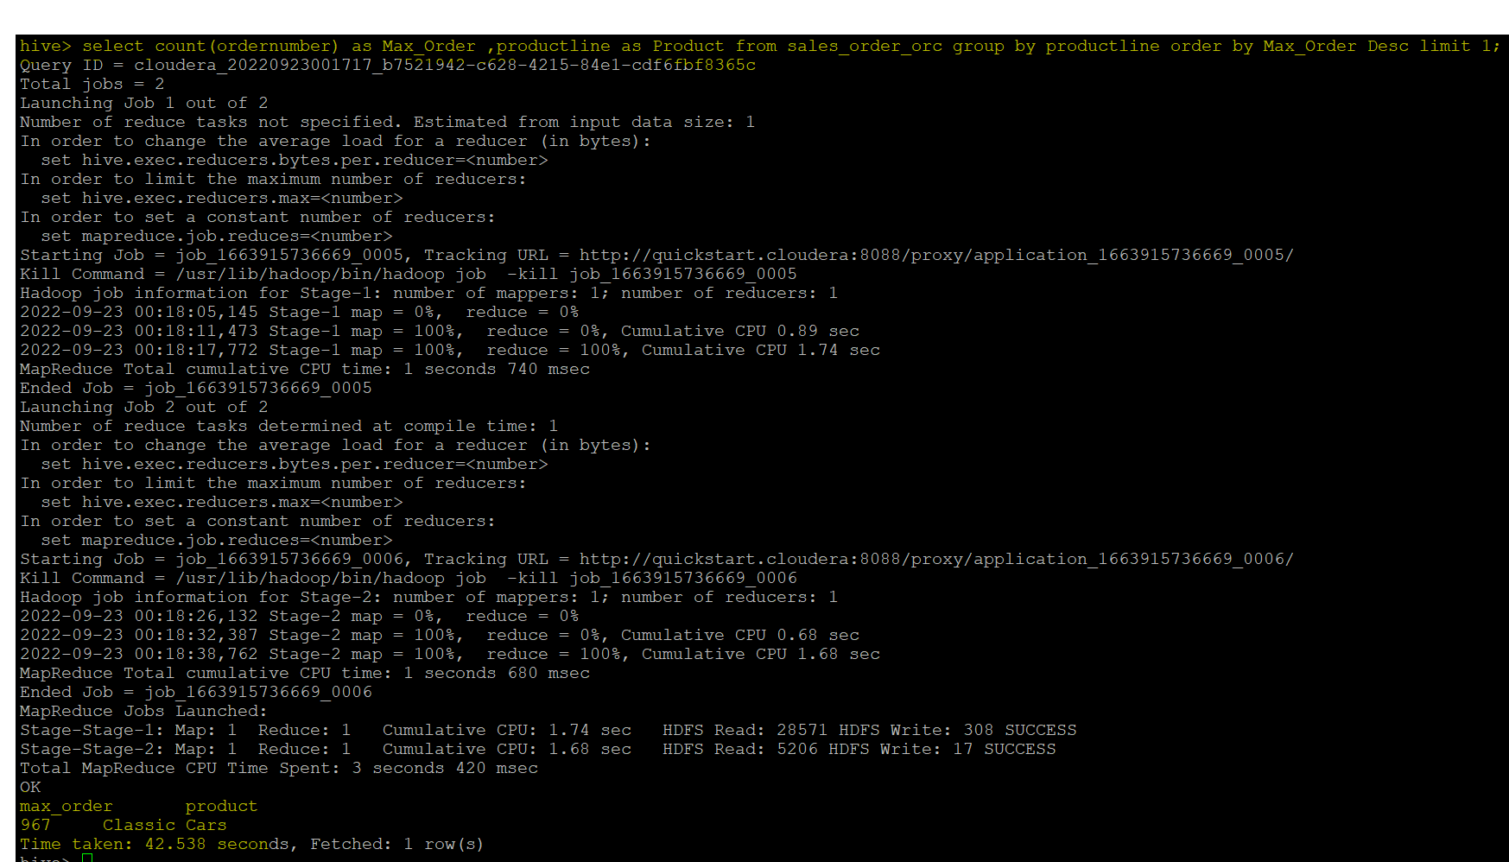

**c. Calculate the total sales for each quarter -**

select sum(sales)as Total_Sale,qtr_id as Quater from sales_order_orc group by qtr_id;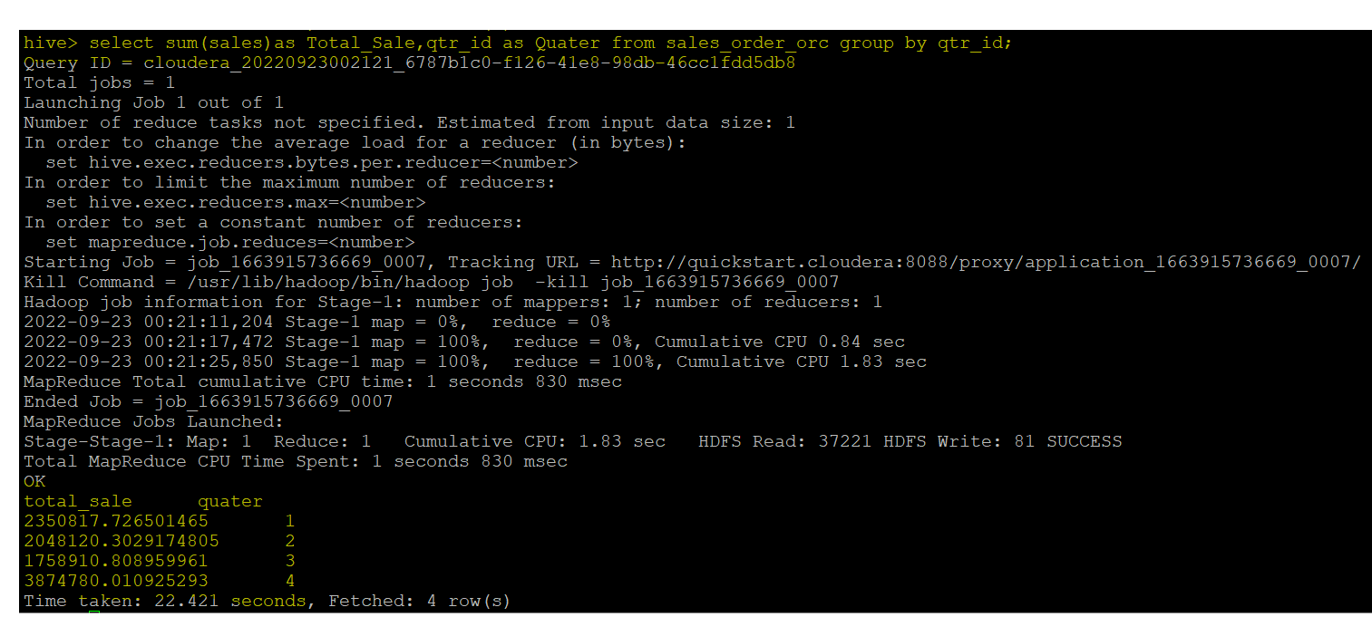

**d. In which quarter sales was minimum –**

select sum(sales) as Sales ,qtr_id as Quater from sales_order_orc group by qtr_id order by Sales Asc limit 1 ;

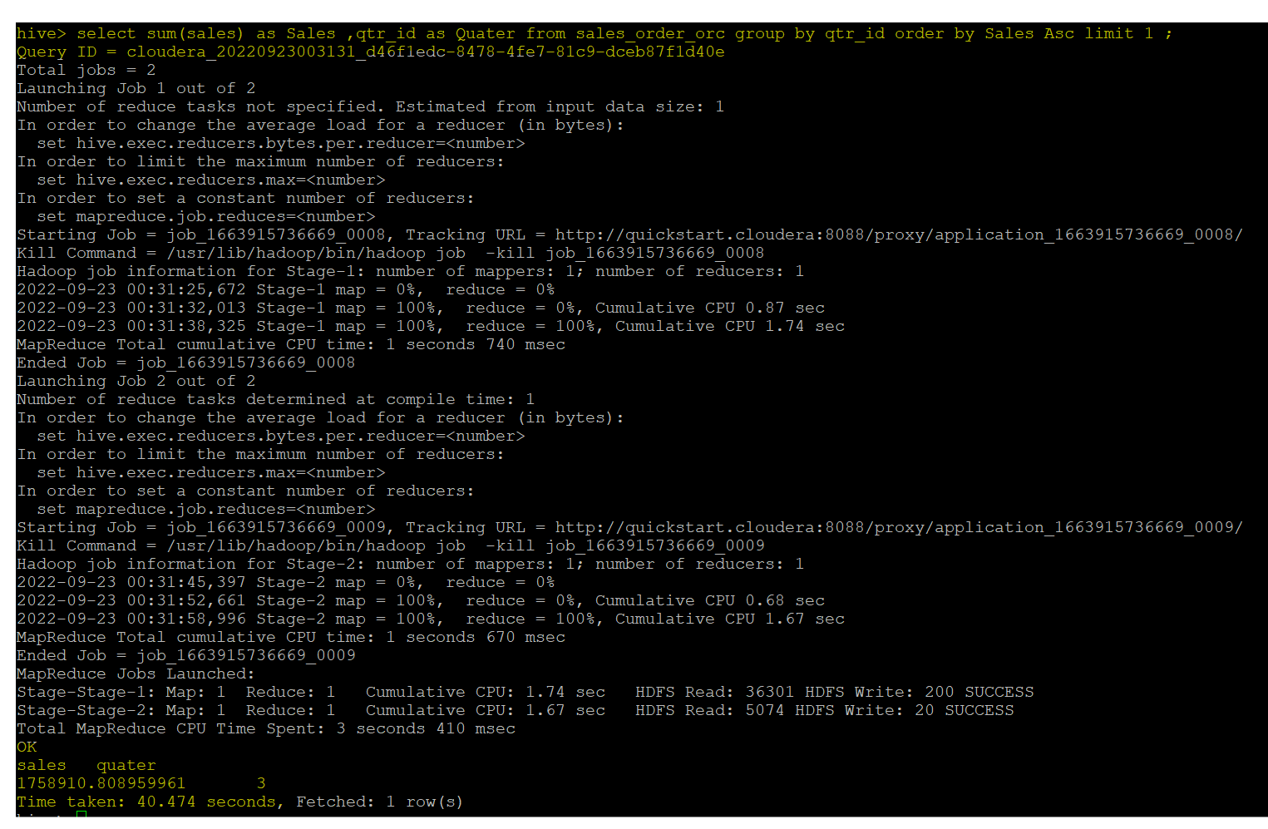

**e. In which country sales was maximum and in which country sales was minimum –**

**Maximum -**

select sum(sales) as Maximum_Sales ,Country from sales_order_orc group by country order by Maximum_Sales Desc limit 1 ;

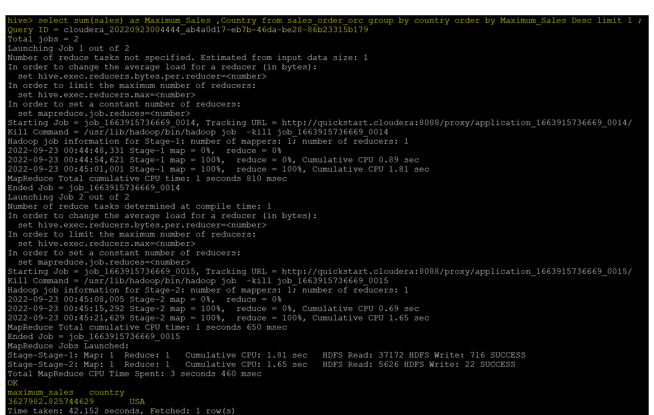

**Minimum Sales –**

select sum(sales) as Minimum_Sales ,Country from sales_order_orc group by country order by Minimum_Sales Asc limit 1 ;

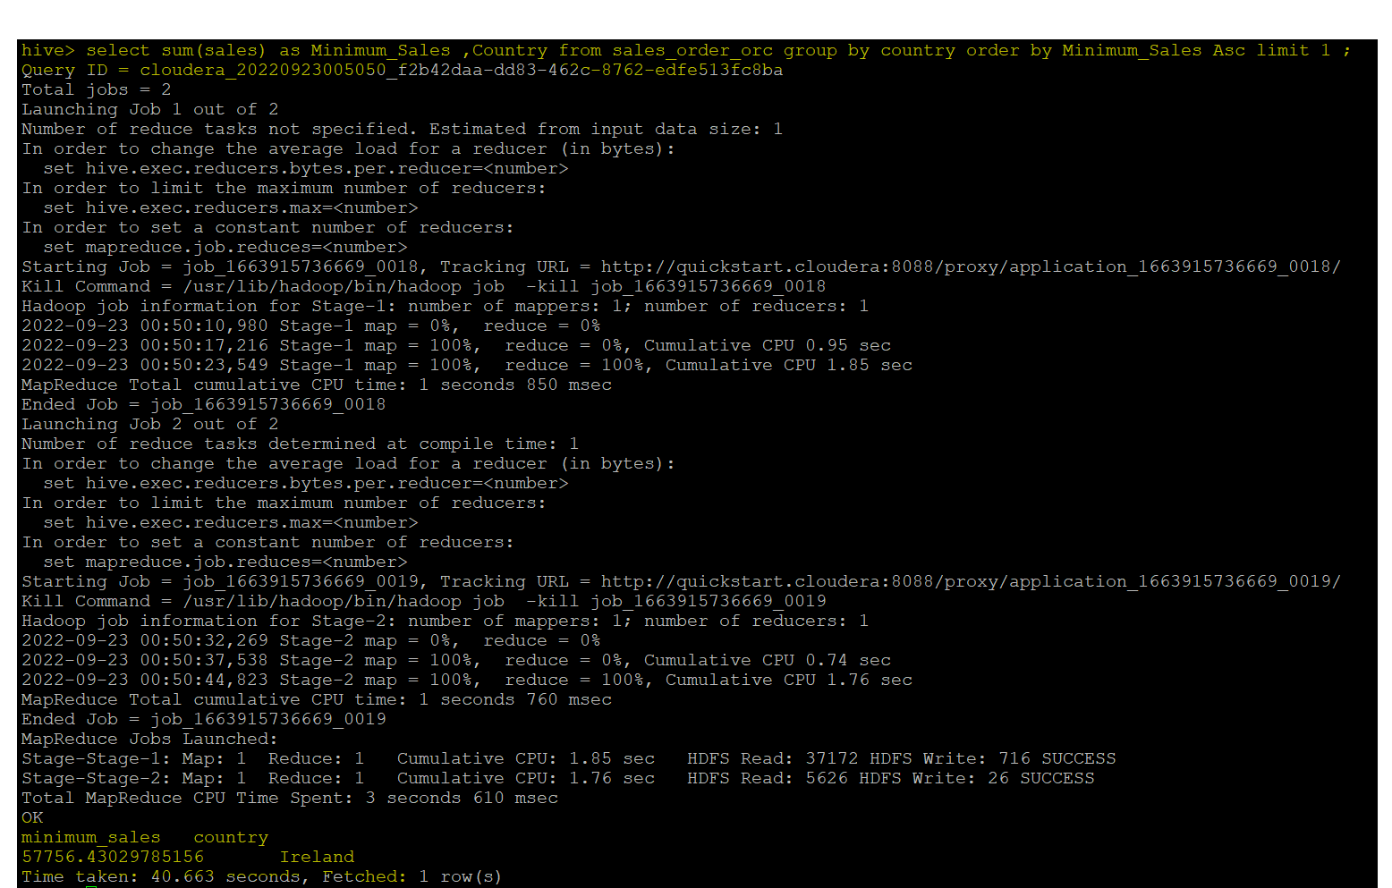

**f. Calculate quarterly sales for each city --**

select sum(sales) Sales,qtr_id Quater,city as City from sales_order_orc group by qtr_id,city;

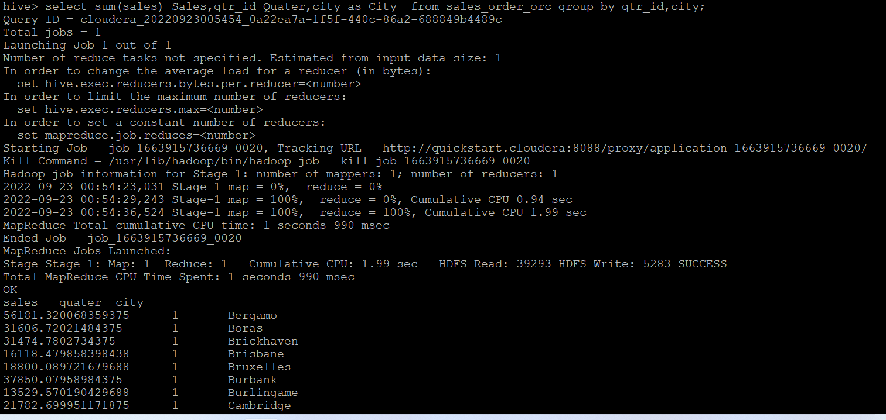

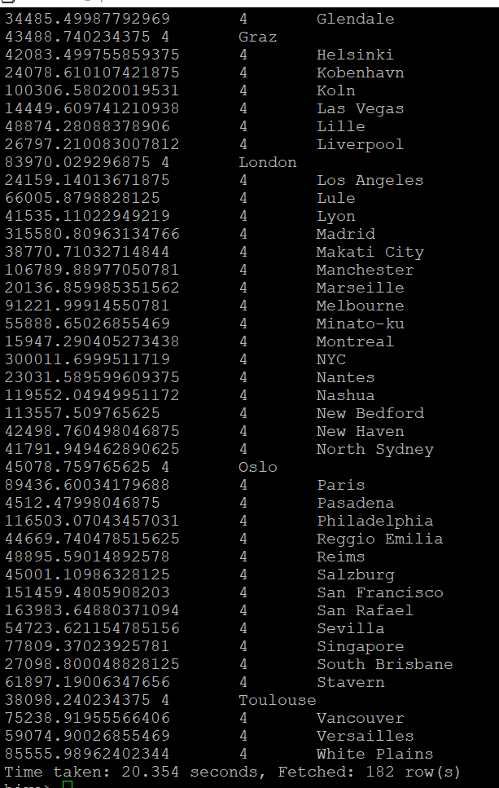

**h. Find a month for each year in which maximum number of quantities were sold---**

select month_id, max(QUANTITYORDERED),year_id from sales_order_orc group by year_id;

