**Title - Hive Mini Project 1 – Big Data class ineuron**

Name -Mayur Thele

Email – [Mayur.thele1@gmail.com](mailto:Mayur.thele1@gmail.com)

**Project info and requirement –**

This is a real time dataset of the ineuron technical consultant team. You have to perform hive analysis on this given dataset.

Download Dataset 1 - https://drive.google.com/file/d/1WrG-9qv6atP-W3P_-gYln1hHyFKRKMHP/view

Download Dataset 2 - https://drive.google.com/file/d/1-JIPCZ34dyN6k9CqJa-Y8yxIGq6vTVXU/view

Note: both files are csv files.

**Problem Statement 1-**

**Create a schema based on the given dataset**

**Solution –**

**Table 1 –**

create table tbl_AgentLogingReport(

SL_No int,

Agent string,

Date string,

Login_Time string,

Logout_Time string,

Duration string)

row format delimited

fields terminated by ','

tblproperties("skip.header.line.count"="1");

**Table 2 –**

create table tbl_AgentPerformance(

SL_No int,

Date string,

Agent_Name string,

Total_Chats int,

Average_Response_Time string,

Average_Resolution_Time string,

Average_Rating float,

Total_Feedback int)

row format delimited

fields terminated by ','

tblproperties("skip.header.line.count"="1");

**CLI Output –**

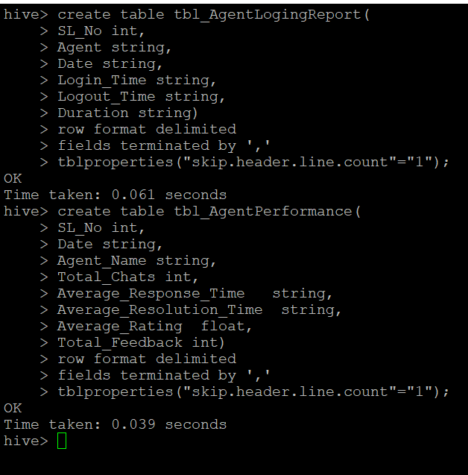

**Problem Statement 2-**

**Dump the data inside the hdfs in the given schema location.**

**Solution –**

load data inpath '/tmp/AgentPerformance.csv' into table tbl_AgentPerformance;

load data inpath '/tmp/AgentLogingReport.csv' into table tbl_AgentLogingReport;

**CLI Output –**

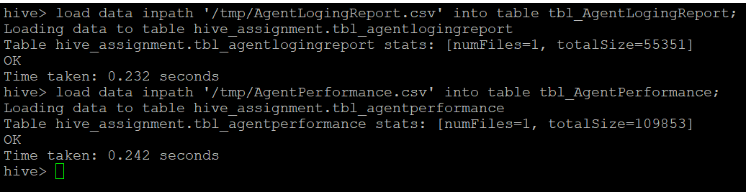

**Problem Statement 3-**

**List of all agents' names.**

**Solution –**

Select distinct Agent_Name as Agent_Name from tbl_AgentPerformance;

**CLI Output –**

Output is too big to capture in single window so the initial and final line snapshot is attached below -

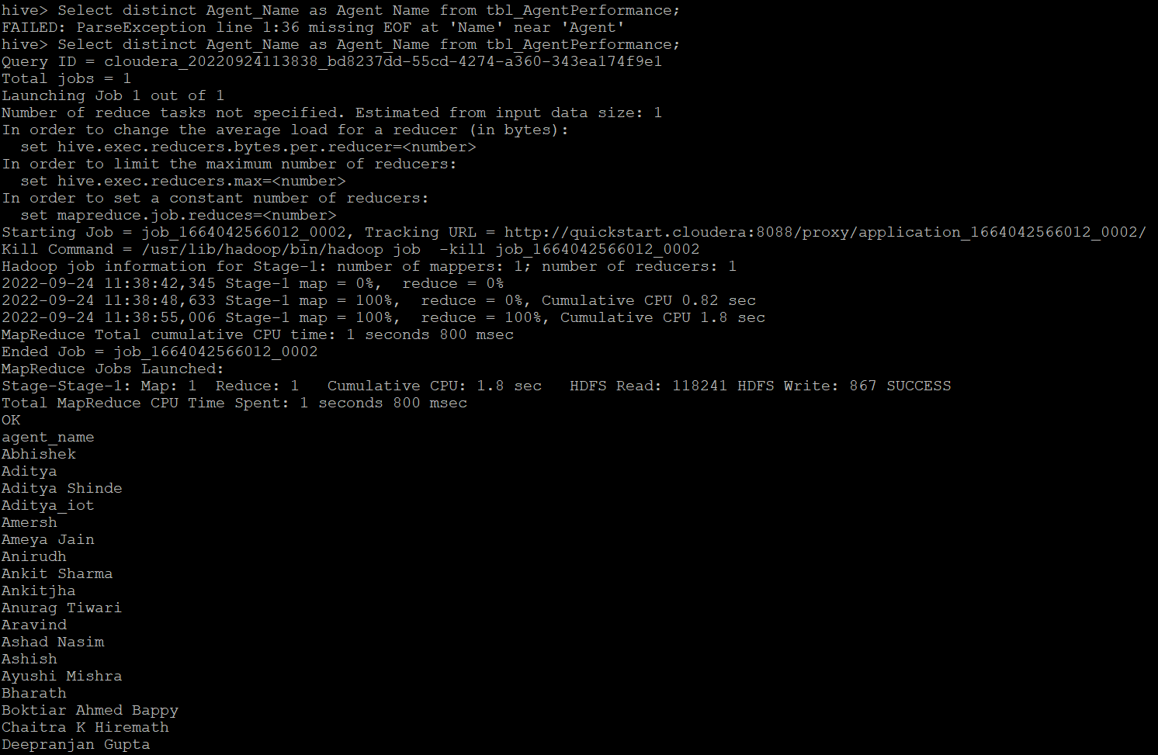

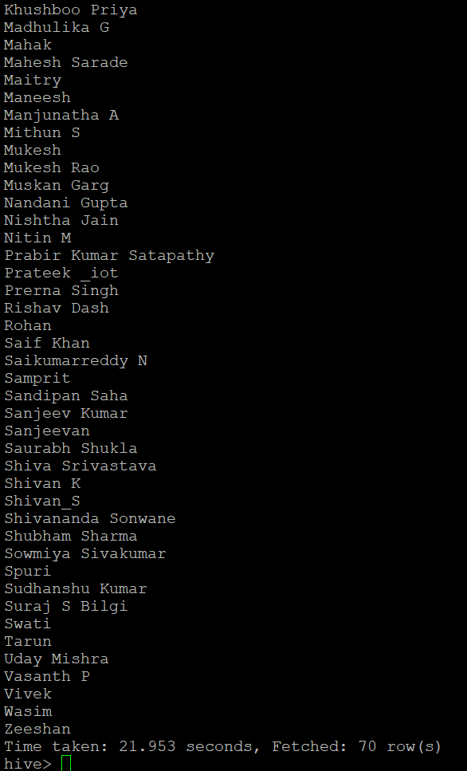

**Problem Statement 4-**

**Find out agent average rating.**

**Solution –**

As per problem solution we need to find the average rating for each agent

Select Agent_name,avg(Average_Rating) as Average_rating_of_Client from tbl_AgentPerformance group by agent_name;

**CLI Output –**

Output is too big to capture in single window so the initial and final line snapshot is attached below

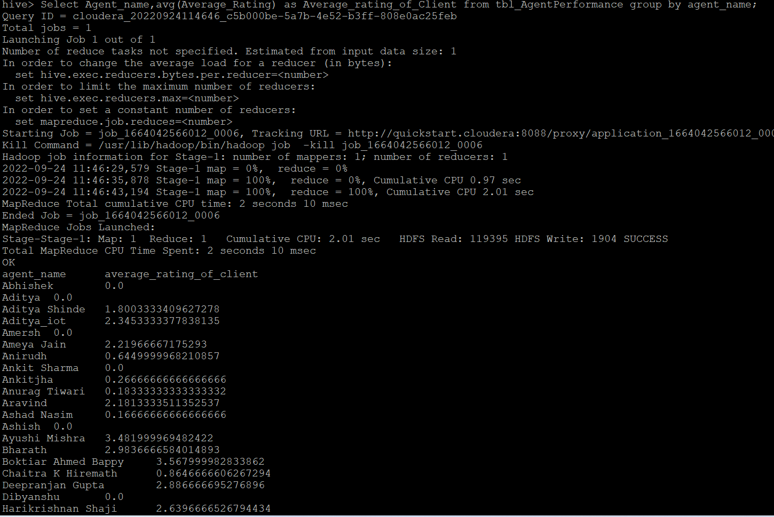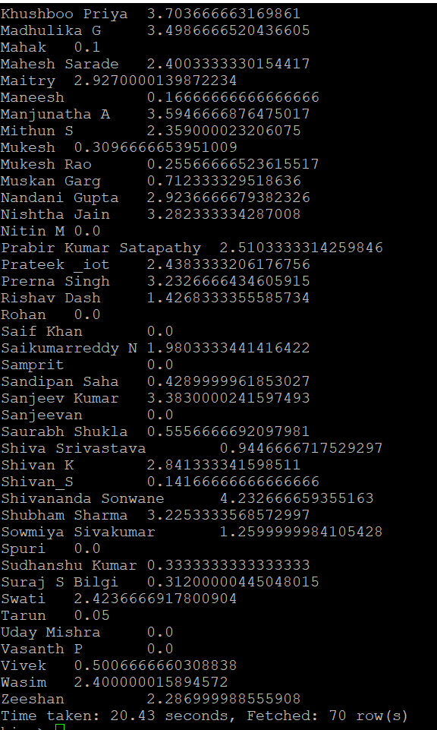

**Problem Statement 5-**

**Total working days for each agents –**

**Solution –**

select count(distinct date)as Working_day, Agent from tbl_AgentLogingReport group by agent;

**CLI Output –**

Output is too big to capture in single window so the initial and final line snapshot is attached below

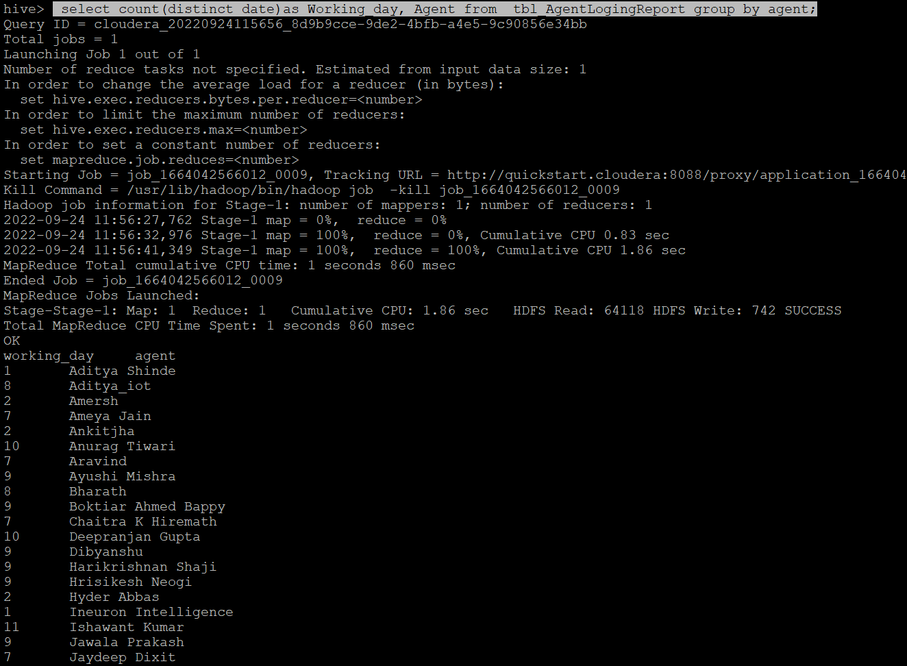

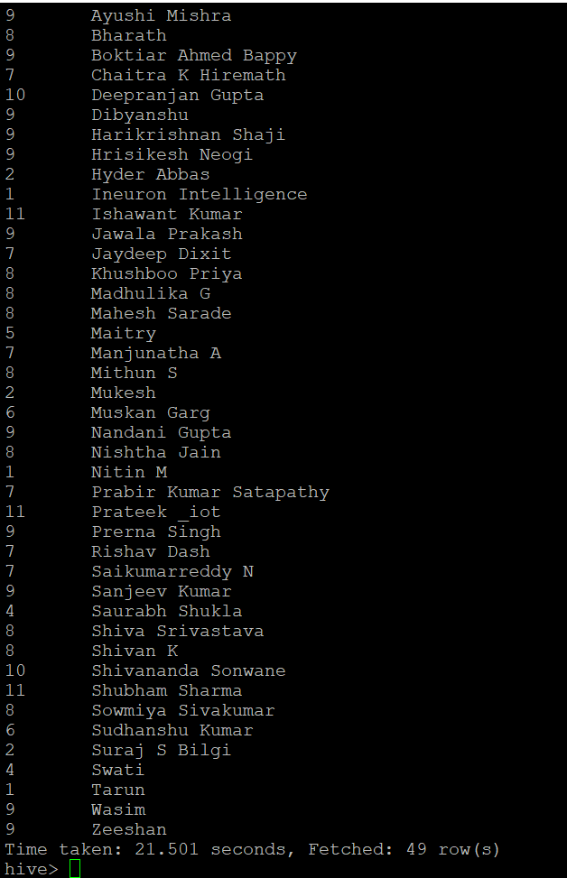

**Problem Statement 6-**

**Total query that each agent have taken -**

**Solution –**

*Considering query means the questions so equivalent to chat*

Select Agent_name,sum(total_chats) as Query_Taken_By_Agent from tbl_AgentPerformance group by agent_name;

**CLI Output –**

Output is too big to capture in single window so the initial and final line snapshot is attached below

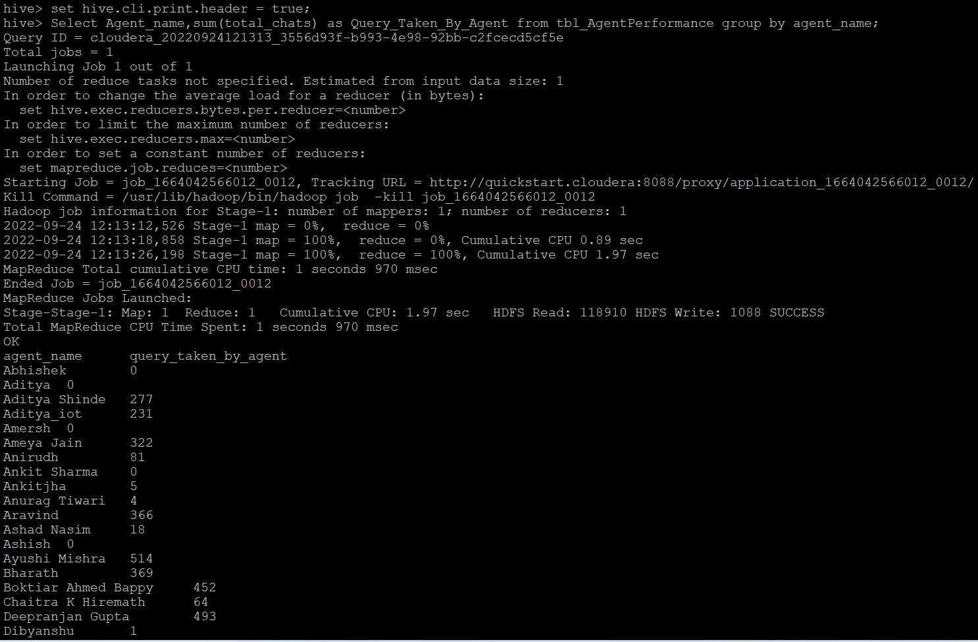

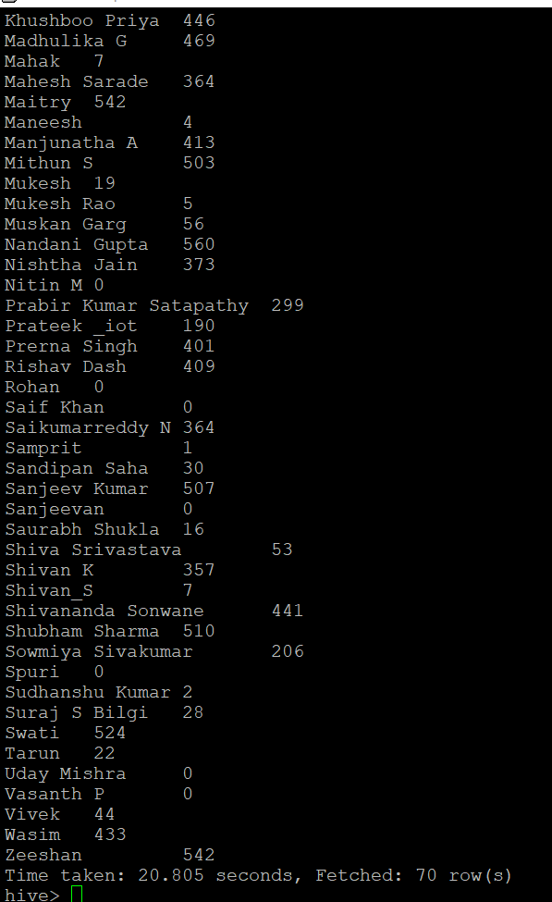

**Problem Statement 7-**

**Total Feedback that each agent have received -**

**Solution –**

Select Agent_name,sum(total_feedback) as Feedback_Recied_By_Agent from tbl_AgentPerformance group by agent_name;

**CLI Output –**

Output is too big to capture in single window so the initial and final line snapshot is attached below

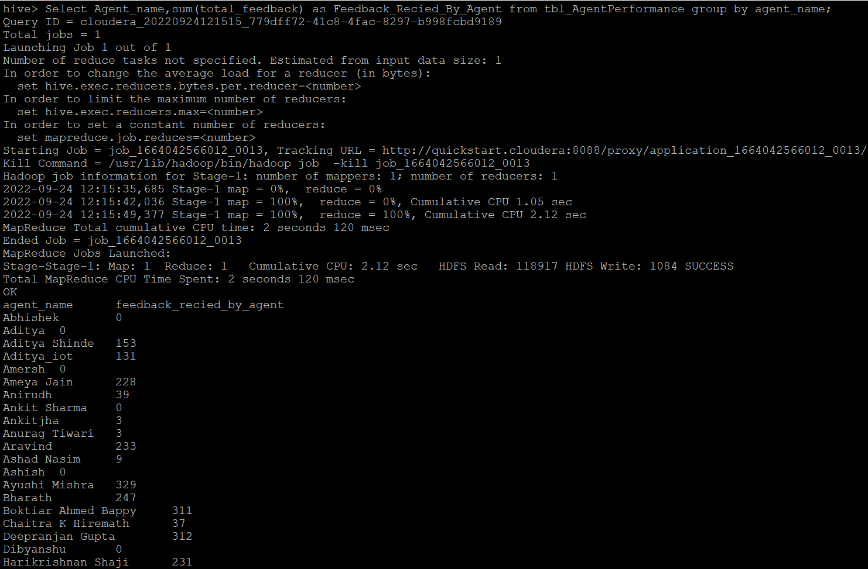

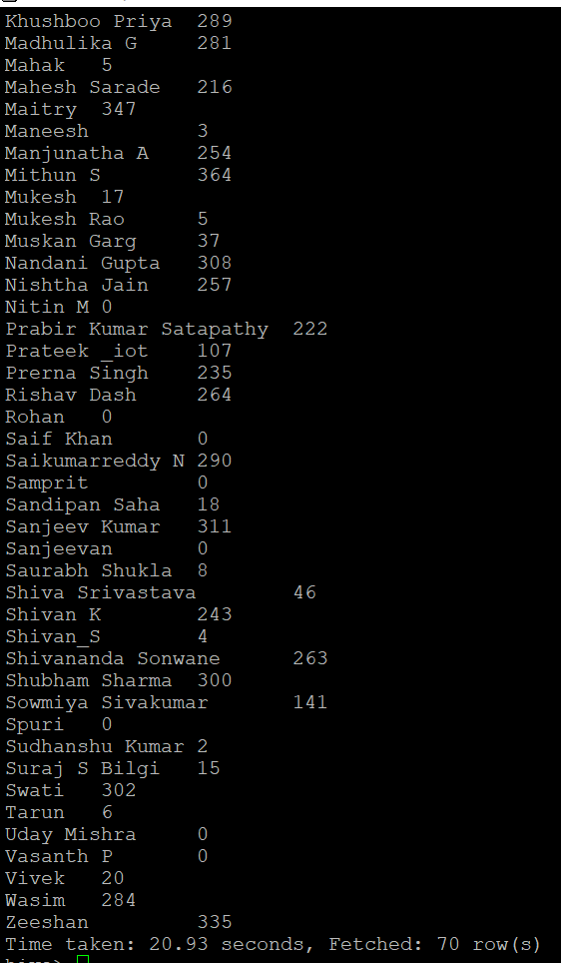

**Problem Statement 8-**

**Agent name who have average rating between 3.5 to 4 -**

**Solution –**

Select distinct Agent_name from tbl_AgentPerformance where average_rating between 3.5 and 4.0;

**CLI Output –**

Output is too big to capture in single window so the initial and final line snapshot is attached below

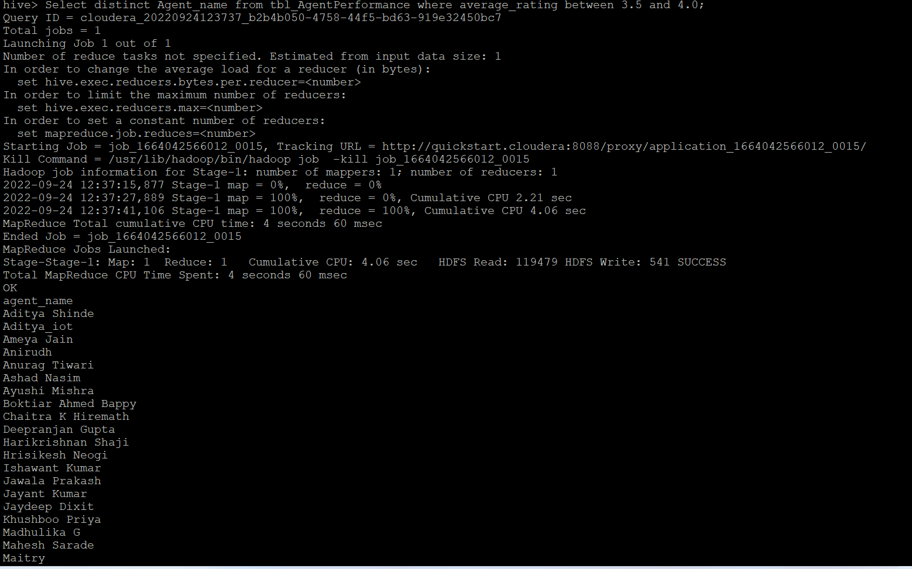

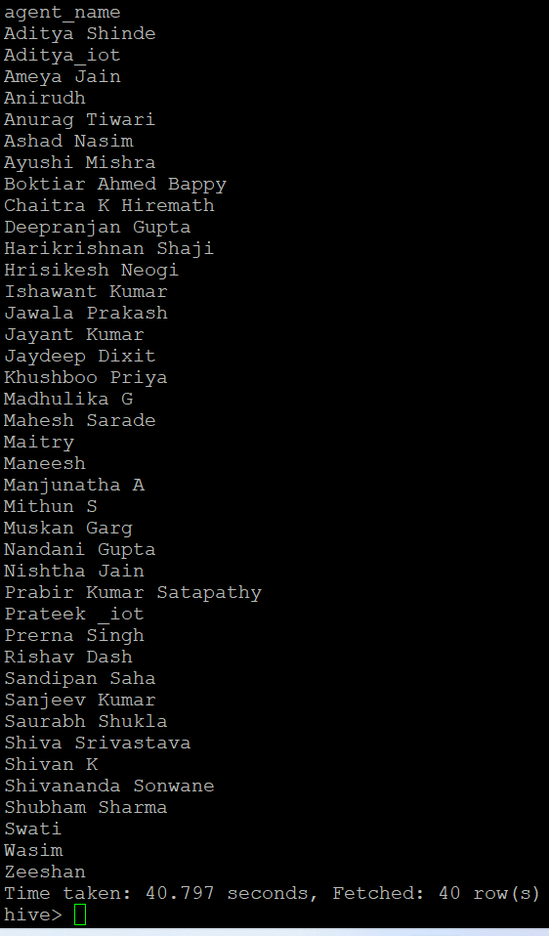

**Problem Statement 9-**

**Agent name who have rating less than 3.5 –**

**Solution –**

Select distinct Agent_name from tbl_AgentPerformance where average_rating < 3.5;

**CLI Output –**

Output is too big to capture in single window so the initial and final line snapshot is attached below

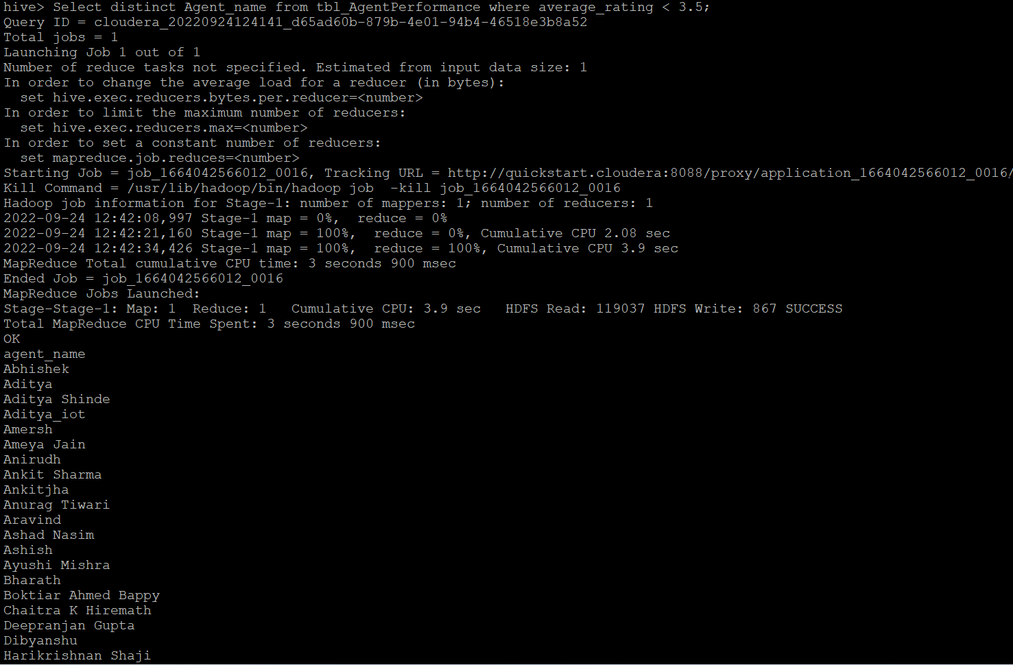

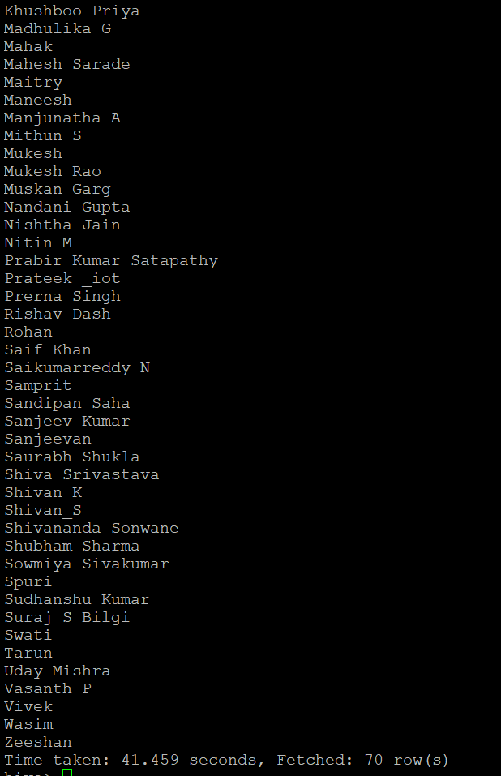

**Problem Statement 10-**

**Agent name who have rating more than 4.5 -**

**Solution –**

Select distinct Agent_name from tbl_AgentPerformance where average_rating > 4.5;

**CLI Output –**

Output is too big to capture in single window so the initial and final line snapshot is attached below

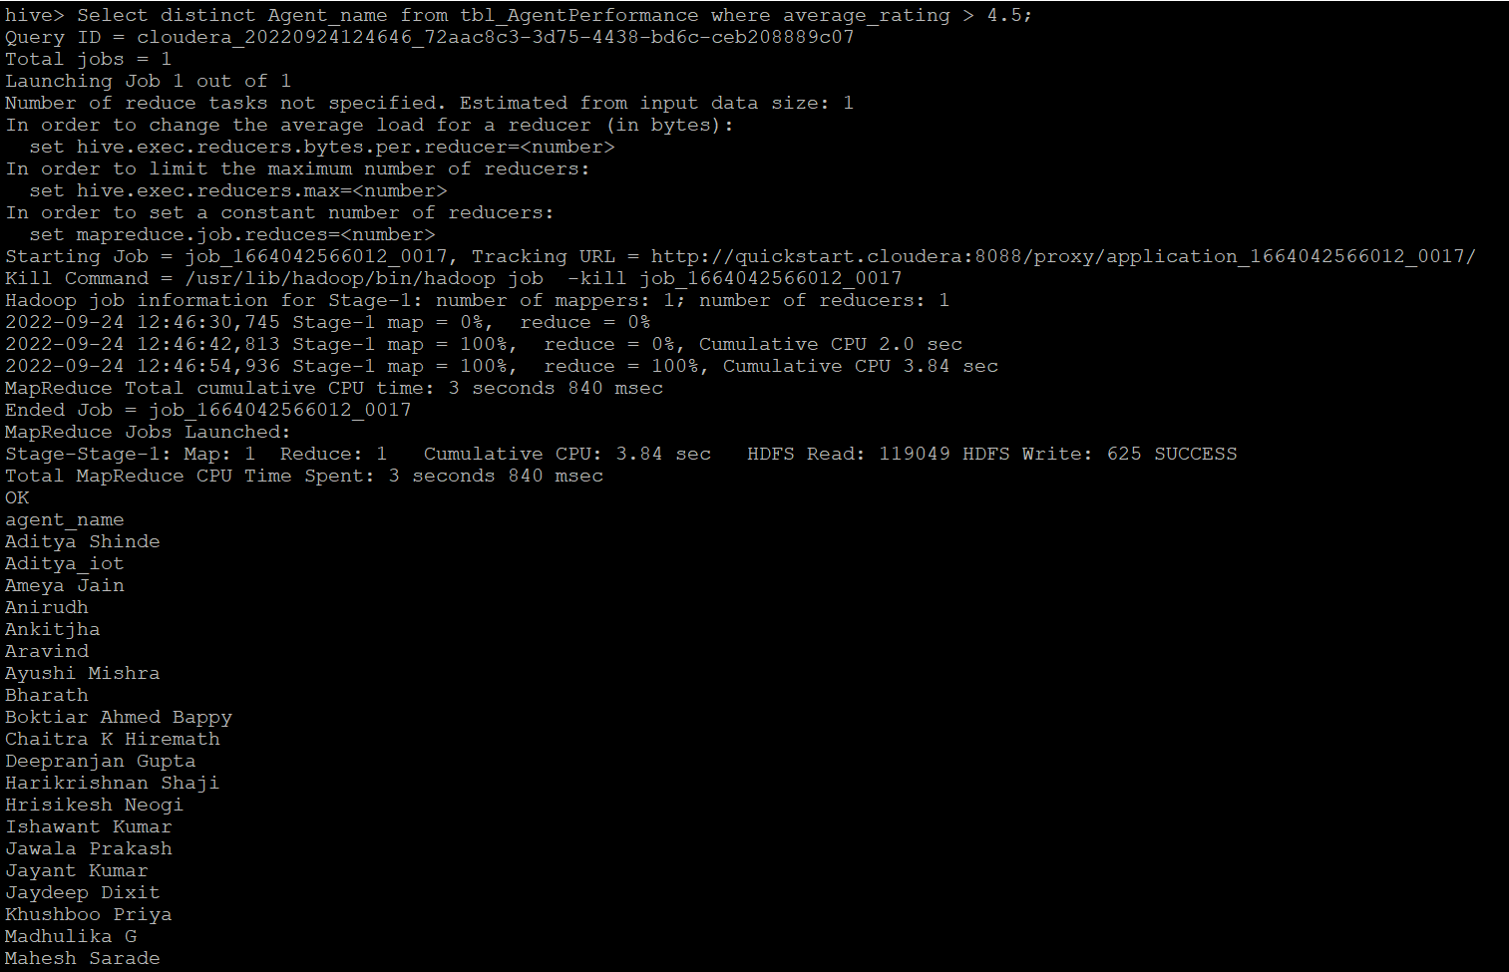

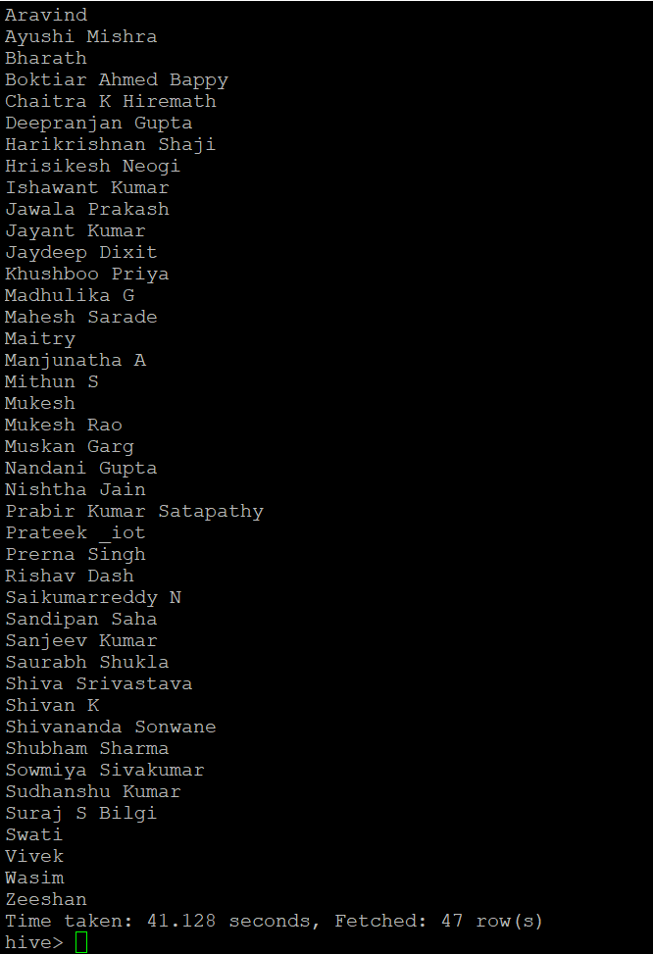

**Problem Statement 11-**

**How many feedback agents have received more than 4.5 average**

**Solution –**

Select agent_name,sum(total_feedback) as Feedback from tbl_AgentPerformance group by agent_name having avg(total_feedback) >4.5

**CLI Output –**

Output is too big to capture in single window so the initial and final line snapshot is attached below

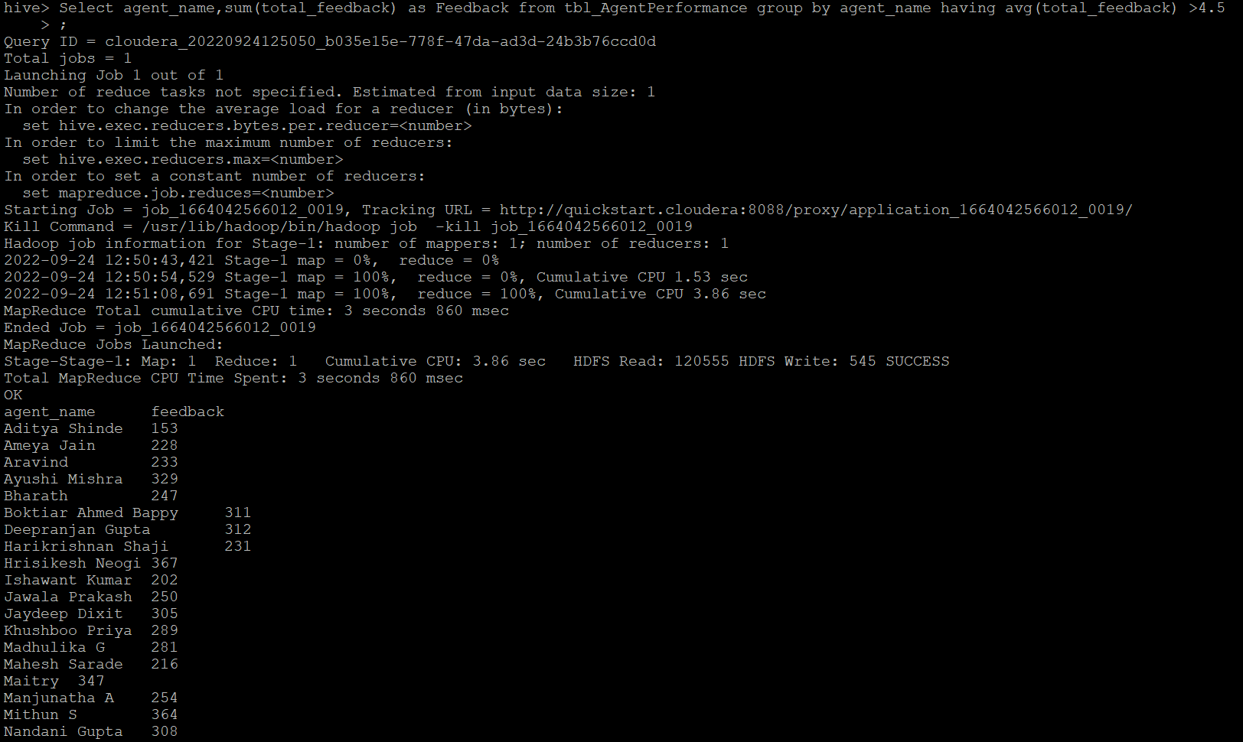

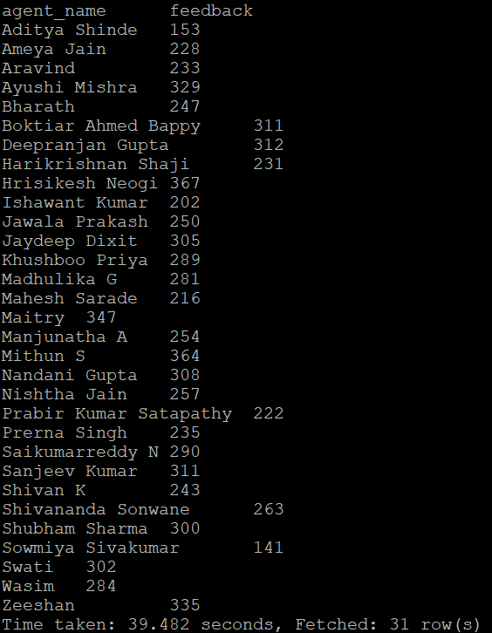

**Problem Statement 12-**

**Average weekly response time for each agent**

**Solution –** *we have used unix_timestamp and from_unixtime function to convet string into time or date data. And Cast function to convert date/time data after aggregation into BigInt and then to string for print purpose*

select from_unixtime(cast(avg(unix_timestamp(Average_Response_Time,'HH:mm:ss'))as bigint),'HH:mm:ss') as Average_Response_Time, week, agent_name

from

(select weekofyear(from_unixtime(unix_timestamp(date,'mm/dd/yyyy')))as week, Average_Response_Time ,agent_name from tbl_AgentPerformance) new_tab

group by week,agent_name;

**CLI Output –**

Complete output with respective quarter

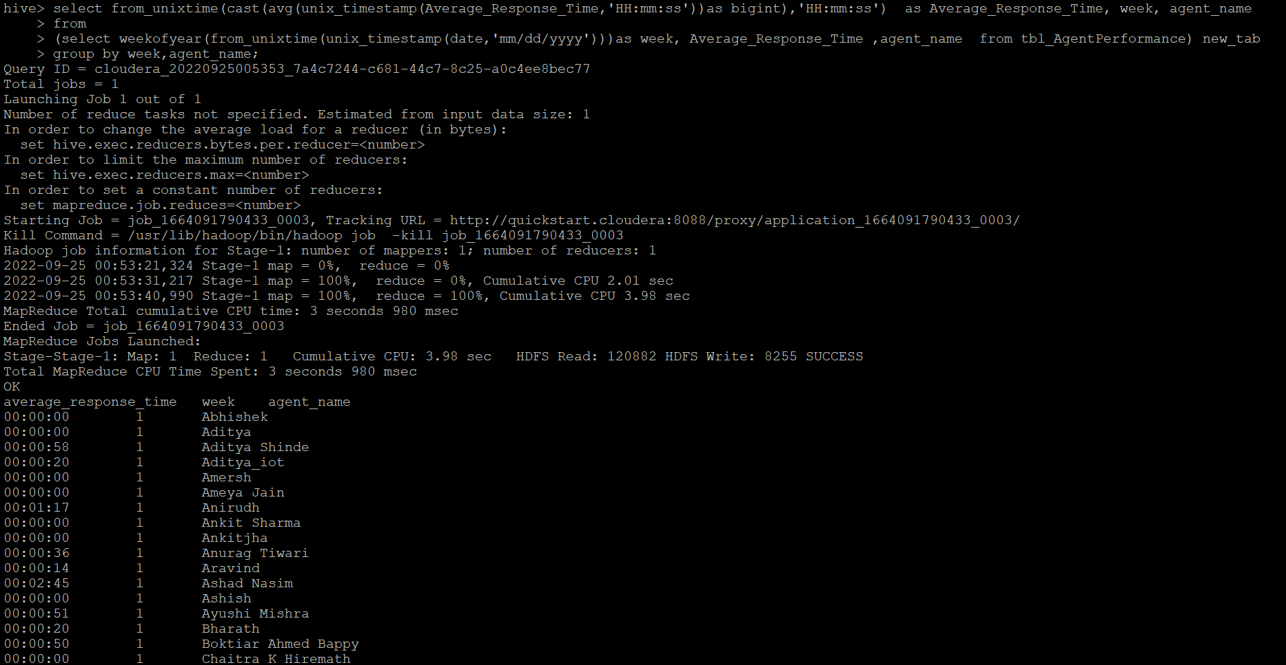

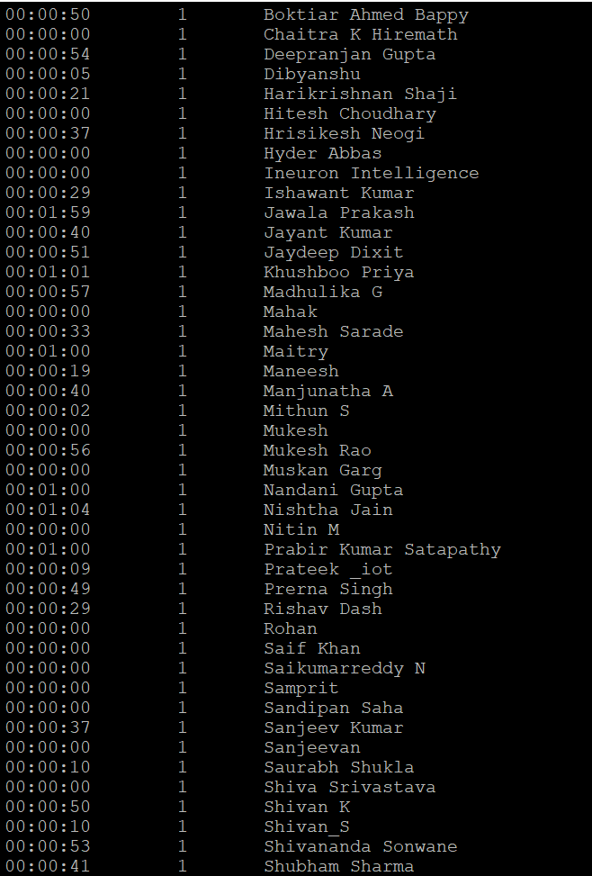 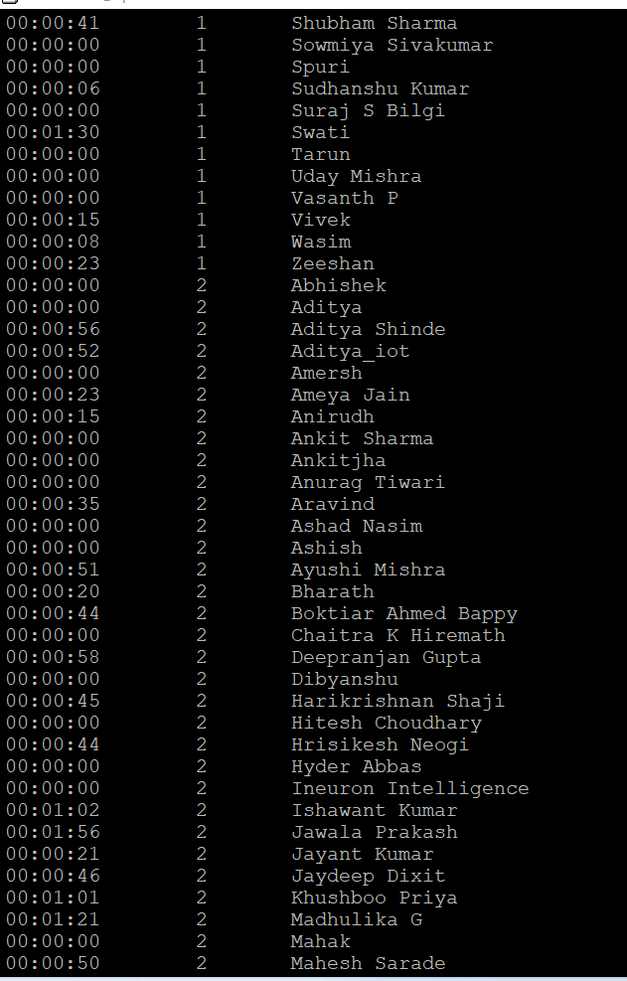

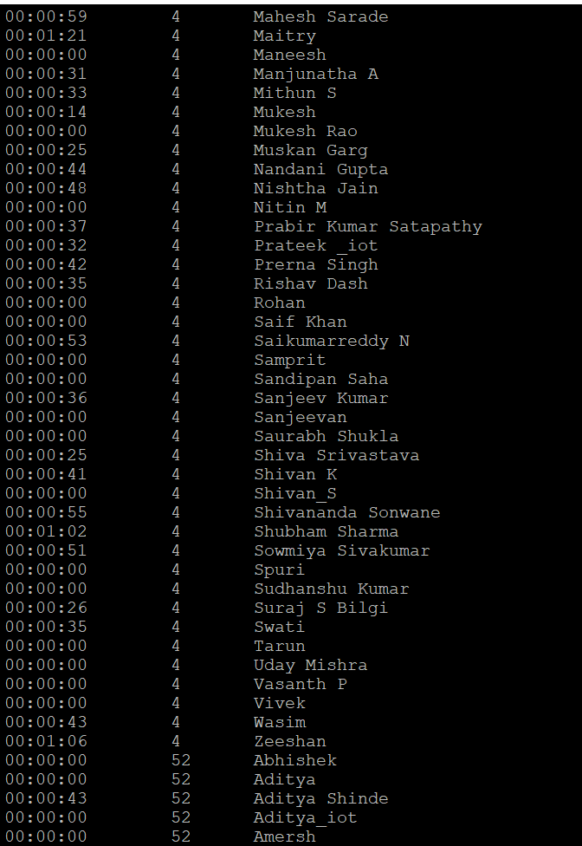 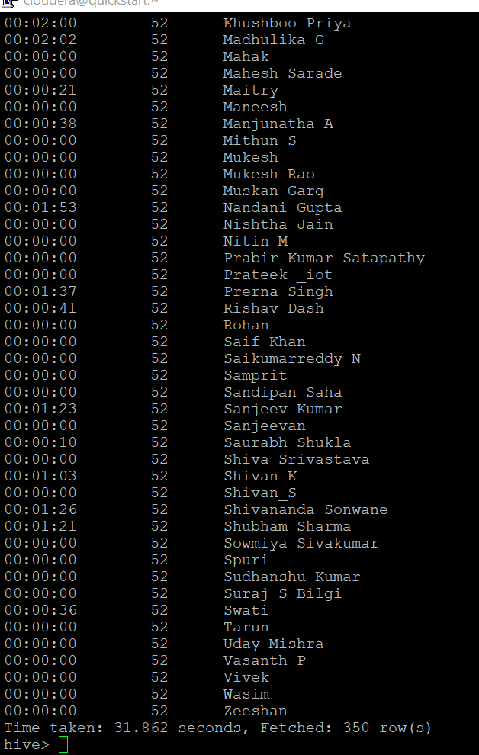

**Problem Statement 13-**

**Average weekly resolution time for each agents**

**Solution –** *we have used unix_timestamp and from_unixtime function to convet string into time or date data. And Cast function to convert date/time data after aggregation into BigInt and then to string for print purpose*

select from_unixtime(cast(avg(unix_timestamp(Average_Resolution_Time,'HH:mm:ss'))as bigint),'HH:mm:ss') as Average_Resolution_Time, week, agent_name

from

(select weekofyear(from_unixtime(unix_timestamp(date,'mm/dd/yyyy')))as week,Average_Resolution_Time,agent_name from tbl_AgentPerformance) new_tab

group by week,agent_name;

**CLI Output –**

Complete output

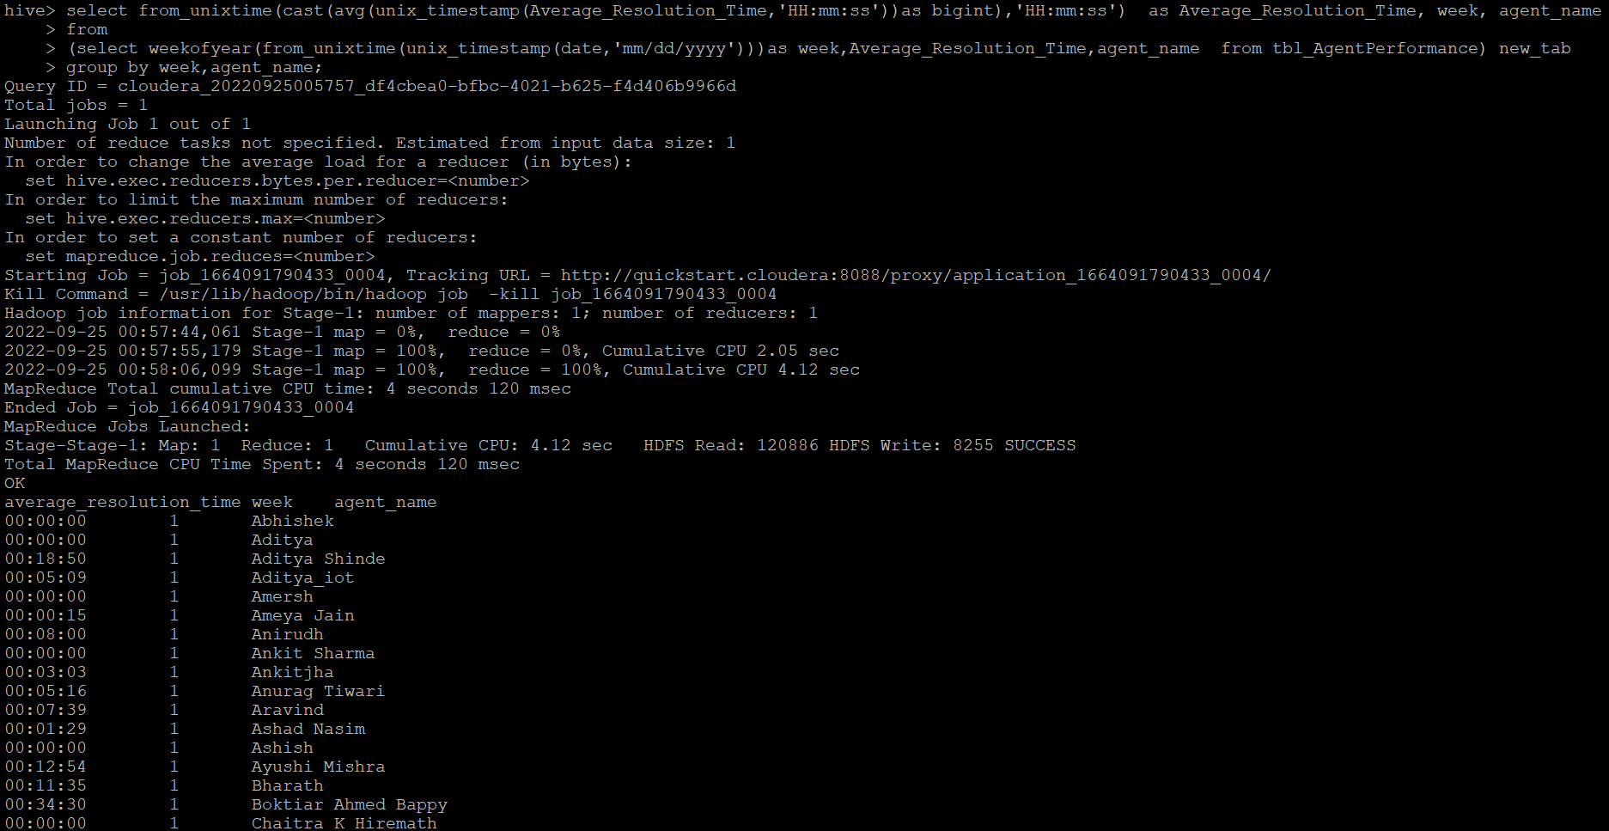

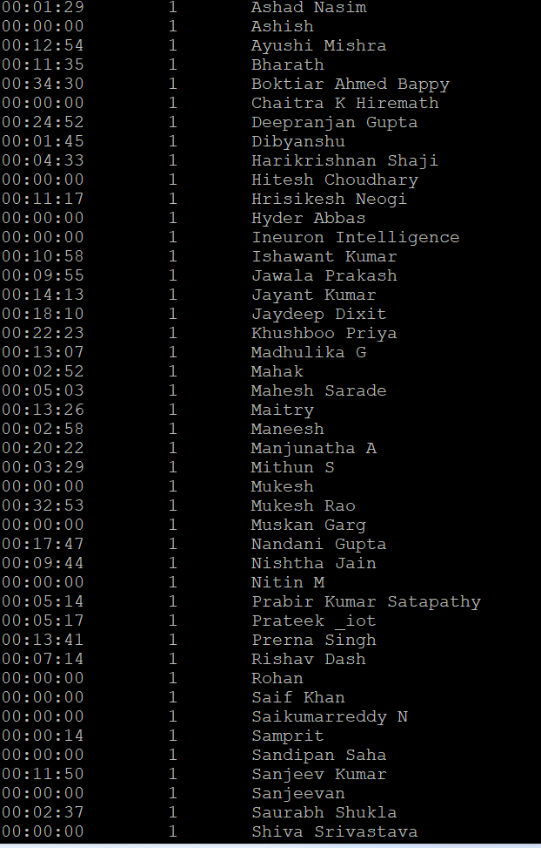 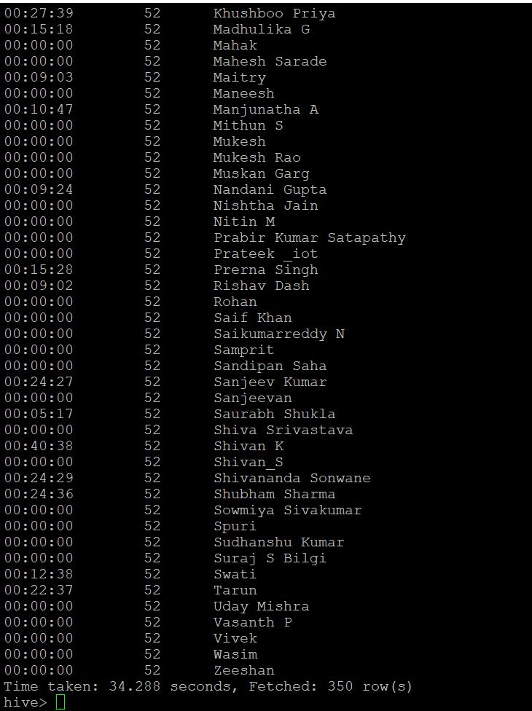

**Problem Statement 14-**

**Find the number of chat on which they have received a feedback**

**Solution –**

*As per problem statement ‘they’ means “agent” so we have found the feedback per ‘agent ‘*

select sum(total_chats) as Chat,agent_name from tbl_agentperformance where total_feedback > 0 group by agent_name;

**CLI Output –**

Output is too big to capture in single window so the initial and final line snapshot is attached below

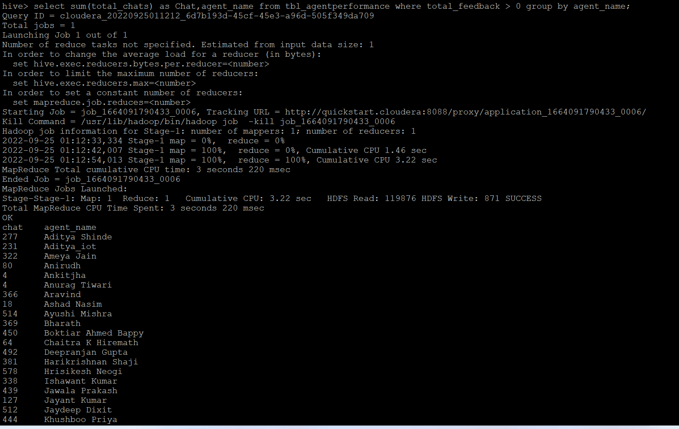

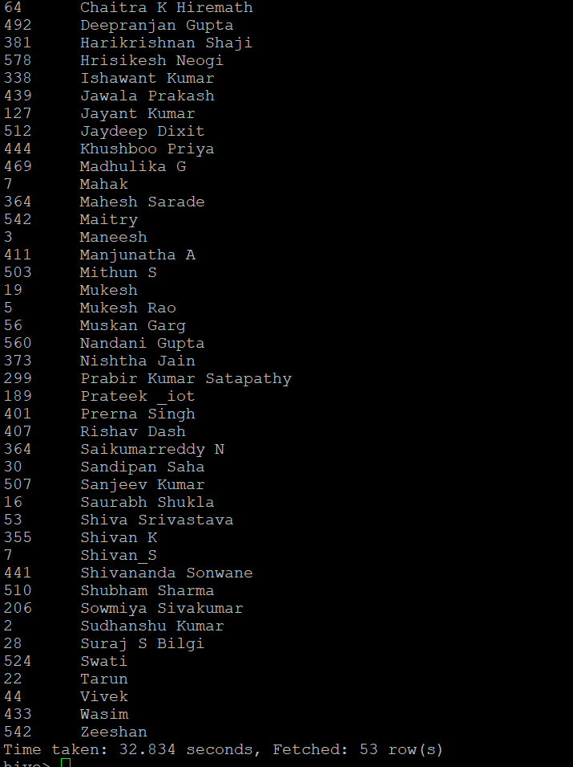

**Problem Statement 15-**

**Total contribution hour for each and every agents weekly basis**

**Solution –** *we have used unix_timestamp and from_unixtime function to convet string into time or date data. And Cast function to convert date/time data after aggregation into BigInt and then to string for print purpose*

select from_unixtime(cast(avg(unix_timestamp(duration,'HH:mm:ss'))as bigint),'HH') as contribution_in_Hours , week, agent as agent_name

from

(select weekofyear(from_unixtime(unix_timestamp(date, 'dd-MMM-yy') ))as week,duration,agent from tbl_Agentlogingreport) new_tab

group by week,agent;

**CLI Output –**

Output is too big to capture in single window so the initial and final line snapshot is attached below

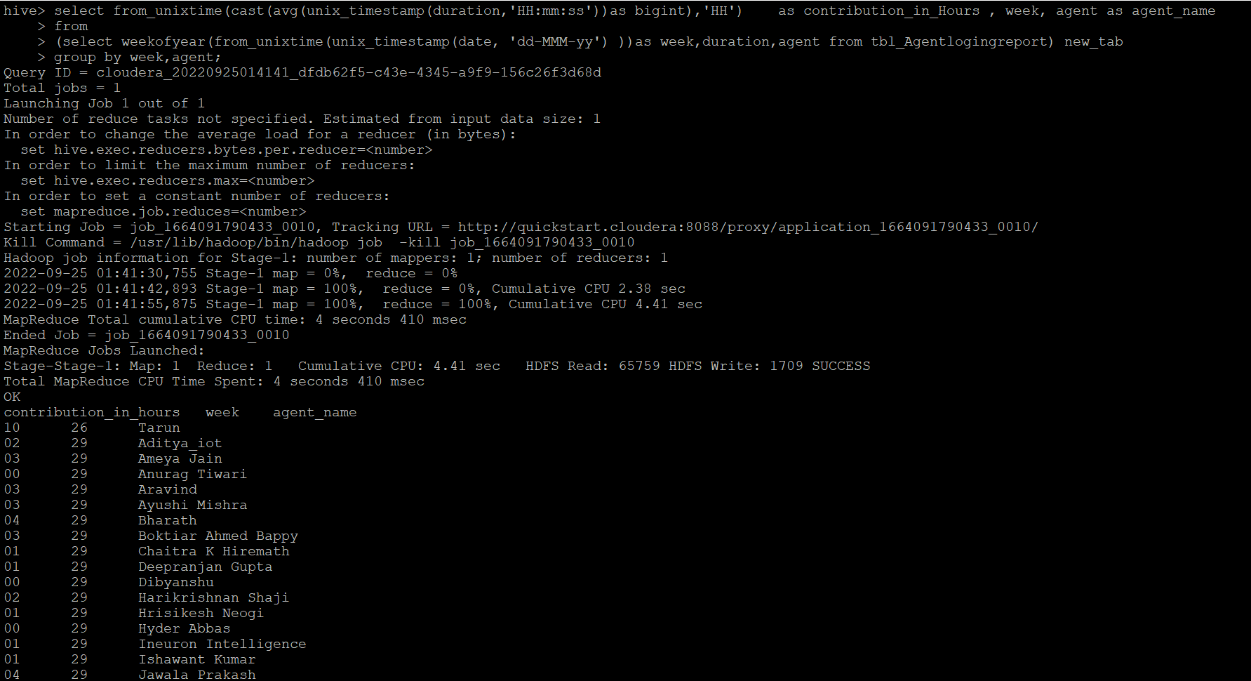

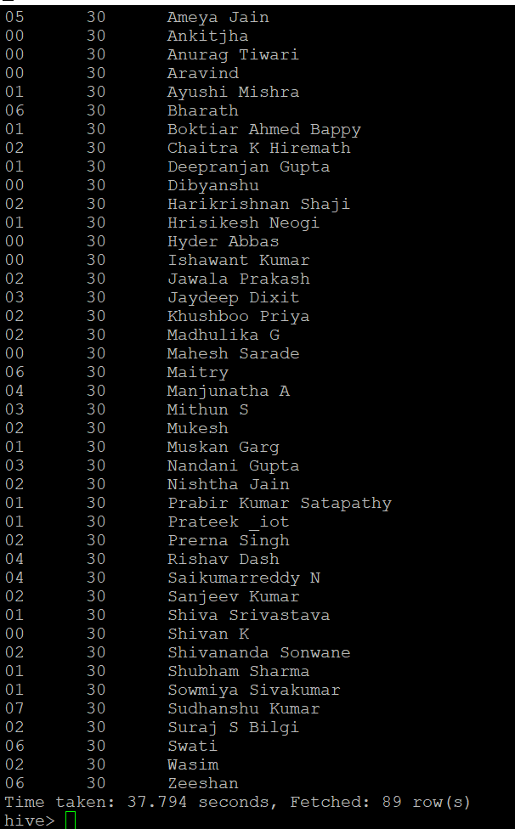

**Problem Statement 16-**

**Perform inner join, left join and right join based on the agent column and after joining the table export that data into your local system.-**

**Solution –**

**Inner Join Query –**

INSERT OVERWRITE directory '/tmp/Hive_Assignment/Inner_Join' row format delimited fields terminated by ','

SELECT * FROM tbl_AgentLogingReport l inner join tbl_AgentPerformance p

on l.agent=p.agent_name ;

**CLI Output –**

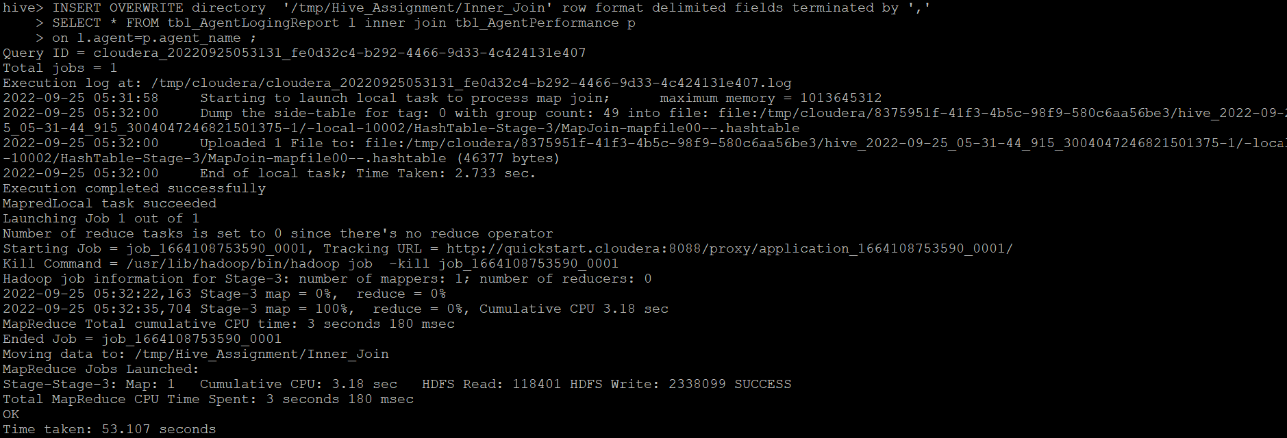

**Left Join Query –**

INSERT OVERWRITE directory '/tmp/Hive_Assignment/Left_Join' row format delimited fields terminated by ','

SELECT * FROM tbl_AgentLogingReport l left join tbl_AgentPerformance p

on l.agent=p.agent_name ;

**CLI Output –**

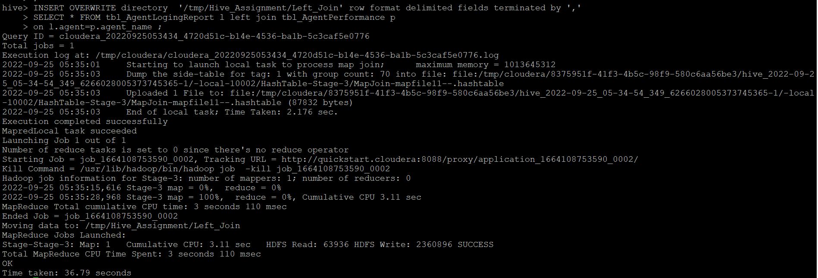

**Right Join Query –**

INSERT OVERWRITE directory '/tmp/Hive_Assignment/Right_Join' Join' row format delimited fields terminated by ','

SELECT * FROM tbl_AgentLogingReport l right join tbl_AgentPerformance p

on l.agent=p.agent_name ;

**CLI Output –**

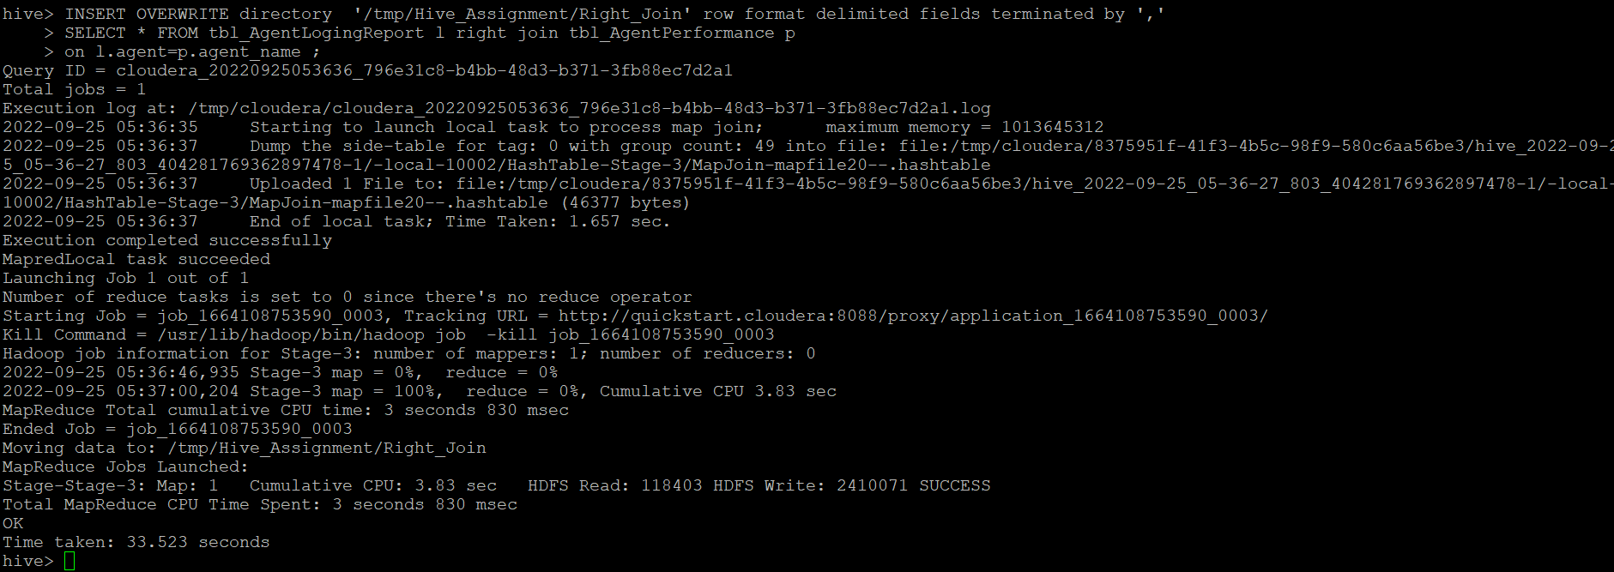

**Files stored in HDFS location -**

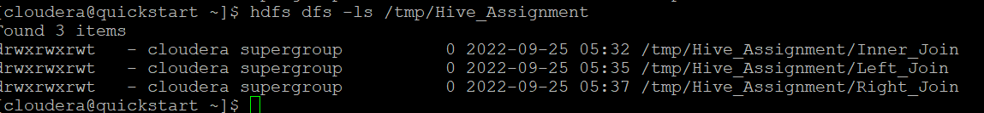

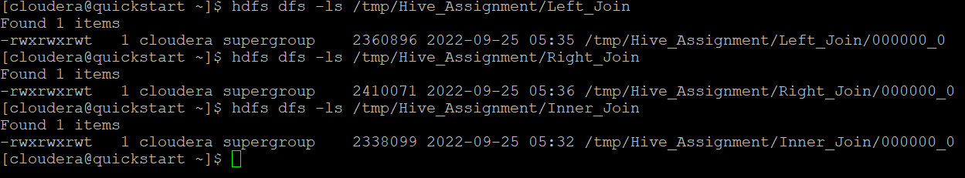

**Files loaded into ClouderaVM from HDFS location -**

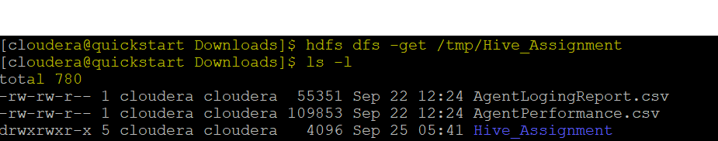

**Files loaded into local Pc using FileZilla-**

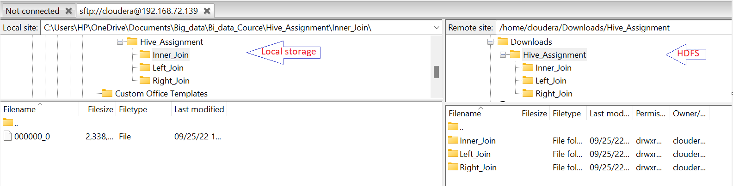

**Problem Statement 17-**

**Perform partitioning on top of the agent column and then on top of that perform bucketing for each partitioning.**

**Solution –**

**Table 1 Partitioning and Bucketing –**

create table tbl_AgentLogingReport_Partion_buck(

SL_No int,

Date string,

Login_Time string,

Logout_Time string,

Duration string)

partitioned by (Agent string)

clustered by (SL_No) into 2 buckets ;

**Set Necessary properties –**

SET hive.enforce.bucketing=true;

SET hive.exec.dynamic.partition=true;

SET hive.exec.dynamic.partition.mode=nonstrict;

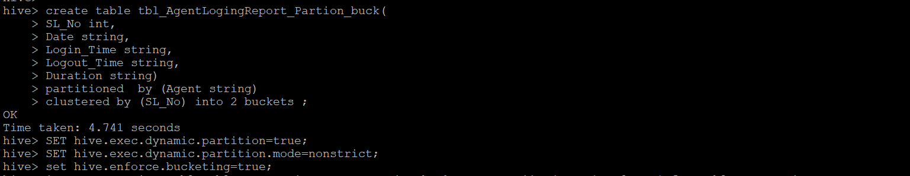

**Data Insert from stg table to Partitioning and Bucketing table –**

insert overwrite tbl_AgentLogingReport_Partion_buck partition(Agent) select SL_No,Date, Login_Time, Logout_Time, Duration,agent from tbl_AgentLogingReport;

**CLI Output –**

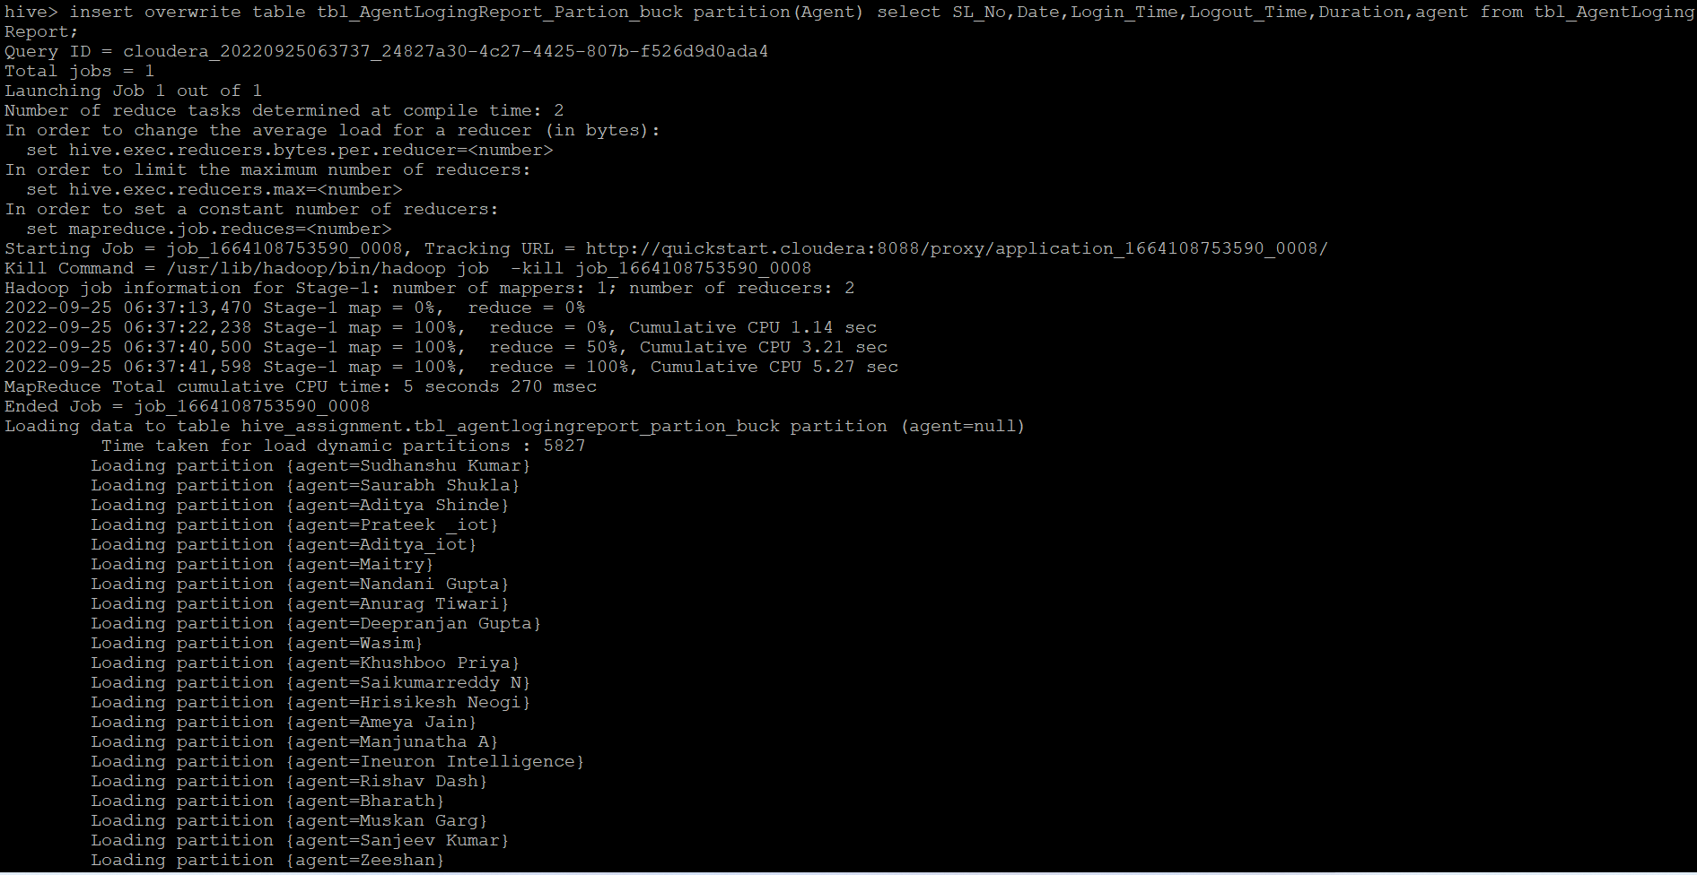

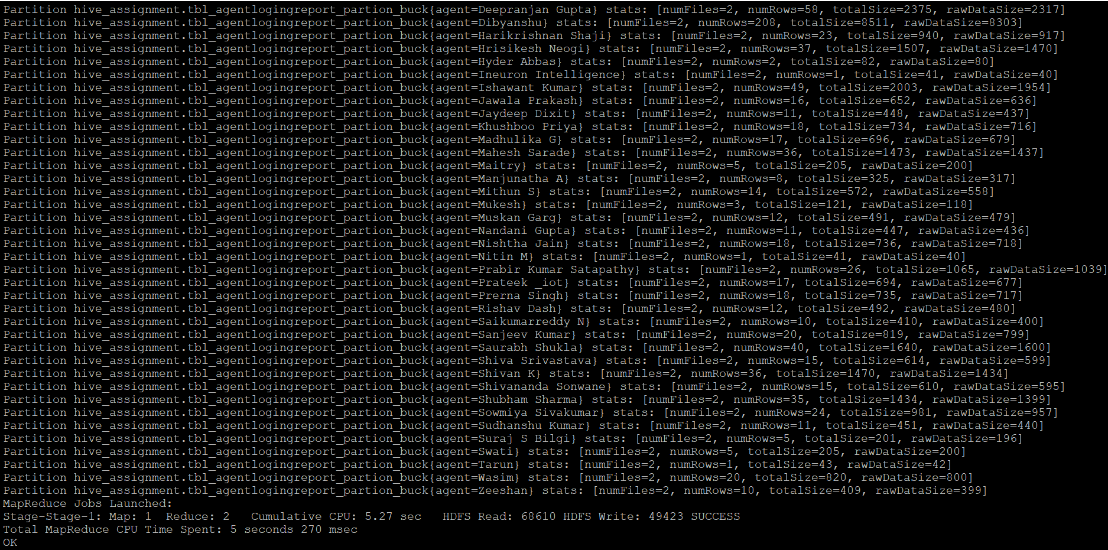

**Partitioning and Bucketing got created at Table location HDFS –**

hdfs dfs -ls /user/hive/warehouse/hive_assignment.db/tbl_AgentLogingReport_Partion_buck/agent=*

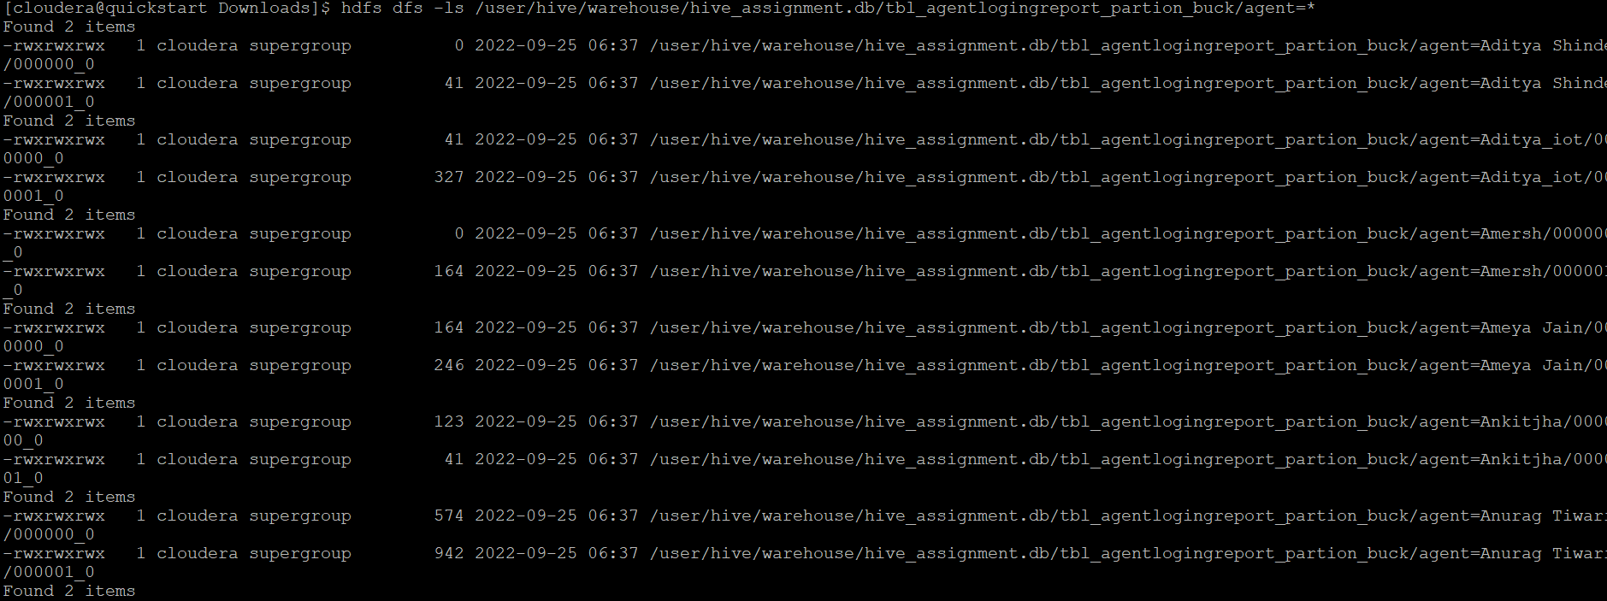

**Table 2 Partitioning and Bucketing –**

create table tbl_AgentPerformance_Partion_buck

(

SL_No int,

Date string,

Total_Chats int,

Average_Response_Time string,

Average_Resolution_Time string,

Average_Rating float,

Total_Feedback int)

partitioned by (Agent_Name string)

clustered by (SL_No) into 2 buckets;

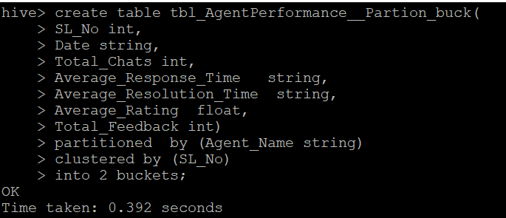

**Set Necessary properties –**

SET hive.enforce.bucketing=true;

SET hive.exec.dynamic.partition=true;

SET hive.exec.dynamic.partition.mode=nonstrict;

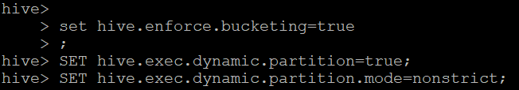

**Data Insert from stg table to Partitioning and Bucketing table –**

insert overwrite table tbl_AgentPerformance_Partion_buck partition(Agent_name) select SL_No,Date,Total_Chats,Average_Response_Time,Average_Resolution_Time,Average_Rating,Total_Feedback,Agent_name from tbl_AgentPerformance;

**CLI Output –**

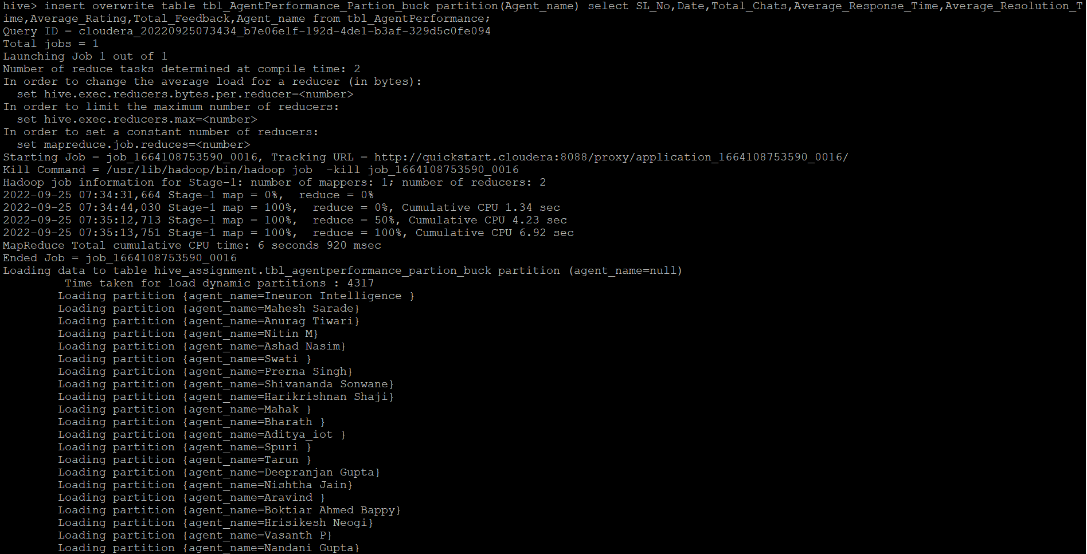

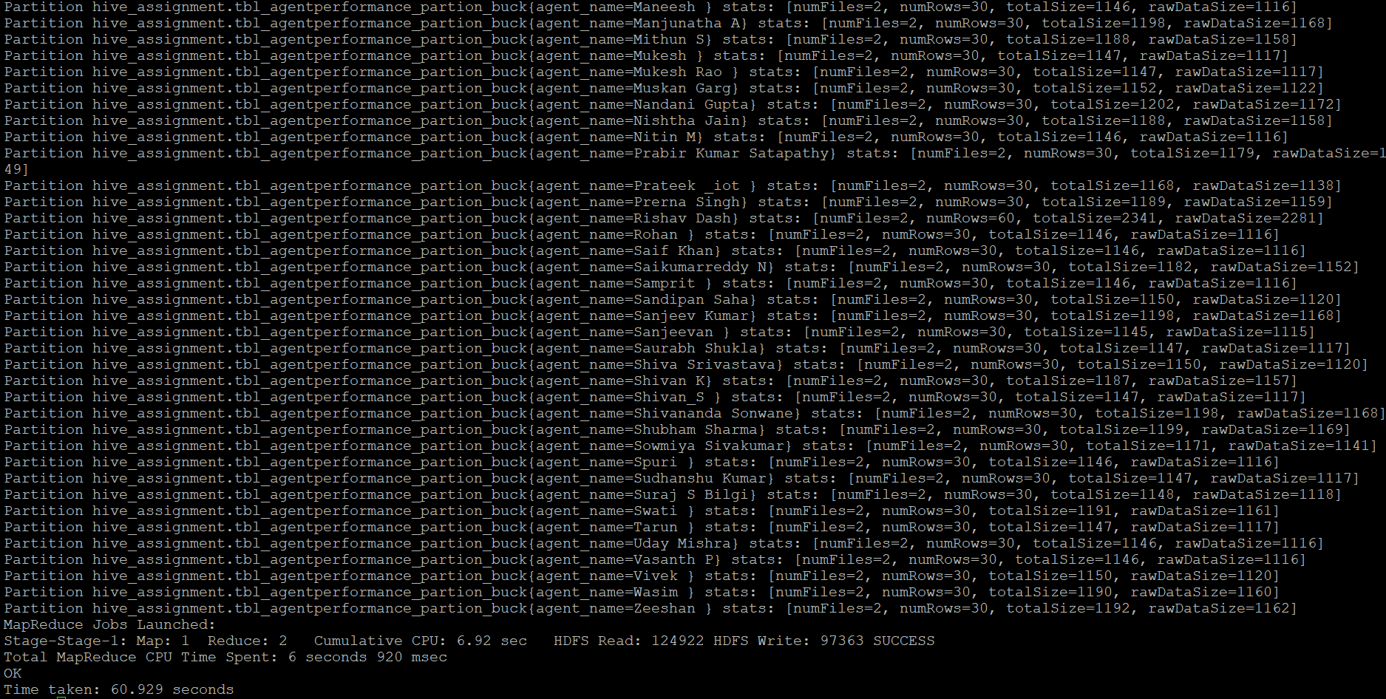

**Partitioning and Bucketing got created at Table location HDFS –**

hdfs dfs -ls /user/hive/warehouse/hive_assignment.db/tbl_agentperformance_partion_buck/agent_name*

