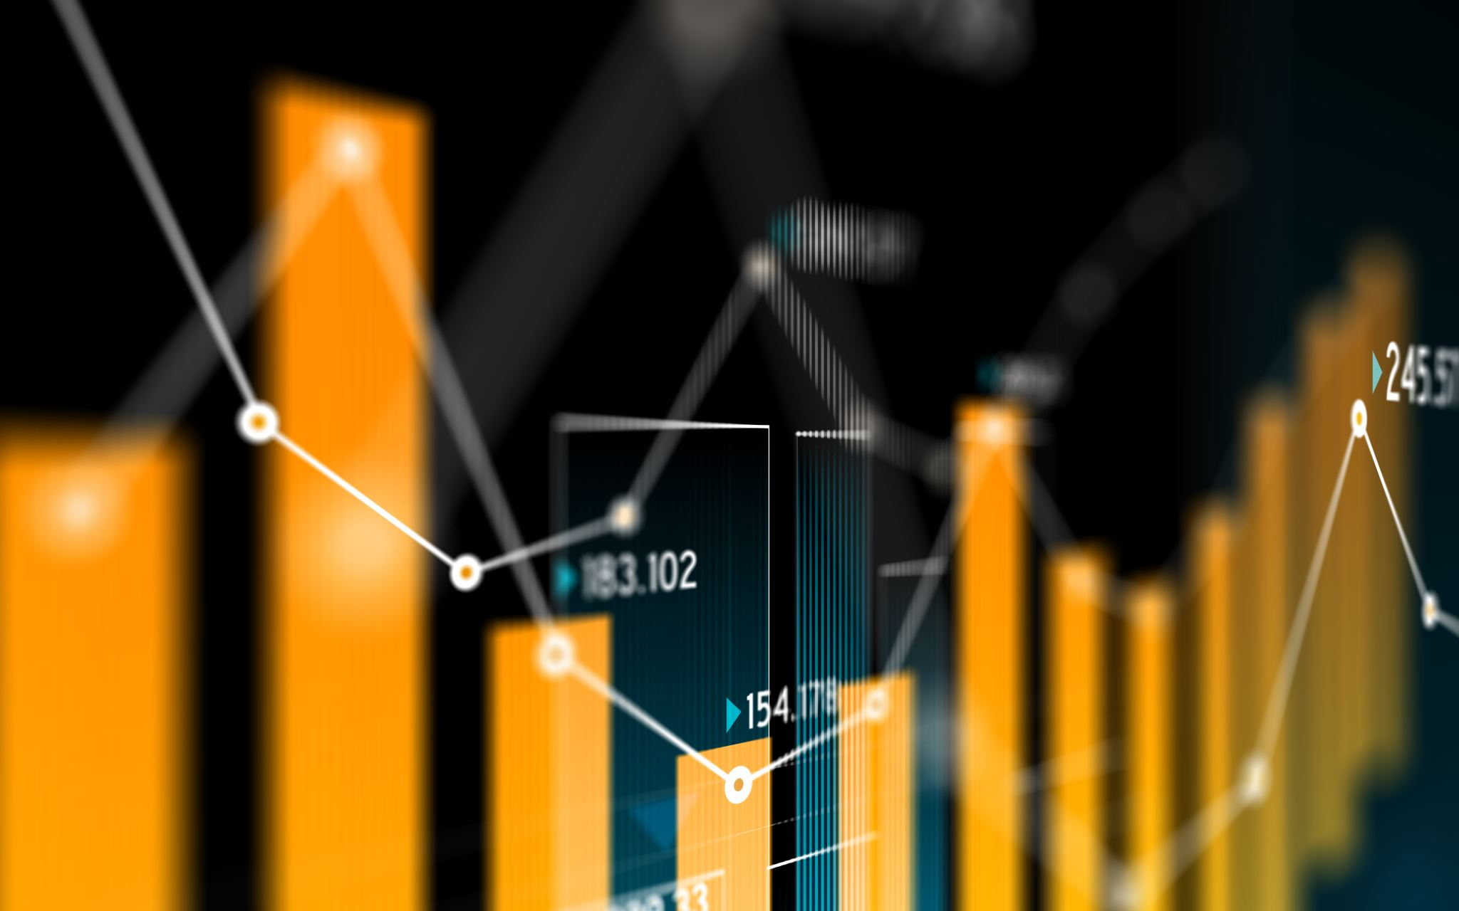

Big Data Project

Co2 Emission Change between 2004 and 2014

Group Members:

Member 1

Member 2

Member 3

Member 4

Member 5

TOPIC & TASKS

Add Link to used dataset here

APPROACH

RESULTS

HELPFUL RESOURCES

KMeans: <https://spark.apache.org/docs/2.0.0-preview/ml-clustering.html>

KMeans: <https://rsandstroem.github.io/sparkkmeans.html>

Installing GeoPandas on Windows: <https://geoffboeing.com/2014/09/using-geopandas-windows/>

ColorMaps: <https://matplotlib.org/examples/color/colormaps_reference.html>