Stage 1: Setting Up the Kubernetes Cluster and Static Web App
- Set Up Minikube:
  - Ensure Minikube is installed and running on the local Ubuntu machine.
  - Verify the Kubernetes cluster is functioning correctly.
- Deploy Static Web App:
  - Create a Dockerfile for a simple static web application (e.g., an HTML page served by Nginx).
  - Build a Docker image for the static web application.
  - Push the Docker image to Docker Hub or a local registry.
- Kubernetes Deployment:
  - Write a Kubernetes deployment manifest to deploy the static web application.
  - Write a Kubernetes service manifest to expose the static web application within the cluster.
  - Apply the deployment and service manifests to the Kubernetes cluster.
Deliverables:
- Dockerfile for the static web app
- Docker image URL
- Kubernetes deployment and service YAML files

Kubernetes cluster function verification:
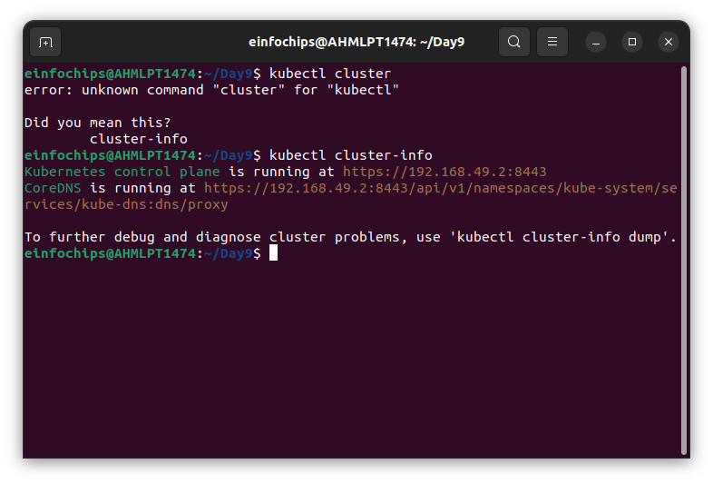
Build Docker image:
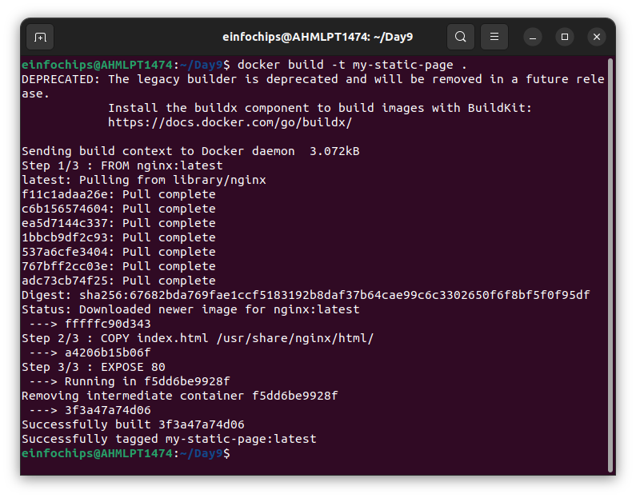
Docker image pushed on docker:

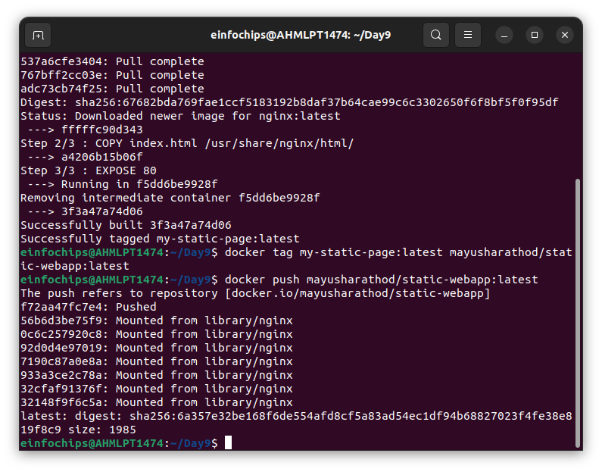
Deployment and Service applied:
