Stage 2: Configuring Ingress Networking
- Install and Configure Ingress Controller:
  - Install an ingress controller (e.g., Nginx Ingress Controller) in the Minikube cluster.
  - Verify the ingress controller is running and accessible.
- Create Ingress Resource:
  - Write an ingress resource manifest to route external traffic to the static web application.
  - Configure advanced ingress rules for path-based routing and host-based routing (use at least two different hostnames and paths).
  - Implement TLS termination for secure connections.
  - Configure URL rewriting in the ingress resource to modify incoming URLs before they reach the backend services.
  - Enable sticky sessions to ensure that requests from the same client are directed to the same backend pod.
Deliverables:
- Ingress controller installation commands/scripts
- Ingress resource YAML file with advanced routing, TLS configuration, URL rewriting, and sticky sessions

Creating ingress resource:
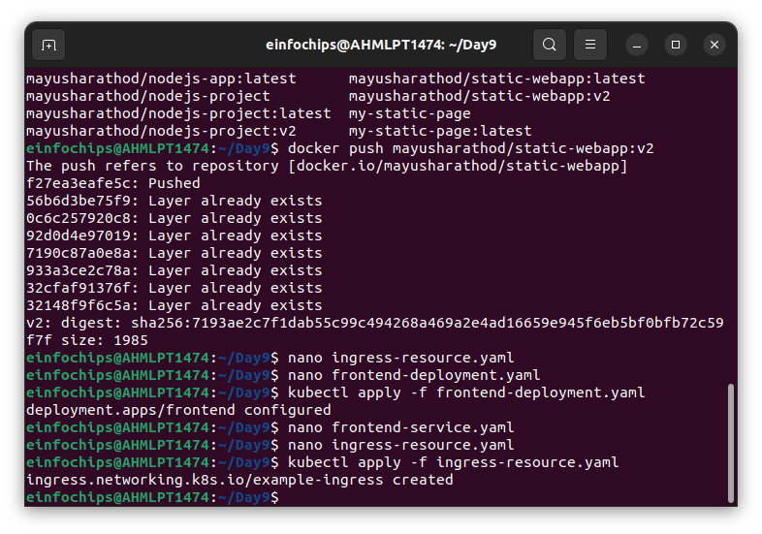
Adding minikube ip as host:
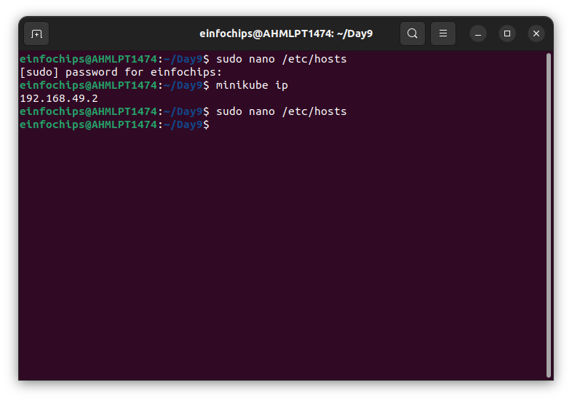
Tls auth certificate and key generated:
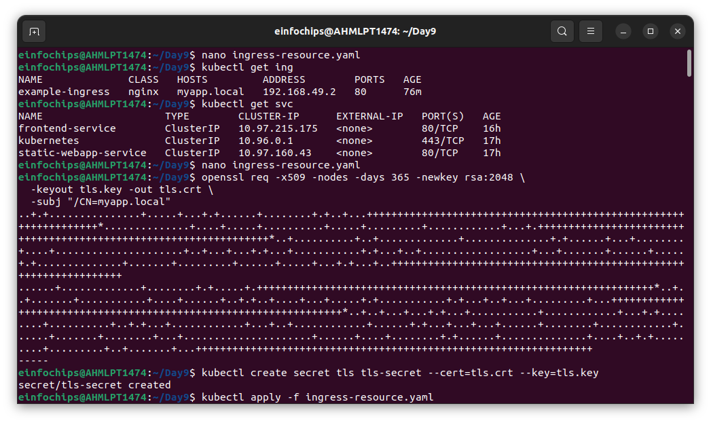

Output :


