Stage 4: Final Validation and Cleanup
- Final Validation:
  - Validate the ingress networking, URL rewriting, and sticky sessions configurations by accessing the web application through different hostnames and paths.
  - Verify the application's availability and performance during different load conditions.
- Cleanup:
  - Provide commands or scripts to clean up the Kubernetes resources created during the project (deployments, services, ingress, HPA).
Deliverables:
- Final validation report documenting the testing process and results
- Cleanup commands/scripts

Output:
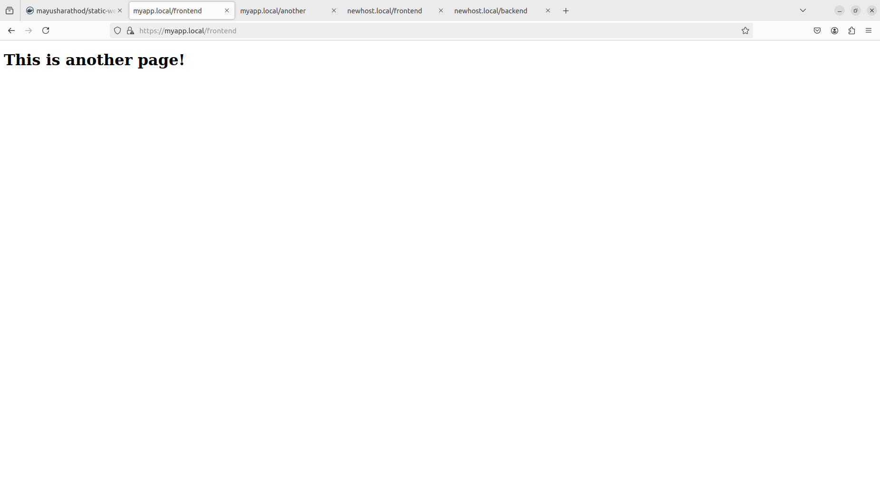
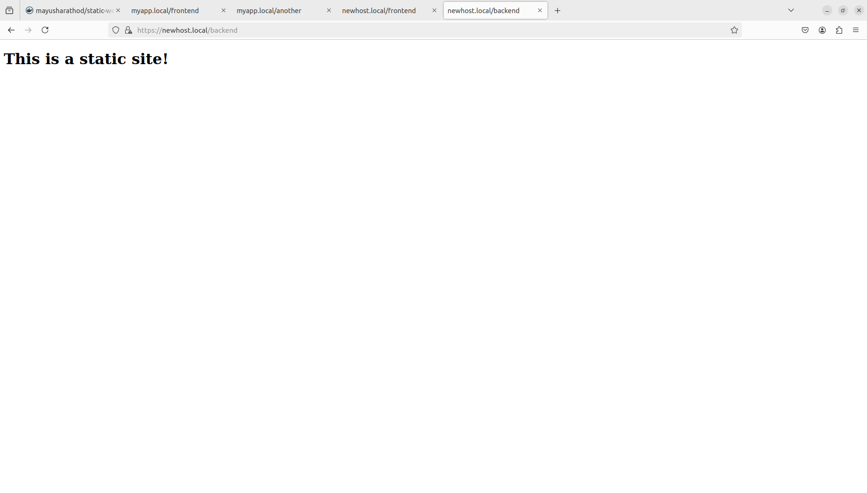
Cleanup:

