**Documentation**

1. **Introduction**

* **Overview of the project**

The project is about implementing the BOIDS algorithm with some modifications in it. The Boids algorithm is a simple yet powerful computational model that simulates the behaviour of flocking birds, schooling fish, or herding animals. The algorithm was first introduced in 1986 by Craig Reynolds, a computer graphics researcher at Symbolics, a computer systems company. The name "boids" is a combination of "bird-oid object," meaning objects that behave like birds.

* **Project goals and objectives**

The goal of the project is to implement the BOIDS algorithm with some modifications in it. The objective is to observe the change in the behaviour of the boids. We are introducing a predator into the environment and the boids are supposed to move away from the predator.

* **Limitations**

While implementing the boids algorithm we tried to put the energy factor in it, how the energy of boids will make the behaviour change. We wanted to address questions like what if the energy of boids is low how will they interact with each other? Due to the too-dynamic generation of objects in the flock system, generating an energy meter for each of them and calculating energy for a variable number of particles is too dynamic and complex. And moreover, it was challenging to build a relationship between speed and energy, since the properties like speed, cohesion etc are calculated independently for each particle in the flock.

In the real world, there are factors like hunger, fear etc. which we have not addressed in the implementation of the code.

1. **Getting Started**

* Installation instructions

<vfxapprentice.com/blog/install-unreal-engine-quick-start#:~:text=First%20you'll%20need%20to,go%20and%20click%20on%20install.>

* System requirements

Unreal Engine 5 minimum requirements on Windows

* Operating system: Windows 10 64-bit
* Processor: Quad-core Intel or AMD 2.5 GHz or superior
* Memory: 8GB RAM
* Graphics Card: Any DirectX 11 or 12 compatible card

Unreal Engine 5 minimum requirements on Mac

* Operating system: macOS Monterrey
* Processor: Quad-core Intel 2.5 GHz or superior
* Memory: 8GB RAM
* Graphics Card: Any Metal 1.2 compatible card

1. **Unreal Engine 5.1**

Unreal Engine is a 3D computer graphics game engine developed by Epic Games. It is one of the most advanced real-time 3D creation tool. We have used Unreal Engine to build this simulation.

1. **Observations**

After running the scripts we have a number of inputs to change the simulation. These are:

Input: Default Value

**BOIDS Number**: 100

This represents the number of boids in the simulation.

**BOID Scale**: 0.5

It is the size of the boid object which we can control within the game engine.

**Speed**: 0.4

This is the speed of the boid which we can control in the simulation.

**Cohesion**: 0.008

Each agent tries to move towards the centre of its neighbours to create a sense of unity in the flock.

**Alignment**: 0.05

Each agent tries to match the velocity of its neighbours to create a sense of coherence in the flock.

**Separation factor**: 0.05

Each agent tries to maintain a minimum distance from its neighbours to avoid collisions.

**Visual range**: 18

It is the range of how much can the boid see ahead of him, on a scale of x, y, and z axis 18 points on the scale.

**Predator visual range**: 30

It is the range of how much can the boid see ahead of him, on a scale of x, y, and z axis 30 points on the scale.

**Predator speed**: 0.5

This input represents the speed of the predator.

**Predator scale**: 1

It represents the size of the predator.

**Predator hunt factor**: 0.005

How actively it can chase the boid?

With all the default values we can see the boids making a flocking behaviour trying to stay away from the predator. We can see this in Fig. 1.

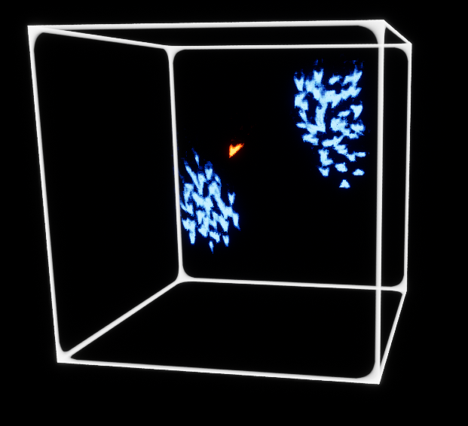

Fig. 1

**Cohesion:** After increasing the cohesion factor the boids made a group of themselves and stuck to that group.

* Boids were not mixing with the other flock and sticking to their own flock. Like a static flock.
* Increasing the cohesion affected a lot to flocking behaviour, boids tend to not move much and stay in one position.
* We can see in Fig. 2 that After changing the cohesion value to 0.08, boids made two flocks and were not moving much.

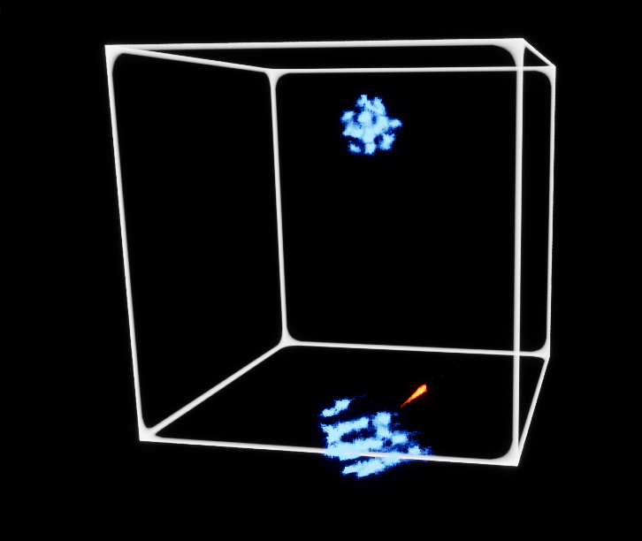

Fig. 2

**Alignment**: if we increase the value of the alignment it is moving in the straight direction and no randomness can be seen. This is making the flocking behaviour unreal.

After increasing the value, boids are moving with too much randomness and are highly unstable. But flocking behaviour is still can be seen. It can be seen in Fig. 3.

Similarly, if we decrease the alignment value the boids are moving away from each other and fail to form a flock.

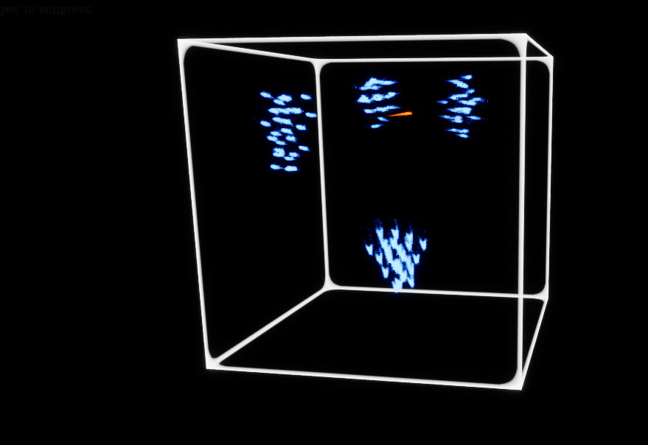

Fig. 3

**Separation factor**. – It can be seen in Fig. 5 After increasing the value of separation, and flocking behaviour the boids are trying to flock, but due to their high value, they are moving away from each other. It seems like at a certain point that the flocking is losing.

If we decrease the value of separation it is turning into one. But they are still forming groups.

Because of this, boids are not trying to separate from each other, resulting in packed flocks. It can be seen in Fig. 4.

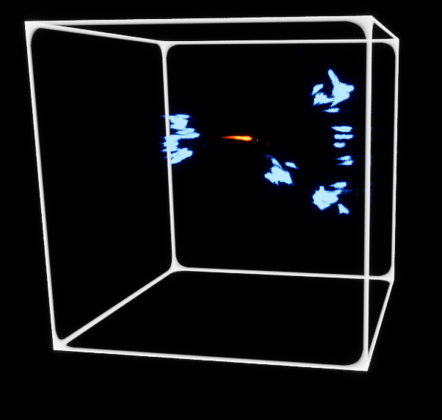

Fig. 4, separation = 0.0005

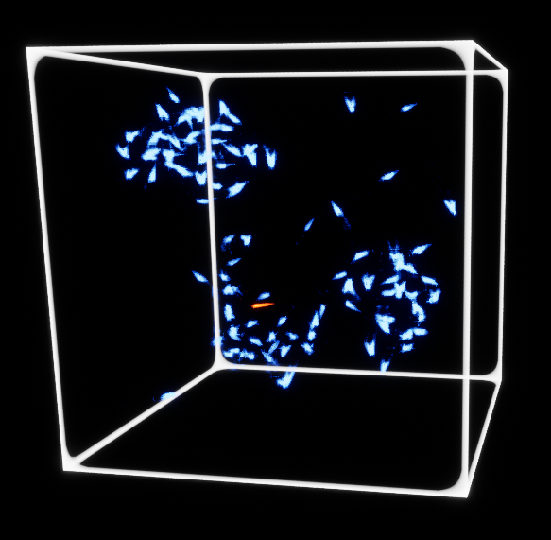

Fig. 5, separation = 0.5

**Predator speed**: if we increase the speed of the boids the flocking behaviour changes. The clusters are decreasing.

* The flock density is increasing the boids and not getting a chance to get in contact with other boids. As the predator comes close the scattering of boids increases.

**Predator hunt factor**: if we increase the value, the predator is turning its direction very fast, making it highly unstable. Sometimes, the predator can penetrate the flock.

After the implementation and analysis of the Boids algorithm with some modification, we came to the conclusion mentioned above.

**`**