Art Standards
THOSE THICK OUTLINES

Character Design
Based on asian folklore and legends

Assets Design
Based on asian temples and houses

3D Character Models
- Workflow
- Sculpt overall shape
- Retopologize
- UV Unwrap
- Texture Paint
- Rigg
- Animate

- Style
- Low Poly

3D Assets Models
- Workflow
- Modeling
- UV Unwrap
- Texture Paint
- Style
- Low Poly
- Inspired by japanese architecture but exaggerated and otherworldly

Level Design
- Workflow
- Blockage Planing
- Grand Asset Placing
- Minor Asset Placing
- UV Unwrap
- Seamless Texture Painting

- Style
- Pretty Vertical n Stuff

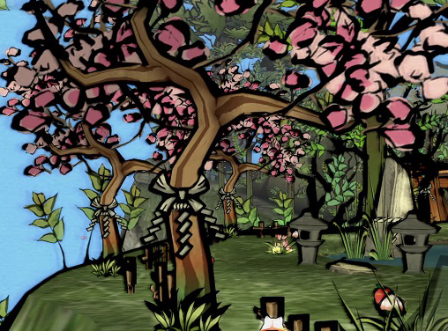
Asset Texture
Hand painted directly on the 3D model.
Cartoony look.
The black color need to be FULL black to give the nankin impression.
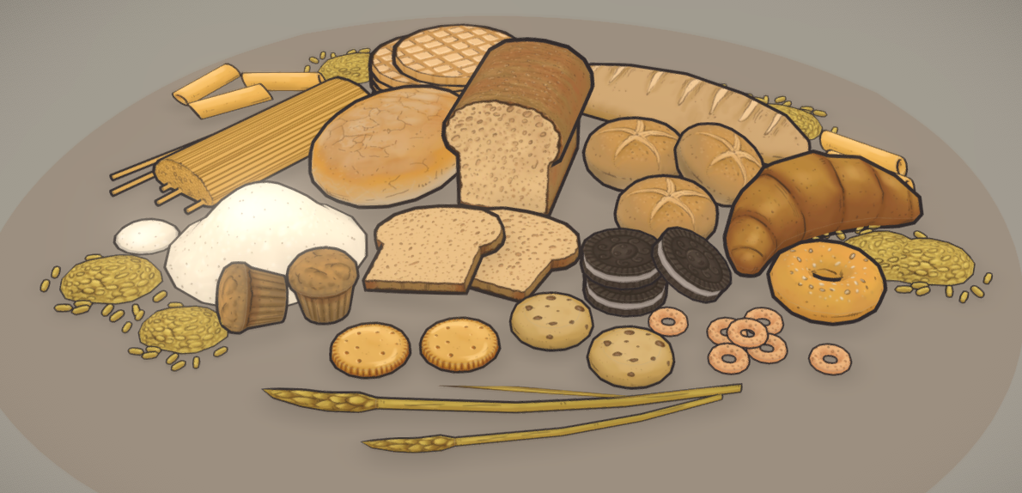

Character Textures
Hand painted directly on the 3D model.
Cartoony look.

Seamless Textures
Duknow. 256X256 Seamless Images.
Will be put on floor, walls...
Can be of any cool style other than realistic.
Just keeping the projects harmony and it will bee fine.

Shading
Cell Shading with a Thick Outline.
Really dark shadow and very little in between shadows.
Maybe some really low fog just covering the feet.
Maybe some ambient occlusion with sharp edges.
Too soon to decide.

Skybox
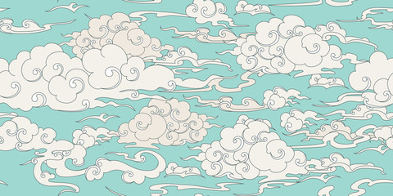
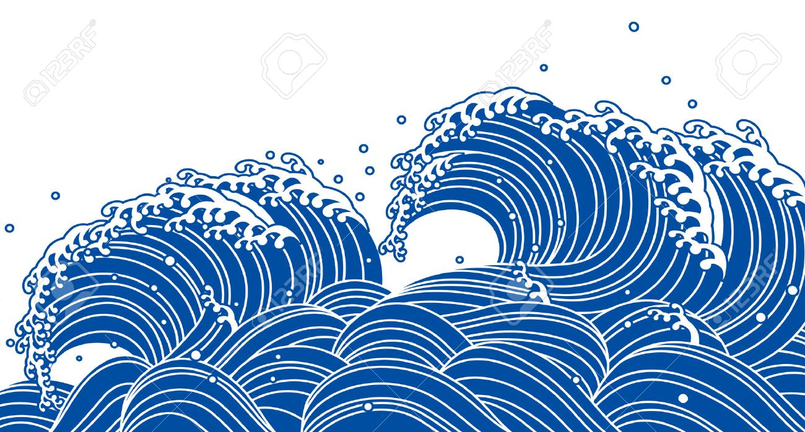
Cartoony clouds in a colorfull sky and some waves in the horizon… idk

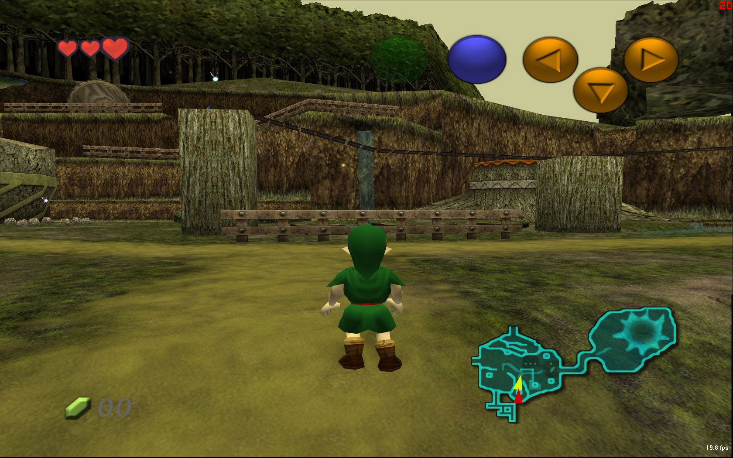
Out of Bounds Sprites
Plane image billboard with a black outline to remind Japanese theater(Noh) background images.
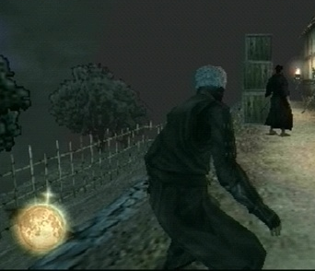
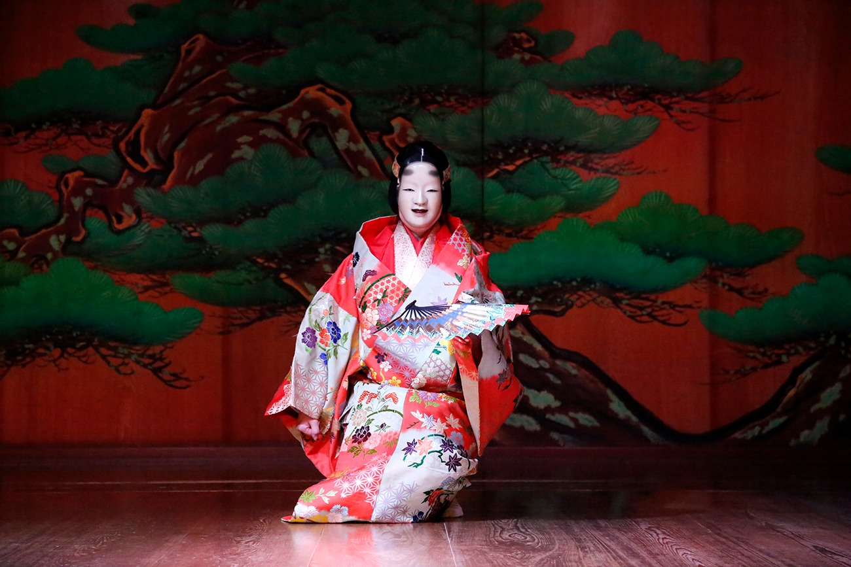
Composed mostly by trees

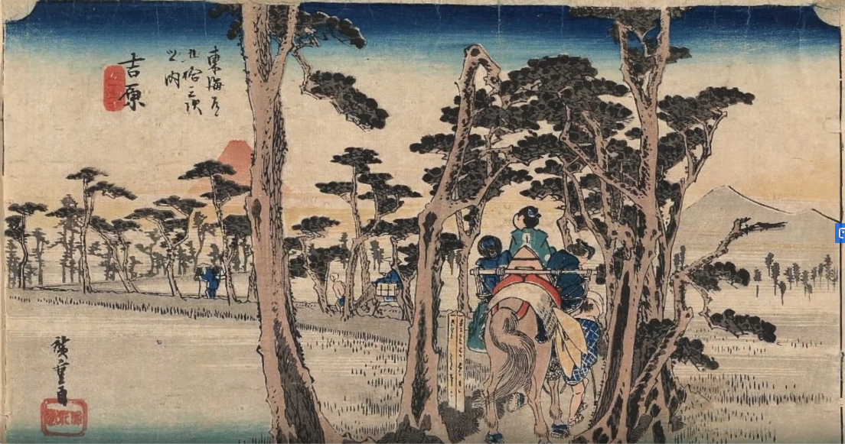
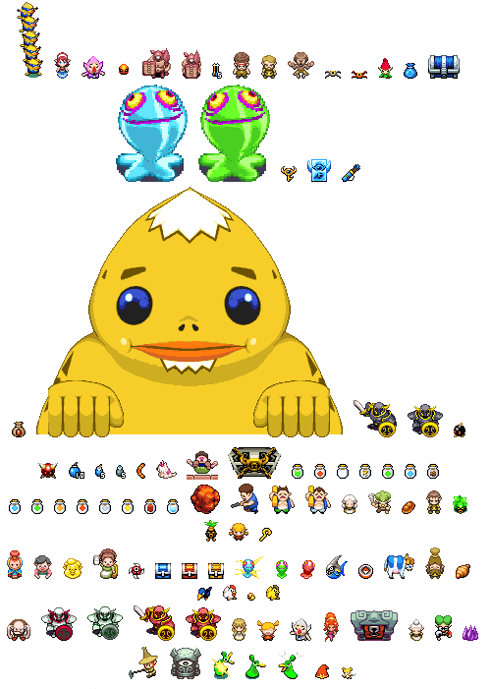
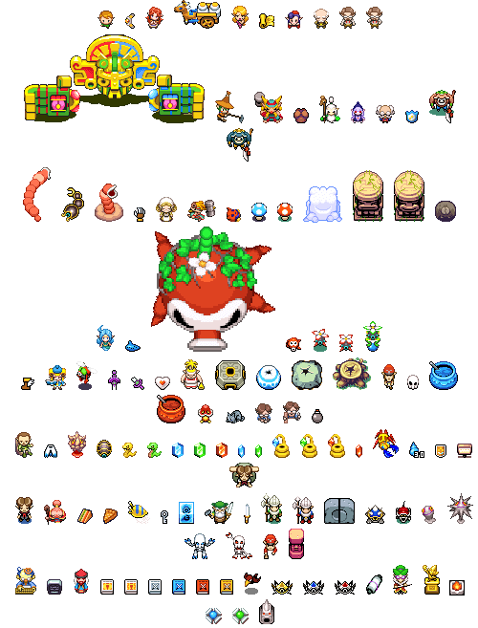

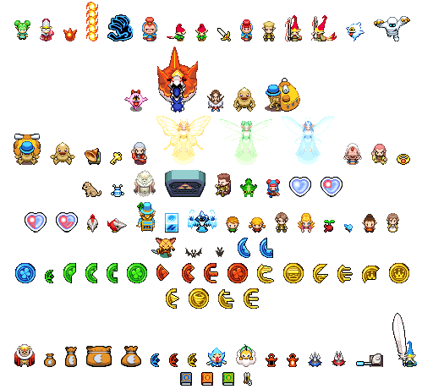
HUD
Can’t say yet

Particles
Can’t say yet

Animations
Walking cycles based on the theatrical way of moving different character in Noh

