JDBC

Java Database Connectivity
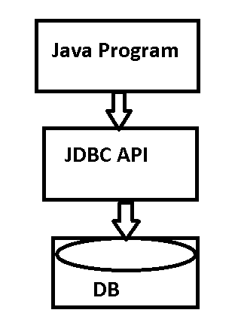

Open Database Connectivity(ODBC):

Low level API to connect to any type of backend database management system.
Available in Windows platform.

Data Source Name (DSN):

Has details of the backend database. Details like

- Database driver
- Location of the database
- Database name
- User name
- Password, etc.,

Three Types of DSN:

- User DSN : local to the user who creates it.
- System DSN : global to the users of a particular system
- File DSN : global to all users of all systems.

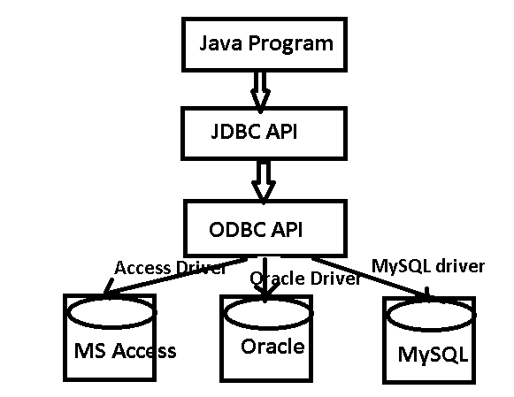
Package used:

java.sql.*;

Three important Interfaces:

- Connection
- Statement
  - Statement
  - PreparedStatement
  - CallableStatement
- ResultSet

Connection interface:

to connect to the backend database management system.

Connection object also provides:

- information about tables
- supported SQL grammar
- stored procedures
- Stored functions, etc

Important Methods:

public abstract void close() throws SQLException
public abstract void commit() throws SQLException
public abstract Statement createStatement() throws SQLException
public abstract DatabaseMetaData getMetaData() throws SQLException
public abstract CallableStatement prepareCall(String sql) throws SQLException
public abstract PreparedStatement prepareStatement(String sql) throws SQLException
public abstract void rollback() throws SQLException
public abstract void setAutoCommit(boolean autoCommit) throws SQLException

Statement interface:

It is used to execute an SQL statement.
Here the Statement object is compiled and executed every time the statement is executed.

Important Methods:

public abstract ResultSet executeQuery(String sql) throws SQLException
public abstract int executeUpdate(String sql) throws SQLException
public abstract void close() throws SQLException
public void addBatch(String sql)
void clearBatch()
int[] executeBatch()

JDBC Process:

- Load the Driver
- Establish connection to the backend database
- Create Statement Object
- Perform database transaction
- Close connection

ResultSet Interface:

A resultset is created from the output of a query.
Only one ResultSet object is associated with one Statement object.

ResultSet Types:

ResultSet.TYPE_FORWARD_ONLY
ResultSet.TYPE_SCROLL_SENSITIVE
ResultSet.TYPE_SCROLL_INSENSITIVE

ResultSet Concurrency:

ResultSet.CONCUR_UPDATABLE
ResultSet.CONCUR_READ_ONLY

Methods:

boolean absolute(int row)
Moves the cursor to the given row number in this ResultSet object.
void afterLast()
Moves the cursor to the end of this ResultSet object, just after the last row.
void beforeFirst()
Moves the cursor to the front of this ResultSet object, just before the first row.
void cancelRowUpdates()
Cancels the updates made to the current row in this ResultSet object.
void close()
Releases this ResultSet object's database and JDBC resources immediately instead of waiting for this to happen when it is automatically closed.

void deleteRow()
Deletes the current row from this ResultSet object and from the underlying database.
void close()
Releases this ResultSet object's database and JDBC resources immediately instead of waiting for this to happen when it is automatically closed.
double getDouble(int columnIndex)
Retrieves the value of the designated column in the current row of this ResultSet object as a double in the Java programming language.
double getDouble(String columnLabel)
Retrieves the value of the designated column in the current row of this ResultSet object as a double in the Java programming language.
float getFloat(int columnIndex)
Retrieves the value of the designated column in the current row of this ResultSet object as a float in the Java programming language.
float getFloat(String columnLabel)
Retrieves the value of the designated column in the current row of this ResultSet object as a float in the Java programming language.
int getInt(int columnIndex)
Retrieves the value of the designated column in the current row of this ResultSet object as an int in the Java programming language.
int getInt(String columnLabel)
Retrieves the value of the designated column in the current row of this ResultSet object as an int in the Java programming language.
String getString(int columnIndex)
Retrieves the value of the designated column in the current row of this ResultSet object as a String in the Java programming language.
String getString(String columnLabel)
Retrieves the value of the designated column in the current row of this ResultSet object as a String in the Java programming language.
void insertRow()
Inserts the contents of the insert row into this ResultSet object and into the database.
boolean isAfterLast()
Retrieves whether the cursor is after the last row in this ResultSet object.
boolean isBeforeFirst()
Retrieves whether the cursor is before the first row in this ResultSet object.
boolean isClosed()
Retrieves whether this ResultSet object has been closed.
boolean isFirst()
Retrieves whether the cursor is on the first row of this ResultSet object.
boolean isLast()
Retrieves whether the cursor is on the last row of this ResultSet object.
boolean last()
Moves the cursor to the last row in this ResultSet object.
boolean next()
Moves the cursor froward one row from its current position.
boolean previous()
Moves the cursor to the previous row in this ResultSet object.
void refreshRow()
Refreshes the current row with its most recent value in the database.
boolean relative(int rows)
Moves the cursor a relative number of rows, either positive or negative.
void updateDouble(int columnIndex, double x)
Updates the designated column with a double value.
void updateDouble(String columnLabel, double x)
Updates the designated column with a double value.
void updateFloat(int columnIndex, float x)
Updates the designated column with a float value.
void updateFloat(String columnLabel, float x)
Updates the designated column with a float value.
void updateInt(int columnIndex, int x)
Updates the designated column with an int value.
void updateInt(String columnLabel, int x)
Updates the designated column with an int value.
void updateString(int columnIndex, String x)
Updates the designated column with a String value.
void updateString(String columnLabel, String x)
Updates the designated column with a String value.

Refer to Examples:
- InsertingUsingResultSetExample.java
- UpdatingUsingResultSetExample.java
- DeletingUsingResultSetExample.java

PreparedStatement Interface:

It extends Statement interface.
Here a SQL statement is precompiled and stored in a PreparedStatement object.
The same statement is executed multiple times with different values without recompiling.

Methods:

void |  |  | setFloat(String colname, float x)  Sets the designated parameter to the given Java float value.
void |  |  | setFloat(int parameterIndex, float x)  Sets the designated parameter to the given Java float value.
void |  | setInt(String colname, int x)  Sets the designated parameter to the given Java int value.
void |  |  | setInt(int parameterIndex, int x)  Sets the designated parameter to the given Java int value.
void |  |  | setString(String colname, String x)  Sets the designated parameter to the given Java String value.
void |  |  | setString(int parameterIndex, String x)  Sets the designated parameter to the given Java String value.
void |  | addBatch()  Adds a set of parameters to this PreparedStatement object's batch of commands.
boolean |  |  |  | execute()  Executes the SQL statement in this PreparedStatement object, which may be any kind of SQL statement.
ResultSet |  |  |  |  | executeQuery()  Executes the SQL query in this PreparedStatement object and returns the ResultSet object generated by the query.
int | executeUpdate()  Executes the SQL statement in this PreparedStatement object, which must be an SQL Data Manipulation Language (DML) statement, such as INSERT, UPDATE or DELETE; or an SQL statement that returns nothing, such as a DDL statement.

Refer Example:
PreparedStatementExample.java
CallableStatement Interface:

This interface is used to execute SQL stored procedures.
Set methods are used for IN parameter.
Get methods are used for OUT parameters.
A CallableStatement can return one ResultSet object or multiple ResultSet objects.
It extends PreparedStatement interface.

Methods:

Void setInt(String parameterName, int x) throws SQLException
Sets the designated parameter to the given Java int value. The driver converts this to an SQL INTEGER value when it sends it to the database.

Void setFloat(String parameterName, float x) throws SQLException
Sets the designated parameter to the given Java float value. The driver converts this to an SQL FLOAT value when it sends it to the database.

Void setString(String parameterName, String x) throws SQLException
Sets the designated parameter to the given Java String value. The driver converts this to an SQL VARCHAR or LONGVARCHAR value (depending on the argument's size relative to the driver's limits on VARCHAR values) when it sends it to the database.

void registerOutParameter(int parameterIndex,int sqlType) throws SQLException
Registers the OUT parameter in ordinal position parameterIndex to the JDBC type sqlType. All OUT parameters must be registered before a stored procedure is executed.

String getString(String parameterName) throws SQLException
Retrieves the value of a JDBC CHAR, VARCHAR, or LONGVARCHAR parameter as a String in the Java programming language.

Int getInt(String parameterName) throws SQLException
Retrieves the value of a JDBC INTEGER parameter as an int in the Java programming language.

Float getFloat(String parameterName) throws SQLException
Retrieves the value of a JDBC FLOAT parameter as a float in the Java programming language.

Double getDouble(String parameterName) throws SQLException
Retrieves the value of a JDBC DOUBLE parameter as a double in the Java programming language.

String getString(int parameterIndex) throws SQLException
Retrieves the value of the designated JDBC CHAR, VARCHAR, or LONGVARCHAR parameter as a String in the Java programming language.

Int getInt(int parameterIndex) throws SQLException
Retrieves the value of the designated JDBC INTEGER parameter as an int in the Java programming language.

Float getFloat(int parameterIndex) throws SQLException
Retrieves the value of the designated JDBC FLOAT parameter as a float in the Java programming language.

Refer Example:

CallableStatementExample.java

Transaction:

A transaction is a set of DML statements performed on one or more tables in a database.

Eg:

St.executeUpdate(“insert into emp values( 101, ‘ann’, 2000)”);
St.executeUpdate(“insert into emp values( 102, ‘beena’,32000)”);
St.executeUpdate(“delete from emp where empno=105”);

Con.commit(); / con.rollback();

A transaction can either be committed or rolled back.

Batch Process:

A batch process is a set of SQL commands which are stored in the memory as a batch of commands in the memory and they are executed sequentially one after the other when the batch process is executed.

Batching can be done with:

- Statement Object
- PreparedStatement Object

Refer examples:

BatchingWithStatement.java

BatchingWithPreparedStatement.java
Using Save Point:

Save Point is a name given to a part of a transaction which can be either committed or rolledback.

Refer Example:

SavePointExample.java
Meta Data:

Meta data is information about the
- Database
- Tables
- Views, etc.,

DatabaseMetaData Interface:

This interface is used to retrieve information about the
- Database
- Tables
- Columns
- Indexes, etc.,

Connection
- DatabaseMetaData getMetaData()

DatbaseMetaData

- getDatabaseProductName()
- getUserName()
- getURL()
- getSchema()
- getPrimaryKeys()
- get Procedures()
- getTables()

ResultSetMetaData Interface:

Describes information about columns or a table or ResultSet.

ResultSet method
- ResultSetMetaData getMetaData()

ResultSetMetaData methods
- getColumnCount()
- getColumnName(int index)
- getColumnType(int index)
Data Types:

SQL Types | Java Types
Char | String
Varchar | String
Numeric | BigDecimal
Decimal | BigDecimal
BIT | Boolean

Exceptions:

There are basically 3 types of exceptions thrown by JDBC methods.

- SQLException : due to errors in SQL statements and syntax/ queries.
  - Methods of SQLException:
    - getNextException()
    - getErrorCode()

- SQLWarnings: throws warnings received by Connection from the database management system.
- Methods of Connection
  - getWarnings()
  - getNextWarning()

- Data Truncation : thrown when data is lost due to truncation.

