Ashiquzzaman Fahim

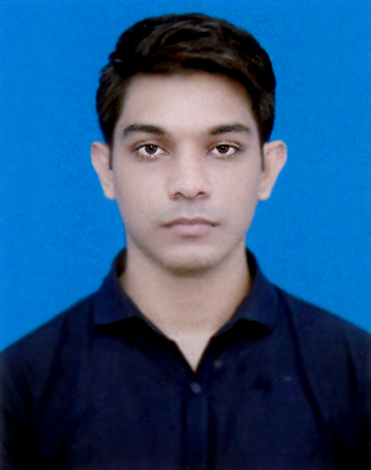

ID:18202063

H/P: 01521400144

Email: mazfahim0@gmail.com

|  |
| --- |
| **Profile Summary** |

I am a student of Computer Science and Engineering at Chittagong Independent University interested to create solutions for problems in our daily life with the help of my engineering knowledge and skills. I am a problem solver. I can create innovative and practical solutions to problems I face in daily life. I have very keen interest in programming and software development and web development. I also love to share my new found knowledge with people surrounding me.

|  |
| --- |
| **Education** |

|  |  |  |  |  |
| --- | --- | --- | --- | --- |
| **Qualification** | **Year** | **Concentration/Major** | **Institute** | **CGPA/ %/ Achievements** |
| B.Sc. (3rd Year) | 2020 | Computer Science and Engineering | Chittagong Independent University | 3.41 (Up to September 2020) |
| HSC | 2016 | Science | Chittagong University Laboratory School & College | 4.08/5 |
| SSC | 2014 | Science | Chittagong University Laboratory School & College | 5 / 5 |

|  |
| --- |
| **Skills** |

|  |  |  |  |
| --- | --- | --- | --- |
| C | Java | HTML | CSS |
| JavaScript | MS Word | MS Excel | MS PowerPoint |
| Python | MySQL | PHP | Android |

|  |
| --- |
| **Extra-curricular Activities / Positions of Responsibility** |

* Secretary, IEEE Student Branch CIU, February 2019 – February 2020 (1 year)
* Event Co-ordinator, Independent Science and Engineering Club January 2020 – June 2020 (6 months)
* Event Co-ordinator, Independent Science and Engineering Club July 2019 – December 2019 (6 months)
* Member, ChittagongIndependentUniversity Club January 2020 – June 2020 (6 months)

|  |
| --- |
| **Personal details** |

**Male, DOB: 15/08/1999**

**Blood Group: O+**

**Religion: Muslim**

**Address: Moriyam Plaza 2 No Gate Bazar, Chittagong University, Chittagong.**