Air Quality Category Tables

Processed on 2024-02-29 17:31:26 PST.

*Disclaimer: Data presented here come from a variety of sources and do not represent official EPA measurements. Please visit* [*AirNow*](https://www.airnow.gov) *for official measurements.*

The following tables summarize the cumulative number of days air quality monitors spent in each AQI category during wildfire season.

The ‘Old’ table and barplot are calculated using the 2023 PM2.5 NAAQS while the ‘New’ table and barplot are calculated using the 2024 PM2.5 NAAQS.

# 2012

**Using Old (2023) PM2.5 NAAQS**

Good

Moderate

USG

Unhealthy

Very Unhealthy

Hazardous

Missing

Wenatchee

18

5

6

5

1

1

86

Leavenworth

94

15

4

9

0

0

0

Twisp

97

12

4

5

0

0

4

Winthrop

99

14

7

2

0

0

0

Omak

102

18

1

1

0

0

0

**Using New (2024) PM2.5 NAAQS**

Good

Moderate

USG

Unhealthy

Very Unhealthy

Hazardous

Missing

Wenatchee

13

10

6

5

1

1

86

Leavenworth

84

25

4

9

0

0

0

Twisp

81

28

4

5

0

0

4

Winthrop

88

25

6

3

0

0

0

Omak

87

33

1

1

0

0

0

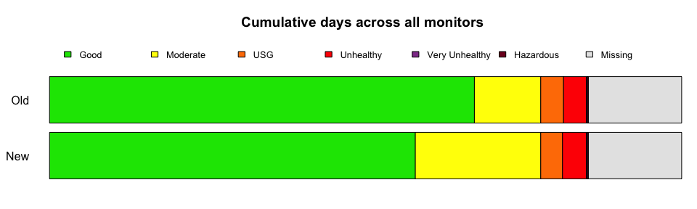

# 2013

**Using Old (2023) PM2.5 NAAQS**

Good

Moderate

USG

Unhealthy

Very Unhealthy

Hazardous

Missing

Wenatchee

49

6

0

0

0

0

68

Leavenworth

108

11

0

0

0

0

4

Twisp

112

9

0

0

0

0

2

Winthrop

111

7

0

0

0

0

5

Omak

65

17

0

0

0

0

41

**Using New (2024) PM2.5 NAAQS**

Good

Moderate

USG

Unhealthy

Very Unhealthy

Hazardous

Missing

Wenatchee

45

10

0

0

0

0

68

Leavenworth

94

25

0

0

0

0

4

Twisp

97

24

0

0

0

0

2

Winthrop

96

22

0

0

0

0

5

Omak

56

26

0

0

0

0

41

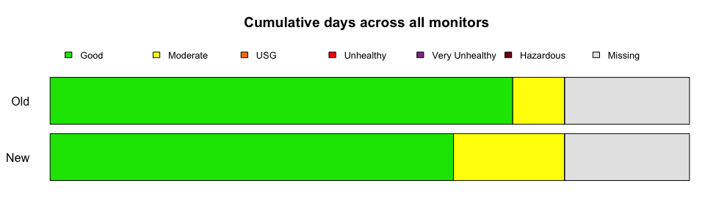

# 2014

**Using Old (2023) PM2.5 NAAQS**

Good

Moderate

USG

Unhealthy

Very Unhealthy

Hazardous

Missing

Wenatchee

90

19

1

2

0

0

10

Leavenworth

74

25

6

0

0

0

17

Twisp

93

16

2

2

0

0

9

Winthrop

78

12

1

0

0

0

31

Omak

49

17

0

0

0

0

56

**Using New (2024) PM2.5 NAAQS**

Good

Moderate

USG

Unhealthy

Very Unhealthy

Hazardous

Missing

Wenatchee

83

26

1

2

0

0

10

Leavenworth

66

32

7

0

0

0

17

Twisp

76

33

2

2

0

0

9

Winthrop

68

22

1

0

0

0

31

Omak

39

27

0

0

0

0

56

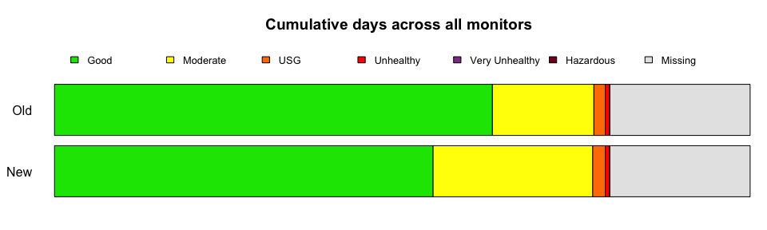

# 2015

**Using Old (2023) PM2.5 NAAQS**

Good

Moderate

USG

Unhealthy

Very Unhealthy

Hazardous

Missing

Wenatchee

90

7

1

0

0

0

24

Leavenworth

102

17

3

0

0

0

0

Twisp

77

26

1

8

0

0

10

Winthrop

53

10

0

0

0

0

59

Omak

68

31

5

4

2

5

7

**Using New (2024) PM2.5 NAAQS**

Good

Moderate

USG

Unhealthy

Very Unhealthy

Hazardous

Missing

Wenatchee

84

13

1

0

0

0

24

Leavenworth

92

27

3

0

0

0

0

Twisp

63

40

1

5

3

0

10

Winthrop

41

22

0

0

0

0

59

Omak

55

44

5

4

1

6

7

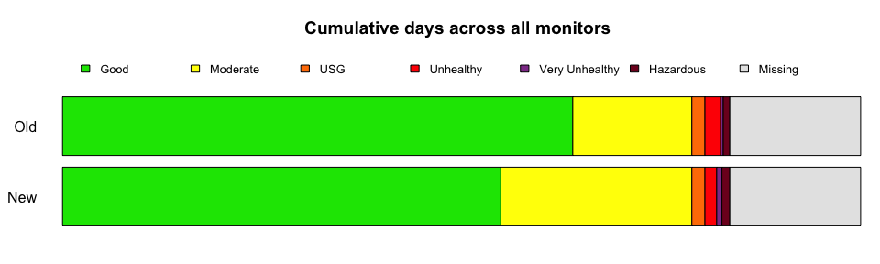

# 2016

**Using Old (2023) PM2.5 NAAQS**

Good

Moderate

USG

Unhealthy

Very Unhealthy

Hazardous

Missing

Wenatchee

81

5

0

0

0

0

36

Leavenworth

103

3

0

0

0

0

16

Twisp

121

1

0

0

0

0

0

Winthrop

98

1

0

0

0

0

23

Omak

51

6

0

0

0

0

65

Chelan

55

0

0

0

0

0

67

**Using New (2024) PM2.5 NAAQS**

Good

Moderate

USG

Unhealthy

Very Unhealthy

Hazardous

Missing

Wenatchee

78

8

0

0

0

0

36

Leavenworth

100

6

0

0

0

0

16

Twisp

116

6

0

0

0

0

0

Winthrop

95

4

0

0

0

0

23

Omak

44

13

0

0

0

0

65

Chelan

55

0

0

0

0

0

67

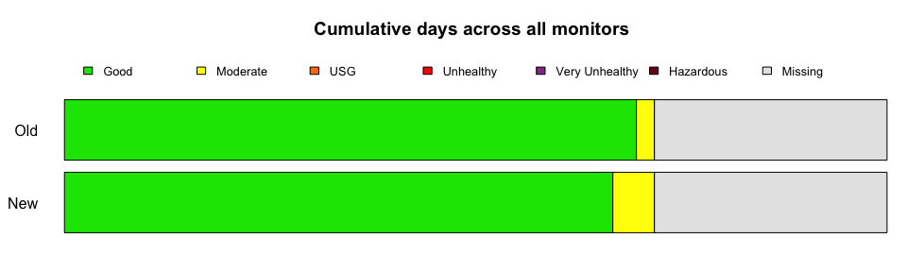

# 2017

**Using Old (2023) PM2.5 NAAQS**

Good

Moderate

USG

Unhealthy

Very Unhealthy

Hazardous

Missing

Wenatchee

83

18

9

9

3

0

0

Leavenworth

77

14

1

1

0

0

29

Twisp

79

27

4

12

0

0

0

Winthrop

82

25

4

11

0

0

0

Omak

75

26

4

10

0

0

7

Chelan

85

9

2

1

1

0

24

**Using New (2024) PM2.5 NAAQS**

Good

Moderate

USG

Unhealthy

Very Unhealthy

Hazardous

Missing

Wenatchee

73

28

9

9

3

0

0

Leavenworth

67

24

1

1

0

0

29

Twisp

69

37

4

12

0

0

0

Winthrop

68

38

5

11

0

0

0

Omak

65

36

3

11

0

0

7

Chelan

80

14

2

0

2

0

24

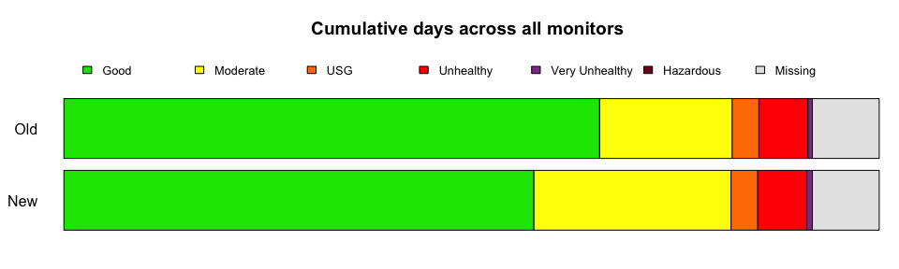

# 2018

**Using Old (2023) PM2.5 NAAQS**

Good

Moderate

USG

Unhealthy

Very Unhealthy

Hazardous

Missing

Wenatchee

83

25

3

7

3

1

0

Leavenworth

82

27

1

9

0

0

3

Twisp

55

20

6

23

1

0

17

Winthrop

75

28

6

12

1

0

0

Omak

57

20

3

12

1

1

28

Chelan

77

19

8

10

4

1

3

**Using New (2024) PM2.5 NAAQS**

Good

Moderate

USG

Unhealthy

Very Unhealthy

Hazardous

Missing

Wenatchee

74

34

3

6

4

1

0

Leavenworth

74

35

1

7

2

0

3

Twisp

47

27

7

21

3

0

17

Winthrop

67

36

6

11

2

0

0

Omak

48

29

3

11

1

2

28

Chelan

70

26

8

8

5

2

3

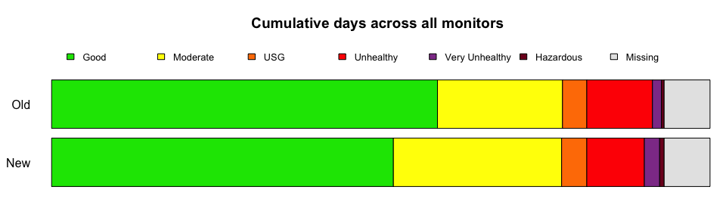

# 2019

**Using Old (2023) PM2.5 NAAQS**

Good

Moderate

USG

Unhealthy

Very Unhealthy

Hazardous

Missing

Wenatchee

117

5

0

0

0

0

0

Leavenworth

104

8

0

0

0

0

10

Twisp

107

0

0

0

0

0

15

Winthrop

120

0

0

0

0

0

2

Omak

111

10

0

0

0

0

1

Chelan

117

2

0

0

0

0

3

**Using New (2024) PM2.5 NAAQS**

Good

Moderate

USG

Unhealthy

Very Unhealthy

Hazardous

Missing

Wenatchee

109

13

0

0

0

0

0

Leavenworth

100

12

0

0

0

0

10

Twisp

98

9

0

0

0

0

15

Winthrop

114

6

0

0

0

0

2

Omak

102

19

0

0

0

0

1

Chelan

112

7

0

0

0

0

3

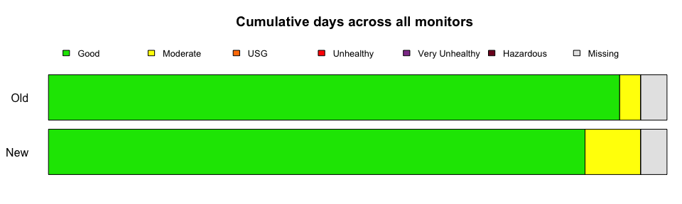

# 2020

**Using Old (2023) PM2.5 NAAQS**

Good

Moderate

USG

Unhealthy

Very Unhealthy

Hazardous

Missing

Wenatchee

98

6

1

6

2

2

7

Leavenworth

103

9

2

6

2

0

0

Twisp

104

9

2

5

2

0

0

Winthrop

105

7

2

6

2

0

0

Omak

88

19

1

5

4

2

3

Chelan

105

5

1

7

2

2

0

**Using New (2024) PM2.5 NAAQS**

Good

Moderate

USG

Unhealthy

Very Unhealthy

Hazardous

Missing

Wenatchee

87

17

1

6

1

3

7

Leavenworth

93

19

2

6

2

0

0

Twisp

95

18

2

5

2

0

0

Winthrop

94

18

2

5

3

0

0

Omak

70

37

1

5

2

4

3

Chelan

99

11

1

6

2

3

0

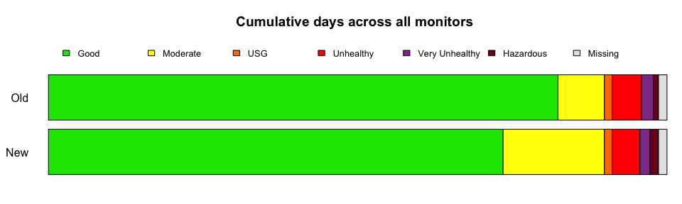

# 2021

**Using Old (2023) PM2.5 NAAQS**

Good

Moderate

USG

Unhealthy

Very Unhealthy

Hazardous

Missing

Wenatchee

113

5

2

2

0

0

0

Leavenworth

88

7

1

3

0

0

23

Twisp

79

21

6

14

2

0

0

Winthrop

76

23

2

11

8

1

1

Omak

49

54

11

5

3

0

0

Chelan

109

8

3

2

0

0

0

**Using New (2024) PM2.5 NAAQS**

Good

Moderate

USG

Unhealthy

Very Unhealthy

Hazardous

Missing

Wenatchee

107

11

2

2

0

0

0

Leavenworth

83

12

1

3

0

0

23

Twisp

64

36

6

12

4

0

0

Winthrop

61

38

2

8

10

2

1

Omak

31

72

11

5

3

0

0

Chelan

100

17

3

2

0

0

0

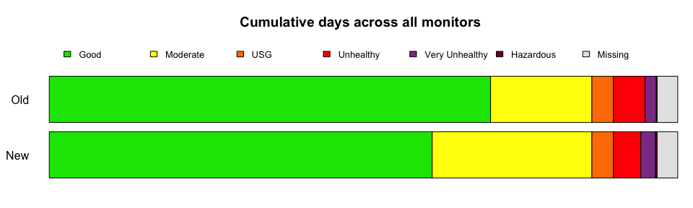

# 2022

**Using Old (2023) PM2.5 NAAQS**

Good

Moderate

USG

Unhealthy

Very Unhealthy

Hazardous

Missing

Wenatchee

77

24

8

13

0

0

0

Leavenworth

65

26

7

12

1

0

11

Twisp

81

31

2

0

1

0

7

Winthrop

89

32

0

0

1

0

0

Omak

80

34

2

0

0

0

6

Chelan

80

31

1

0

1

0

9

**Using New (2024) PM2.5 NAAQS**

Good

Moderate

USG

Unhealthy

Very Unhealthy

Hazardous

Missing

Wenatchee

73

28

8

13

0

0

0

Leavenworth

60

30

8

12

1

0

11

Twisp

73

39

2

0

1

0

7

Winthrop

78

43

0

0

1

0

0

Omak

59

55

2

0

0

0

6

Chelan

70

41

1

0

1

0

9

