WOXSEN UNIVERSITY
Department of Computer Science and Engineering
PROJECT REPORT
DESIGN AND IMPLEMENTATION OF A DATABASE MANAGEMENT SYSTEM FOR SOFTWARE LICENSE AND SUBSCRIPTION MANAGEMENT SYSTEM
Project 40 · Application name: SUB MAG
Course | Database Management Systems (DBMS) – Semester 3
Faculty | [Faculty Name]
Academic year | 2026–27
Submitted by
S. No. | Name | Roll number
1 | Shreyash Singh | [Roll number]
2 | [Member 2 name] | [Roll number]
3 | [Member 3 name] | [Roll number]
Contents
1. Cover Page 1
2. Abstract 4
3. Introduction and Problem Statement 5
3.1 Background 5
3.2 Problem statement 5
3.3 Proposed solution 5
4. Objectives and Scope 6
4.1 Objectives 6
4.2 Scope 6
4.3 Users and roles 7
4.4 Functional requirements 7
4.5 Business rules 7
5. Software and Hardware Requirements 8
5.1 Software requirements 8
5.2 Hardware requirements 8
6. ER Diagram 9
6.1 Entities 10
6.2 Relationships 11
6.3 Design decisions 11
7. Relational Schema and Normalization 12
7.1 Initial schema (first draft) 12
7.2 Normal forms applied 12
7.3 Functional dependencies 13
7.4 Violations found in the first draft and their fixes 13
7.5 Deliberate design decisions (not violations) 14
7.6 Final relational schema (3NF / BCNF) 14
8. Data Dictionary 15
8.1 Table vendor 15
8.2 Table software_product 15
8.3 Table license_type 15
8.4 Table department 16
8.5 Table app_user 16
8.6 Table device 16
8.7 Table purchase 17
8.8 Table license 17
8.9 Table subscription 17
8.10 Table allocation 18
8.11 Table renewal 18
8.12 Table compliance_check 19
8.13 Business rules and the constraints that enforce them 19
8.14 Indexes (beyond primary key and unique indexes) 19
9. SQL Commands Used (DDL and DML) with Sample Outputs 21
9.1 DDL: database and tables 21
9.2 DDL: triggers for the business rules 22
9.3 DDL: indexes, views and procedures 23
9.4 DML: loading the sample data 23
9.5 DML: insert, update, select and delete with outputs 25
9.6 Rule violations and their outputs 26
10. Queries with Outputs 28
10.1 Basic retrieval 28
10.2 Joins 29
10.3 Aggregate functions 31
10.4 Nested queries (subqueries) 32
10.5 Window functions 34
10.6 Reports through views 35
10.7 Cost analysis 37
11. UI Design and Screenshots 39
11.1 Design approach 39
11.2 Introduction screens 39
11.3 Home page and role-based navigation 40
11.4 Application pages 42
12. Implementation Details 49
12.1 Technology stack 49
12.2 Project structure 49
12.3 Database connectivity 49
12.4 Key code snippets 50
12.5 Running the system 52
13. Testing 53
13.1 Test strategy 53
13.2 Summary of results 53
13.3 Database rule and constraint tests 53
13.4 Service-layer test cases 54
13.5 User-interface test cases 56
13.6 Index usage 57
13.7 Observations 57
14. Conclusion and Future Enhancements 58
14.1 Conclusion 58
14.2 Limitations 58
14.3 Future enhancements 58
15. References 59
16. Contribution of Each Member 60
17. Appendix 61
Appendix A: GitHub repository link 61
Appendix B: Project files 61

2. Abstract
Organizations buy many licensed products and subscriptions and share them across departments. When this is tracked in scattered spreadsheets, licenses expire unnoticed, seats are handed out beyond what was purchased, expired licenses stay assigned to people and devices, and nobody can say what the organization really spends on software.
This project designs and implements a relational database, and a web front end named SUB MAG, that centralizes software license and subscription management. The conceptual model covers twelve entities: vendors, software products, license types, purchases, licenses, subscriptions, departments, users, devices, allocations, renewals and compliance checks. It was converted to a relational schema and normalized to Third Normal Form (the final design also satisfies BCNF). The database is implemented in MySQL 8.0 with primary keys, foreign keys, UNIQUE, NOT NULL, CHECK and DEFAULT constraints, two triggers, two stored procedures, six reporting views and ten supporting indexes.
The five business rules required by the problem statement (unique license keys, allocation within purchased quantity, valid allocation period, no assignment of expired licenses, and positive renewal values) are enforced inside the database, so they hold no matter which application writes the data. A Python and Streamlit application supports purchase recording, license allocation, reclaim, expiry monitoring, renewal, compliance checking, cost analysis and reporting, with role-based access, input validation, friendly error messages and transactions for multi-step operations. The system was verified with 90 automated test cases at database, service and user-interface level, summarized in Section 13.
Keywords: license management, subscription management, MySQL, normalization, triggers, constraints, Streamlit, compliance.

3. Introduction and Problem Statement

3.1 Background
Almost every organization depends on licensed software: office suites, development tools, design applications, databases and cloud subscriptions. Each product is bought from a vendor under a license type (perpetual, annual subscription, concurrent, per-user) for a fixed number of seats and a fixed period. Seats are then assigned to users and devices in different departments, and subscriptions must be renewed before they lapse.

3.2 Problem statement
Without centralized control the following problems appear:
- Unnoticed expiry. Licenses and subscriptions lapse and work stops, or software keeps running unlicensed.
- Over-allocation. More seats are handed out than were purchased, which is an audit and legal risk.
- Stale assignments. Expired or revoked licenses remain assigned to users and devices.
- Idle spend. Paid seats sit unused while other teams run short.
- No cost visibility. Renewal costs, department spending and vendor concentration cannot be reported reliably.
The problem is therefore to design and implement a relational database management system for software license and subscription management, to enforce the business rules in the database, to populate it with realistic data, to provide queries, views and reports, and to build a small application on top of it.

3.3 Proposed solution
The proposed solution is a normalized MySQL database that models vendors, products, license types, purchases, licenses, subscriptions, departments, users, devices, allocations, renewals and compliance checks, together with the SUB MAG web application. Integrity rules live in the schema (constraints and triggers); reporting logic lives in views; operational workflows live in a Python service layer that wraps multi-step changes in transactions.

4. Objectives and Scope

4.1 Objectives
- Analyse the requirements and identify the entities, attributes, relationships and user roles.
- Produce an ER model and convert it to a relational schema normalized to 3NF, with functional dependencies and a data dictionary.
- Implement the database in MySQL with suitable primary keys, foreign keys, UNIQUE, NOT NULL, CHECK and DEFAULT constraints.
- Enforce the key business rules in the database: unique license keys, allocation within purchased quantity, valid allocation period, no assignment of expired licenses and positive renewal values.
- Populate the tables with realistic sample data and prepare queries using joins, aggregates, nested queries and views for license expiry, utilization, compliance gaps, renewal cost, department allocation and vendor portfolio.
- Build a front-end application for purchase recording, license allocation, expiry monitoring, renewal, reclaim, compliance checking, cost analysis and reporting.
- Demonstrate normalization, data integrity, transaction awareness, indexing, input validation and systematic testing.

4.2 Scope
In scope
- Master data: vendors, software products, license types, departments, users and devices.
- Transactions: purchases, licenses (keys and seat pools), subscriptions, allocations, renewals and compliance checks.
- Six reports: license expiry, utilization, compliance gaps, renewal cost, department allocation and vendor portfolio, with CSV export.
- A web application with role-based access, search, validation and error handling.
Out of scope
- Automatic discovery or installation of software on devices.
- Payment processing and invoicing integration.
- Enterprise single sign-on and password authentication (the application selects a user and role from the database instead).

4.3 Users and roles
Role | Responsibilities | Pages available
Admin | Maintain master data and see everything | All 12 pages
License manager | Record purchases, allocate and reclaim licenses, process renewals, monitor expiry | Home, Dashboard, Purchases, Licenses, Allocate, Reclaim, Expiry monitor, Renewals, Cost analysis, Reports
Compliance officer | Run compliance checks and review gaps, utilization and cost | Home, Dashboard, Licenses, Expiry monitor, Compliance, Cost analysis, Reports
Manager (department head) | Read-only cost and report views | Home, Dashboard, Cost analysis, Reports
Employee | Basic read-only view | Home, Dashboard

4.4 Functional requirements
ID | Requirement
FR1 | CRUD for vendors, software products, license types, departments, users and devices
FR2 | Record a purchase and create its license with a unique key and validity window
FR3 | Attach subscription billing details (cycle, auto-renew, cost per cycle) to a license
FR4 | Allocate a license seat to a user, optionally on a device, charged to a department, for a valid period
FR5 | Reject allocation when the license is expired or revoked, fully used, or the period falls outside the license validity
FR6 | Reclaim an allocation, freeing the seat while keeping the history
FR7 | Renew a license: extend its end date and record the renewal with a positive cost
FR8 | Expiry monitoring for the next 30, 60 and 90 days and for already expired licenses
FR9 | Compliance checking for over-allocation, expired-but-in-use and unused licenses, with results stored
FR10 | Cost analysis per vendor, department and product; renewal forecast; idle seat value
FR11 | Six reports with CSV export
FR12 | Search and filter licenses, allocations, purchases and master data
FR13 | Validate all input and show clear messages for rule violations

4.5 Business rules
ID | Rule | Enforced by
BR1 | License keys are unique | UNIQUE constraint on license.license_key
BR2 | Active allocations of a license never exceed its purchased quantity | Trigger on allocation
BR3 | An allocation has a valid period (end after start, inside the license window) | CHECK constraint plus trigger
BR4 | Expired or revoked licenses cannot be assigned | Trigger on allocation
BR5 | Renewal cost is positive | CHECK constraint on renewal.renewal_cost
BR6 | A user holds at most one active seat per license | UNIQUE index on a generated column

5. Software and Hardware Requirements

5.1 Software requirements
Component | Version used | Purpose
Operating system | Windows 11 Home | Development and testing
Database server | MySQL 8.0.46 (InnoDB engine) | Relational database, triggers, views, stored procedures
Programming language | Python 3.13.4 | Application and service layer
Web framework | Streamlit 1.65.0 | Front end
Database driver | mysql-connector-python 26.7.0 | Python to MySQL connectivity
Data library | pandas 3.0.6 | Tabular display and CSV export
Configuration | python-dotenv 1.2.4 | Reads database settings from .env
3D graphics | Three.js r128 (loaded from a CDN) | Animated introduction screens
Web browser | Google Chrome (current) | Running the application
Command-line client | mysql 8.0 client | Loading the SQL scripts

5.2 Hardware requirements
Item | Minimum | Recommended
Processor | Dual-core, 2 GHz | Quad-core, 2.5 GHz or better
Memory | 4 GB | 8 GB
Disk space | 1 GB free | 2 GB free
Display | 1280 × 720 | 1920 × 1080
Graphics | Any (software rendering works) | WebGL-capable GPU for a smooth 3D introduction
Network | Needed once for the 3D library and fonts | Broadband

6. ER Diagram
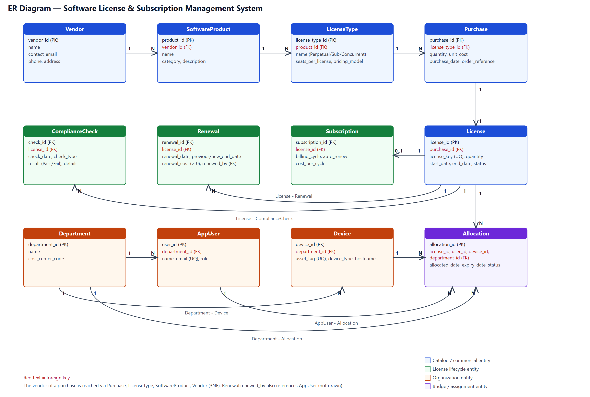
Figure 1: ER diagram of the Software License and Subscription Management System (parent side marked 1, child side marked N)

6.1 Entities
Entity | Purpose | Key attributes
Vendor | Company that sells software | vendor_id, name, contact_email, phone, address
SoftwareProduct | A product sold by a vendor | product_id, vendor_id, name, category, description
LicenseType | A way a product is licensed | license_type_id, product_id, name, seats_per_license, pricing_model
Purchase | A purchase line for a quantity of one license type | purchase_id, license_type_id, quantity, unit_cost, purchase_date, order_reference
License | The purchased pool of seats and its validity window | license_id, purchase_id, license_key, quantity, start_date, end_date, status
Subscription | Billing details of a subscription license | subscription_id, license_id, billing_cycle, auto_renew, cost_per_cycle
Department | Organizational unit and cost center | department_id, name, cost_center_code
AppUser | A person who can hold licenses | user_id, department_id, name, email, role
Device | A computer or server a license can be installed on | device_id, department_id, asset_tag, device_type, hostname
Allocation | Assignment of one seat to a user (and optionally a device) | allocation_id, license_id, user_id, device_id, department_id, allocated_date, expiry_date, status
Renewal | One renewal event of a license | renewal_id, license_id, renewal_date, previous_end_date, new_end_date, renewal_cost, renewed_by
ComplianceCheck | The stored result of one compliance check | check_id, license_id, check_date, check_type, result, details

6.2 Relationships
Relationship | Cardinality | Meaning
Vendor – SoftwareProduct | 1 : N | A vendor sells many products
SoftwareProduct – LicenseType | 1 : N | A product can be licensed in several ways
LicenseType – Purchase | 1 : N | A license type can be bought many times
Purchase – License | 1 : 1 | Each purchase creates one license (a pool of seats)
License – Subscription | 1 : 0..1 | Only subscription-type licenses have billing details
License – Allocation | 1 : N | A license is split into many seats
License – Renewal | 1 : N | A license can be renewed many times
License – ComplianceCheck | 1 : N | A license is checked repeatedly over time
Department – AppUser | 1 : N | A department has many users
Department – Device | 1 : N | A department owns many devices
Department – Allocation | 1 : N | A department is charged for many seats
AppUser – Allocation | 1 : N | A user can hold many seats
Device – Allocation | 1 : N (optional) | A device can carry many licenses; user-only licenses have no device
AppUser – Renewal | 1 : N (optional) | Records who processed a renewal (not drawn in the figure)

6.3 Design decisions
- The vendor of a purchase is not stored on the purchase. It is reached through Purchase → LicenseType → SoftwareProduct → Vendor, which avoids a transitive dependency (see Section 7).
- Each purchase creates exactly one license, so seat capacity and validity live on license. Splitting a purchase into several licenses would only require relaxing one unique constraint.
- Allocation.department_id is the department charged for the seat. It can differ from the user's home department (cross-charging), so it is a genuine fact of the allocation and not a redundant copy.

7. Relational Schema and Normalization

7.1 Initial schema (first draft)
The first attempt folded related facts into wide tables. A typical example is a single PURCHASE_RECORD table:
PURCHASE_RECORD(purchase_id, purchase_date, quantity, unit_cost,
vendor_id, vendor_name, vendor_email,
product_id, product_name, product_category,
license_type_id, license_type_name,
license_key_1, license_key_2, license_key_3, ...,
allocated_user_1, allocated_user_2, ...)
Problems: repeating groups (license_key_1..n, allocated_user_1..n) violate 1NF; vendor and product attributes are repeated on every purchase (update and insertion anomalies); and the table mixes facts of different grain (purchase, vendor, product, allocation).
Decomposing it gave the first relational draft:
VENDOR(vendor_id, name, contact_email, phone, address)
SOFTWARE_PRODUCT(product_id, vendor_id, name, category, description)
LICENSE_TYPE(license_type_id, product_id, name, seats_per_license, pricing_model)
PURCHASE(purchase_id, vendor_id, product_id, license_type_id, quantity, unit_cost, total_cost, purchase_date, order_reference)
LICENSE(license_id, purchase_id, license_key, quantity, start_date, end_date, status)
SUBSCRIPTION(subscription_id, license_id, billing_cycle, subscription_start, subscription_end, auto_renew, cost_per_cycle)
DEPARTMENT(department_id, name, cost_center_code)
APP_USER(user_id, name, email, department_id, role)
DEVICE(device_id, department_id, asset_tag, device_type, hostname)
ALLOCATION(allocation_id, license_id, user_id, device_id, department_id, allocated_date, expiry_date, status)
RENEWAL(renewal_id, license_id, renewal_date, previous_end_date, new_end_date, renewal_cost, renewed_by)
COMPLIANCE_CHECK(check_id, license_id, check_date, check_type, result, details)

7.2 Normal forms applied
- 1NF: all values are atomic and there are no repeating groups; every table has a primary key.
- 2NF: every table has a single-column surrogate primary key, so partial dependencies cannot occur.
- 3NF: no non-key attribute depends on another non-key attribute. This is where the first draft needed correction.

7.3 Functional dependencies
Table | Functional dependencies
vendor | vendor_id → name, contact_email, phone, address
software_product | product_id → vendor_id, name, category, description
license_type | license_type_id → product_id, name, seats_per_license, pricing_model
purchase | purchase_id → license_type_id, quantity, unit_cost, purchase_date, order_reference
license | license_id → purchase_id, license_key, quantity, start_date, end_date, status; license_key → license_id
subscription | subscription_id → license_id, billing_cycle, auto_renew, cost_per_cycle; license_id → subscription_id
department | department_id → name, cost_center_code; cost_center_code → department_id
app_user | user_id → name, email, department_id, role; email → user_id
device | device_id → department_id, asset_tag, device_type, hostname; asset_tag → device_id
allocation | allocation_id → license_id, user_id, device_id, department_id, allocated_date, expiry_date, status
renewal | renewal_id → license_id, renewal_date, previous_end_date, new_end_date, renewal_cost, renewed_by
compliance_check | check_id → license_id, check_date, check_type, result, details

Every determinant above is a key (primary or candidate key), which is the BCNF condition. The final design is therefore in BCNF, which is stronger than 3NF.

7.4 Violations found in the first draft and their fixes
# | Problem in the first draft | Dependency | Normal form | Fix
1 | purchase.vendor_id stored next to license_type_id | license_type_id → product_id → vendor_id | 3NF | Removed. The vendor is reached through license_type, software_product and vendor
2 | purchase.product_id stored next to license_type_id | license_type_id → product_id | 3NF | Removed
3 | purchase.total_cost | total_cost = quantity × unit_cost | 3NF (derived value) | Removed. Computed in queries and views
4 | subscription_start / subscription_end duplicate the license dates | license_id → start_date, end_date | 3NF | Removed from subscription
5 | renewal.renewed_by as free text | the name depends on a user, not on the renewal | 3NF | Replaced by a foreign key to app_user
6 | Vendor and department names copied to child tables | child → parent_id → parent_name | 3NF | Children keep only the foreign key
7 | license_key_1..n, allocated_user_1..n, renewal_1..n | repeating groups | 1NF | Separate tables: license, allocation, renewal

7.5 Deliberate design decisions (not violations)
- allocation.department_id versus app_user.department_id. The first is the department charged for the seat, the second is the user's home department. A user can be cross-charged to another cost center, so user_id does not determine the charged department and no transitive dependency exists. The same reasoning applies to device.department_id (owning department).
- license.quantity. Seat capacity equals purchase.quantity × license_type.seats_per_license when the license is created. It is stored so the allocation trigger can check capacity quickly and so a capacity can later be adjusted (for example a vendor true-down) without touching the purchase. The dependency spans tables, so it is not a 3NF violation inside license.
- license.status. Expired can be derived from end_date, but Revoked cannot, so the status is kept as an explicit lifecycle state. The views and the trigger check both status and date.

7.6 Final relational schema (3NF / BCNF)
vendor(vendor_id PK, name UQ, contact_email, phone, address)
software_product(product_id PK, vendor_id FK, name, category, description)
license_type(license_type_id PK, product_id FK, name, seats_per_license, pricing_model)
purchase(purchase_id PK, license_type_id FK, quantity, unit_cost, purchase_date, order_reference UQ)
license(license_id PK, purchase_id FK UQ, license_key UQ, quantity, start_date, end_date, status)
subscription(subscription_id PK, license_id FK UQ, billing_cycle, auto_renew, cost_per_cycle)
department(department_id PK, name UQ, cost_center_code UQ)
app_user(user_id PK, department_id FK, name, email UQ, role)
device(device_id PK, department_id FK, asset_tag UQ, device_type, hostname)
allocation(allocation_id PK, license_id FK, user_id FK, device_id FK NULL, department_id FK,
allocated_date, expiry_date, status)
renewal(renewal_id PK, license_id FK, renewal_date, previous_end_date, new_end_date,
renewal_cost, renewed_by FK)
compliance_check(check_id PK, license_id FK, check_date, check_type, result, details)

8. Data Dictionary
The tables below were generated from the live database catalog (information_schema) so that they match the implemented schema exactly. Data types are MySQL types; PK is a primary key, FK a foreign key, UNIQUE a single-column unique constraint.

8.1 Table vendor
Column | Data type | Constraints | Description
vendor_id | int | PK, AUTO_INCREMENT | Surrogate key
name | varchar(100) | NOT NULL, UNIQUE | Vendor name
contact_email | varchar(150) | NOT NULL | Sales/support contact
phone | varchar(30) | — | Contact phone
address | varchar(255) | — | Postal address

Table-level constraints:
- CHECK chk_vendor_email: (contact_emaillike '_%@_%._%')

8.2 Table software_product
Column | Data type | Constraints | Description
product_id | int | PK, AUTO_INCREMENT | Surrogate key
vendor_id | int | NOT NULL, FK → vendor(vendor_id) | Owning vendor
name | varchar(100) | NOT NULL | Product name
category | varchar(50) | NOT NULL | e.g. Productivity, DevTools
description | varchar(255) | — | Short description

Table-level constraints:
- UNIQUE uq_product_vendor_name on (vendor_id,name)

8.3 Table license_type
Column | Data type | Constraints | Description
license_type_id | int | PK, AUTO_INCREMENT | Surrogate key
product_id | int | NOT NULL, FK → software_product(product_id) | Product this type belongs to
name | varchar(60) | NOT NULL | e.g. Annual Subscription, Perpetual
seats_per_license | int | NOT NULL, DEFAULT 1 | Seats granted by one purchased unit
pricing_model | varchar(20) | NOT NULL | Perpetual, Subscription, Concurrent or Per-User

Table-level constraints:
- UNIQUE uq_ltype_product_name on (product_id,name)
- CHECK chk_ltype_model: (pricing_modelin ('Perpetual','Subscription','Concurrent','Per-User'))
- CHECK chk_ltype_seats: (seats_per_license> 0)

8.4 Table department
Column | Data type | Constraints | Description
department_id | int | PK, AUTO_INCREMENT | Surrogate key
name | varchar(80) | NOT NULL, UNIQUE | Department name
cost_center_code | varchar(20) | NOT NULL, UNIQUE | Finance cost center

8.5 Table app_user
Column | Data type | Constraints | Description
user_id | int | PK, AUTO_INCREMENT | Surrogate key
department_id | int | NOT NULL, FK → department(department_id) | Home department
name | varchar(100) | NOT NULL | Full name
email | varchar(150) | NOT NULL, UNIQUE | Login/contact email
role | varchar(20) | NOT NULL, DEFAULT 'Employee' | Drives access in the application

Table-level constraints:
- CHECK chk_user_email: (emaillike '_%@_%._%')
- CHECK chk_user_role: (rolein ('Employee','Manager','Admin','LicenseManager','Compliance'))

8.6 Table device
Column | Data type | Constraints | Description
device_id | int | PK, AUTO_INCREMENT | Surrogate key
department_id | int | NOT NULL, FK → department(department_id) | Owning department
asset_tag | varchar(40) | NOT NULL, UNIQUE | Inventory tag
device_type | varchar(30) | NOT NULL | Laptop, Desktop, Server, VM
hostname | varchar(80) | — | Network host name

8.7 Table purchase
Column | Data type | Constraints | Description
purchase_id | int | PK, AUTO_INCREMENT | Surrogate key
license_type_id | int | NOT NULL, FK → license_type(license_type_id) | What was bought (vendor/product derived from it)
quantity | int | NOT NULL | Units purchased
unit_cost | decimal(12,2) | NOT NULL | Price per unit for the term
purchase_date | date | NOT NULL, DEFAULT curdate() | Date of purchase
order_reference | varchar(50) | UNIQUE | PO / invoice number

Table-level constraints:
- CHECK chk_purchase_cost: (unit_cost>= 0)
- CHECK chk_purchase_qty: (quantity> 0)

8.8 Table license
Column | Data type | Constraints | Description
license_id | int | PK, AUTO_INCREMENT | Surrogate key
purchase_id | int | NOT NULL, UNIQUE, FK → purchase(purchase_id) | Purchase that created it (1:1)
license_key | varchar(100) | NOT NULL, UNIQUE | Unique license key
quantity | int | NOT NULL | Seat capacity
start_date | date | NOT NULL | Validity start
end_date | date | NOT NULL | Validity end
status | varchar(10) | NOT NULL, DEFAULT 'Active' | Active, Expired or Revoked

Table-level constraints:
- CHECK chk_license_dates: (end_date>start_date)
- CHECK chk_license_qty: (quantity> 0)
- CHECK chk_license_status: (statusin ('Active','Expired','Revoked'))

8.9 Table subscription
Column | Data type | Constraints | Description
subscription_id | int | PK, AUTO_INCREMENT | Surrogate key
license_id | int | NOT NULL, UNIQUE, FK → license(license_id) | Subscription license (1:0..1)
billing_cycle | varchar(10) | NOT NULL | Monthly, Quarterly or Annual
auto_renew | tinyint(1) | NOT NULL, DEFAULT 0 | Renews automatically
cost_per_cycle | decimal(12,2) | NOT NULL | Amount charged each cycle

Table-level constraints:
- CHECK chk_sub_cost: (cost_per_cycle> 0)
- CHECK chk_sub_cycle: (billing_cyclein ('Monthly','Quarterly','Annual'))

8.10 Table allocation
Column | Data type | Constraints | Description
allocation_id | int | PK, AUTO_INCREMENT | Surrogate key
license_id | int | NOT NULL, FK → license(license_id) | License the seat comes from
user_id | int | NOT NULL, FK → app_user(user_id) | Seat holder
device_id | int | FK → device(device_id) | Device the seat is used on (optional)
department_id | int | NOT NULL, FK → department(department_id) | Department charged
allocated_date | date | NOT NULL, DEFAULT curdate() | Allocation start
expiry_date | date | NOT NULL | Allocation end
status | varchar(10) | NOT NULL, DEFAULT 'Active' | Active, Reclaimed or Expired
active_user_key | int | STORED GENERATED | Generated: user_id while Active, else NULL (enforces one active seat per user per license)

Table-level constraints:
- UNIQUE uq_active_seat on (license_id,active_user_key)
- CHECK chk_alloc_period: (expiry_date>allocated_date)
- CHECK chk_alloc_status: (statusin ('Active','Reclaimed','Expired'))

8.11 Table renewal
Column | Data type | Constraints | Description
renewal_id | int | PK, AUTO_INCREMENT | Surrogate key
license_id | int | NOT NULL, FK → license(license_id) | Renewed license
renewal_date | date | NOT NULL, DEFAULT curdate() | Date processed
previous_end_date | date | NOT NULL | End date before renewal
new_end_date | date | NOT NULL | End date after renewal
renewal_cost | decimal(12,2) | NOT NULL | Cost of the renewal
renewed_by | int | FK → app_user(user_id) | User who processed it

Table-level constraints:
- CHECK chk_renewal_cost: (renewal_cost> 0)
- CHECK chk_renewal_dates: (new_end_date>previous_end_date)

8.12 Table compliance_check
Column | Data type | Constraints | Description
check_id | int | PK, AUTO_INCREMENT | Surrogate key
license_id | int | NOT NULL, FK → license(license_id) | Checked license
check_date | date | NOT NULL, DEFAULT curdate() | Date of check
check_type | varchar(30) | NOT NULL | Over-allocation, Expired-in-use, Unused or Key-audit
result | varchar(4) | NOT NULL | Pass or Fail
details | varchar(255) | — | Human-readable finding

Table-level constraints:
- CHECK chk_check_result: (resultin ('Pass','Fail'))
- CHECK chk_check_type: (check_typein ('Over-allocation','Expired-in-use','Unused','Key-audit'))

8.13 Business rules and the constraints that enforce them
Business rule | Mechanism
Unique license keys | license.license_key is UNIQUE NOT NULL (constraint uq_license_key)
Allocation within purchased quantity | Triggers trg_allocation_bi and trg_allocation_bu count active allocations against license.quantity
Valid allocation period | CHECK (expiry_date > allocated_date) plus a trigger check that the period lies inside the license validity window
No assignment of expired licenses | The same triggers reject a license whose status is not Active or whose end date has passed
Positive renewal values | CHECK (renewal_cost > 0) on renewal
One active seat per user per license | Unique index on (license_id, active_user_key), where active_user_key is a stored generated column equal to user_id while the allocation is Active and NULL otherwise (MySQL has no partial indexes)

8.14 Indexes (beyond primary key and unique indexes)
InnoDB automatically indexes every foreign key and every UNIQUE constraint (license key, email, asset tag, order reference and so on). The extra indexes below were added for frequently searched attributes.
Table | Index | Columns | Purpose
allocation | idx_alloc_dept_status | department_id,status | Department allocation listings
allocation | idx_alloc_expiry | expiry_date | Allocation expiry sweeps
allocation | idx_alloc_license_status | license_id,status | Seat counting for utilization and the allocation trigger
app_user | idx_user_name | name | User search box
compliance_check | idx_check_license_date | license_id,check_date | Compliance history per license
device | idx_device_hostname | hostname | Device search
license | idx_license_end_status | end_date,status | Expiry monitoring (end_date range + status)
purchase | idx_purchase_date | purchase_date | Cost analysis by period
renewal | idx_renewal_date | renewal_date | Renewal cost by period
software_product | idx_product_name | name | Product search box

9. SQL Commands Used (DDL and DML) with Sample Outputs
All scripts are in the sql/ folder and are run in this order:
Script | Content
01_schema.sql | Database, tables, constraints and the business-rule triggers
02_indexes.sql | Indexes on frequently searched attributes
03_seed_data.sql | Realistic sample data (relative to the run date)
05_views.sql | Six reporting views
06_procedures.sql | Expiry sweep and compliance check procedures
04_queries.sql | The query library (run any time after the views exist)

9.1 DDL: database and tables
DROP DATABASE IF EXISTS license_mgmt;
CREATE DATABASE license_mgmt CHARACTER SET utf8mb4 COLLATE utf8mb4_0900_ai_ci;
USE license_mgmt;
The license table, which carries the unique key rule, the quantity and date checks and the status check:
CREATE TABLE license (
license_id INT AUTO_INCREMENT PRIMARY KEY,
purchase_id INT NOT NULL,
license_key VARCHAR(100) NOT NULL,
quantity INT NOT NULL,
start_date DATE NOT NULL,
end_date DATE NOT NULL,
status VARCHAR(10) NOT NULL DEFAULT 'Active',
CONSTRAINT uq_license_key UNIQUE (license_key), -- BR1
CONSTRAINT uq_license_purchase UNIQUE (purchase_id),
CONSTRAINT fk_license_purchase FOREIGN KEY (purchase_id) REFERENCES purchase (purchase_id),
CONSTRAINT chk_license_qty CHECK (quantity > 0),
CONSTRAINT chk_license_dates CHECK (end_date > start_date),
CONSTRAINT chk_license_status CHECK (status IN ('Active','Expired','Revoked'))
) ENGINE=InnoDB;
The allocation table, with its foreign keys, period check and generated column for the one-active-seat rule:
CREATE TABLE allocation (
allocation_id INT AUTO_INCREMENT PRIMARY KEY,
license_id INT NOT NULL,
user_id INT NOT NULL,
device_id INT NULL,
department_id INT NOT NULL, -- department charged
allocated_date DATE NOT NULL DEFAULT (CURDATE()),
expiry_date DATE NOT NULL,
status VARCHAR(10) NOT NULL DEFAULT 'Active',
-- BR6: one active seat per user per license (MySQL has no partial unique index)
active_user_key INT GENERATED ALWAYS AS (IF(status = 'Active', user_id, NULL)) STORED,
CONSTRAINT uq_active_seat UNIQUE (license_id, active_user_key),
CONSTRAINT fk_alloc_license FOREIGN KEY (license_id) REFERENCES license (license_id),
CONSTRAINT fk_alloc_user FOREIGN KEY (user_id) REFERENCES app_user (user_id),
CONSTRAINT fk_alloc_device FOREIGN KEY (device_id) REFERENCES device (device_id),
CONSTRAINT fk_alloc_dept FOREIGN KEY (department_id) REFERENCES department (department_id),
CONSTRAINT chk_alloc_period CHECK (expiry_date > allocated_date), -- BR3 (part 1)
CONSTRAINT chk_alloc_status CHECK (status IN ('Active','Reclaimed','Expired'))
) ENGINE=InnoDB;
The renewal table, which carries the positive renewal value rule:
CREATE TABLE renewal (
renewal_id INT AUTO_INCREMENT PRIMARY KEY,
license_id INT NOT NULL,
renewal_date DATE NOT NULL DEFAULT (CURDATE()),
previous_end_date DATE NOT NULL,
new_end_date DATE NOT NULL,
renewal_cost DECIMAL(12,2) NOT NULL,
renewed_by INT NULL,
CONSTRAINT fk_renewal_license FOREIGN KEY (license_id) REFERENCES license (license_id),
CONSTRAINT fk_renewal_user FOREIGN KEY (renewed_by) REFERENCES app_user (user_id),
CONSTRAINT chk_renewal_cost CHECK (renewal_cost > 0), -- BR5
CONSTRAINT chk_renewal_dates CHECK (new_end_date > previous_end_date)
) ENGINE=InnoDB;

9.2 DDL: triggers for the business rules
CHECK constraints cannot look at other rows or tables, so the quantity, validity-window and expiry rules are implemented as triggers. The license row is locked with FOR UPDATE so two concurrent allocations cannot both take the last seat.
CREATE TRIGGER trg_allocation_bi
BEFORE INSERT ON allocation
FOR EACH ROW
BEGIN
DECLARE v_qty INT;
DECLARE v_start DATE;
DECLARE v_end DATE;
DECLARE v_status VARCHAR(10);
DECLARE v_used INT;
IF NEW.status = 'Active' THEN
SELECT quantity, start_date, end_date, status
INTO v_qty, v_start, v_end, v_status
FROM license WHERE license_id = NEW.license_id FOR UPDATE;
IF v_status <> 'Active' OR v_end < CURDATE() THEN
SIGNAL SQLSTATE '45000' SET MESSAGE_TEXT = 'Cannot allocate an expired or revoked license';
END IF;
IF NEW.allocated_date < v_start OR NEW.expiry_date > v_end THEN
SIGNAL SQLSTATE '45000' SET MESSAGE_TEXT = 'Allocation period must lie within the license validity window';
END IF;
SELECT COUNT(*) INTO v_used FROM allocation
WHERE license_id = NEW.license_id AND status = 'Active';
IF v_used >= v_qty THEN
SIGNAL SQLSTATE '45000' SET MESSAGE_TEXT = 'Allocation exceeds purchased quantity for this license';
END IF;
END IF;
END$$
trg_allocation_bu applies the same checks when an allocation is re-activated or its dates or license change.

9.3 DDL: indexes, views and procedures
CREATE INDEX idx_license_end_status ON license (end_date, status);
CREATE INDEX idx_alloc_license_status ON allocation (license_id, status);
CREATE INDEX idx_alloc_dept_status ON allocation (department_id, status);
CREATE INDEX idx_purchase_date ON purchase (purchase_date);
The base reporting view, which joins the license to its purchase, type, product and vendor and counts active seats:
CREATE OR REPLACE VIEW vw_license_utilization AS
SELECT l.license_id,
l.license_key,
v.vendor_id,
v.name AS vendor,
p.product_id,
p.name AS product,
lt.name AS license_type,
lt.pricing_model,
l.status,
l.start_date,
l.end_date,
l.quantity AS capacity,
COALESCE(a.active_cnt, 0) AS active_allocated,
l.quantity - COALESCE(a.active_cnt, 0) AS seats_available,
ROUND(100 * COALESCE(a.active_cnt, 0) / l.quantity, 1) AS utilization_pct,
ROUND(pu.unit_cost / lt.seats_per_license, 2) AS cost_per_seat,
pu.quantity * pu.unit_cost AS purchase_cost
FROM license l
JOIN purchase pu ON pu.purchase_id = l.purchase_id
JOIN license_type lt ON lt.license_type_id = pu.license_type_id
JOIN software_product p ON p.product_id = lt.product_id
JOIN vendor v ON v.vendor_id = p.vendor_id
LEFT JOIN (SELECT license_id, COUNT(*) AS active_cnt
FROM allocation
WHERE status = 'Active'
GROUP BY license_id) a ON a.license_id = l.license_id;
The expiry sweep and compliance check are stored procedures (sp_expire_overdue, sp_run_compliance_check, see 06_procedures.sql).

9.4 DML: loading the sample data
03_seed_data.sql loads realistic data through ordinary INSERT statements, so every allocation passes through the triggers. Dates are written relative to CURDATE(), so the expiring, expired and active cases stay valid whenever the demo is run.
INSERT INTO vendor (vendor_id, name, contact_email, phone, address) VALUES
(1, 'Microsoft', 'enterprise@microsoft.example', '+1-425-555-0101', 'One Microsoft Way, Redmond, WA'),
(2, 'Adobe', 'sales@adobe.example', '+1-408-555-0102', '345 Park Avenue, San Jose, CA');
INSERT INTO allocation (license_id, user_id, device_id, department_id, allocated_date, expiry_date)
SELECT 1, user_id, NULL, department_id, CURDATE() - INTERVAL 200 DAY, CURDATE() + INTERVAL 125 DAY
FROM app_user WHERE user_id IN (1,2,3,5,10,11,15,18,22);
Rows loaded:
Table | Rows loaded
vendor | 8
software_product | 13
license_type | 16
department | 6
app_user | 30
device | 20
purchase | 17
license | 17
subscription | 12
allocation | 75
renewal | 11
compliance_check | 8
allocation (status = Active) | 72

Sample of the vendor table:
vendor_​id | name | contact_​email | phone
1 | Microsoft | enterprise@microsoft.example | +1-425-555-0101
2 | Adobe | sales@adobe.example | +1-408-555-0102
3 | JetBrains | sales@jetbrains.example | +420-555-0103
4 | Atlassian | licensing@atlassian.example | +61-2-5550-0104
5 | Zoom | business@zoom.example | +1-888-555-0105
6 | Oracle | licensing@oracle.example | +1-650-555-0106
7 | Autodesk | sales@autodesk.example | +1-415-555-0107
8 | Salesforce | enterprise@salesforce.example | +1-415-555-0108

Sample of the license table:
license_​id | license_​key | quantity | start_​date | end_​date | status
1 | M365-E3-7F2A-91C4-0001 | 12 | 2025-02-08 | 2027-02-08 | Active
2 | VSENT-3B91-AA02-5D17-0002 | 6 | 2024-12-10 | 2026-12-10 | Active
3 | WINSRV-91C0-4E2B-7A33-0003 | 3 | 2024-11-05 | 2099-12-31 | Active
4 | CCALL-5E10-77B4-C2D8-0004 | 5 | 2024-10-31 | 2026-10-31 | Active
5 | ACRPRO-A7F3-1190-6B2C-0005 | 8 | 2024-11-30 | 2026-11-30 | Active
6 | IDEAU-C4D2-08E6-93F1-0006 | 4 | 2024-12-25 | 2026-12-25 | Active
7 | PYCHP-2B6E-F451-0D9A-0007 | 4 | 2024-09-16 | 2026-09-16 | Expired
8 | JIRA-CLD-4412-90AB-0008 | 15 | 2026-07-20 | 2026-10-18 | Active
9 | CONF-CLD-8820-17CD-0009 | 15 | 2026-07-20 | 2026-10-18 | Active
10 | ZOOM-BIZ-3391-AF20-0010 | 10 | 2025-04-24 | 2027-04-24 | Active

Showing the first 10 of 17 rows.

9.5 DML: insert, update, select and delete with outputs
INSERT a new vendor
INSERT INTO vendor (name, contact_email, phone) VALUES ('Demo Vendor', 'sales@demo-vendor.example', '+1-555-0100');
Query OK, 1 row(s) affected
UPDATE that vendor
UPDATE vendor SET phone = '+1-555-0199', address = '1 Demo Street' WHERE name = 'Demo Vendor';
Query OK, 1 row(s) affected
SELECT it back
SELECT vendor_id, name, contact_email, phone, address FROM vendor WHERE name = 'Demo Vendor';
vendor_​id | name | contact_​email | phone | address
17 | Demo Vendor | sales@demo-vendor.example | +1-555-0199 | 1 Demo Street

DELETE it
DELETE FROM vendor WHERE name = 'Demo Vendor';
Query OK, 1 row(s) affected
INSERT a purchase (Windows Server perpetual, 2 units)
INSERT INTO purchase (license_type_id, quantity, unit_cost, purchase_date, order_reference) VALUES (3, 2, 972.00, CURDATE(), 'PO-DEMO-001');
Query OK, 1 row(s) affected
INSERT the license it creates
INSERT INTO license (purchase_id, license_key, quantity, start_date, end_date) SELECT purchase_id, 'WINSRV-DEMO-0001-AAAA', 2, CURDATE(), CURDATE() + INTERVAL 365 DAY FROM purchase WHERE order_reference = 'PO-DEMO-001';
Query OK, 1 row(s) affected
Remember the new license id
SET @lic = LAST_INSERT_ID();
Query OK, 0 row(s) affected
INSERT an allocation (seat for user 20, charged to Finance)
INSERT INTO allocation (license_id, user_id, device_id, department_id, expiry_date) VALUES (@lic, 20, NULL, 4, CURDATE() + INTERVAL 100 DAY);
Query OK, 1 row(s) affected
UPDATE: reclaim the seat
UPDATE allocation SET status = 'Reclaimed' WHERE user_id = 20 AND license_id = @lic;
Query OK, 1 row(s) affected
SELECT the result
SELECT l.license_key, l.quantity, a.user_id, a.status FROM license l JOIN allocation a ON a.license_id = l.license_id WHERE l.license_id = @lic;
license_​key | quantity | user_​id | status
WINSRV-DEMO-0001-AAAA | 2 | 20 | Reclaimed

These statements were run inside one transaction and rolled back afterwards, so the sample data used elsewhere in this report is unchanged.

9.6 Rule violations and their outputs
The statements below are rejected by the database. Each was run against the sample data and rolled back.
BR1 - Duplicate license key
-- setup (same transaction): INSERT INTO purchase (license_type_id, quantity, unit_cost, order_reference) VALUES (1, 1, 1.00, 'PO-SPARE');
INSERT INTO license (purchase_id, license_key, quantity, start_date, end_date) SELECT purchase_id, 'M365-E3-7F2A-91C4-0001', 1, CURDATE(), CURDATE() + INTERVAL 5 DAY FROM purchase WHERE order_reference = 'PO-SPARE';
ERROR 1062: Duplicate entry 'M365-E3-7F2A-91C4-0001' for key 'license.uq_license_key'
BR2 - Allocate beyond purchased quantity (license 10 is full)
INSERT INTO allocation (license_id, user_id, department_id, expiry_date) VALUES (10, 20, 4, CURDATE() + INTERVAL 100 DAY);
ERROR 1644: Allocation exceeds purchased quantity for this license
BR3a - Expiry date not after allocation date
INSERT INTO allocation (license_id, user_id, department_id, allocated_date, expiry_date) VALUES (1, 20, 4, CURDATE(), CURDATE());
ERROR 3819: Check constraint 'chk_alloc_period' is violated.
BR3b - Allocation period outside the license window
INSERT INTO allocation (license_id, user_id, department_id, expiry_date) VALUES (1, 20, 4, CURDATE() + INTERVAL 400 DAY);
ERROR 1644: Allocation period must lie within the license validity window
BR4a - Assign an expired license
INSERT INTO allocation (license_id, user_id, department_id, expiry_date) VALUES (7, 20, 4, CURDATE() + INTERVAL 5 DAY);
ERROR 1644: Cannot allocate an expired or revoked license
BR4b - Assign a revoked license
INSERT INTO allocation (license_id, user_id, department_id, expiry_date) VALUES (17, 20, 4, CURDATE() + INTERVAL 5 DAY);
ERROR 1644: Cannot allocate an expired or revoked license
BR5 - Renewal cost of zero
INSERT INTO renewal (license_id, previous_end_date, new_end_date, renewal_cost) VALUES (1, CURDATE(), CURDATE() + INTERVAL 5 DAY, 0);
ERROR 3819: Check constraint 'chk_renewal_cost' is violated.
BR6 - Same user gets a second active seat on a license
INSERT INTO allocation (license_id, user_id, department_id, expiry_date) VALUES (1, 1, 1, CURDATE() + INTERVAL 100 DAY);
ERROR 1062: Duplicate entry '1-1' for key 'allocation.uq_active_seat'

10. Queries with Outputs
The query library (sql/04_queries.sql) contains 36 queries grouped by technique. Representative queries from each group are shown with their actual output. Outputs were captured on 2026-10-06.

10.1 Basic retrieval
A2. Licenses expiring in the next 30 days
SELECT license_id, license_key, end_date, DATEDIFF(end_date, CURDATE()) AS days_left
FROM license
WHERE status = 'Active'
AND end_date BETWEEN CURDATE() AND CURDATE() + INTERVAL 30 DAY
ORDER BY end_date;
Output:
license_​id | license_​key | end_​date | days_​left
8 | JIRA-CLD-4412-90AB-0008 | 2026-10-18 | 12
9 | CONF-CLD-8820-17CD-0009 | 2026-10-18 | 12
4 | CCALL-5E10-77B4-C2D8-0004 | 2026-10-31 | 25

10.2 Joins
B1. Full allocation listing: who holds which license, on which device, charged to whom
SELECT a.allocation_id, u.name AS holder, hd.name AS home_dept, cd.name AS charged_dept,
p.name AS product, v.name AS vendor, dv.hostname AS device,
a.allocated_date, a.expiry_date, a.status
FROM allocation a
JOIN app_user u ON u.user_id = a.user_id
JOIN department hd ON hd.department_id = u.department_id
JOIN department cd ON cd.department_id = a.department_id
JOIN license l ON l.license_id = a.license_id
JOIN purchase pu ON pu.purchase_id = l.purchase_id
JOIN license_type lt ON lt.license_type_id = pu.license_type_id
JOIN software_product p ON p.product_id = lt.product_id
JOIN vendor v ON v.vendor_id = p.vendor_id
LEFT JOIN device dv ON dv.device_id = a.device_id
WHERE a.status = 'Active'
ORDER BY v.name, p.name, u.name;
Output:
allocation_​id | holder | home_​dept | charged_​dept | product | vendor | device | allocated_​date | expiry_​date | status
33 | Anil Kulkarni | Finance | Finance | Acrobat Pro | Adobe | NULL | 2026-04-09 | 2026-11-30 | Active
30 | Arjun Verma | Sales | Sales | Acrobat Pro | Adobe | NULL | 2026-04-09 | 2026-11-30 | Active
29 | Meera Joshi | Sales | Sales | Acrobat Pro | Adobe | NULL | 2026-04-09 | 2026-11-30 | Active
31 | Pooja Reddy | Sales | Sales | Acrobat Pro | Adobe | NULL | 2026-04-09 | 2026-11-30 | Active
36 | Rahul Menon | Human Resources | Finance | Acrobat Pro | Adobe | NULL | 2026-04-09 | 2026-11-30 | Active
32 | Sunita Pillai | Human Resources | Human Resources | Acrobat Pro | Adobe | NULL | 2026-04-09 | 2026-11-30 | Active
23 | Aditya Jain | Marketing | Marketing | Creative Cloud All Apps | Adobe | NULL | 2025-12-10 | 2026-10-31 | Active
25 | Neel Patel | Marketing | Marketing | Creative Cloud All Apps | Adobe | NULL | 2025-12-10 | 2026-10-31 | Active
22 | Shreya Kohli | Marketing | Marketing | Creative Cloud All Apps | Adobe | NULL | 2025-12-10 | 2026-10-31 | Active
24 | Zoya Khan | Marketing | Marketing | Creative Cloud All Apps | Adobe | NULL | 2025-12-10 | 2026-10-31 | Active

Showing the first 10 of 72 rows.
B2. Cross-charged seats: charged department differs from the user's home department
SELECT u.name AS holder, hd.name AS home_dept, cd.name AS charged_dept, p.name AS product
FROM allocation a
JOIN app_user u ON u.user_id = a.user_id
JOIN department hd ON hd.department_id = u.department_id
JOIN department cd ON cd.department_id = a.department_id
JOIN license l ON l.license_id = a.license_id
JOIN purchase pu ON pu.purchase_id = l.purchase_id
JOIN license_type lt ON lt.license_type_id = pu.license_type_id
JOIN software_product p ON p.product_id = lt.product_id
WHERE a.status = 'Active' AND a.department_id <> u.department_id;
Output:
holder | home_​dept | charged_​dept | product
Rahul Menon | Human Resources | Finance | Acrobat Pro

B3. LEFT JOIN: every license type with how many licenses were bought (including none)
SELECT lt.license_type_id, p.name AS product, lt.name AS license_type, COUNT(pu.purchase_id) AS purchases
FROM license_type lt
JOIN software_product p ON p.product_id = lt.product_id
LEFT JOIN purchase pu ON pu.license_type_id = lt.license_type_id
GROUP BY lt.license_type_id, p.name, lt.name
ORDER BY purchases, p.name;
Output:
license_​type_​id | product | license_​type | purchases
5 | Acrobat Pro | Pro Annual | 1
12 | AutoCAD | Named User Annual | 1
14 | AutoCAD | Network Concurrent Perpetual | 1
9 | Confluence | Cloud Standard Monthly | 1
4 | Creative Cloud All Apps | All Apps Annual | 1
6 | IntelliJ IDEA Ultimate | Ultimate Annual | 1
8 | Jira Software | Cloud Standard Monthly | 1
16 | Jira Software | Data Center 10-User Pack | 1
1 | Microsoft 365 E3 | E3 Annual Subscription | 1
11 | Oracle Database Enterprise | Processor Perpetual | 1

Showing the first 10 of 16 rows.

10.3 Aggregate functions
C1. Seats allocated per license with utilization %
SELECT l.license_id, p.name AS product, l.quantity AS capacity,
COUNT(a.allocation_id) AS active_seats,
ROUND(100 * COUNT(a.allocation_id) / l.quantity, 1) AS utilization_pct
FROM license l
JOIN purchase pu ON pu.purchase_id = l.purchase_id
JOIN license_type lt ON lt.license_type_id = pu.license_type_id
JOIN software_product p ON p.product_id = lt.product_id
LEFT JOIN allocation a ON a.license_id = l.license_id AND a.status = 'Active'
GROUP BY l.license_id, p.name, l.quantity
ORDER BY utilization_pct DESC;
Output:
license_​id | product | capacity | active_​seats | utilization_​pct
6 | IntelliJ IDEA Ultimate | 4 | 5 | 125.00
12 | AutoCAD | 3 | 3 | 100.00
10 | Zoom Workplace | 10 | 10 | 100.00
4 | Creative Cloud All Apps | 5 | 4 | 80.00
5 | Acrobat Pro | 8 | 6 | 75.00
7 | PyCharm Professional | 4 | 3 | 75.00
1 | Microsoft 365 E3 | 12 | 8 | 66.70
2 | Visual Studio | 6 | 4 | 66.70
3 | Windows Server | 3 | 2 | 66.70
9 | Confluence | 15 | 8 | 53.30
11 | Oracle Database Enterprise | 2 | 1 | 50.00
13 | Sales Cloud | 8 | 4 | 50.00
8 | Jira Software | 15 | 7 | 46.70
15 | Visual Studio | 5 | 2 | 40.00

Showing the first 14 of 17 rows.
C2. Purchase spend per vendor (HAVING filters vendors above 10,000)
SELECT v.name AS vendor, COUNT(*) AS purchases, SUM(pu.quantity * pu.unit_cost) AS spend
FROM purchase pu
JOIN license_type lt ON lt.license_type_id = pu.license_type_id
JOIN software_product p ON p.product_id = lt.product_id
JOIN vendor v ON v.vendor_id = p.vendor_id
GROUP BY v.vendor_id, v.name
HAVING SUM(pu.quantity * pu.unit_cost) > 10000
ORDER BY spend DESC;
Output:
vendor | purchases | spend
Oracle | 1 | 95,000.00
Microsoft | 4 | 32,089.00
Autodesk | 2 | 25,700.00
Salesforce | 1 | 14,400.00

C4. Licenses by pricing model: count, total seats, min/avg/max unit cost
SELECT lt.pricing_model, COUNT(*) AS licenses, SUM(l.quantity) AS seats,
MIN(pu.unit_cost) AS min_cost, ROUND(AVG(pu.unit_cost), 2) AS avg_cost, MAX(pu.unit_cost) AS max_cost
FROM license l
JOIN purchase pu ON pu.purchase_id = l.purchase_id
JOIN license_type lt ON lt.license_type_id = pu.license_type_id
GROUP BY lt.pricing_model;
Output:
pricing_​model | licenses | seats | min_​cost | avg_​cost | max_​cost
Subscription | 12 | 112.00 | 61.92 | 926.54 | 3,500.00
Perpetual | 3 | 10.00 | 972.00 | 16,557.00 | 47,500.00
Per-User | 1 | 3.00 | 2,100.00 | 2,100.00 | 2,100.00
Concurrent | 1 | 4.00 | 4,850.00 | 4,850.00 | 4,850.00

10.4 Nested queries (subqueries)
D1. Licenses with NO active allocation (unused spend) - NOT EXISTS
SELECT l.license_id, l.license_key, l.quantity
FROM license l
WHERE l.status = 'Active'
AND NOT EXISTS (SELECT 1 FROM allocation a
WHERE a.license_id = l.license_id AND a.status = 'Active');
Output:
license_​id | license_​key | quantity
14 | ACAD-NET-5C77-B310-0014 | 4

D2. Users holding more active licenses than the average user (scalar subquery)
SELECT u.user_id, u.name, COUNT(*) AS licenses_held
FROM allocation a
JOIN app_user u ON u.user_id = a.user_id
WHERE a.status = 'Active'
GROUP BY u.user_id, u.name
HAVING COUNT(*) > (SELECT AVG(c) FROM (SELECT COUNT(*) AS c FROM allocation
WHERE status = 'Active' GROUP BY user_id) t)
ORDER BY licenses_held DESC;
Output:
user_​id | name | licenses_​held
1 | Aarav Mehta | 5
2 | Isha Kapoor | 5
3 | Rohan Das | 5
10 | Meera Joshi | 5
11 | Arjun Verma | 5
15 | Sunita Pillai | 4
18 | Anil Kulkarni | 4
6 | Sneha Iyer | 4
22 | Harsh Vardhan | 3
4 | Priya Nair | 3
27 | Shreya Kohli | 3
12 | Pooja Reddy | 3
5 | Karan Malhotra | 3

D3. Over-allocated licenses (correlated subquery in WHERE)
SELECT l.license_id, l.license_key, l.quantity
FROM license l
WHERE (SELECT COUNT(*) FROM allocation a
WHERE a.license_id = l.license_id AND a.status = 'Active') > l.quantity;
Output:
license_​id | license_​key | quantity
6 | IDEAU-C4D2-08E6-93F1-0006 | 4

D4. Expired licenses that still have active allocations (IN subquery)
SELECT license_id, license_key, end_date
FROM license
WHERE (status = 'Expired' OR end_date < CURDATE())
AND license_id IN (SELECT license_id FROM allocation WHERE status = 'Active');
Output:
license_​id | license_​key | end_​date
7 | PYCHP-2B6E-F451-0D9A-0007 | 2026-09-16

D7. The most expensive purchase per vendor (correlated subquery with MAX)
SELECT v.name AS vendor, p.name AS product, pu.quantity * pu.unit_cost AS cost
FROM purchase pu
JOIN license_type lt ON lt.license_type_id = pu.license_type_id
JOIN software_product p ON p.product_id = lt.product_id
JOIN vendor v ON v.vendor_id = p.vendor_id
WHERE pu.quantity * pu.unit_cost = (
SELECT MAX(pu2.quantity * pu2.unit_cost)
FROM purchase pu2
JOIN license_type lt2 ON lt2.license_type_id = pu2.license_type_id
JOIN software_product p2 ON p2.product_id = lt2.product_id
WHERE p2.vendor_id = v.vendor_id);
Output:
vendor | product | cost
Adobe | Creative Cloud All Apps | 3,299.40
Atlassian | Jira Software | 7,000.00
Autodesk | AutoCAD | 19,400.00
JetBrains | IntelliJ IDEA Ultimate | 3,594.00
Microsoft | Visual Studio | 17,994.00
Oracle | Oracle Database Enterprise | 95,000.00
Salesforce | Sales Cloud | 14,400.00
Zoom | Zoom Workplace | 2,400.00

10.5 Window functions
E1. Rank vendors by total purchase spend
SELECT v.name AS vendor, SUM(pu.quantity * pu.unit_cost) AS spend,
RANK() OVER (ORDER BY SUM(pu.quantity * pu.unit_cost) DESC) AS spend_rank
FROM purchase pu
JOIN license_type lt ON lt.license_type_id = pu.license_type_id
JOIN software_product p ON p.product_id = lt.product_id
JOIN vendor v ON v.vendor_id = p.vendor_id
GROUP BY v.vendor_id, v.name;
Output:
vendor | spend | spend_​rank
Oracle | 95,000.00 | 1
Microsoft | 32,089.00 | 2
Autodesk | 25,700.00 | 3
Salesforce | 14,400.00 | 4
Atlassian | 9,395.80 | 5
Adobe | 5,218.44 | 6
JetBrains | 4,590.00 | 7
Zoom | 3,600.00 | 8

10.6 Reports through views
The six required reports are implemented as views, each hiding the multi-table join behind a simple name.
F1. License expiry (expired + next 90 days)
SELECT * FROM vw_license_expiry ORDER BY days_remaining;
Output:
license_​id | license_​key | vendor | product | end_​date | days_​remaining | expiry_​bucket | active_​allocated | auto_​renew
7 | PYCHP-2B6E-F451-0D9A-0007 | JetBrains | PyCharm Professional | 2026-09-16 | -20 | Expired | 3 | 0
8 | JIRA-CLD-4412-90AB-0008 | Atlassian | Jira Software | 2026-10-18 | 12 | 0-30 days | 7 | 1
9 | CONF-CLD-8820-17CD-0009 | Atlassian | Confluence | 2026-10-18 | 12 | 0-30 days | 8 | 1
4 | CCALL-5E10-77B4-C2D8-0004 | Adobe | Creative Cloud All Apps | 2026-10-31 | 25 | 0-30 days | 4 | 0
16 | JIRA-DC-7710-A4E2-0016 | Atlassian | Jira Software | 2026-11-20 | 45 | 31-60 days | 5 | 0
5 | ACRPRO-A7F3-1190-6B2C-0005 | Adobe | Acrobat Pro | 2026-11-30 | 55 | 31-60 days | 6 | 1
2 | VSENT-3B91-AA02-5D17-0002 | Microsoft | Visual Studio | 2026-12-10 | 65 | 61-90 days | 4 | 0
6 | IDEAU-C4D2-08E6-93F1-0006 | JetBrains | IntelliJ IDEA Ultimate | 2026-12-25 | 80 | 61-90 days | 5 | 1

F2. Utilization, lowest first (waste) and over-allocated licenses show negative seats_available
SELECT license_id, vendor, product, capacity, active_allocated, seats_available, utilization_pct
FROM vw_license_utilization
WHERE status = 'Active'
ORDER BY utilization_pct;
Output:
license_​id | vendor | product | capacity | active_​allocated | seats_​available | utilization_​pct
14 | Autodesk | AutoCAD | 4 | 0 | 4 | 0.00
16 | Atlassian | Jira Software | 20 | 5 | 15 | 25.00
15 | Microsoft | Visual Studio | 5 | 2 | 3 | 40.00
8 | Atlassian | Jira Software | 15 | 7 | 8 | 46.70
11 | Oracle | Oracle Database Enterprise | 2 | 1 | 1 | 50.00
13 | Salesforce | Sales Cloud | 8 | 4 | 4 | 50.00
9 | Atlassian | Confluence | 15 | 8 | 7 | 53.30
1 | Microsoft | Microsoft 365 E3 | 12 | 8 | 4 | 66.70
2 | Microsoft | Visual Studio | 6 | 4 | 2 | 66.70
3 | Microsoft | Windows Server | 3 | 2 | 1 | 66.70

Showing the first 10 of 15 rows.
F3. Compliance gaps
SELECT * FROM vw_compliance_gaps ORDER BY gap_type, license_id;
Output:
license_​id | license_​key | vendor | product | gap_​type | capacity | active_​allocated | detail | cost_​at_​risk
7 | PYCHP-2B6E-F451-0D9A-0007 | JetBrains | PyCharm Professional | Expired-in-use | 4 | 3 | Expired on 2026-09-16 with 3 active allocation(s) | 0.00
6 | IDEAU-C4D2-08E6-93F1-0006 | JetBrains | IntelliJ IDEA Ultimate | Over-allocation | 4 | 5 | 1 seat(s) over purchased quantity | 0.00
14 | ACAD-NET-5C77-B310-0014 | Autodesk | AutoCAD | Unused | 4 | 0 | 0 of 4 seats allocated | 19,400.00

F4. Renewal cost by year / vendor / product
SELECT * FROM vw_renewal_cost_summary ORDER BY renewal_year DESC, total_renewal_cost DESC;
Output:
renewal_​year | vendor | product | renewals | total_​renewal_​cost | avg_​renewal_​cost
2026 | Salesforce | Sales Cloud | 1 | 15,120.00 | 15,120.00
2026 | Microsoft | Microsoft 365 E3 | 1 | 5,443.20 | 5,443.20
2026 | Zoom | Zoom Workplace | 1 | 2,520.00 | 2,520.00
2026 | Atlassian | Jira Software | 1 | 128.36 | 128.36
2026 | Atlassian | Confluence | 1 | 81.27 | 81.27
2025 | Microsoft | Visual Studio | 1 | 18,893.70 | 18,893.70
2025 | Atlassian | Jira Software | 1 | 7,350.00 | 7,350.00
2025 | JetBrains | IntelliJ IDEA Ultimate | 1 | 3,773.70 | 3,773.70
2025 | Adobe | Creative Cloud All Apps | 1 | 3,464.37 | 3,464.37
2025 | Adobe | Acrobat Pro | 1 | 2,014.99 | 2,014.99
2025 | JetBrains | PyCharm Professional | 1 | 1,045.80 | 1,045.80

F5. Department allocation
SELECT * FROM vw_department_allocation ORDER BY allocated_seat_cost DESC;
Output:
department_​id | department | cost_​center_​code | active_​seats | licenses_​in_​use | allocated_​seat_​cost | cost_​share_​pct
5 | IT Operations | CC-500 | 9 | 4 | 51,626.00 | 55.00
1 | Engineering | CC-100 | 29 | 8 | 24,502.36 | 26.10
2 | Sales | CC-200 | 16 | 5 | 10,107.48 | 10.80
6 | Marketing | CC-600 | 8 | 4 | 5,281.44 | 5.60
3 | Human Resources | CC-300 | 5 | 4 | 1,213.80 | 1.30
4 | Finance | CC-400 | 5 | 4 | 1,213.68 | 1.30

F6. Vendor portfolio
SELECT * FROM vw_vendor_portfolio ORDER BY total_spend DESC;
Output:
vendor_​id | vendor | products | licenses | total_​seats | seats_​allocated | purchase_​spend | renewal_​spend | total_​spend
6 | Oracle | 1 | 1 | 2.00 | 1.00 | 95,000.00 | 0.00 | 95,000.00
1 | Microsoft | 3 | 4 | 26.00 | 16.00 | 32,089.00 | 24,336.90 | 56,425.90
8 | Salesforce | 1 | 1 | 8.00 | 4.00 | 14,400.00 | 15,120.00 | 29,520.00
7 | Autodesk | 1 | 2 | 7.00 | 3.00 | 25,700.00 | 0.00 | 25,700.00
4 | Atlassian | 2 | 3 | 50.00 | 20.00 | 9,395.80 | 7,559.63 | 16,955.43
2 | Adobe | 2 | 2 | 13.00 | 10.00 | 5,218.44 | 5,479.36 | 10,697.80
3 | JetBrains | 2 | 2 | 8.00 | 8.00 | 4,590.00 | 4,819.50 | 9,409.50
5 | Zoom | 1 | 2 | 15.00 | 10.00 | 3,600.00 | 2,520.00 | 6,120.00

10.7 Cost analysis
G1. Idle spend: cost of seats paid for but not allocated, per license (valid licenses only)
SELECT license_id, vendor, product, seats_available,
ROUND(seats_available * cost_per_seat, 2) AS idle_cost
FROM vw_license_utilization
WHERE status = 'Active' AND end_date >= CURDATE() AND seats_available > 0
ORDER BY idle_cost DESC;
Output:
license_​id | vendor | product | seats_​available | idle_​cost
11 | Oracle | Oracle Database Enterprise | 1 | 47,500.00
14 | Autodesk | AutoCAD | 4 | 19,400.00
13 | Salesforce | Sales Cloud | 4 | 7,200.00
2 | Microsoft | Visual Studio | 2 | 5,998.00
16 | Atlassian | Jira Software | 15 | 5,250.00
15 | Microsoft | Visual Studio | 3 | 3,597.00
1 | Microsoft | Microsoft 365 E3 | 4 | 1,728.00
3 | Microsoft | Windows Server | 1 | 972.00
8 | Atlassian | Jira Software | 8 | 782.40
4 | Adobe | Creative Cloud All Apps | 1 | 659.88
5 | Adobe | Acrobat Pro | 2 | 479.76
9 | Atlassian | Confluence | 7 | 433.44

G2. Total estimated cost of seats currently allocated vs. idle across the estate
SELECT ROUND(SUM(LEAST(active_allocated, capacity) * cost_per_seat), 2) AS allocated_value,
ROUND(SUM(GREATEST(seats_available, 0) * cost_per_seat), 2) AS idle_value
FROM vw_license_utilization
WHERE status = 'Active' AND end_date >= CURDATE();
Output:
allocated_​value | idle_​value
92,598.76 | 94,000.48

11. UI Design and Screenshots

11.1 Design approach
The application is named SUB MAG. Its visual identity uses three colors: black (navigation and cards), cream (page background) and red (accents and calls to action). Display type is a heavy sans-serif; body text is a clean sans-serif. The interface follows a few principles:
- Role-aware navigation. The sidebar and the Home page show only what the signed-in role may open.
- One task per page. Each page maps to a workflow: purchase, allocate, reclaim, monitor expiry, renew, check compliance, analyse cost, report.
- Errors in plain language. Database rule violations and invalid input are shown as short messages rather than stack traces.
- Confirmation for destructive actions. Reclaim, delete and the expiry sweep require an explicit confirmation.

11.2 Introduction screens
When the site loads, a full-screen introduction plays. Page 1 shows the SUB MAG title with animated 3D objects. A scroll, swipe or double tap makes the 3D objects burst apart and the feature cards assemble into page 2, which explains what the system offers. Another scroll or swipe lifts the introduction away and reveals the application.
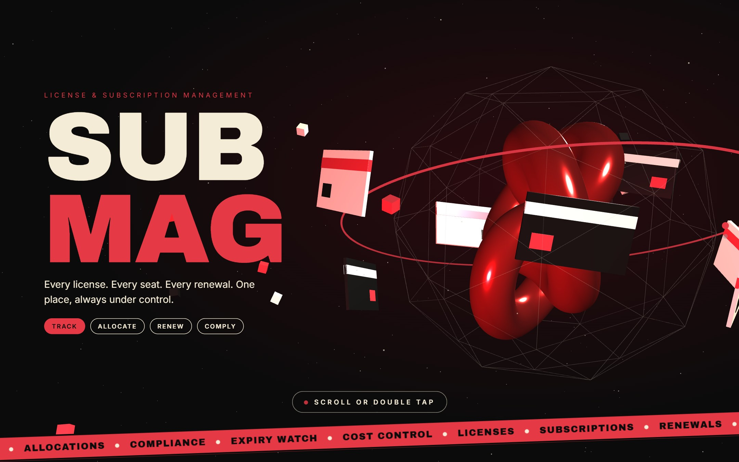
Figure 2: Introduction, page 1 – SUB MAG title with 3D objects
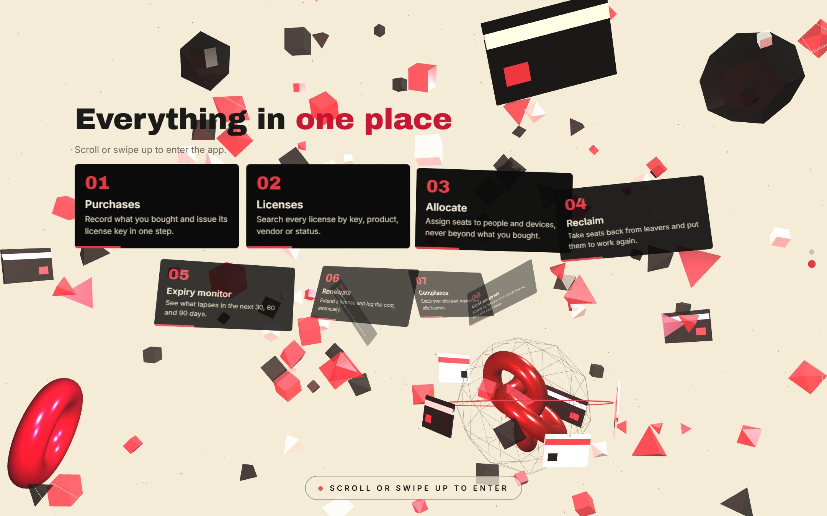
Figure 3: Transition – the 3D objects explode and the feature cards assemble
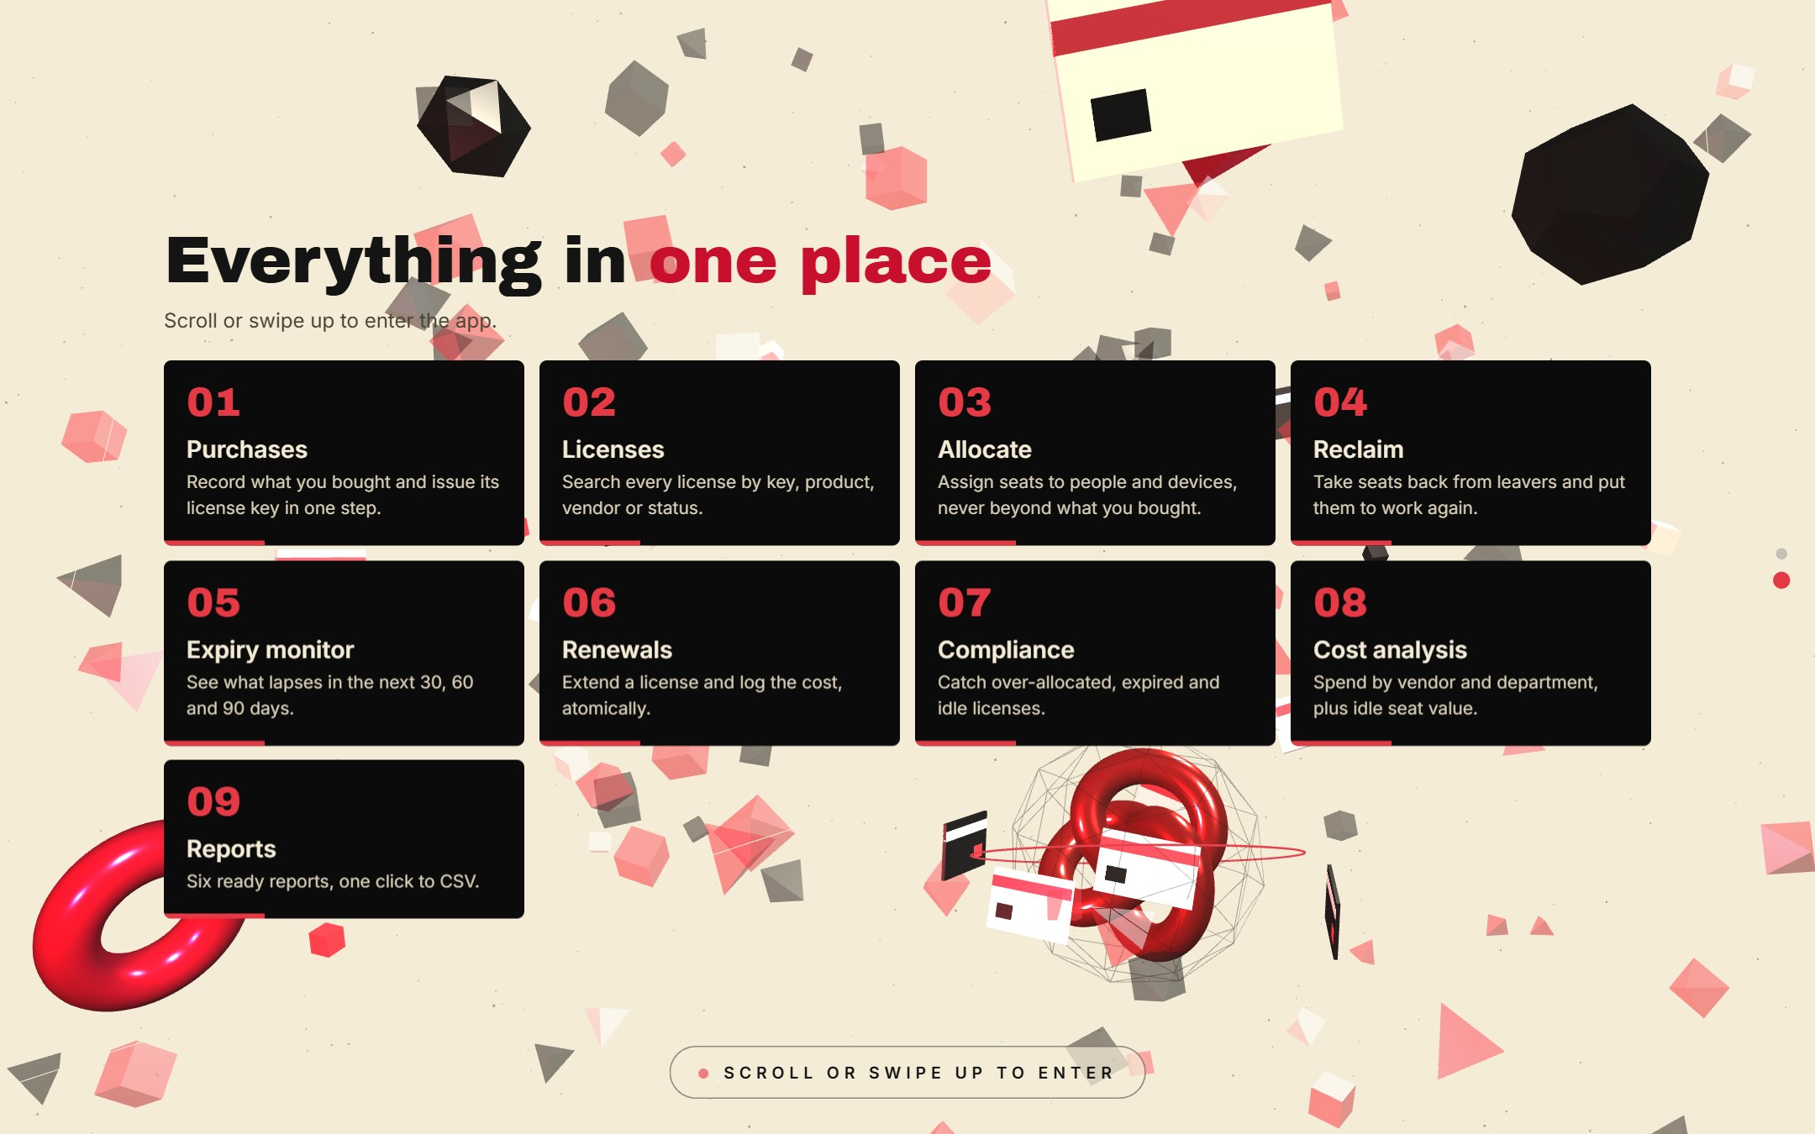
Figure 4: Introduction, page 2 – "Everything in one place"

11.3 Home page and role-based navigation
The Home page greets the user, shows five live figures from the database and then a "toolkit" card for every page the user's role can open. Tapping a card jumps straight to that page.
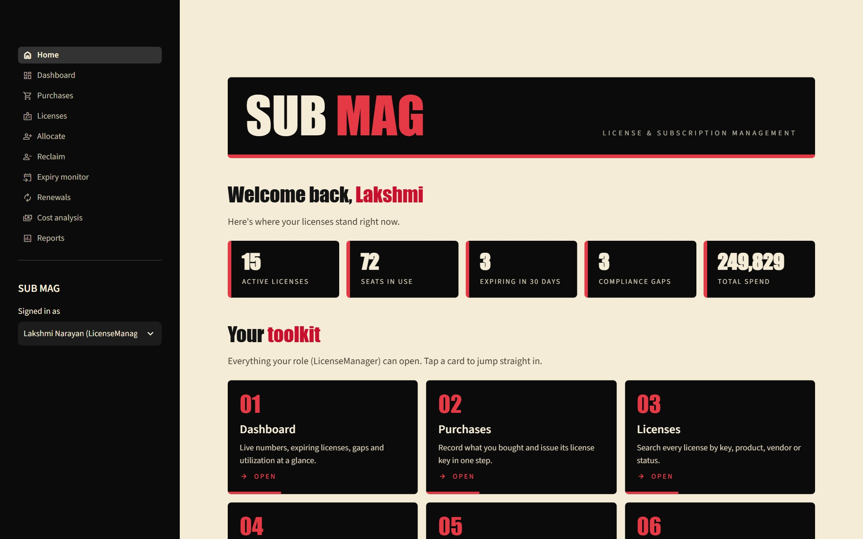
Figure 5: Home page (License manager) – banner, live figures and toolkit
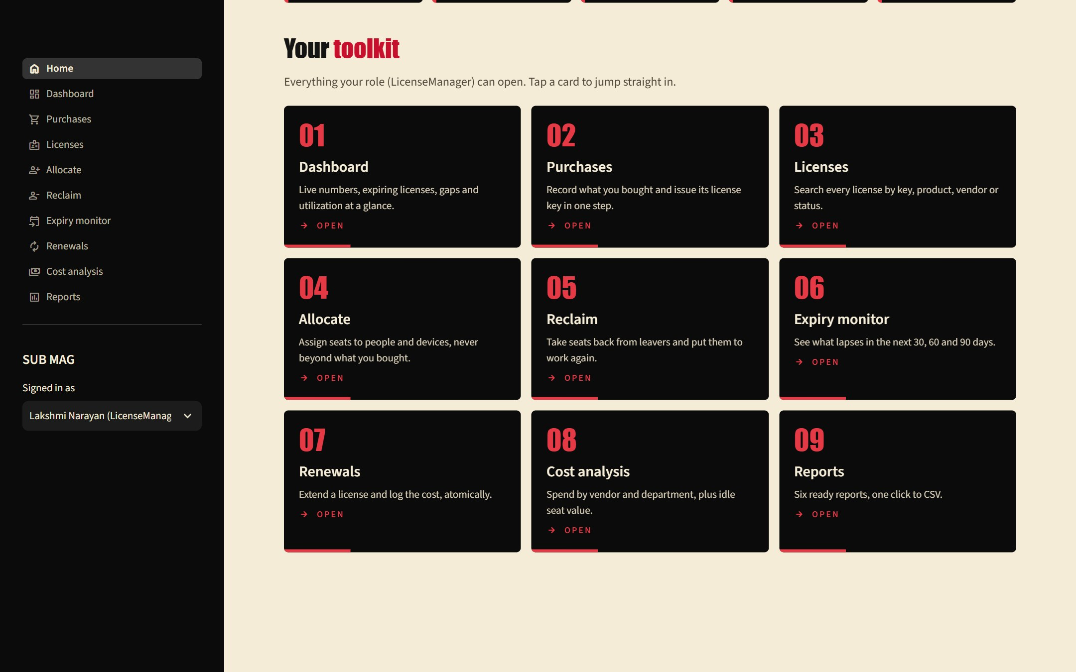
Figure 6: Toolkit cards for the License manager role (9 cards)
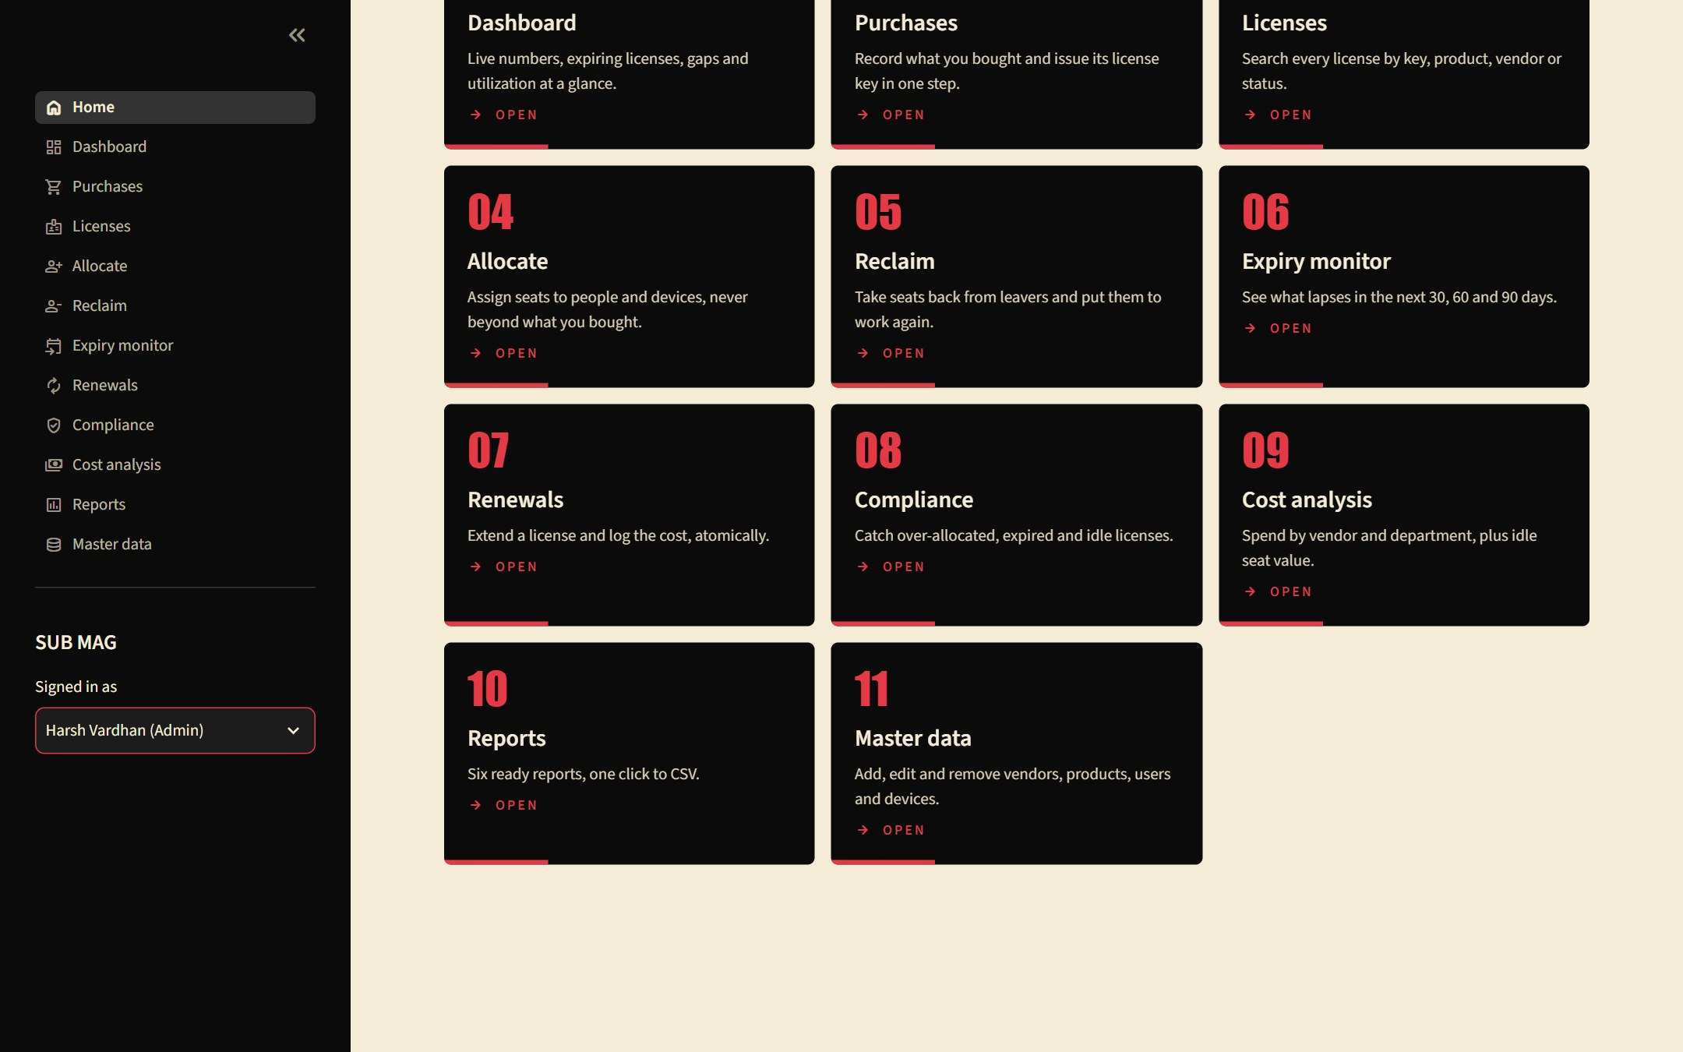
Figure 7: Toolkit cards for the Admin role (11 cards, including Compliance and Master data)

11.4 Application pages
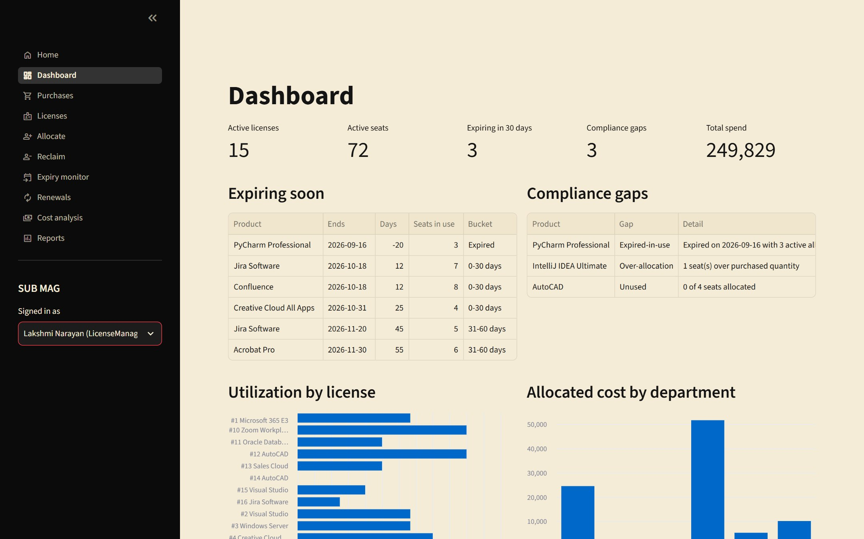
Figure 8: Dashboard – key figures, expiring licenses, compliance gaps and utilization
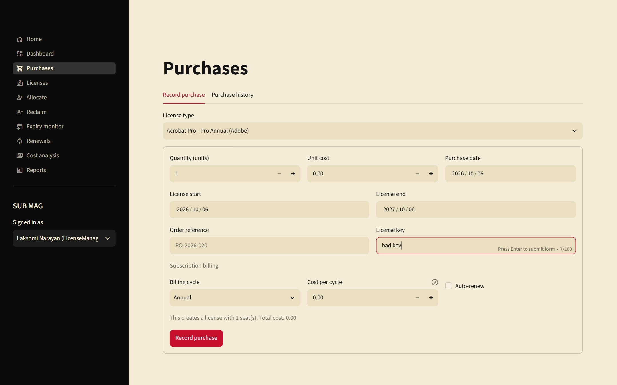
Figure 9: Purchases – recording a purchase (license type, quantity, cost, dates, key, subscription billing)
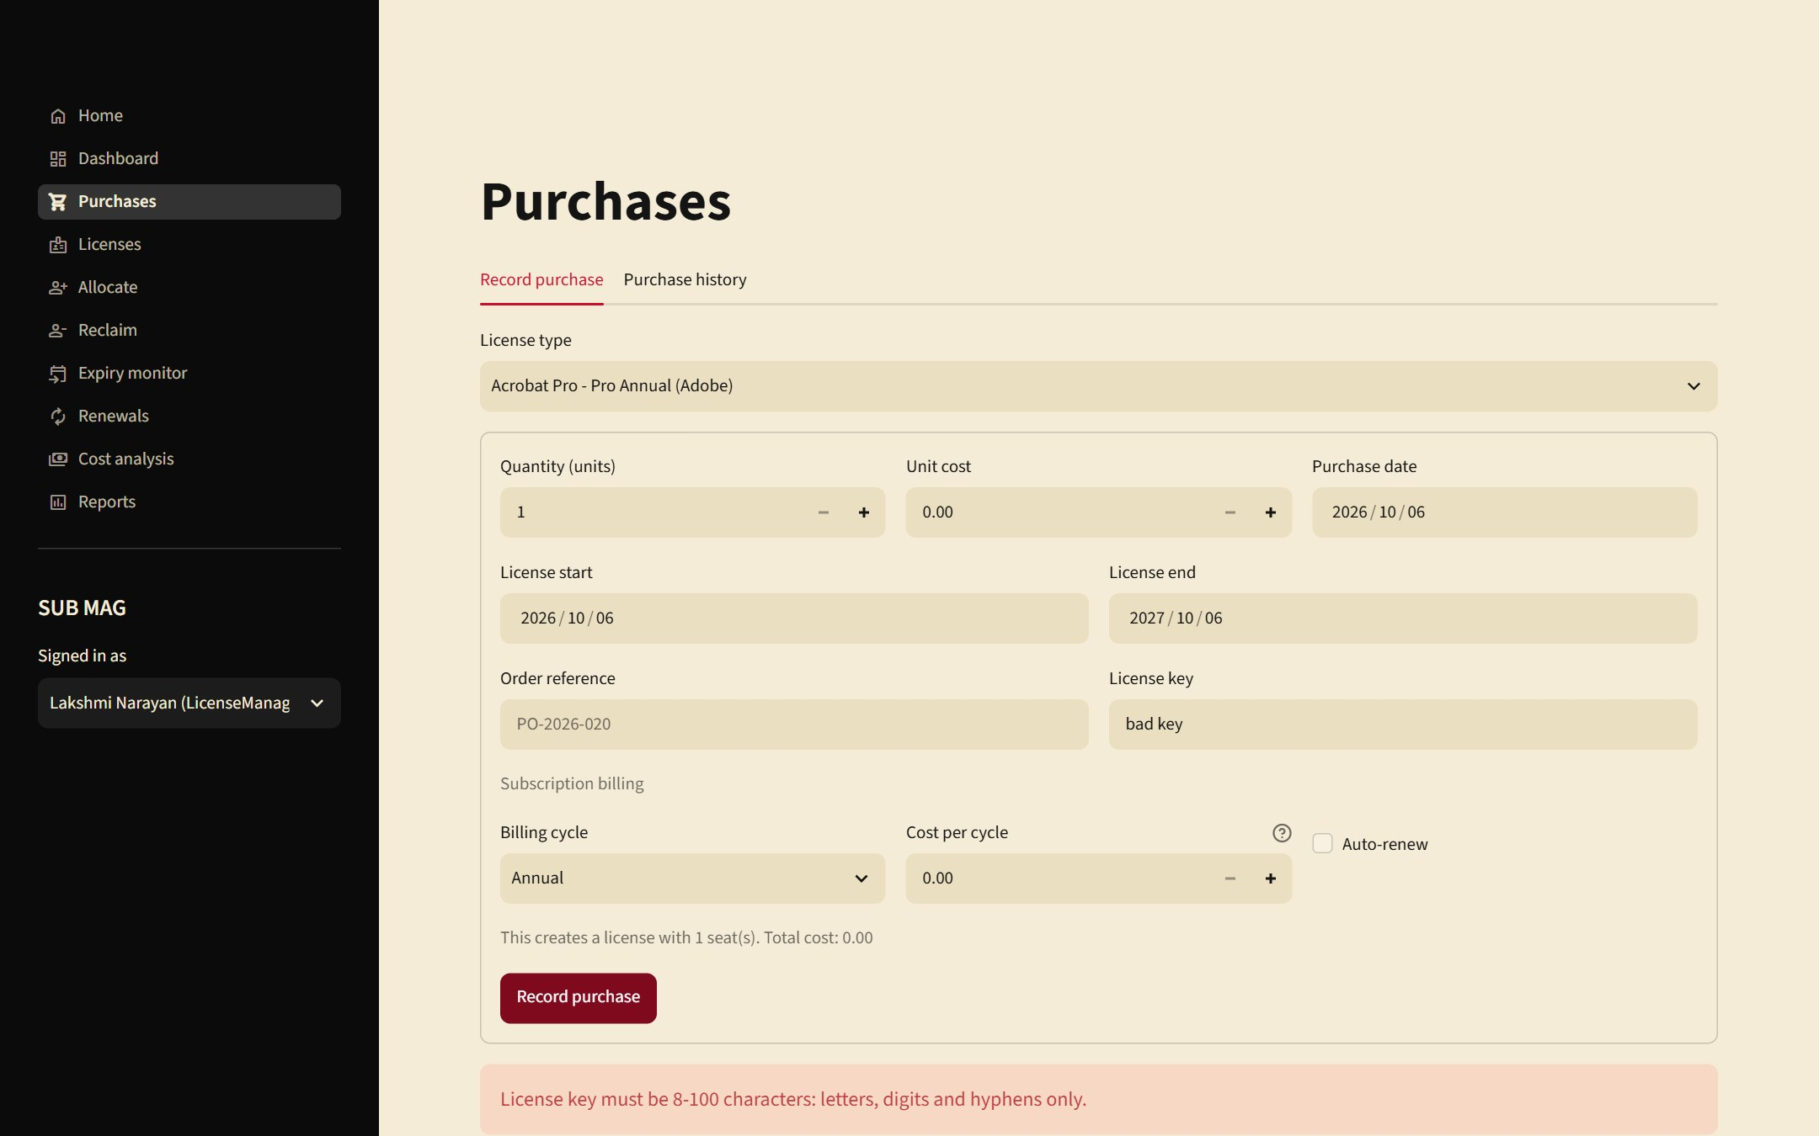
Figure 10: Input validation – an invalid license key is rejected with a clear message
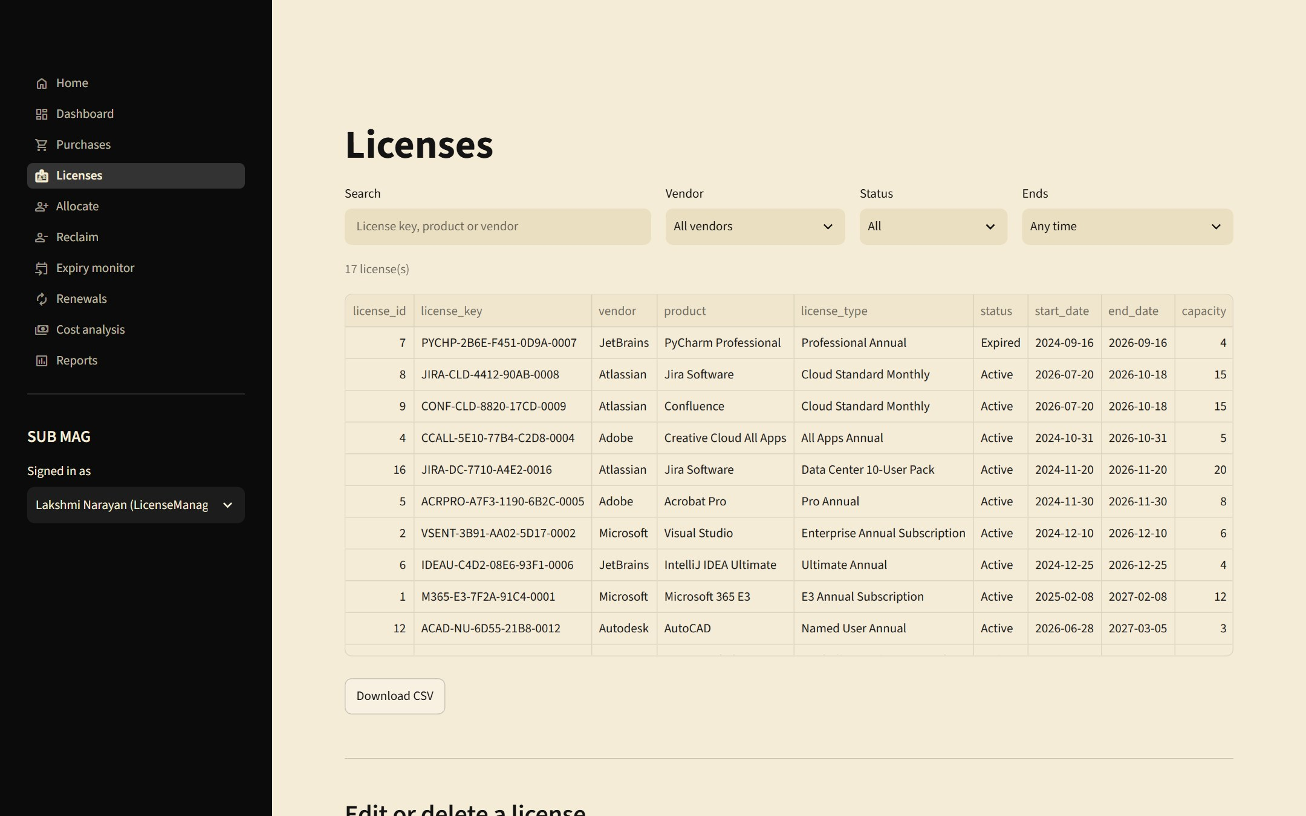
Figure 11: Licenses – search and filter by key, product, vendor, status and expiry window
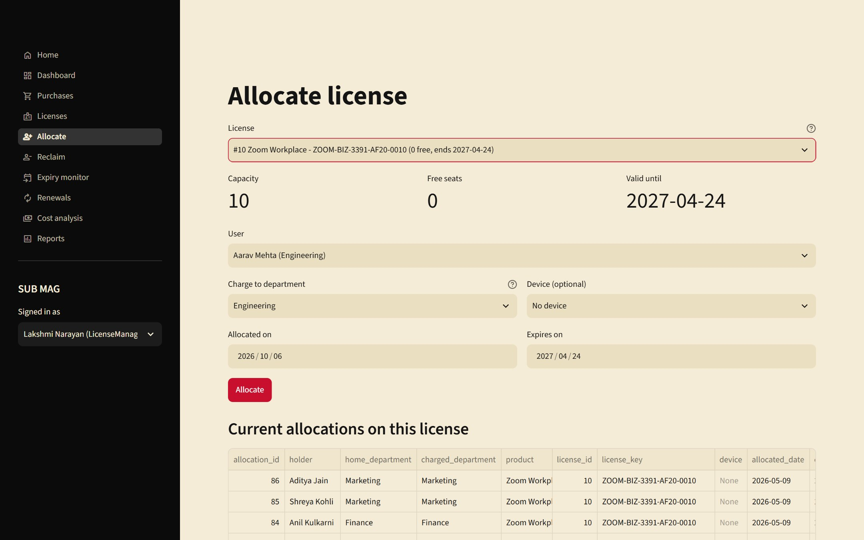
Figure 12: Allocate – choose a license, user, charged department, device and dates
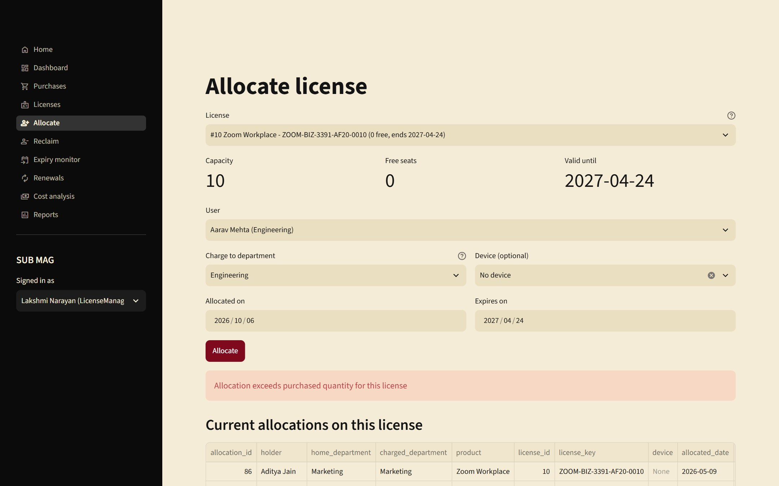
Figure 13: Business rule in action – allocating on a full license is refused by the database trigger
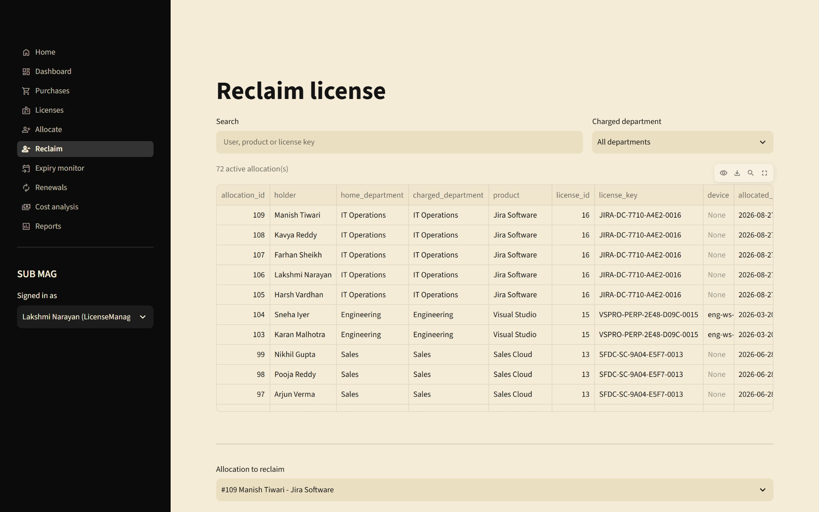
Figure 14: Reclaim – release a seat after confirmation
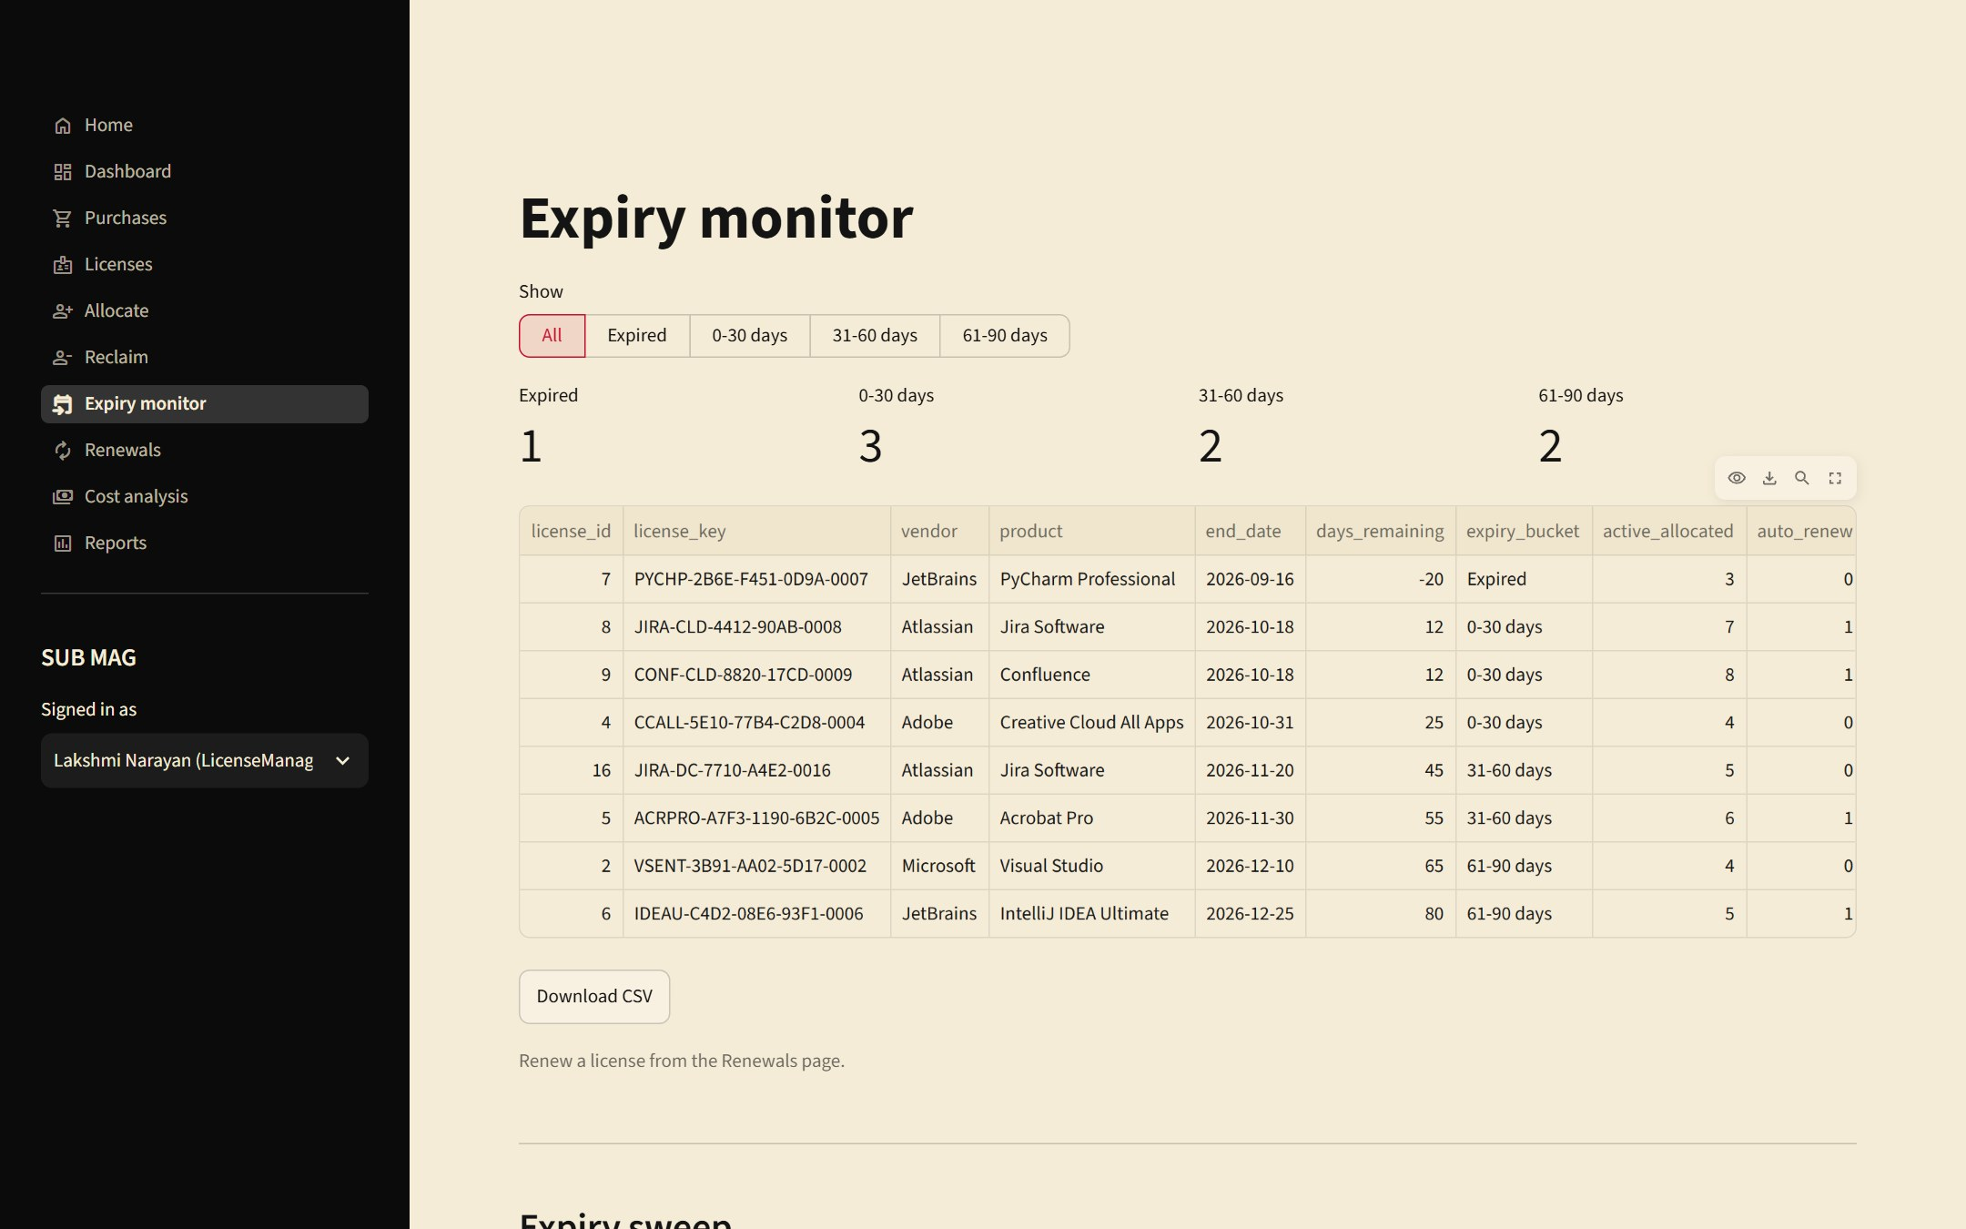
Figure 15: Expiry monitor – expired and expiring licenses with an expiry sweep
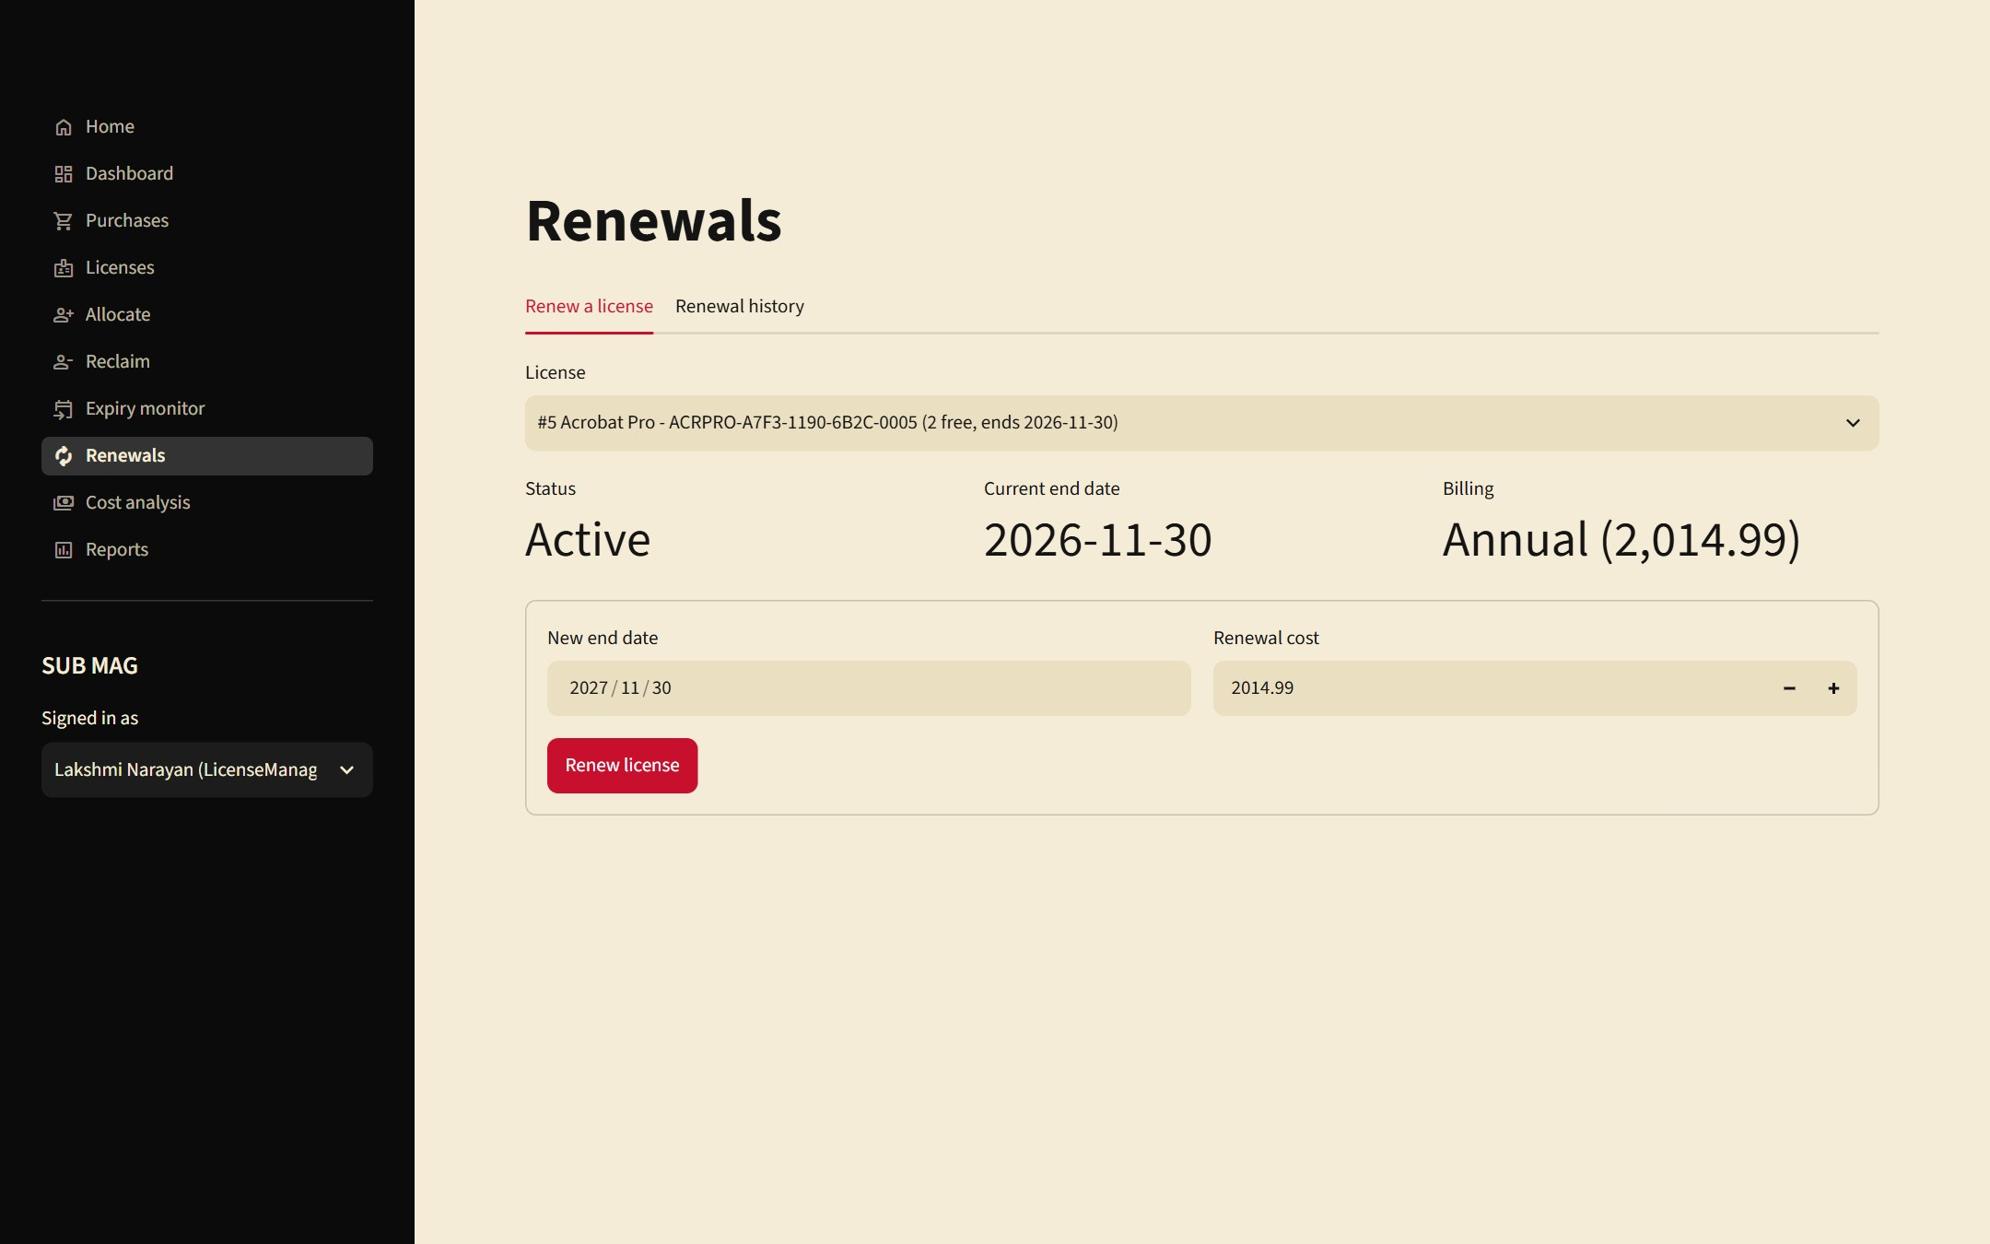
Figure 16: Renewals – extend a license and log the renewal cost
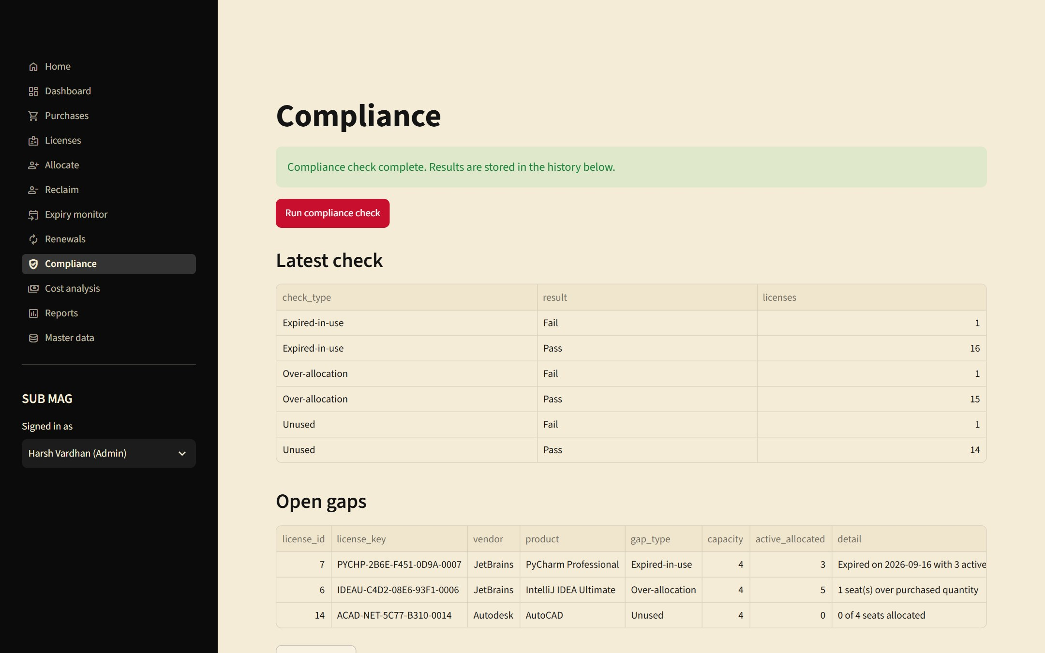
Figure 17: Compliance – run a check and review open gaps (Admin view)
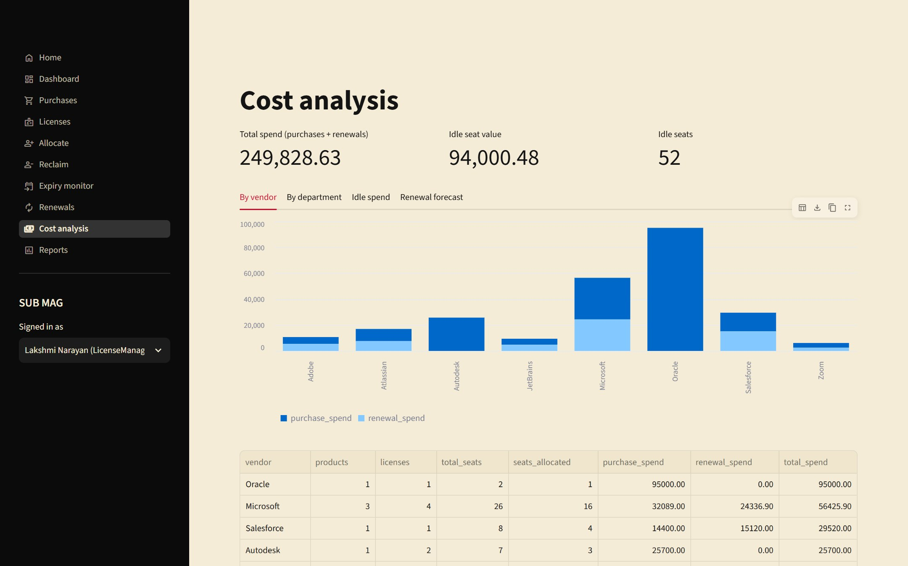
Figure 18: Cost analysis – spend by vendor and department, idle spend and renewal forecast
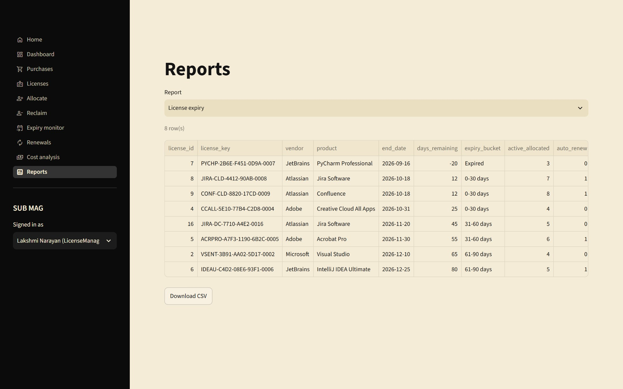
Figure 19: Reports – the six reports with CSV download
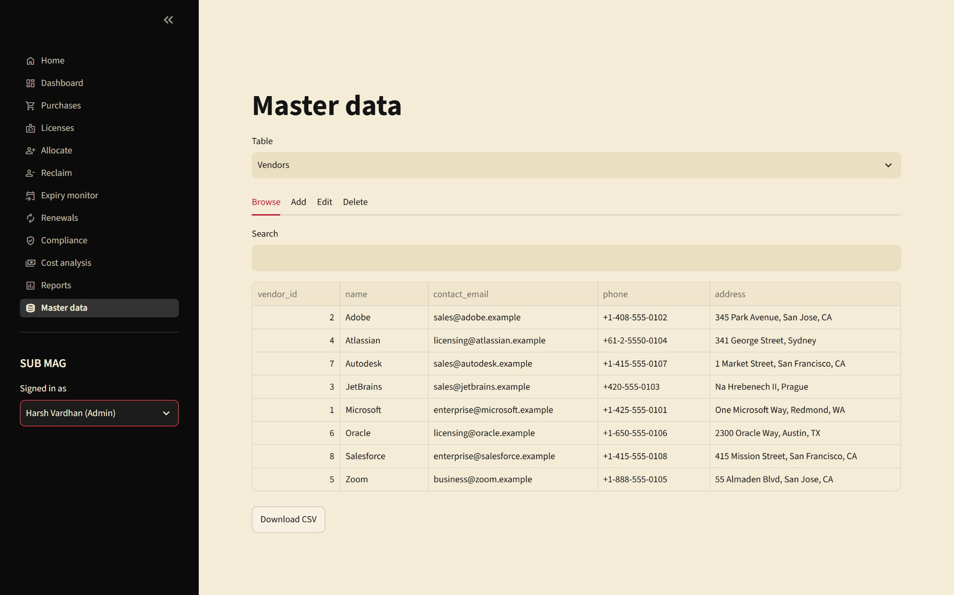
Figure 20: Master data – browse, add, edit and delete vendors, products, license types, departments, users and devices

12. Implementation Details

12.1 Technology stack
Layer | Technology | Responsibility
Presentation | Streamlit 1.65 (Python), Three.js for the introduction | Pages, forms, tables, charts, role-based navigation
Application services | Python modules in app/services/ | Business operations, transactions, validation
Data access | mysql-connector-python through app/db.py | Connections, transactions, error translation
Database | MySQL 8.0 (InnoDB) | Storage, constraints, triggers, views, stored procedures

Size of the implementation:
Part | Files | Lines
Python application (app/) | 28 | 1957
SQL scripts (sql/) | 6 | 1070

12.2 Project structure
dbms project/
├── docs/ requirements, ER diagram, normalization, data dictionary
├── sql/ 01_schema, 02_indexes, 03_seed_data, 04_queries, 05_views, 06_procedures
├── app/
│ ├── main.py entry point: introduction, sign-in, role-based navigation
│ ├── config.py reads database settings from .env
│ ├── db.py connections, transactions, error translation
│ ├── validators.py input validation
│ ├── services/ purchases, licenses, allocations, renewals, compliance, reports, master, lookups
│ ├── views/ one module per page, plus the introduction (splash.py)
│ └── .streamlit/config.toml red, black and cream theme
└── report/ this report and its images

12.3 Database connectivity
Connection settings come from environment variables (loaded from app/.env), so no password is stored in the code.
DB = {
"host": os.getenv("DB_HOST", "127.0.0.1"),
"port": int(os.getenv("DB_PORT", "3306")),
"user": os.getenv("DB_USER", "root"),
"password": os.getenv("DB_PASSWORD", ""),
"database": os.getenv("DB_NAME", "license_mgmt"),
}
db.py provides three building blocks: query() for reads, transaction() for multi-step writes, and call_procedure() for stored procedures. Values are always passed as bound parameters, never concatenated into SQL.

12.4 Key code snippets

Transactions
Every multi-step write runs inside transaction(). It commits when the block finishes and rolls back everything if any step fails.
@contextmanager
def transaction():
"""Yield a cursor; commit on success, roll back everything on any error."""
conn = connect()
try:
cur = conn.cursor(dictionary=True)
yield cur
conn.commit()
except Error as e:
conn.rollback()
raise translate(e) from e
except Exception:
conn.rollback()
raise
finally:
conn.close()

Turning database errors into user-friendly messages
Trigger messages and constraint violations are translated into plain sentences, so the user never sees a raw database error.
def translate(err: Error) -> AppError:
"""Turn a driver error into a message a user can act on."""
msg = err.msg or str(err)
if err.errno == 1644: # SIGNAL from a business-rule trigger
return AppError(msg)
if err.errno in (1062, 3819):
m = re.search(r"key '(?:\w+\.)?(\w+)'", msg) or re.search(r"constraint '(\w+)'", msg)
if m and m.group(1) in CONSTRAINT_MESSAGES:
return AppError(CONSTRAINT_MESSAGES[m.group(1)])
return AppError("That value conflicts with an existing record or violates a data rule.")
if err.errno == 1451:
return AppError("This record is still referenced by other records, so it can't be deleted.")
if err.errno == 1452:
return AppError("A selected related record doesn't exist.")
if err.errno in (1048, 1364):
return AppError("A required field is missing.")
if err.errno in (2003, 2002, 1045, 1049):
return AppError("Can't connect to the database. Check the DB settings in app/.env and that MySQL is running.")
return AppError(f"Database error: {msg}")

Recording a purchase (purchase, license and subscription together)
If the license key is a duplicate, the purchase row is rolled back too, so no orphan purchase is left behind.
def record_purchase(license_type_id, quantity, unit_cost, purchase_date, order_reference,
license_key, start_date, end_date, billing_cycle=None, auto_renew=False,
cost_per_cycle=None):
"""Create purchase + license (+ subscription) atomically. Returns ids."""
order_reference = v.clean(order_reference)
license_key = v.clean(license_key)
billing_cycle = v.clean(billing_cycle)
v.validate_purchase(license_type_id, quantity, unit_cost, purchase_date, order_reference,
license_key, start_date, end_date, billing_cycle, cost_per_cycle)
with db.transaction() as cur:
cur.execute("SELECT seats_per_license FROM license_type WHERE license_type_id = %s",
(license_type_id,))
lt = cur.fetchone()
if not lt:
raise db.AppError("That license type no longer exists.")
cur.execute("""INSERT INTO purchase (license_type_id, quantity, unit_cost, purchase_date, order_reference)
VALUES (%s, %s, %s, %s, %s)""",
(license_type_id, quantity, unit_cost, purchase_date, order_reference))
purchase_id = cur.lastrowid
key = license_key or generate_key()
cur.execute("""INSERT INTO license (purchase_id, license_key, quantity, start_date, end_date)
VALUES (%s, %s, %s, %s, %s)""",
(purchase_id, key, quantity * lt["seats_per_license"], start_date, end_date))
license_id = cur.lastrowid
if billing_cycle:
cur.execute("""INSERT INTO subscription (license_id, billing_cycle, auto_renew, cost_per_cycle)
VALUES (%s, %s, %s, %s)""",
(license_id, billing_cycle, bool(auto_renew), cost_per_cycle))
return {"purchase_id": purchase_id, "license_id": license_id, "license_key": key,
"seats": quantity * lt["seats_per_license"]}

Allocating a license
The service only validates input and inserts. The quantity, expiry and validity-window rules are enforced by the database trigger, so they cannot be bypassed.
def allocate(license_id, user_id, device_id, department_id, allocated_date, expiry_date):
v.validate_allocation(license_id, user_id, department_id, allocated_date, expiry_date)
with db.transaction() as cur:
cur.execute("""INSERT INTO allocation (license_id, user_id, device_id, department_id,
allocated_date, expiry_date)
VALUES (%s, %s, %s, %s, %s, %s)""",
(license_id, user_id, device_id, department_id, allocated_date, expiry_date))
return cur.lastrowid

Renewing a license
The license row is locked, the renewal is logged with the previous end date, and the end date is extended in the same transaction.
def renew_license(license_id, new_end_date, cost, renewed_by, renewal_date=None):
"""Extend a license and log the renewal in one transaction."""
v.validate_renewal(license_id, new_end_date, cost)
with db.transaction() as cur:
cur.execute("SELECT end_date, status FROM license WHERE license_id = %s FOR UPDATE", (license_id,))
lic = cur.fetchone()
if not lic:
raise db.AppError("That license no longer exists.")
if lic["status"] == "Revoked":
raise db.AppError("A revoked license can't be renewed. Change its status first.")
if new_end_date <= lic["end_date"]:
raise db.AppError(f"The new end date must be after the current end date ({lic['end_date']}).")
cur.execute("""INSERT INTO renewal (license_id, renewal_date, previous_end_date, new_end_date,
renewal_cost, renewed_by)
VALUES (%s, COALESCE(%s, CURDATE()), %s, %s, %s, %s)""",
(license_id, renewal_date, lic["end_date"], new_end_date, cost, renewed_by))
renewal_id = cur.lastrowid
cur.execute("UPDATE license SET end_date = %s, status = 'Active' WHERE license_id = %s",
(new_end_date, license_id))
return renewal_id

Input validation
def validate_renewal(license_id, new_end_date, cost):
e = []
if not license_id:
e.append("Select a license.")
if not isinstance(new_end_date, date):
e.append("Enter the new end date.")
if cost is None or cost <= 0:
e.append("Renewal cost must be greater than zero.")
elif cost > 100_000_000:
e.append("Renewal cost looks too large. Check the amount.")
_raise(e)

Role-based navigation
ROLE_PAGES = {
"Admin": list(PAGES),
"LicenseManager": ["home", "dashboard", "purchases", "licenses", "allocate", "reclaim",
"expiry", "renewals", "cost", "reports"],
"Compliance": ["home", "dashboard", "licenses", "expiry", "compliance", "cost", "reports"],
"Manager": ["home", "dashboard", "cost", "reports"],
"Employee": ["home", "dashboard"],
}

12.5 Running the system
1. mysql -u root -p < sql/01_schema.sql (repeat for 02, 03, 05, 06)
2. cd app
3. copy .env.example .env (then put the MySQL password in .env)
4. pip install -r requirements.txt
5. streamlit run main.py (opens http://localhost:8501)

13. Testing

13.1 Test strategy
Testing was done at three levels, all run against a real MySQL 8.0 instance loaded with the sample data:
- Database level. SQL statements that deliberately break each constraint and business rule, checking that the database refuses them with the expected error.
- Service level. A Python script calls the application's service functions directly, covering the success paths, the failure paths, validation and transaction rollback.
- User-interface level. Streamlit's headless test harness renders every page for every role and performs real interactions (selecting items, filling forms, clicking buttons) and checks the messages shown.
Because the sample data is generated relative to the run date, the tests are repeatable on any day. The database was reloaded from the seed scripts before each test run.

13.2 Summary of results
Test level | Test cases | Passed | Failed
Database rules and constraints (SQL) | 14 | 14 | 0
Service layer (Python, against MySQL) | 59 | 59 | 0
User-interface interactions (Streamlit) | 17 | 17 | 0
Total | 90 | 90 | 0

All test cases passed.

13.3 Database rule and constraint tests
Each row is a statement that the database is expected to refuse. "Pass" means it was refused with the response shown.
ID | Attempted operation | Database response | Result
BR1 | Duplicate license key | ERROR 1062: Duplicate entry 'M365-E3-7F2A-91C4-0001' for key 'license.uq_license_key' | Pass
BR2 | Allocate beyond purchased quantity (license 10 is full) | ERROR 1644: Allocation exceeds purchased quantity for this license | Pass
BR3a | Expiry date not after allocation date | ERROR 3819: Check constraint 'chk_alloc_period' is violated. | Pass
BR3b | Allocation period outside the license window | ERROR 1644: Allocation period must lie within the license validity window | Pass
BR4a | Assign an expired license | ERROR 1644: Cannot allocate an expired or revoked license | Pass
BR4b | Assign a revoked license | ERROR 1644: Cannot allocate an expired or revoked license | Pass
BR5 | Renewal cost of zero | ERROR 3819: Check constraint 'chk_renewal_cost' is violated. | Pass
BR6 | Same user gets a second active seat on a license | ERROR 1062: Duplicate entry '1-1' for key 'allocation.uq_active_seat' | Pass
C1 | Negative purchase quantity | ERROR 3819: Check constraint 'chk_purchase_qty' is violated. | Pass
C2 | Invalid email format for a vendor | ERROR 3819: Check constraint 'chk_vendor_email' is violated. | Pass
C3 | License end date before start date | ERROR 3819: Check constraint 'chk_license_dates' is violated. | Pass
C4 | Invalid status value | ERROR 3819: Check constraint 'chk_license_status' is violated. | Pass
C5 | Foreign key to a missing record | ERROR 1452: Cannot add or update a child row: a foreign key constraint fails (license_mgmt.allocation, CONSTRAINTfk_alloc_userFOREIGN KEY (user_id) REFERENCESapp_user(user_id)) | Pass
C6 | Delete a vendor that still has products | ERROR 1451: Cannot delete or update a parent row: a foreign key constraint fails (license_mgmt.software_product, CONSTRAINTfk_product_vendorFOREIGN KEY (vendor_id) REFERENCESvendor(vendor_id)) | Pass

13.4 Service-layer test cases
ID | Service-layer test case | Result
S-01 | purchase creates license with generated key | Pass
S-02 | subscription row created | Pass
S-03 | duplicate license key rejected | Pass
S-04 | failed purchase rolled back (no orphan purchase) | Pass
S-05 | duplicate order reference rejected | Pass
S-06 | negative quantity validated | Pass
S-07 | end before start validated | Pass
S-08 | bad key format validated | Pass
S-09 | list_purchases search | Pass
S-10 | allocate succeeds | Pass
S-11 | same user twice rejected | Pass
S-12 | over quantity rejected (capacity 3) | Pass
S-13 | period outside license window rejected | Pass
S-14 | expired license rejected | Pass
S-15 | revoked license rejected | Pass
S-16 | expiry before allocation validated | Pass
S-17 | reclaim frees seat | Pass
S-18 | reclaim twice rejected | Pass
S-19 | freed seat can be reused | Pass
S-20 | list_allocations filter | Pass
S-21 | renewal cost zero rejected | Pass
S-22 | renewal not extending rejected | Pass
S-23 | renewal extends license | Pass
S-24 | renewal logged with previous end | Pass
S-25 | revoked renewal rejected | Pass
S-26 | renewing expired license reactivates it | Pass
S-27 | compliance run produces summary | Pass
S-28 | gaps detected (over-allocation, unused) | Pass
S-29 | rerun same day is idempotent | Pass
S-30 | compliance history filter | Pass
S-31 | expiry sweep expires license and allocations | Pass
S-32 | search by text | Pass
S-33 | search expiring within 30 | Pass
S-34 | update license | Pass
S-35 | update with dup key rejected | Pass
S-36 | delete license with history rejected | Pass
S-37 | delete clean license works | Pass
S-38 | report License expiry | Pass
S-39 | report Utilization | Pass
S-40 | report Compliance gaps | Pass
S-41 | report Renewal cost | Pass
S-42 | report Department allocation | Pass
S-43 | report Vendor portfolio | Pass
S-44 | kpis | Pass
S-45 | idle spend | Pass
S-46 | renewal forecast | Pass
S-47 | spend by product | Pass
S-48 | master update | Pass
S-49 | master dup name | Pass
S-50 | master bad email | Pass
S-51 | master required | Pass
S-52 | master delete referenced | Pass
S-53 | master delete | Pass
S-54 | master list Vendors | Pass
S-55 | master list Products | Pass
S-56 | master list License types | Pass
S-57 | master list Departments | Pass
S-58 | master list Users | Pass
S-59 | master list Devices | Pass

13.5 User-interface test cases
In addition to the cases below, every page was rendered for each of the four main roles (Admin, License manager, Compliance, Manager), 48 page renders in total, with no errors; and the Home page was verified to show exactly the expected number of cards for each of the five roles (Admin 11, License manager 9, Compliance 6, Manager 3, Employee 1).
ID | UI interaction test case | Result
U-01 | allocate on full license shows quantity error | Pass
U-02 | allocate success shows flash | Pass
U-03 | duplicate seat error | Pass
U-04 | purchase duplicate key error | Pass
U-05 | purchase invalid key validation | Pass
U-06 | purchase valid submit succeeds (perpetual) | Pass
U-07 | subscription purchase defaults cost per cycle | Pass
U-08 | renewal cost 0 rejected | Pass
U-09 | reclaim without confirm blocked | Pass
U-10 | reclaim with confirm succeeds | Pass
U-11 | compliance run flash | Pass
U-12 | expiry sweep runs | Pass
U-13 | allocate read-only for Compliance role | Pass
U-14 | reclaim read-only for Compliance role | Pass
U-15 | purchases read-only for Compliance role | Pass
U-16 | renewals read-only for Compliance role | Pass
U-17 | master data invalid email | Pass

13.6 Index usage
An EXPLAIN of the expiry query shows that the optimizer uses the index on license(end_date, status): the access type is range and the chosen key is idx_license_end_status, so only the licenses inside the date window are read instead of scanning the whole table. A second run with FORCE INDEX produces the same access path (the estimated row count differs only because the optimizer's estimates are approximate).
EXPLAIN SELECT license_id, license_key, end_date FROM license WHERE status = 'Active' AND end_date BETWEEN CURDATE() AND CURDATE() + INTERVAL 30 DAY;
id | table | type | possible_​keys | key | rows | Extra
1 | license | range | idx_license_end_status | idx_license_end_status | 3 | Using index condition

EXPLAIN SELECT license_id, license_key, end_date FROM license FORCE INDEX (idx_license_end_status) WHERE status = 'Active' AND end_date BETWEEN CURDATE() AND CURDATE() + INTERVAL 30 DAY;
id | table | type | possible_​keys | key | rows | Extra
1 | license | range | idx_license_end_status | idx_license_end_status | 1 | Using index condition

13.7 Observations
- Rule violations are caught at the database even when the application is bypassed, which is the intended behaviour of the design.
- A failed purchase (duplicate key) leaves no orphan purchase row, confirming that the transaction rolls back.
- The tests exposed one usability gap during development: for subscription purchases the cost per billing cycle had to be retyped. It was fixed by defaulting it to the total purchase cost and then re-tested.

14. Conclusion and Future Enhancements

14.1 Conclusion
The project delivers a complete license and subscription management system: a normalized (3NF/BCNF) MySQL database with twelve tables, a full set of integrity constraints, two triggers and two stored procedures that enforce the five required business rules inside the database, six reporting views, ten supporting indexes, realistic sample data, a library of 36 queries and a Streamlit application with role-based access. All 90 automated test cases passed. The system shows that putting integrity rules in the database, rather than only in application code, keeps the data correct no matter how it is accessed, and that views and procedures keep the reporting and maintenance logic simple and reusable.

14.2 Limitations
- Users are chosen from a list rather than signing in with a password.
- Each purchase creates one license; splitting a purchase into several licenses is not supported yet.
- A single currency is assumed.
- Because the allocation trigger locks the license row (FOR UPDATE), MySQL refuses an allocation statement that also reads the license table in a subquery (error 1442). Allocations are therefore created with explicit values, which is what the application does.
- The 3D introduction needs an internet connection the first time (Three.js and fonts are loaded from a CDN) and was tested on desktop Chrome only.
- Automated tests are scripts run by hand rather than part of a continuous integration pipeline.

14.3 Future enhancements
- Real authentication (hashed passwords or single sign-on) and per-role database accounts.
- E-mail or chat alerts for licenses nearing expiry and for new compliance gaps.
- Bulk import of purchases, users and devices from CSV files.
- An audit trail table recording who changed which allocation, renewal or license and when.
- Automatic discovery of installed software on devices to compare with allocations.
- Multi-currency support and exchange-rate-aware cost reports.
- A REST API so other tools can read and update the data.
- Packaging with Docker and a CI pipeline that runs the automated tests on every change.
- A mobile-friendly layout and an offline-capable introduction (bundled graphics library and fonts).

15. References
- R. Elmasri and S. B. Navathe, Fundamentals of Database Systems, 7th ed., Pearson, 2016.
- A. Silberschatz, H. F. Korth and S. Sudarshan, Database System Concepts, 7th ed., McGraw-Hill, 2019.
- C. J. Date, An Introduction to Database Systems, 8th ed., Pearson, 2003.
- Oracle Corporation, MySQL 8.0 Reference Manual (CHECK constraints, triggers, stored procedures, generated columns, window functions), https://dev.mysql.com/doc/refman/8.0/en/
- Streamlit Inc., Streamlit Documentation, https://docs.streamlit.io
- Oracle Corporation, MySQL Connector/Python Developer Guide, https://dev.mysql.com/doc/connector-python/en/
- Python Software Foundation, Python 3 Documentation, https://docs.python.org/3/
- pandas development team, pandas Documentation, https://pandas.pydata.org/docs/
- Three.js authors, Three.js Documentation, https://threejs.org/docs/
- Course lecture notes and laboratory manual, Database Management Systems, Woxsen University.

16. Contribution of Each Member
Member | Roll number | Contribution
Shreyash Singh | [Roll number] | [e.g. database design and DDL, triggers and procedures, application and user interface, testing, report]
[Member 2 name] | [Roll number] | [e.g. requirements, ER diagram, normalization, data dictionary, sample data]
[Member 3 name] | [Roll number] | [e.g. queries and views, test cases, screenshots, documentation]

17. Appendix

Appendix A: GitHub repository link
[GitHub repository link – to be added after the project is pushed]

Appendix B: Project files
File | Content
docs/requirements.md | Problem statement, scope, users and requirements
docs/er-diagram.svg | ER diagram
docs/initial-schema.md | First-draft schema before normalization
docs/normalization.md | Functional dependencies and 3NF analysis
docs/data-dictionary.md | Table structures
sql/01_schema.sql … 06_procedures.sql | Database scripts
app/ | The SUB MAG application
report/PROJECT_REPORT.md | This report

